Welcome to Advanced Autosport Technologies’ information pack on the Polo 86 & 86C including the G40. As a company we are proud to offer probably the greatest selection of tuning parts for the Polo mark 2 and 3 in the UK, covering every aspect of the car from styling to retro fitting of catalytic converters.

Engine Kits

POLO 86 & 86C
TUNING-KIT...01 | 65 BHP 1.1
Twin Weber 40 DCOE - Inlet manifold - fitting. **Brake modifications required!**
Second hand carbs available and make kit cheaper !! | Price £1028.64
TUNING-KIT...02 | 75 BHP 1.3
Twin Weber 40 DCOE - Inlet manifold - fitting.
Second hand carbs available and make kit cheaper !! | Price £1028.64
TUNING-KIT...03 | 72 BHP 1.3
Twin Weber 40 DCOE - Inlet manifold - fitting.
Second hand carbs available and make kit cheaper !! | Price £1111.91
TUNING-KIT...04 | 86 BHP 1.3
Twin Weber 40 DCOE - Inlet manifold - fitting.
Second hand carbs available and make kit cheaper !! | Price £1028.64
TUNING-KIT...05 | 90 BHP 1.3
Twin Weber 40 DCOE - Inlet manifold - Cylinder head work - Valves 37/32 mm- SM pistons - SM exhaust manifold - Head gasket - Fitting kit
Second hand carbs available and make kit cheaper !! | Price £3219.16
TUNING-KIT...06 - 1450cc | 110 BHP 1.05-1.3
Twin Weber 40 DCOE - Inlet manifold - Cylinder head work - Valves 37/32mm- SM pistons - SM exhaust manifold - Head gasket - Fitting kit - 1450 cc - SM Sportcamshaft
Second hand carbs available and make kit cheaper !! | Price £4582.16
TUNING-KIT...10 | 75 BHP 1.3 - NZ
SM Sportcamshaft- Sports exhaust system- Sports airfilter
 | Price £514.16
TUNING-KIT...07 | 110 BHP 1.3
Weber Alpha Management - 40mm Throttle bodies - Metal catalyst **Brake, suspension and speedo modifications required!**
Other management & throttle body systems available - please call | Price £2063.79
TUNING-KIT...11 | 90 BHP 1.3 - 3F
SM Sportcamshaft 264° - Inlet manifold (modified) - Sports exhaust system
 | Price £534. 05
TUNING-KIT...12 | 90 BHP 1.3
Weber Alpha Management - 40mm Throttle bodies - Airbox - SM Sportcamshaft 280°
 | Price £2768.83
POLO G40
TUNING-KIT... 20 | 136 BHP 1.3
SM Pulley 70/68/65mm- Sports exhaust system with tailpipes 90x63 or Ø 90- Platinum Sparkplugs
 | Price £594.16
TUNING-KIT... 21 | 148 BHP 1.3

Kit 20 plus Rolling Road set up with print out

 | Price £177.41
TUNING-KIT... 22 | 160 BHP 1.3
Kit 20 plus SM Sportcamshaft 264° - Adjustable Vernier - Cylinder head work with competition valves
 | Price £1719.83
TUNING-KIT... 23 | 180 BHP 1.3
G 60 Supercharger parts and fitting kit - SM Pulley 80mm
 | Price £2498.28
TUNING-KIT... 24 - 1425cc | 198 BHP + 1.3
G 60 Supercharger - 1425cc kit - SM Pistons - SM Sportcamshaft- Cylinder head work with competition valves - Adjustable Vernier - Modified throttle bodies - Larger diameter inlet manifold - SM exhaust manifold - adjustable fuel pressure regulator
 | Price £3964.66
TUNING-KIT... 25 | up to 260 BHP 1.3
Kit 24 plus Weber Alpha Management System- SM Intercooler
Other management & throttle body systems available - please call | Price £5775.00

All the parts we use for our engine kits are made especially for us and have been thoroughly tested, we do not use reground or reprofiled items. They can also all be bought separately from us – we can also tailor engine work to any engine regardless of what modifications may have been carried out on it before. Contact us with your requirements and we will be able to give you specifications and advice. For the more serious enquiry we can arrange for you to see a built up engine along with the component parts.
We supply oil cooler, charge coolers, catch tanks, intercoolers and radiators in either standard sizes or made to measure. Our service and product range also encompasses braided fuel and oil hoses along with all the fixtures and fittings – for the safety minded we stock a complete range of fire extinguishers too!
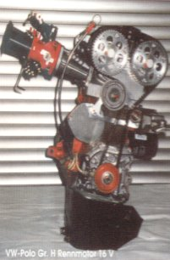
200+ bhp 1300 16 valve engine

Stop Press! New engine developments are to be launched by September, using different management and injection systems Advanced Autosport are hoping to offer an up-rated and up-dated range of kits offering the same power but at considerably lower cost.

Suspension

We stock the following suspension: FK, Bilstein, AVO, H&R and our own development parts. In general we recommend Bilstein for ultimate performance and FK for economical performance. Our own suspension parts are tailored more to competition use but offer the performances road driver ultimate adjustability.
The Polo 86 & 86C have easily up-gradable suspension systems but suffer from strange steering placement that makes most coilover kits excessively expensive unless you part exchange your uprights.
AAT have developed a coilover system using your own uprights and inserts selected from a range of manufacturers. By using 2¼” ID coil springs we are able to offer a wide range of spring lengths and rates, which can be catered for ultra-low show cars as well as road and track cars.
Non-coilover suspension kits are available, the range of lowering starts at 20 mm and stops at the extra low FK kit which drops the Polo an amazing 85 mm front and 70 mm rear. We are able to offer a range of extra low springs to fit normal dampers if required, these take about 3 weeks to be made. Whilst we understand that an extra low car looks impressive it has to be pointed out that the stresses placed on the car in certain areas (driveshafts and CV joints for example) are well in excess of those VW designed the parts to cope with. If you run your car too low it will damage and/or wear parts quickly. Naturally there will be no warranty cover for parts that break because of that.
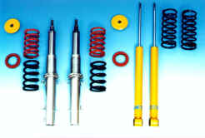

We supply a complete range of strut and turret braces, front and rear, upper and lower as well as under body protection. Our braces come from a variety of suppliers including Sorg Motorsport, OMP, Sparco and Wiechers. They are available in many styles including polished and carbon look. Strut brace prices are as follows:~

Front Upper: Rear:
OMP – steel £37.60 inc VAT OMP – steel £22.00 inc VAT

Sparco – steel £47.00 inc VAT Sorg Motorsport (3pc) £88.00 inc VAT
Sorg Motorsport (3pc) £88.00 inc VAT Wiechers – steel £25.00 inc VAT
Wiechers – steel (3pc) £55.50 inc VAT Wiechers – steel (3pc) £38.70 inc VAT
Wiechers – Alu (3pc) £85.00 inc VAT Wiechers – Alu £35.00 inc VAT
Wiechers – Alu (3pc) £61.77 inc VAT

Front Lower:
Sorg Motorsport £52.00 inc VAT
Sorg Motorsport (extra stiff) £85.00 inc VAT
Wiechers – steel £35.00 inc VAT

Wiechers – steel (low car) £37.00 inc VAT
Wiechers – Alu £44.00 inc VAT

Sorg Motorsport braces have won races, rallies sprints and hillclimbs – including national championships. For the serious competitor these are the best braces available. For road use all of the above are suitable, choice depends on what colours you like and the style you require – Wiechers follow the contours of the engine bay more and are red, Sparco are straight, generally, and red in colour. OMP are very similar in design to Sparco but are bright Yellow. Sorg Motorsport are black in colour but offer the best fit and stiffening of any of the above braces.

We are able to offer a range of top mounts to suit every motoring need, from ones that lower the car by 10 – 15mm to alloy motorsport mounts that allow castor and camber to be changed.

Body panels & Styling

We offer a range of styling products for the Polo 86 & 86C including bumpers, grills and spoilers. AAT supply JE Design, Rieger, Mattig and RSL Motorsport products along with many others including our ever popular DTM mirrors that retail at £17.00 plus VAT each! Also ask about our range of carbon fibre race mirrors.
AAT also supply light weight panels and wide arch kits, all of which are derived from motorsport. We can offer a vast range of front splitters that have a genuine effect – most of these are not the most suitable for road use but do really work aerodynamically.
We offer a complete range of air intakes and vents for body work, including bonnet and roof along with various styles of mesh if required. Brake and engine ducting can be supplied in various lengths and diameters along with intakes to suit.

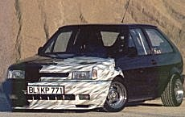

Interior

We offer a complete range of products for the interior of any car. Products include competition seats(FIA homoglated), road seats, pedal sets, steering wheels (with airbags if required), gear knobs, coloured dials, extra gauges, fire extinguishers, foot braces, map lights, carbon fibre parts, road and race seatbelts / harnesses (FIA Homoglated) as well as Roll bars and cages.
Roll cages can be supplied to suit all uses, including weld in and chromed. We supply Wiechers, OMP, Sparco, Safety Devices and Custom Cages roll bars and cages along with a wide range of braces. Roll bars and cages can be made to measure for any vehicle, one off specials not a problem. Polished aluminium rear roll cages start from £270.00 including Vat with a normal rear cage starting at about £129.00 including VAT. A full roll cage starts at £250.00 including Vat for Polo 86 and 86C Coupe and ‘Steilheck’.
VDO gauges start @ £23.00 + VAT for water temperature, oil temperature, oil pressure, fuel pressure, voltmeter, etc.
Road and competition seats start at £90 + VAT, from companies like Recaro, Sparco, OMP, Kingdragon, Corbeau, König, and Cobra.
Seats belts and harnesses are available in many colours and styles including 3 point, 4 point, 5 point and 6 point fixing. Made by Sabelt, OMP, Sparco, Kingdragon, TRS, Safety Devices, Willans and many more. Prices for harnesses start at £40.00 and stop at £206.80 including VAT.

Wheels

We are exclusive stockists for RSL wheels as well as Sorg Performance light wheels, we are one of the UK’s most competitive ATS dealers, we offer Compomotive wheels along with OZ, BBS and many others. We offer the ever popular 3 piece TH wheel in a wide range of sizes at some of the cheapest prices in the UK. Our wheel range encompasses sizes from 13” to 20” from 5½ to 10J. We are also one of the few companies offering 8x15 ATS Cup wheels (we offer a far greater range of deep dish wheels but the Cup offers Old school styling with a deep dish). AAT are also able to supply magnesium wheels for motorsport use and the ultimate weight saving.

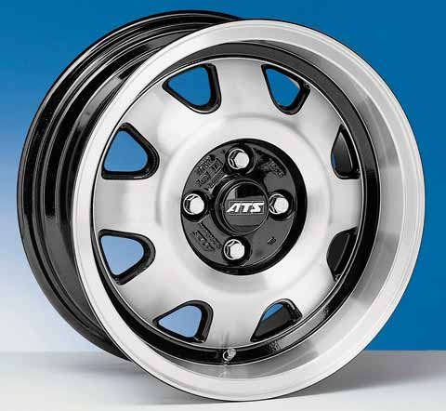

Brakes

From replacement pads to complete upgrades we offer the whole range for all Polos, bigger discs are no problem, ultimate performance pads are also no problems. For race, rally or road AAT have an answer – many just a day away. Our ultimate brake conversion is the G60 280 mm kit. This kit offers all the stopping power required by our 260 bhp engine conversion whilst using Volkswagen parts, the range of discs and pads available means that every requirement is suitably covered.. We can fabricate mountings for AP Racing brakes for race and rally vehicles if required.
We offer a made to measure service for braided hosing (including fuel and oil hoses), you give us you old hose and we supply an exact replica but braided. These hoses can be supplied with a variety of coverings, including blue, yellow and red poly sheathing. Dot 4 and 5.1 fluids stocked.
Performance air filters & induction kits

Advanced Autosport Technologies are one of the few companies in the UK to offer a performance induction air filter kit for the Polo 86C GT. This kit increases the air flowing in through the induction system and thus allows a greater level of performance from the engine. Easy to fit – can be done in 10 minutes by the most inexperienced owner. There is a simlar kit available for the G40 but the GT kit is the most impressive item, no longer need GT drivers try and make their own kits ~ AAT offer an off the shelf kit.
We also supply and stock a wide range of performance air filters and induction kits for the rest of the Polo range, including a Group N and A (race and rally) legal systems. We supply a range of airfilters from the following manufacturers: King Dragon, K&N, Pipercross, OMP, Sparco, ITG and a few more.

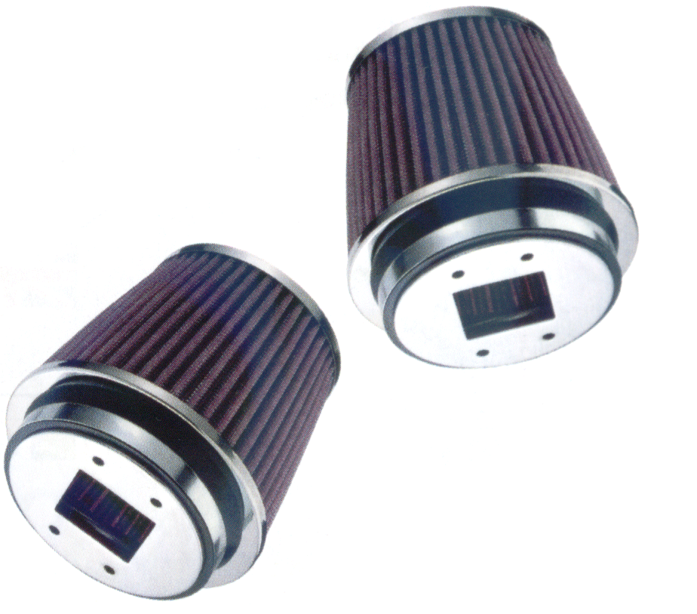
Part of the induction kit for the Polo GT & G40.

