電通二甲微處理器實驗 實驗結報

實驗名稱 | Lab12–溫溼度感測器
組別 |  | 組員 | 06051166-阮佑宸

- 實驗目的
    - 運用溫溼度感測器測量該地方的溫溼度
    - 將測量溫溼度上傳至MCS Cloud
- 實驗步驟
CHECK POINT 1
讓DHT-11可以一直亮測溫濕度
CHECK POINT 2
整合Timer與DHT-11測量溫溼度
CHECK POINT 3
使用Timer每隔10秒將測量溫溼度上傳至MCS Cloud
- 程式碼
CHECK POINT 1
// Example testing sketch for various DHT humidity/temperature sensors
// Written by ladyada, public domain

// REQUIRES the following Arduino libraries:
// - DHT Sensor Library: https://github.com/adafruit/DHT-sensor-library
// - Adafruit Unified Sensor Lib: https://github.com/adafruit/Adafruit_Sensor

#include "DHT.h"

#define DHTPIN 2 // Digital pin connected to the DHT sensor
// Feather HUZZAH ESP8266 note: use pins 3, 4, 5, 12, 13 or 14 --
// Pin 15 can work but DHT must be disconnected during program upload.

// Uncomment whatever type you're using!
//#define DHTTYPE DHT11 // DHT 11
#define DHTTYPE DHT11 // DHT 22 (AM2302), AM2321
//#define DHTTYPE DHT21 // DHT 21 (AM2301)

// Connect pin 1 (on the left) of the sensor to +5V
// NOTE: If using a board with 3.3V logic like an Arduino Due connect pin 1
// to 3.3V instead of 5V!
// Connect pin 2 of the sensor to whatever your DHTPIN is
// Connect pin 4 (on the right) of the sensor to GROUND
// Connect a 10K resistor from pin 2 (data) to pin 1 (power) of the sensor

// Initialize DHT sensor.
// Note that older versions of this library took an optional third parameter to
// tweak the timings for faster processors. This parameter is no longer needed
// as the current DHT reading algorithm adjusts itself to work on faster procs.
DHT dht(DHTPIN, DHTTYPE);

void setup() {
Serial.begin(9600);
Serial.println(F("DHTxx test!"));

dht.begin();
}

void loop() {
// Wait a few seconds between measurements.
delay(2000);

// Reading temperature or humidity takes about 250 milliseconds!
// Sensor readings may also be up to 2 seconds 'old' (its a very slow sensor)
float h = dht.readHumidity();
// Read temperature as Celsius (the default)
float t = dht.readTemperature();
// Read temperature as Fahrenheit (isFahrenheit = true)
float f = dht.readTemperature(true);

// Check if any reads failed and exit early (to try again).
if (isnan(h) || isnan(t) || isnan(f)) {
Serial.println(F("Failed to read from DHT sensor!"));
return;
}

// Compute heat index in Fahrenheit (the default)
float hif = dht.computeHeatIndex(f, h);
// Compute heat index in Celsius (isFahreheit = false)
float hic = dht.computeHeatIndex(t, h, false);

Serial.print(F("Humidity: "));
Serial.print(h);
Serial.print(F("% Temperature: "));
Serial.print(t);
Serial.print(F("°C "));
Serial.print(f);
Serial.print(F("°F Heat index: "));
Serial.print(hic);
Serial.print(F("°C "));
Serial.print(hif);
Serial.println(F("°F"));
}
CHECK POINT 2
#include "Arduino.h"
#include "LTimer.h"
#include "DHT.h"
#define DHTTYPE DHT11
#define DHTPIN 2
DHT dht(DHTPIN, DHTTYPE);
// instantiation

LTimer timer1(LTIMER_1);
float h,t,f;
// callback function for timer1
void _callback1(void *usr_data)
{
// Check if any reads failed and exit early (to try again).
if (isnan(h) || isnan(t) || isnan(f)) {
Serial.println(F("Failed to read from DHT sensor!"));
return;
}

// Compute heat index in Fahrenheit (the default)
float hif = dht.computeHeatIndex(f, h);
// Compute heat index in Celsius (isFahreheit = false)
float hic = dht.computeHeatIndex(t, h, false);

Serial.print(F("Humidity: "));
Serial.print(h);
Serial.print(F("% Temperature: "));
Serial.print(t);
Serial.print(F("*C "));
Serial.print(f);
Serial.print(F("*F Heat index: "));
Serial.print(hic);
Serial.print(F("°C "));
Serial.print(hif);
Serial.println(F("*F"));
}

void setup() {
Serial.begin(9600);
Serial.println(F("DHTxx test!"));
dht.begin();
// initialization
timer1.begin();
// start the execution
timer1.start(1000, LTIMER_REPEAT_MODE, _callback1, NULL);
}
void loop() {

// Reading temperature or humidity takes about 250 milliseconds!
// Sensor readings may also be up to 2 seconds 'old' (its a very slow sensor)
h = dht.readHumidity();
// Read temperature as Celsius (the default)
t = dht.readTemperature();
// Read temperature as Fahrenheit (isFahrenheit = true)
f = dht.readTemperature(true);
}
CHECK POINT 3
#include "MCS.h"
#include "Arduino.h"
#include "LTimer.h"
#include "DHT.h"
#include <LWiFi.h>
#include <WiFiClient.h>
#define DHTPIN 2
#define DHTTYPE DHT11
#define _SSID "Mr.RUAN"
#define _KEY "Iamfrom871223"
DHT dht(DHTPIN, DHTTYPE);
LTimer timer0(LTIMER_1);
// Assign device id / key of your test device
MCSDevice mcs("D9GGWTkU", "IJw45Ix1kYFS0tbG");
MCSDisplayFloat Data1("Data1");
MCSDisplayFloat Data2("Data2");
volatile float f=0;
volatile float h=0;
volatile float t=0;
int flag=0;
void _callback0(void *usr_data)
{
flag = 1;
}

void setup() {
// setup Serial output at 9600
Serial.begin(9600);
// setup Wifi connection
while(WL_CONNECTED != WiFi.status())
{
Serial.print("WiFi.begin(");
Serial.print(_SSID);
Serial.print(",");
Serial.print(_KEY);
Serial.println(")...");
WiFi.begin(_SSID, _KEY);
}
Serial.println("WiFi connected !!");

// setup MCS connection
mcs.addChannel(Data1);
mcs.addChannel(Data2);
while(!mcs.connected())
{
Serial.println("MCS.connect()...");
mcs.connect();
}
Serial.println("MCS connected !!");
timer0.begin();
dht.begin();
timer0.start(1000, LTIMER_REPEAT_MODE, _callback0, NULL);
// read LED value from MCS server
}
void loop() {
// call process() to allow background processing, add timeout to avoid high cpu usage
h = dht.readHumidity();
t = dht.readTemperature();
Serial.print("process(");
Serial.print(millis());
Serial.println(")");
mcs.process(100);
if(flag){
Data1.set(h);
Data2.set(t);
flag = 0;
}
// updated flag will be cleared in process(), user must check it after process() call.

// check if need to re-connect
while(!mcs.connected())
{
Serial.println("re-connect to MCS...");
mcs.connect();
if(mcs.connected())
Serial.println("MCS connected !!");
}
}

- 實驗結果及分析
本次實驗利用了溫溼度感測器測量該地方的溫溼度，並傳到pc上和MCS Cloud
- 心得討論
我認為這次的實驗還滿可以接受的，只是我的感測器並沒給我燒掉的機會就壞了，真是十分無奈。
- 修正電路圖
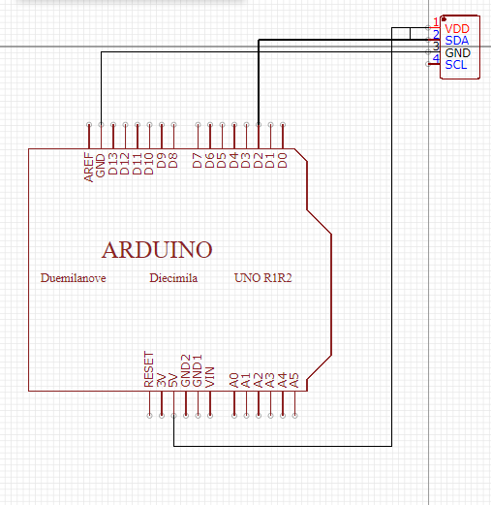

修正程式碼

