METEOROLOGICAL SATELLITE: SENSING PRINCIPLES, DATA COLLECTION AND ANALYSIS

CERTIFICATE

This is to certified that the project report title “Meteorological satellite: sensing principles, data collection and analysis” is work done by Mr. YOUNKAP NINA Duplex, Air Traffic Controller Officer/Computer Science Engineer, IMD Advanced Training in Meteorological Instrumentation & Information System Batch No. IX, ICITC. Under my supervision.

I recommend the project report for submission.

Place :

Date :

Tchamabo Urbain

ACKNOWLEDGEMENT

I am grateful to Shri S. SENGUPTA, Scientist-E, who has guided me on this project with his immense knowledge and experience.

I am grateful to officers and staffs of training section for the support extended throughout the training period

INTRODUCTION

Background of satellite remote sensing

A/Remote sensing

A1/Why Remote Sensing

The general concept behind remote sensing is to monitor Geographical, Biological and Physical characteristics of Land, Water and Atmosphere. It can offer a snap shot of state of the system at a particular point in time and 2D space. A combination of such “observations” gives valuable Information on the resource under study. These Information flow from analysts to managers to decision makers for successful interventions. In this report our focus is remote sensing for weather observation

A2/Definition

"Remote sensing is the science (and to some extent, art) of acquiring information about the Earth's surface without actually being in contact with it. This is done by sensing and recording reflected or emitted energy and processing, analysing, and applying that information." (f)

A3/Electromagnetic Spectrum

Solar radiation can be divided into different wavelengths call EM spectrum

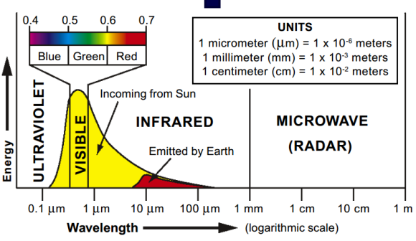

Figure : Electromagnetic spectrum

Most Multispectral satellite can acquire data in visible and infrared region (including the thermal infrared region). Now days there is an increasing demand for data in microwaves region, because the microwave energy can penetrate through the cloud.

A4/SOURCE OF RADIATION

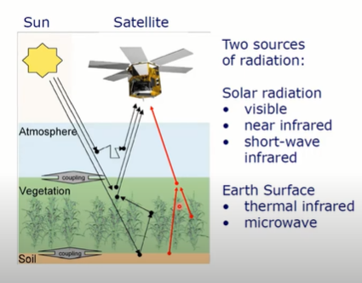

We have two majors source of radiation: Sun and Earth.

Sun is the mayor source of radiation with highest energy in visible, near infrared and short-wave infrared region as shown on picture above.

Earth surface can also emit energy usually in thermal Infrared and microwaves region.

A5/INTERACTION IN THE ATMOSPHERE

Before radiation used for remote sensing reaches the Earth's surface it has to travel through some distance of the Earth's atmosphere. Different processes happening due to the presence of particles and gases in the atmosphere. Some get scattered, some get absorbed, some managed to transmit through the atmosphere and get absorbed by the earth, and some get reflected. This reflected energy is capture by the sensor on board of satellite. They are some energies emitted from the earth which are directly proportional to the heat of that particular object. This emitted energy can also be recorded by sensor on board of satellite if that sensor has capabilities to record energy in thermal infrared region. A sensor on board a satellite can record emitted or reflected radiation depending on the capabilities of the sensors.

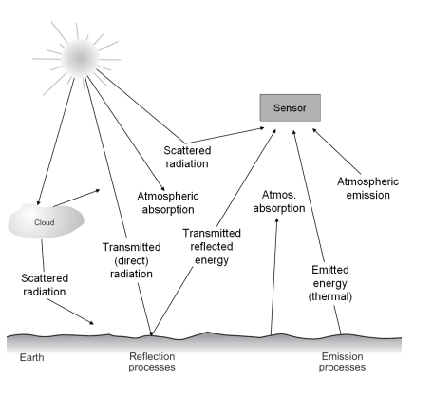

Figure: Energy interaction in the atmosphere and earth surface.

A6/HOW DOES IT WORK?

As we said above, the energy is either emitted or reflected. And this emission or reflection on energy depend on the different land use type e.g. trees, water, hill. They all have different level of reflectance, and this radiation of energy from different land use type will be recorded by the sensor installed in the satellite. Many time what is record by satellite is directly proportional to top of the atmosphere (level at which the effect of absorption and scattering is not relevant). The which is recorded at sensor is proportional to what could be at the top of atmosphere eg temperature and humidity recorded is equal to brightness temperature (TOA Temperature), and we have to apply some correction convert brightness temperature to surface temperature. The same go to reflectance, we have to convert TOA reflectance energy to surface reflectance energy. This process is call atmospheric correction. This how satellite records energy and how it correspond to different land use type.

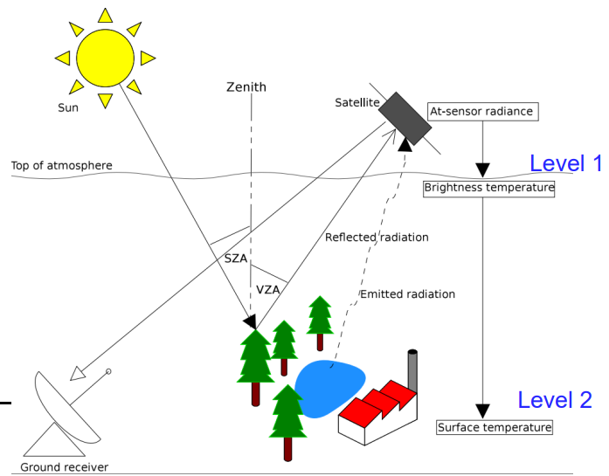

A7/ SPECTRAL SIGNATURE

Wavelength-dependent reflected energy provides key information on distinguishing feature in the satellite image, each object has distinct spectral signature helping us to distinguish.

A7/ CATEGORY OF SATELLITE

There are different category of satellite based on:

* Source of energy (Passive and Active Sensors)
* Orbit (Polar, Geo-stationary or sun-synchronous satellite)
* Resolutions (Spatial, Spectral, Radiometric and Temporal resolutions)
* Objectives (communication, weather, navigation, earth observation, etc.)
* Tableau (GEOS R, LANDSAT 8)
* Landsat8: Polar/Sun Synchronous orbiting satellite

Landsat 5/7/8

NASA

Spatial resolution - 30 m

Landsat 8 has 11 spectral bands

Revisit 16 days

Since 1980

Coverage - Global

Available : https://earthexplorer.usgs.gov

Satellite remote sensing

CASE STUDY 1: GOES-R Series

A/GOES Overview and History

The Geostationary Operational Environmental Satellite Program (GOES) is a joint effort of NASA and the National Oceanic and Atmospheric Administration (NOAA). The GOES system currently consists of GOES-13, operating as GOES-East, in the eastern part of the constellation at 75 degrees west longitude and GOES-15, operating as GOES-West, at 135 degrees west longitude. The GOES-R series will maintain the two-satellite system implemented by the current GOES series. However, the locations of the operational GOES-R satellites will be 75 degrees west longitude and 137 degrees west longitude. The latter is a shift in order to eliminate conflicts with other satellite systems. The GOES-R series operational lifetime extends through December 2036.

These spacecraft help meteorologists observe and predict local weather events, including thunderstorms, tornadoes, fog, hurricanes, flash floods and other severe weather. In addition, GOES observations have proven helpful in monitoring dust storms, volcanic eruptions and forest fires.The benefits that directly enhance the quality of human life and protection of Earth's environment include:

* Supporting the search-and-rescue satellite aided system (SARSAT)
* Contributing to the development of worldwide environmental warning services and enhancements of basic environmental services
* Improving the capability for forecasting and providing real-time warning of solar disturbances
* Providing data that may be used to extend knowledge and understanding of the atmosphere and its processes

The next series of GOES satellites includes GOES-R, S, T and U.

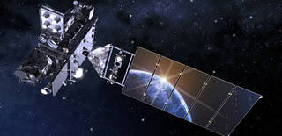

GOES Project History

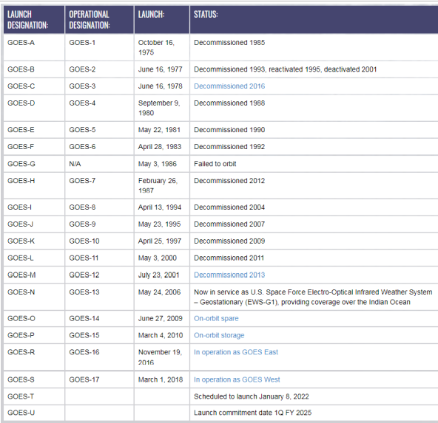

GOES-R Series Instruments

GOES-R Series has six instruments on board:

Earth-pointing:

● Advanced Baseline Imager (ABI) - the primary instrument for imaging Earth’s weather, oceans and environment.

● Geostationary Lightning Mapper (GLM) - a single-channel, near-infrared optical transient detector that can identify momentary changes in an optical scene, indicating the presence of lightning.

Sun-pointing:

● Extreme Ultraviolet and X-ray Irradiance Sensors (EXIS) - monitors solar irradiance in the upper atmosphere using two primary sensors: the Extreme Ultraviolet Sensor (EUVS) and the X-Ray Sensor (XRS).

● Solar Ultraviolet Imager (SUVI) - a telescope that monitors the sun in the extreme ultraviolet wavelength range, detecting solar flares and solar eruptions, and compiling full disk solar images.

In-situ:

● Magnetometer (MAG) - measures the space environment magnetic field that controls charged particle dynamics in the outer region of the magnetosphere

● Space Environment In-Situ Suite (SEISS) - monitors proton, electron, and heavy ion fluxes in the magnetosphere using four sensors: the Energetic Heavy Ion Sensor (EHIS), the High and Low Magnetospheric Particle Sensors (MPS-HI and MPS-LO), and the Solar and Galactic Proton Sensor (SGPS).

Only two sensors are used for atmospheric purpose, ABI and GLM

D/Advanced Baseline Imager (ABI)

ABI is a multi-channel passive imaging radiometer that images Earth’s weather, oceans and environment with 16 spectral bands (2 visible, 4 near-infrared, and 10 infrared channels).

[ABI Bands Quick Information Guides (goes-r.gov)](https://www.goes-r.gov/mission/ABI-bands-quick-info.html)

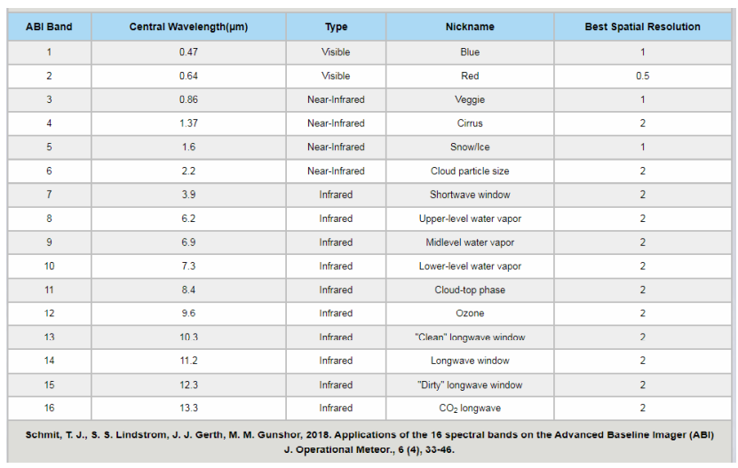

2. ABI Data Collection Approach and Operations

There are three major components of ABI that work together to collect observations of the Earth, space, and calibration targets as a system. These are the scanning mirrors, the Four Mirror Anastigmat (FMA) telescope, and the Focal Plane Modules (FPMs) (Figure 2).

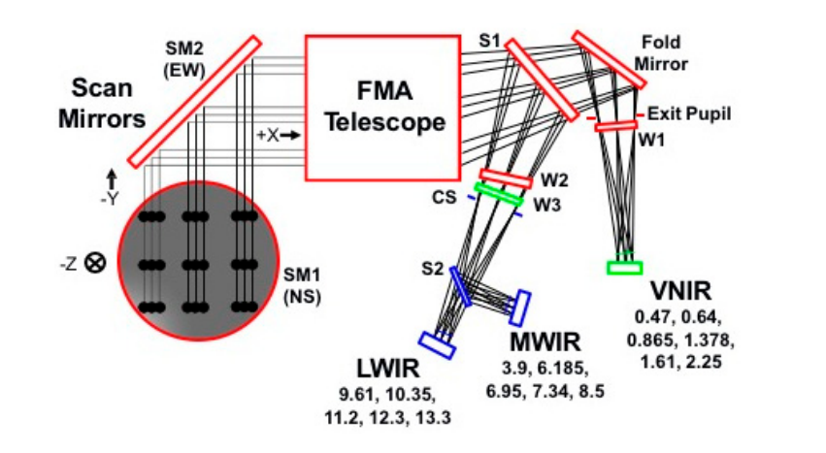

Figure 2. ABI optical components. (SM = Scan Mirror; EW = East–West; NS = North–South; FMA = Four Mirror Anastigmat; S1, S2 = Beamsplitter 1 and 2; CS = Cold Stop; W1, W2, W3 = Windows 1, 2, and 3; LWIR = Longwave Infrared; VNIR = Visible and Near IR; MW IR = Mid-Wave IR)

ABI MODES OF OPERATION

Full Disk: Hemispheric Coverage of 83° local zenith angle, temporal resolution of 5-15 minutes, and spatial resolution of 0.5 to 2km

Mesoscale: Provides coverage over a 1000x1000km box with a temporal resolution of 30 seconds, and spatial resolution of 0.5 to 2km.

Continental US/Pacific US: The CONUS and PACUS scans are performed every five minutes, providing coverage of the 5000km (east/west) and 3000km (north/south) rectangle over the continental United States (GOES-16) or the Pacific Ocean, including Hawaii (GOES-17). The spatial resolution is 0.5 to 2km.

Flex Modes: The flex modes provide a full disk scan every 10 minutes (mode 6) or every 15 minutes (mode 3), a CONUS/PACUS every five minutes, and two mesoscale domains every 60 seconds (or one sub-region every 30 seconds).

<https://www.goes-r.gov/spacesegment/abi.html>

ABI Products

ABI base product

ABI Met product

The following is a list ABI meteorological and space weather data products that are available to the user community.

Advanced Baseline Imager (ABI)

Aerosol detection (including smoke and dust)

Aerosol optical depth (AOD)

Aerosol particle size

Clear sky masks

Cloud layers/heights

Cloud and moisture imagery

Cloud optical depth

Cloud particle size distribution

Cloud top height

Cloud top phase

Cloud top pressure

Cloud top temperature

Derived motion winds

Derived stability indices

Downward shortwave radiation: surface

Fire/hot spot characterization

Hurricane intensity estimation

Land surface albedo

Land surface bidirectional reflectance factor

Land surface temperature (skin)

Legacy vertical moisture profile

Legacy vertical temperature profile

Radiances

Rainfall rate/QPE

Reflected shortwave radiation: TOA

Sea and lake ice: age

Sea and lake ice: concentration

Sea and lake ice: motion

Sea surface temperature (skin)

Snow cover

Total precipitable water

Volcanic ash: detection and height

<https://www.goes-r.gov/products/overview.html#ABI>

DATA ANALYSIS

A/Technique 1: Access Data Files

Access Data Files: NOAA CLASS

Access Data Files: Amazon, Microsoft, OCC

Access Data Files: Google Cloud

Use Python to Retrieve Data from AWS

B/ Technique 2: READ META DATA

Bash linux

Python

Technique 3: Plot a single band ABI Channel

Technique 3: Technique: Radiance to Reflectance

Technique 4: Technique: Generating Composites

Technique 5: Convert NetCDF files to GeoTIFFs

Technique 6 : Using GIS Software

CASE STUDY 1 : TOA, LST, TOA REFLETANCE, NDVI COMPUTATION FROM LANDSAT 8 IMAGE

CASE STUDY 2 : TEMP, RH, SWdown, WIND computation from GLDAS and comparation with those measures from Ground Observation

CASE STUDY 3 : TEMP, RH, SWdown, WIND computation from GLDAS monthy average and comparation with those measures from Ground Observation

CASE STUDY 4 : Precipitation aggregation over crop year 2020/2021 at Garoua Station and comparation with those acquired through ground observation.

Conclusion and Future Enhancement

Reference