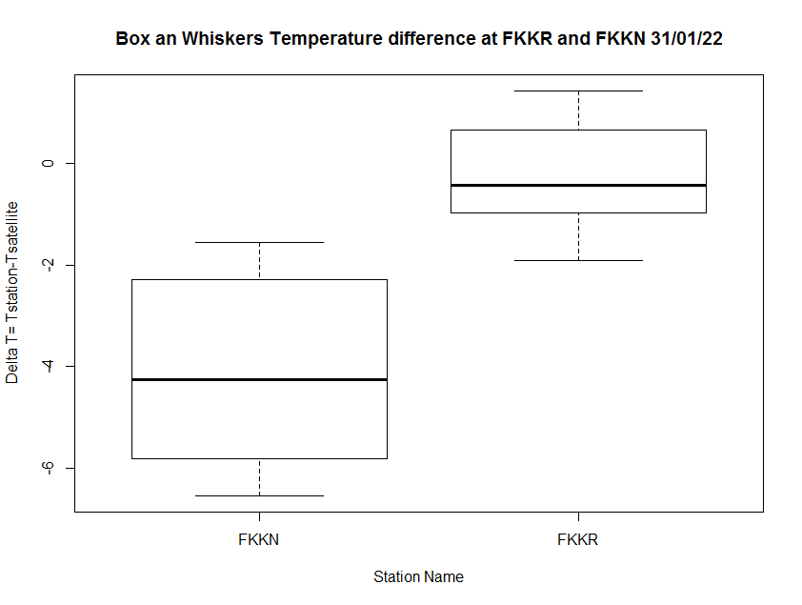

On the whole the satelitte overestimates the temperature,but in FKKR the difference is less (1°C) compared to FKKN where we can have up to -6°C, that might be explained by the uneven landshape over FKKN.

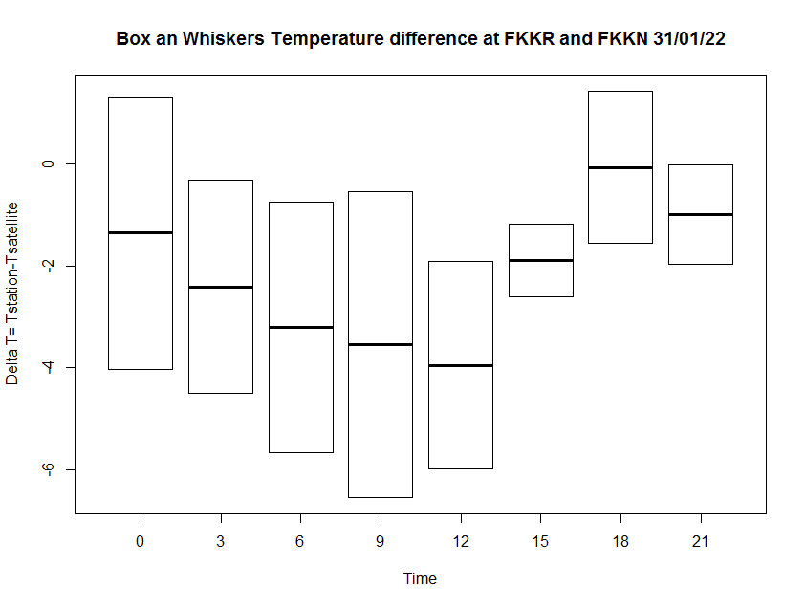

Regardless to the time, the temperature is over estimated by the satellite,nevertheless the difference is high from 6 to 12 AM,when the sun shines most.

FKKR :

summary(dfkkr$deltaT)

Min. 1st Qu. Median Mean 3rd Qu. Max.

-1.9206 -0.8698 -0.4401 -0.2568 0.3114 1.4147

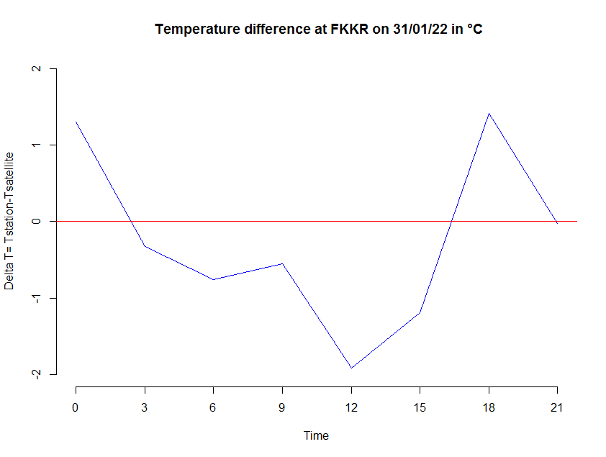

FKKN

summary(dfkkn$deltaT)

Min. 1st Qu. Median Mean 3rd Qu. Max.

-6.531 -5.734 -4.261 -4.103 -2.452 -1.555

>

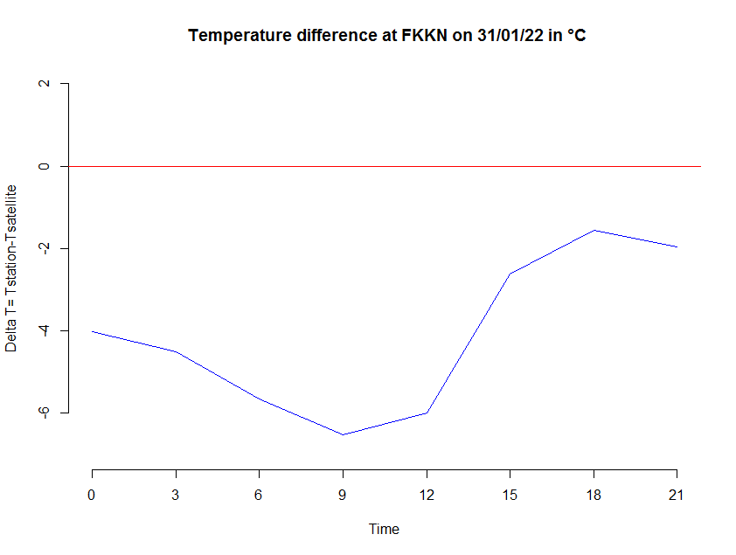

Relative Humidity

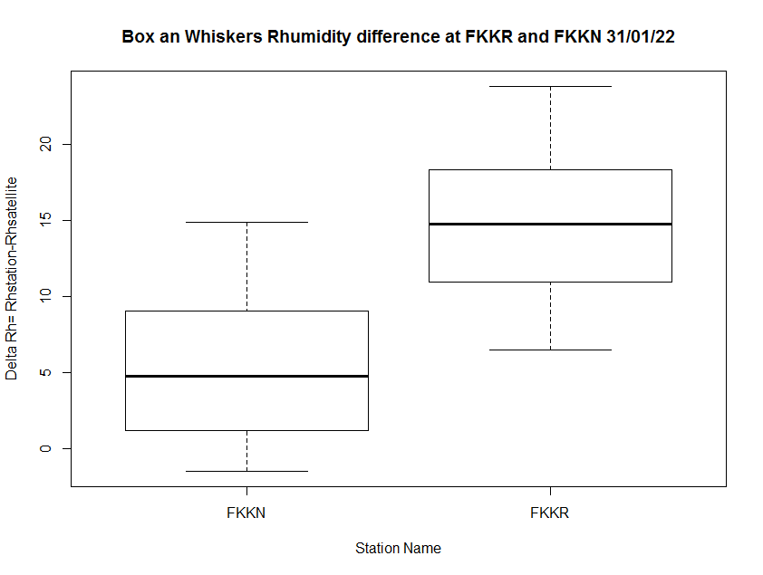

On the whole the Relative humidity is under estimated by the satellite

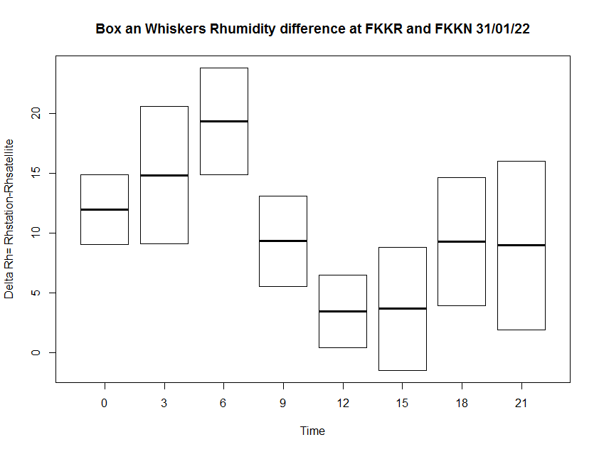

The difference of Rh is more than 10% from 0 to 6 AM and less than 10% from 9 to 21 AM

FKKR

summary(dfkkr$deltaRh)

Min. 1st Qu. Median Mean 3rd Qu. Max.

6.462 12.025 14.750 14.774 17.146 23.763

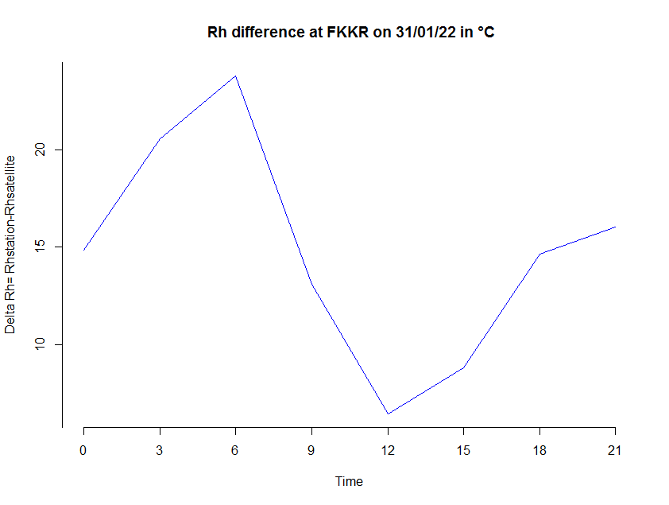

FKKN

summary(dfkkn$deltaRh)

Min. 1st Qu. Median Mean 3rd Qu. Max.

-1.455 1.557 4.750 5.421 9.040 14.843

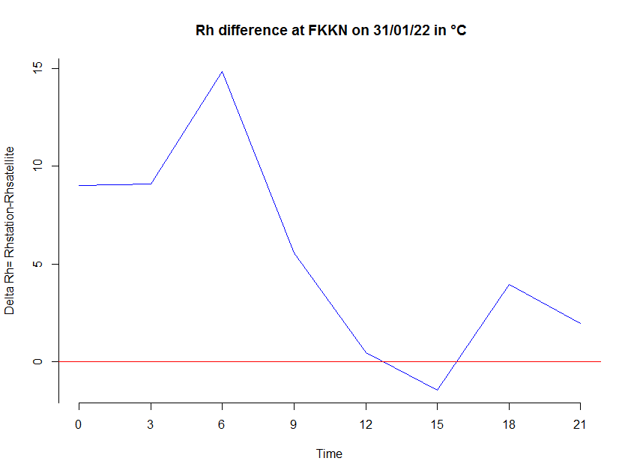

Pressure

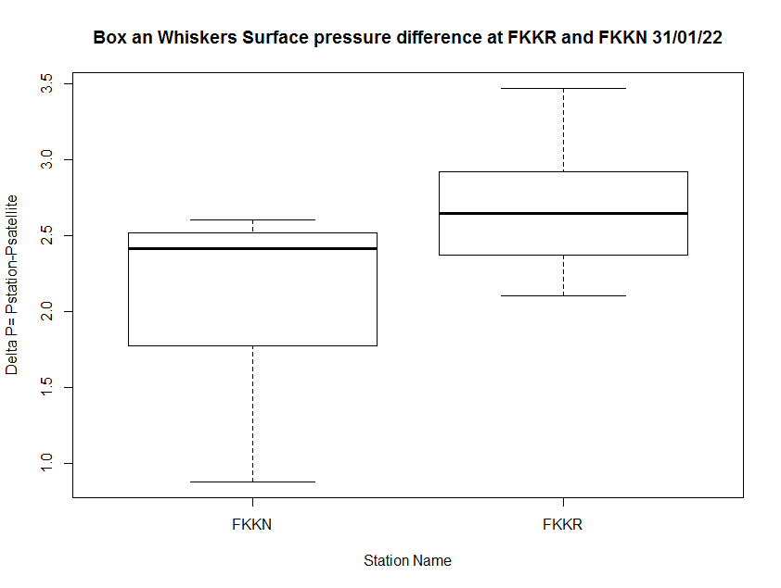

On the whole the surface pressure is under estimated by the satellite, however the Gap is Greater in FKKR than in FKKN

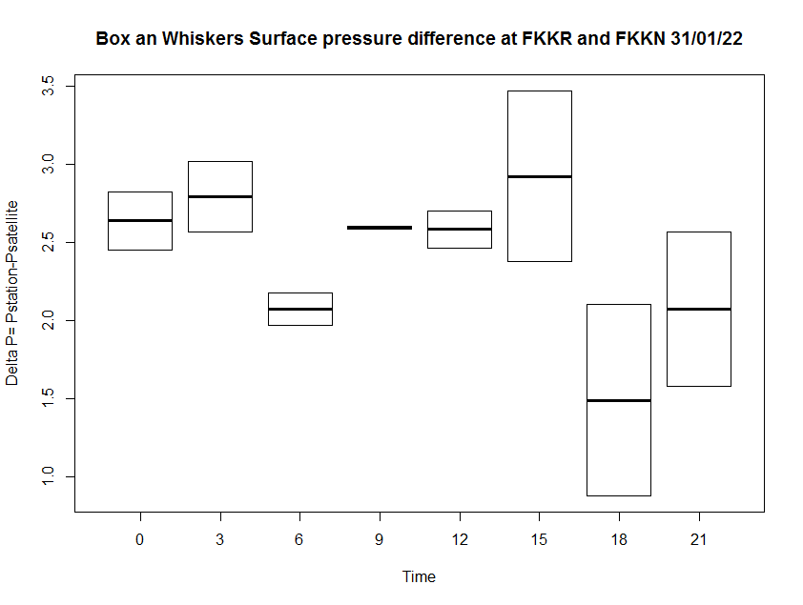

The pressure is under estimated, the difference of pressure has two minimum ( at 6 and 18 AM) and two maximum (at 3 and 15 AM) ,this refers to the daily cycle of the pressure

FKKR

Min. 1st Qu. Median Mean 3rd Qu. Max.

2.099 2.470 2.641 2.679 2.871 3.465

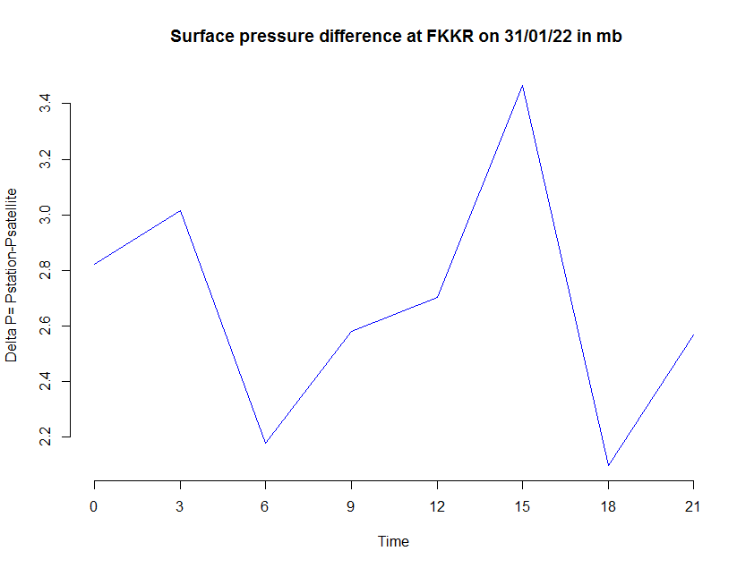

FKKN

summary(dfkkn$deltaP)

Min. 1st Qu. Median Mean 3rd Qu. Max.

0.8786 1.8681 2.4125 2.1089 2.4855 2.5983

