

**Faculty of engineering - Shoubra**

**Benha University**

**Research Article / Research Project / Literature Review**

in fulfillment of the requirements of

|  |  |
| --- | --- |
| **Department** | **Computer Engineering** |
| **Division** | **------------** |
| **Academic Year** | **2019-2020 Preparatory** |
| **Course name** | **Computer** |
| **Course code** | **ECE001** |

**Title: -**

**Artificial Intelligence**

By:

|  |  |  |  |
| --- | --- | --- | --- |
|  | Name | Edu mail | B.N |
| 1 | يوسف خالد يوسف عبد المنعم | youssif196187@feng.bu.edu.eg | 1056 |

**Approved by:**

|  |  |
| --- | --- |
| Examiners committee | Signature |
| Dr.Ahmed Bayoumi |  |
| Dr.Shady Elmashad |  |
| Dr. Abdelhamid Attaby |  |

**Application Brief**

Artificial Intelligence (AI) is a widespread branch of computer science concerned with building intelligent machines capable of performing tasks that normally require human intelligence. Artificial intelligence is a multi-disciplinary science with many approaches, but advances in machine learning and deep learning create a paradigm shift in every sector in the technology industry.

Artificial intelligence can benefit the economy by helping companies develop. Robots will help people do their job better. Man, and machine combination cannot be stopped. With deep learning and machine learning, artificial intelligence can become smarter over time, thereby increasing business efficiency. Artificial intelligence will also greatly reduce the possibility of a human error.

**screenshots**

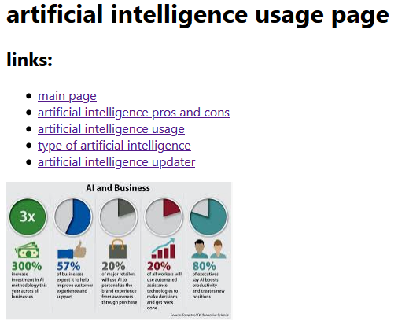

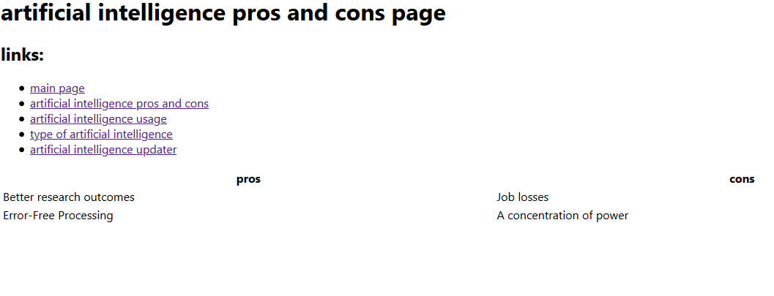

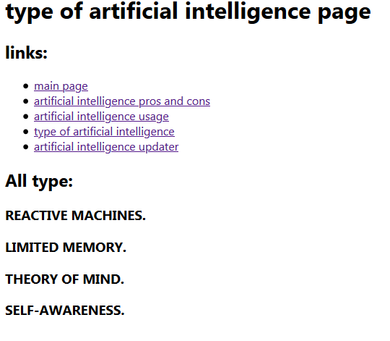

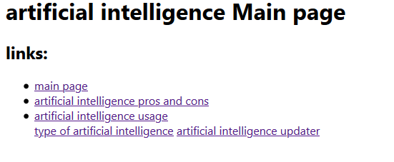

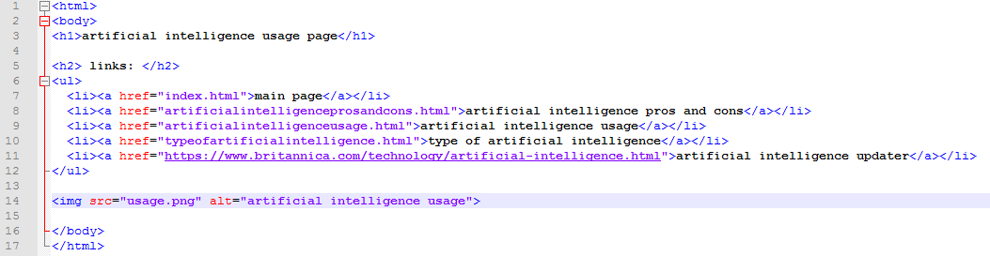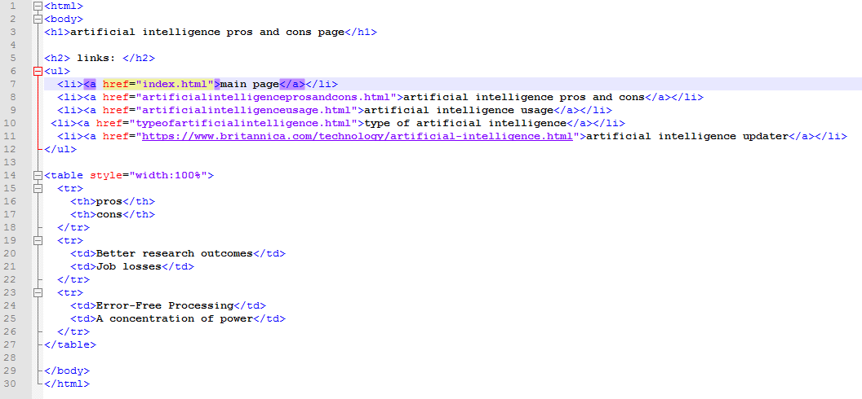**Source Code**

**References**

1. <https://builtin.com/artificial-intelligence>
2. <https://futureoflife.org/>
3. The Egyptian Knowledge Bank, EKB.