Predictive Modeling of Austing Texas housing prices & Decoding Email Spam
Navigating the relms of solving realworld problems using predictive modeling and analysis
Name: Youssef Alij, Student number: x20252561 Lecturuer: Dr Nagahamulla H

Abstract
This project navigates the realms of regression and classification, tackling real world challenges such as predicting housing prices in Austin Texas, and email spam detection models in aims to enhance email communication. In the realms of housing, the focus lies on understanding Austin Texas Housing market and the nuanced interplay of various features that determines the price of homes. This is achieved by building and training a linear model that predicts the housing market. Simultaneously, the classification task aims to further enhance digital communication by studying the pattern of a spam emails and flagging them. The project employs machine learning algorithms such as KNN, Logistical regression, and Linear regression to navigate the intricacies of predictive modelling.

Introduction
Predictive modelling can have a profound impact on real-world scenarios, business today hire data scientists to foresee opportunities and capitalise on them. This project embarks on two problems, predicting housing prices and the classification of emails, two problems which prove to have a major impact on people and companies from an economic and financial standpoint.
The objective of this project is to use a combination of machine learning algorithms to address practical problems in predicting the housing market and the digital communication market.
For the first task (regression task), I employed the use of Linear regression, a machine learning algorithm aimed at constructing a model that can foresee the housing prices accurately. Exploring this dataset involved extensive data pre-processing, exploratory analysis, and evaluation of model performance. In addition to the selection of four most informative predictors for housing prices to further evaluate our models performance.
The second task (Classification task) focuses on the enhancement of email filtration and identification of spam emails, with intentions to enhance digital communication by implementing machine learning algorithms such as K-Nearest Neighbours (KNN) and Logistic Regression. The classification task delves into the complexity of the dataset by mirroring the same data processing techniques as the regression task.
As we unravel the intricacies within these domains, sections of this report will provide a detailed comprehensive exploration to the methodologies, statistics, and key findings to offer a comprehensive narrative of our predictive modelling.

Motovation

The motivation behind building a machine learning algorithm to predict housing prices and classifying emails stems from their impact on people and businesses. For example, housing prices provides a key indication of a country’s economic health, directly influencing banking decisions and investments of people and businesses. By choosing this real-world problem I aim to investigate the dynamics of the housing market in Austin Texas.
The same could be said for email communication, in our digital age the constant issue of email spams has shown to be effective in disrupting communication and causing havoc within businesses. Some Emails today are also mis-classified as spam which as a result may limit the communication between the sender and the receiver. Spam emails also possess security risks, such as click jacking or fishing used by cyber attackers to gain access into employee’s computers with intent of harming the business.

data statistics

The dataset for the regression task is composed of 15,171 rows and 47 columns. It contains various features that describes the properties listed include home type, city, address, coordinates, property tax rate, number of bedrooms, and many more specific details about home utilities. As for the classification task, the data set is composed of 75,419 rows of data and five columns that describe the features of an email such as label which is a binary classification for the email, subject, email to, email from, and message.

Categorical features (Rregression taks)
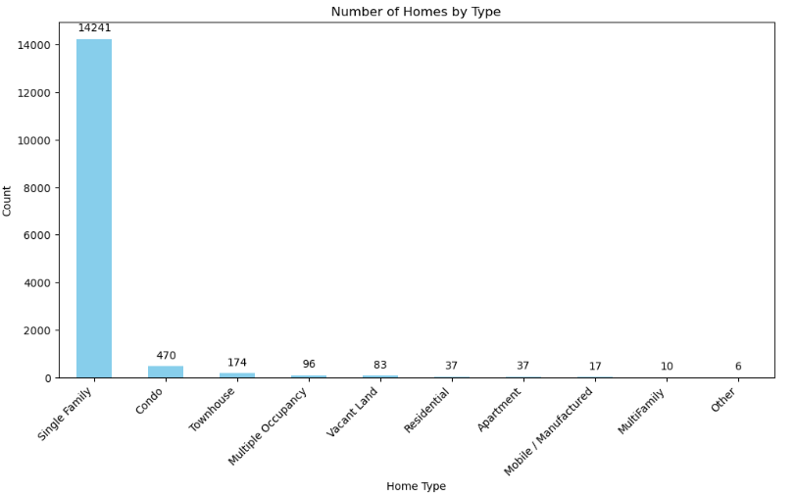
Before starting with filtering the data I decided to look at the demographic of this dataset and analyse what big portion of these house listings are located.
A large portion of the data set shows that almost 99% of the housing listings is in Austin Texas while some are in Del Valle with 0.57% and Pflugerville with a percentage of 0.24%. Furthermore, a large percentage of the home types of distribution seems to be a single-family home with a 94% percent, followed by Condo 3% and Townhouses being 1%. Before processing the data, I have removed some predictor from the dataset such as homeImage, description, numberOfGarage spaces, and many more. The reason behind dropping some of the columns is because these predictors don’t provide meaningful data that would accurately predict our target variable, which is the current price listing of the home (latesPrice).

Numerical features analysis (Mean,SD, IQR)

Before performing the statistical analysis for the data set, I cleaned the data of any null values as well as transforming any categorical data into continuous predictors using the Label encoder method (). I have then proceeded to analyses various numerical features, such as Property Tax rate, latest price, and number of Price changes. Thes values should provide an understanding of the range and distribution of these features. However, with the provided statistics the numbers shown are likely to be a result of rounding or calculation error.

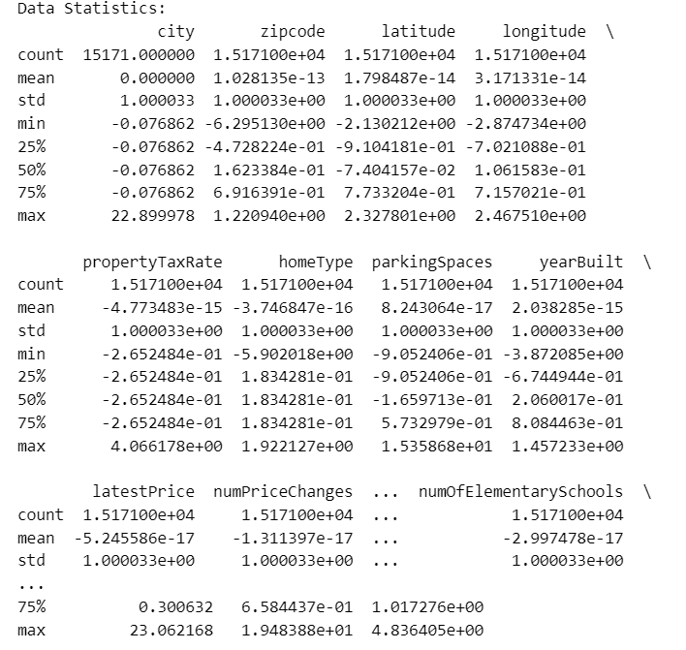

Data visuilisation and removal of outliers

For data visualisation, I have produced Boxplots for all the predictor as well as the four selected features for the further analysis, four features include the lates price, Living area per square foot, and number of bedrooms.
Outliers have been addressed using the interquartile range method (IQR), this aims to ensure that values that might affect the model are mitigated, thus promoting a robust regression model.
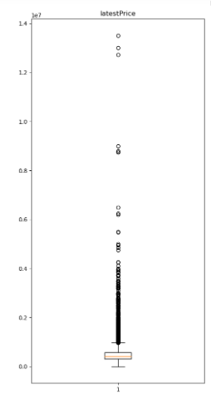
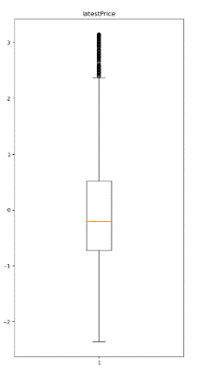

Categorical features (Classification taks)

I have conducted the same data processing for the classification task as the regression task, I checked for null values and converted any datatypes of type object to integers. From there, I standardized the data using the standard scaler method ensuring that all the features have a mean of 0 and standard deviation of 1. This is a crucial step as algorithms such as KNN and Logistic regression tend to be sensitive to the scale of input features.

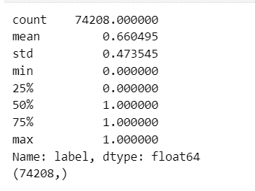
Numerical analysis
The aim here is to analysis the statistical data for each column that describes a feature of a typical spam email. I have dropped only one column (message column) as it provides no meaningful data to model our prediction.

As seen from the figure above, the total number of emails in the data set it 74,208 (count), The mean, which is average number of emails labelled is 0.6605. This indicates that approximately 66% of the emails are classified as spam, while 34% of emails are not spam (spam = 1, not spam = 0). The standard deviation reflects the degree of variability in the labelling of emails, in this case its 0.4735. Higher standard deviation values would suggest greater diversity in a dataset.
Our minimum value is zero, denoting that very few emails are denoted as non-spam (=0). The 25th percentile (Q1) is also zero, indicating that 25% of the dataset are non-spam emails. However, for the median (Q2) the value is 1, indicating that 50% of the data are labelled as spam. The 75th percentile (Q3) is also one, showing that 75% of emails are spam and the maximum value is also one conforming that this dataset is composed of mostly spam emails.
The mean and the standard deviation for both tasks provide us with an insight into the central tendency and variability of our predictors. The percentiles offer us a detailed view of the distribution identifying any outliers and understanding how the datasets are spread-out.

methodology

For both the regression and classification tasks I have used various machine learning algorithms. Before implementing any algorithms, I cleaned the data and split it into 80% training and 20% testing for both tasks. Data scaling and Standardization was also applied to the features in all training sets to ensure a fair comparison.
Linear regression, a supervised learning algorithm was used for the regression task to predict the housing prices, to predicting Austin Texas 2021 housing market I built a model that assumes a linear relationship between the input features such as numberOfBedrooms, area per meter square, and numberOfBathrooms with the target variable which is the price (latesPrice).
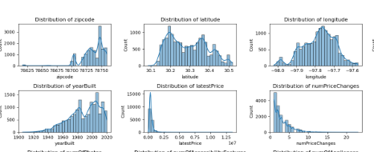
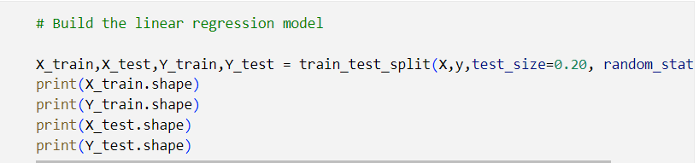
(assume a linear relationship between input features and the target variable which is latestPrice)
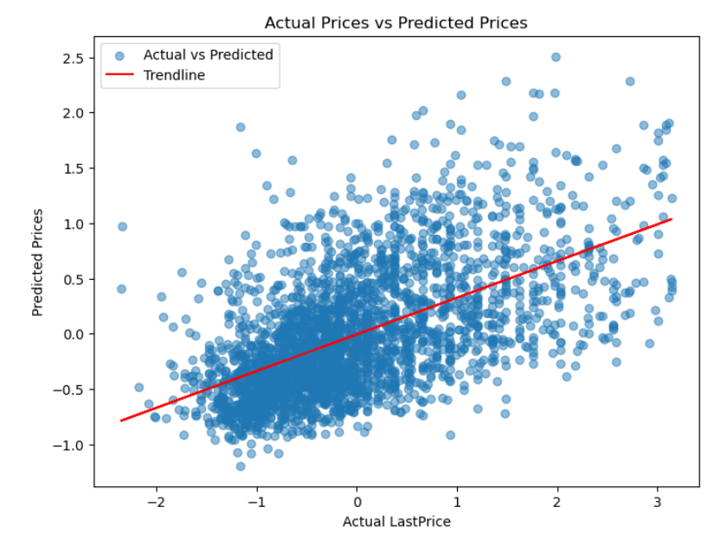
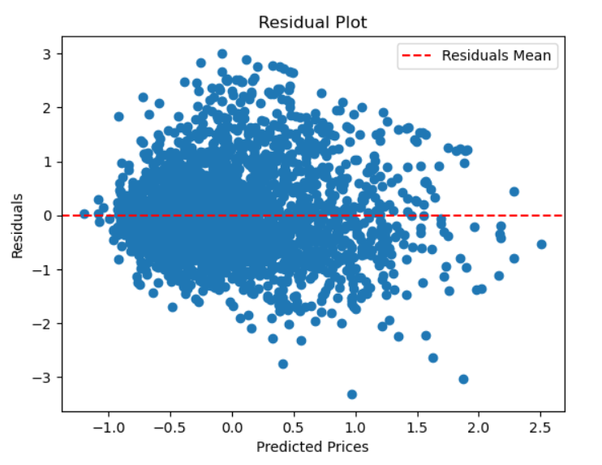
As you can see from the figure above, I used a residual plot to find the problems with the regression task. It turns out that the points are at a widely varying distance from the line, essentially meaning that the data is non-linearly associated. Therefore, this linear model is not appropriate in modelling the give data.
For the classification task I have used two machine learning algorithms KNN and Logistic regression. K-Nearest Neighbours is a versatile algorithm effective for both regression and classification tasks. In this case I used KNN to predict the target variable which is the email label (spam / not spam) by considering the average of k-nearest neighbours in the feature space. A hyperparameter tuning process was employed to find the best combination for maximizing the performance. This was achieved by using Euclidean, Manhattan, and a range of 1-101 K values to measure predictive performance.
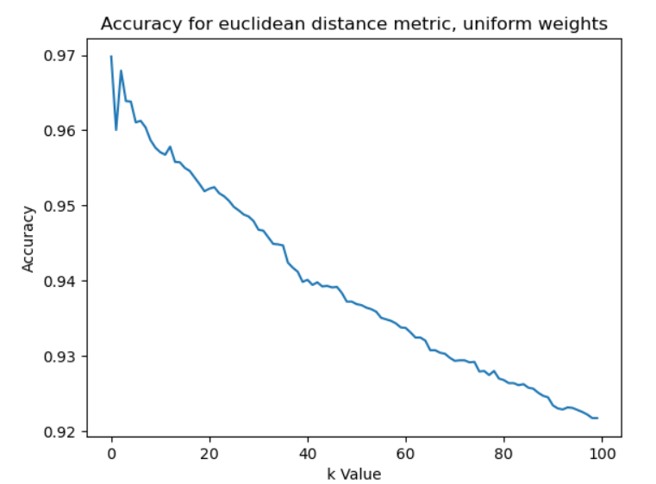
(Exploring distance metrics after scaling, splitting & training data)
Logistical regression is effective in modelling the probability of our target variable which is a binary data type. In this case, we are predicting the probability of an email being labelled as 0 or 1 and evaluating the performance of the model. At the end we provide a summary table divided into four sections that provides the algorithms predictions compared to the actual outcomes. By looking at the results of each section we finally calculate the accuracy of the predicted outcomes, in our classification task the accuracy is 74.10%.

results and evaluation
Multiple evaluation methods were used to comprehensively assess the model’s performance for the regression problem. Key metrics such as R-Square, Mean Absolute Error (MAE), and Mean Squared Error (MSE). The R-squared values for predicting the housing prices provided us with the proportion of variance in the housing prices (one being a perfect fit and 0 being poor fit).
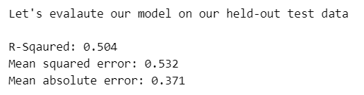
The first model shows that the variance in the testing set was somewhat accurate, suggest that the data accurately fists the model but not quite accurate enough with only 50%. The Means absolute error also shows a 53.2% chance of the model’s prediction accuracy. However, the Mean squared Error is only 37.1% emphasizing the squared differences between the actual values and the predicted values is not precise enough. In other words, the model lacks precision due to the impact of outliers on the overall performance.
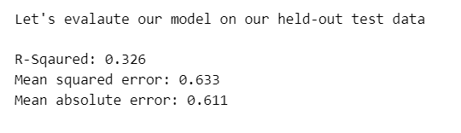
When it came to the further training, I selected four most informative features. Although, after removing more outliers the variance decreased to 32.6% which indicates that the model does not accurately fit the model (a decrease of 20% from the initial model). However, The MAE was 63% making the models predictions for the housing prices more accurate and offering better precision with the MSE value of 61.%.
For the classification problem, the primary evaluation was accuracy of the model. In other words, how well does the model accurately represents the proportion of correctly classified instances over the total number of instances in the test set.
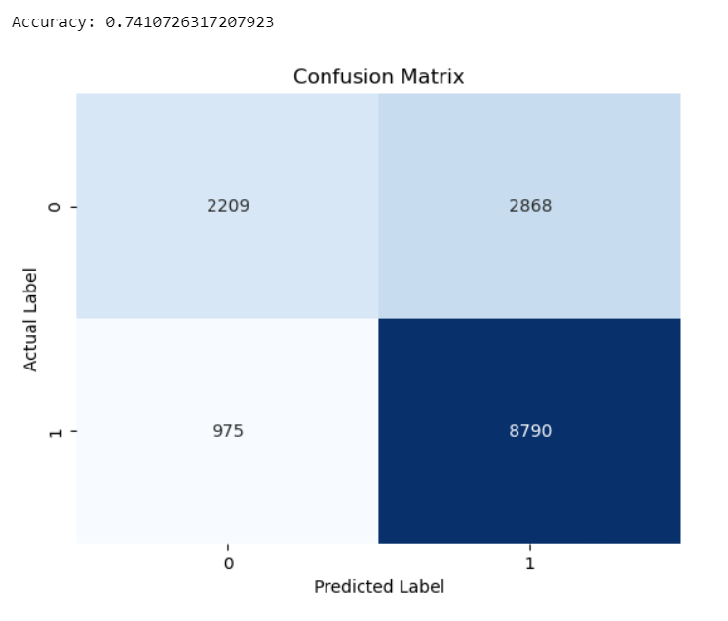
The figure above shows a confusion matrix which breaks down the model’s performance into four categories (True Positive, True Negative, False Positive, False Negative). This breakdown offers a better understanding of the model’s performance, it is shown that the model has an accuracy of 74% percent in predicting email labels.
Upon evaluating the regression and classification models, the accurate metrics for the regression problem provides somewhat between the range of 50% - 45% efficiency in predicting housing prices, where as the classification task has a higher accuracy score of 74% and a well-balanced confusion matrix suggest a reliable model for classifying emails.

conclusion

To conclude, this report covers the essential features and analysis of two distinct machine learning algorithms, linear regression to predict housing prices for the housing market, and classification for email spam probability prediction using KNN and Logistic regression. Each discovery and insight derived from each task plays a pivotal role in understanding the efficacy of applied methodologies for prediction and analysis. The regression task results were some what promising with the model demonstrating an acceptable R-squared value, thus indicating a good fit to the actual housing price listings. Low Mean Absolute errors and Mean Squared Errors underscored the accuracy and precision of the regression model. Furthermore, the classification model that aimed to focused on identifying email spams showcased commendable accuracy as shown by the confusion matrix. However, several enhancements could be considered to further improve more models such as error analysis refinement, and refixing existing features that could contribute to more improvements in models’ accuracy.

