MASCHERPA Audric, SOUFIANI Younousse

Autonomous robot snake, PolySnake

***Abstract*— Snake robots have been a topic of discussion among researchers for a long time. They could be strong enough to bring substantial contributions to the fields which are unsafe/ narrow/ dirty/ hard reachable to humans such as inspections, rescue missions, firefighting, etc. Therefore, this article focuses on a study of the movement of the snake as well as its ability to locate itself in space. To do this we will use 35kg servo motors fused to a camera and a Rasebery Pi card acting as a servo for the snake and allowing it to move and locate itself in its environment all at a reduced price.**

***Index Terms*—Snake robot, mechanical design, locomotion control, environment perception, autonomous system**

1. INTRODUCTION

Nowadays, the world suffers from many natural disasters which cause hundreds or even thousands of victims every year. For example, according to [1] the 1976 Tangshan earthquake was an earthquake that hit the region around Tangshan which ravaged 85% of the buildings in the. The official report claimed 242,769 deaths, but when considered the missing, the injured who later died, and the deaths in nearby Beijing and Tianjin, making it the deadliest earthquake in China and among the top disasters in China.

Thus, in order to optimize the search for people who disappeared in this kind of disaster, it is important to design robots capable of sneaking into closed spaces and locate themselves in their environment which is the main goal of our project like the robots of Professor Shigeo Hirose Fig. 1.

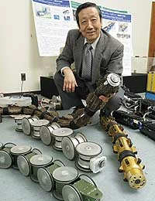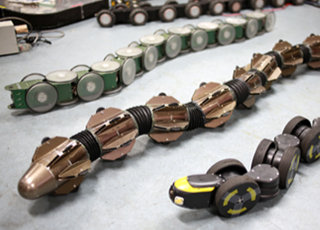

Fig. 1. image of Shigeo Hirose (1) with these snake robots (2) able to move in its environment without outside help [3]

MASCHERPA Audric is with the Cote d'Azur University, Polytech Sophia Nice, CO 06410 FR (corresponding author to provide; e-mail: audric.mascherpa@ etu.univ-cotedazur.fr).

SOUFINANI Younousse is with the Cote d'Azur University, Polytech Sophia Nice, CO 06410 FR (corresponding author to provide; e-mail:Younousse.soufiani@etu.univ-cotedazur.fr).

Unfortunately, not having yet the capacities nor the time to carry out a robot of this amplitude we will be satisfied to program our project so that it can locate using the red arrow.

1. Biological snake, means of transport

Snakes use at least five unique modes of terrestrial locomotion as highlighted [2]. Slide-pushing, Rectilinear, Concertina, Sidewinding and finally lateral undulation which is the common serpentine locomotion of snakes which is underlined by Fig. 2.

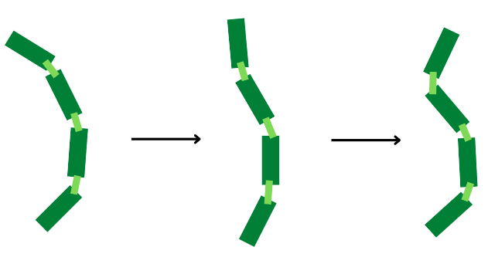

Fig. 2. diagram of the movement of the snake which undulates its body to move and which we use for the PolySnake snake

In lateral undulation, as in simple undulation, waves of lateral bending are propagated along the body from head to tail. This last locomotion is the one we will try to replicate and use for our snake robot.

However, as friction is a critical component of lateral undulation on snakes and would be difficult to reproduce on a robot, only the movement will be replicated, and we will have to find a way to make the robot go forward.

1. Analyzing and avoid obstacles

A. For the detection of surroundings our objective is to use panels with arrows on them which would be detected by a camera to let the robot know in which direction he should go. The camera we use is a Raspberry pi Camera V2 in Fig. 3. which can support 1080p30,720p60 and 640×480p60/90 video. We will use it to detect red arrows on white sheets of paper.

The camera will be connected to a Raspberry Pi Zero 2W which incorporates a quad-core 64-bit Arm Cortex-A53 CPU, clocked at 1GHz. The card will serve as a brain for the robot by giving order to the different components, it is also used for the calculus needed in image recognition.

As distance measuring with a camera seems difficult, we will use a distance sensor (ultrasound sensor) the HC-SR04 which would be used to know when the robot is too close from a wall and thus start the camera to take the direction.

B.The Control of the HC-SRO4 is done by a wire connection with the raspberry pi zero W using this connection to avoid us using another component (arduino uno) which would mean more power consumption and more space needed.

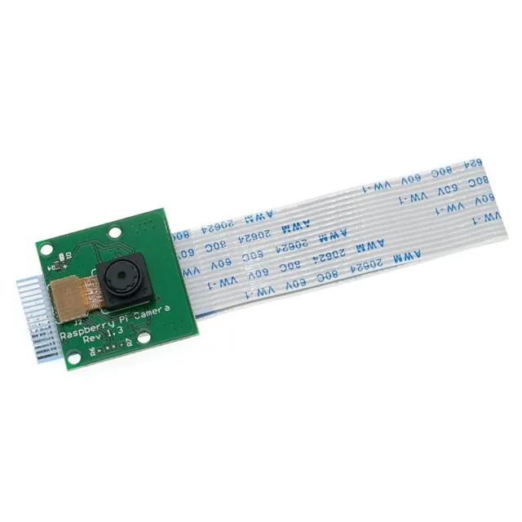

Fig. 3. image of Shigeo Hirose (1) with these snake robots (2) able to move in its environment without outside help

C. After the obstacle detection and the image recognition the robot turns if needed by using the servo motor guiding his head for that and to move the snake do not need anything else than the TD-8135MG which are the servo motors used to mimic the snake undulation.

1. Programmation

The final snake will need a total of two programs or three if you are using another arduino card for the distance measurement.

A.First we need to have the snake undulation for that we use a program in an arduino uno using a sinusoïd function to mimic it.from this program you can modify different aspects of the undulation you can for exemple:

* ad an offset, which would make the snake tend more in a direction.
* modify the amplitude to make the snake take more or less space with his undulations.
* variate speed to accelerate the undulation or slow them.
* and modify the wavelength which is another way to handle the space taken by the motion.

And all that thanks to the line:   
servo[j].write(90 + Amplitude*sin(speed*rads + j*Wavelengths*Shifts)

where j is the number assigned to each servo motor and Shift is the Shift between the servos (a shift depending on the number of servo used).

B.Next we need to detect the obstacle. This will be a new program if used in an arduino nano or just a part of the detection program (the other part being arrow recognition) in the raspberry pi zero w. In both case the principle is the same:

The sensor sends an ultrasound and catches the time for it to come back thanks to that and with the speed of sound we can calculate the distance traveled by the sound and thus the distance separating the snake from the wall (which is half of it).

C.And the other part of the Detection program which is the arrow detection.This program works a lot thanks to the CV2 library used for the contour detection. The principle is quite simple: We first take a picture and from this picture we detect all the contours, among them we only take the ones with 7 sides which match with our arrows. Next we draw a rectangle with the max dimension of the arrow and take the center pixel of it and check if the color is red and if yes then it is one of our arrows. Now we need the direction given by it, for that we detect the tip of the arrow and by comparing his position and the position of the center of the rectangle drawn before we can get the direction.

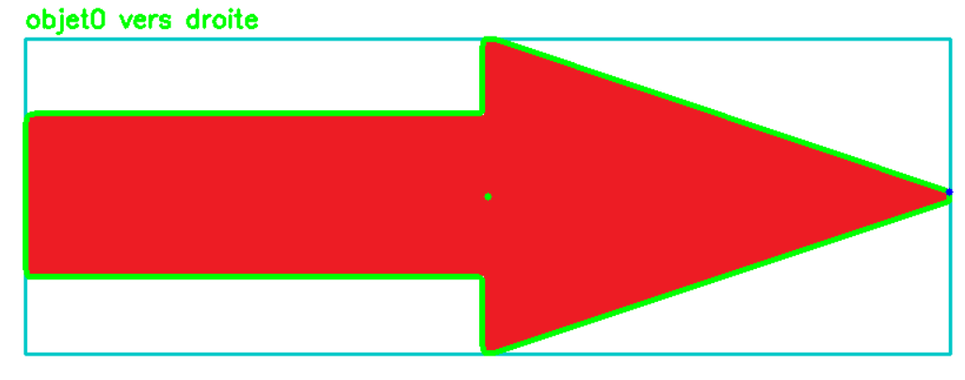

Fig .4. Screen of the arrow detection program in action

D. Finally we need to make a link between the different programs. this won't be a new program but a part of every program. The Detection program will detect the distance with the wall and send a value to the snake undulation program to stop the snake if needed. Then the arrow detection part is activated and the direction obtained by the arrow is sent to the undulation program for the snake to change direction.

1. Mechanical design

Our snake robot body comprises linearly connected modules through joints thanks to servomotors. This will make it possible to imitate as faithfully as possible, using a program for manipulating servomotors, the movement of a snake when it moves.

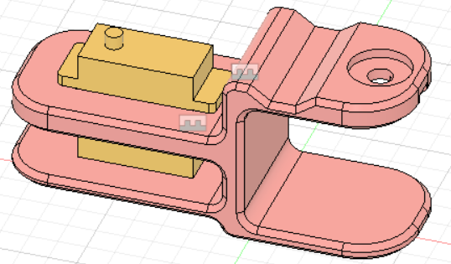

Fig. 5. Screen from Fusion360 software showing a 3D model of the part representing the body of the PolySnake named "module" allowing the servomotors to be linked together.

Thus, by assimilating several modules together, we ended up making a robot similar to the body of a snake and able to imitate its method of movement shown by Fig. 5.

However, it should be kept in mind that although these modules represent 80% of the body of our project, there are still two essential areas to assimilate in order to conclude the modeling of the PolySnake which are: the head and the tail.

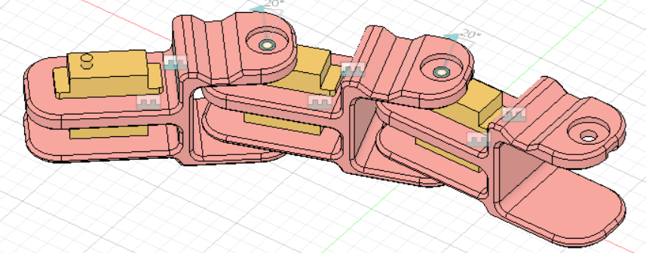

Fig. 6. Screen from Fusion360 software showing a 3D model of an assembly of 3 modules linked together by servomotors and simulating the body of a snake

In our case, the tail will accommodate the best: Li-ion Cell battery reference ICR18650 6700mAh 3.7. while the head will accommodate the Rasbery Pi card and camera as well as the Arduino card and the 2-axis motor.

To simplify understanding here is a diagram in Fig. 6.

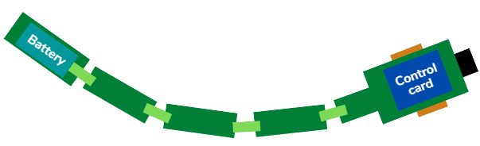

Fig. 7. PolySnake diagram with in green the body of the snake composed of the modules, in orange the wheels, in blue the battery and the control board and finally in black the Rasebery Pi camera.

Finally, the use of wheels in this project is due to the impossibility of moving the PolySnake otherwise due to a lack of suitable material allowing us to make a copy of the scales of a snake allowing it to slide on the ground.

1. Conclusion

To conclude, in order to achieve our goal of an autonomous robot snake, we will use a 3D printed module linked together by 35kg servo motors with an angle of 180° which will allow, using a program, to simulate the movement of a snake. And finally, by integrating a rasebery pi camera into this robot, we will allow it to locate itself in space using visual signals such as arrows and therefore be able to dodge obstacles and sneak into narrow places in a simple and inexpensive way.

References

1. [Ruth](https://www.discoverwalks.com/blog/author/ruth/) on [May 21, 2022](https://www.discoverwalks.com/blog/china/10-of-the-deadliest-natural-disasters-that-happened-in-china/) : “ 10 of the deadliest natural disasters that happened in China“ , Ed. Discover Walks Glob :
2. Brad mood in 2001 : “Snake locomotion” :

<https://userweb.ucs.louisiana.edu/~brm2286/locomotn.htm#:~:text=Lateral%20Undulation%20is%20the%20common%20serpentine%20locomotion%20of,propagated%20along%20the%20body%20from%20head%20to%20tail>.

1. Titech.jap in March 2013 : “ Relentless passion for the creation of robots“

**MASCHERPA Audric** (26/08/2002) Graduated from bac S with honors in mathematics and currently a 3rd year student at Polytech Sophia Nice, specializing in Robotics and autonomous systems.

**SOUFIANI Younousse** (08/09/2002) Graduated from bac S with honors in science of engineering / mathematics and currently a 3rd year student at Polytech Sophia Nice, specializing in Robotics and autonomous systems.