MASCHERPA Audric, SOUFIANI Younousse
Abstract— Snake robots have been a topic of discussion among researchers for a long time. They could be strong enough to bring substantial contributions to the fields which are unsafe/ narrow/ dirty/ hard reachable to human such as inspections, rescue missions, firefighting, etc. Therefore, this article focuses on a study of the movement of the snake as well as its ability to locate itself in space. To do this we will use 35kg servomotors fused to a camera and a Rasebery Pi card acting as a servo for the snake and allowing it to move and locate itself in its environment all at a reduced price.
Autonomous robot snake, PolySnake

Index Terms—Snake robot, mechanical design, locomotion control, environment perception, autonomous system

INTRODUCTION

Nowadays, the world suffers from many natural disasters which cause hundreds or even thousands of victims every year. For example, according to [1] the 1976 Tangshan earthquake was an earthquake that hit the region around Tangshan which ravaged 85% of the buildings in the. The official report claimed 242,769 deaths, but when considered the missing, the injured who later died, and the deaths in nearby Beijing and Tianjin, making it the deadliest earthquake in China and among the top disasters in China.
Thus, in order to optimize the search for people who disappeared in this kind of disaster, it is important to design robots capable of sneaking into closed spaces and locate themselves in their environment which is the main goal of our project like the robots of Professor Shigeo Hirose Fig. 1.

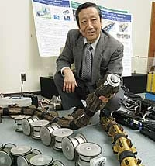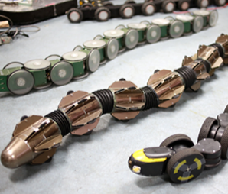
(1)
(2)

Fig. 1. image of Shigeo Hirose (1) with these snake robots (2) able to move in its environment without outside help [3]

MASCHERPA Audric is with the Cote d'Azur University, Polytech Sophia Nice, CO 06410 FR (corresponding author to provide; e-mail: audric.mascherpa@ etu.univ-cotedazur.fr).
SOUFINANI Younousse is with the Cote d'Azur University, Polytech Sophia Nice, CO 06410 FR (corresponding author to provide; e-mail:Younousse.soufiani@etu.univ-cotedazur.fr).

Unfortunately, not having yet the capacities nor the time to carry out a robot of this amplitude we will be satisfied to program our project so that it can this locate using red arrow.

Biological snake, means of transport

Snakes use at least five unique modes of terrestrial locomotion as highlighted [2]. Slide-pushing, Rectilinear, Concertina, Sidewinding and finally lateral undulation which is the common serpentine locomotion of snakes which is underline by Fig. 2.
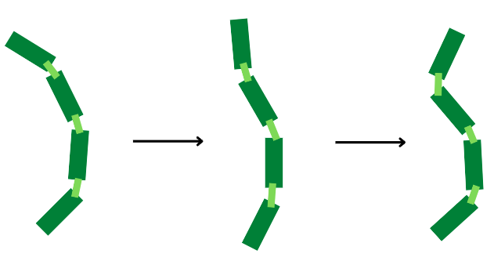

Fig. 2. diagram of the movement of the snake which undulates its body to move and which we use for the PolySnake snake

In lateral undulation, as in simple undulation, waves of lateral bending are propagated along the body from head to tail. This last locomotion is the one we will try to replicate and use for our snake robot.
However, as friction is a critical component of lateral undulation on snakes and would be difficult to reproduce on a robot, only the movement will be replicate, and we will have to find a way to make the robot go forward.

Analyzing and avoid obstacles

A. For the detection of surroundings our objective is to use panels with arrows on them which would be detected by a camera to let the robot know in which direction should he go. The camera we use is a Raspberry pi Camera V2 in Fig. 3. which can support 1080p30,720p60 and 640×480p60/90 video. We will use it to detect red arrows on white sheets of paper.
The camera will be connected to a Raspberry Pi Zero 2 W which incorporates a quad-core 64-bit Arm Cortex-A53 CPU, clocked at 1GHz. The card will serve as a brain for the robot by giving order to the different components, it is also used for the calculus needed in image recognition.

As distance measuring with a camera seems difficult, we may also use a distance sensor (ultrasound sensor, laser sensor…) which would be used to know when the robot is too close from a wall and thus start the camera to take the direction.

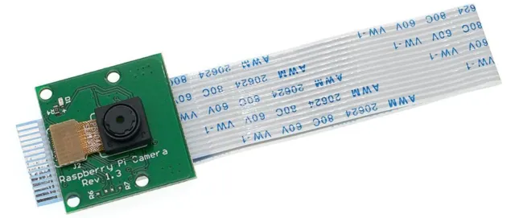

Fig. 3. image of Shigeo Hirose (1) with these snake robots (2) able to move in its environment without outside help

B. After the obstacle detection and the image recognition the robot turn if needed by using the servo motor guiding his head and the wheels equipped on it, the rest of the body will follow the head by sliding on the floor. The motor used is a DC motors 2 axes 5V allowing the robot to go forward or backward.
The servo motors used are TD-8135MG able to move in a 180° and are strong enough to move 35 Kg, they will give the direction.

Mechanical design

Our snake robot body comprises linearly connected modules through joints thanks to servomotors. This will make it possible to imitate as faithfully as possible, using a program for manipulating servomotors, the movement of a snake when it moves.
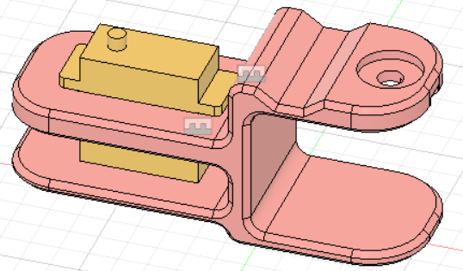

Fig. 4. Screen from Fusion360 software showing a 3D model of the part representing the body of the PolySnake named "module" allowing the servomotors to be linked together.

Thus, by assimilating several modules together, we ended up making a robot similar to the body of a snake and able to imitate its method of movement showing by Fig. 5.
However, it should be kept in mind that although these modules represent 80% of the body of our project, there are still two essential areas to assimilate in order to conclude the modeling of the PolySnake which are: the head and the tail.

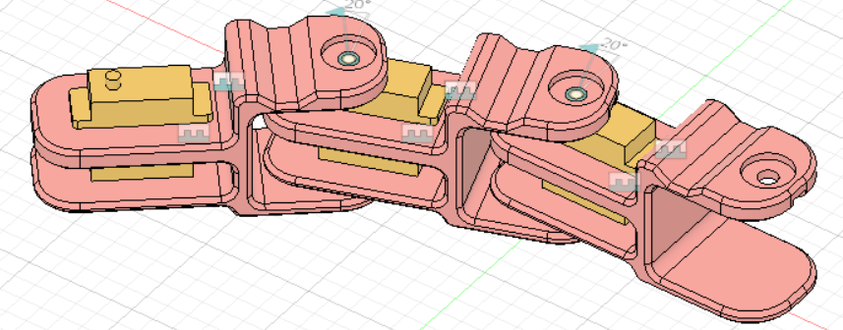
Fig. 5. Screen from Fusion360 software showing a 3D model of an assembly of 3 modules linked together by servomotors and simulating the body of a snake

In our case, the tail will accommodate the best: Li-ion Cell battery reference ICR18650 6700mAh 3.7. while the head will accommodate the Rasbery Pi card and camera as well as the Arduino card and the 2-axis motor.
To simplify understanding here is a diagram in Fig. 6.

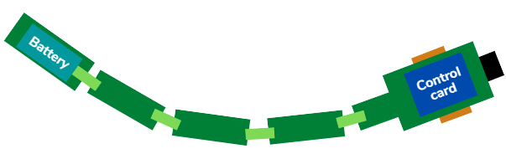
Fig. 6. PolySnake diagram with in green the body of the snake composed of the modules, in orange the wheels, in blue the battery and the control board and finally in black the Rasebery Pi camera.

Finally, the use of wheels in this project is due to the impossibility of moving the PolySnake otherwise due to a lack of suitable material allowing us to make a copy of the scales of a snake allowing it to slide on the ground.

Conclusion
To conclude, in order to achieve our goal of an autonomous robot snake, we will use a 3D printed module linked together by 35kg servomotors with an angle of 180° which will allow, using a program, to simulate the movement of a snake. And finally, by integrating a rasebery pi camera into this robot, we will allow it to locate itself in space using visual signals such as arrows and therefore be able to dodge obstacles and sneak into narrow places in a simple and inexpensive way.
References

- Ruth on May 21, 2022 : “ 10 of the deadliest natural disasters that happened in China“ , Ed. Discover Walks Glob :

- Brad mood in 2001 : “Snake locomotion” :
https://userweb.ucs.louisiana.edu/~brm2286/locomotn.htm#:~:text=Lateral%20Undulation%20is%20the%20common%20serpentine%20locomotion%20of,propagated%20along%20the%20body%20from%20head%20to%20tail.

- Titech.jap in March 2013 : “ Relentless passion for the creation of robots“

MASCHERPA Audric (26/08/2002) Graduated from bac S with honors in mathematics and currently a 3rd year student at Polytech Sophia Nice, specializing in Robotics and autonomous systems.

SOUFIANI Younousse (08/09/2002) Graduated from bac S with honors in science of engineering / mathematics and currently a 3rd year student at Polytech Sophia Nice, specializing in Robotics and autonomous systems.

