风骚走位的新一代链游内测开启了

##### 由专业顶级游戏团队亲力打造的新一代链游Shoot Mania闪亮登场了，该项目力图实现游戏可玩性和区块链设计的完美结合，能够让你真正的在体验好玩的基础上获得NFT，让玩家成为真正游戏的拥有者。作为下一代以操作，游戏性为核心设计的真正链游，此次开启了内测。希望得到你的垂青，并且能够能够反馈给小编你对游戏的意见，以便我们进一步对游戏进行优化和改善。

A new generation of chain tour Shoot Mania, created by professional top-level game teams, is on the stage. This project tries to realize the perfect combination of game playability and blockchain design, which can make you truly get NFT on the basis of fun experience and make players become real game owners. As the next generation of real chain tour with operation and gameplay as its core design, this time the internal test was started. I hope to get your favor and be able to give feedback to Xiaobian about your opinions on the game, so that we can further optimize and improve the game.

# 游戏内容介绍

地球正在遭受攻击，这取决于你来拯救它！

The Earth is under attack and it’s up to you to save it!

射击，躲闪，冲刺，在数百个关卡中战斗，每个关卡都旨在测试你的技能，决心和意志力。

Shoot, dodge, dash, and battle your way through hundreds of levels, each designed to test your skills, resolve, and will power

升级攻击

UPGRADE ATTACKS

收集、赚取和购买大量的武器、技能和能量，以击败邪恶并赢得胜利。武器可以升级为不同的爆炸攻击，以及特定于每个角色的特殊攻击。

Collect, earn, and purchase lots of weapons, skills, and power-ups to defeat evil and win the day. Weapons can be upgraded with varying blast attacks, and specialty attacks specific to each character.

英雄编队

HERO FORMATION

管理你的英雄选择正确的攻击者击败特定的水平，依靠他们的特殊功能技能和攻击。

Manage your heroes to select the right attacker to defeat specific levels, relying on their special features, skills, and attacks.

和朋友一起玩

PLAY WITH FRIENDS

与你的朋友或来自世界各地的其他玩家组队，使用所有可用角色的各种组合建立一个团队。

Team Up with your friends, or other players from around the world and build a team using various combinations of all available characters.

击败邪恶的浪潮

DEFEAT WAVES OF EVIL

通过一波又一波的敌人战斗，同时收集物品，获得经验，学习新技能。

Fight through wave after wave of enemies, while collecting items, gaining experience, and learning new skills

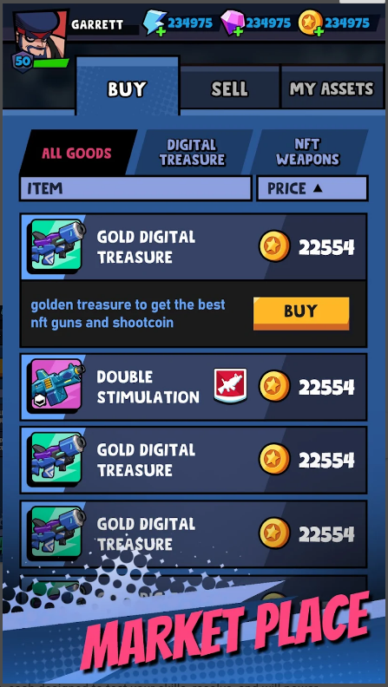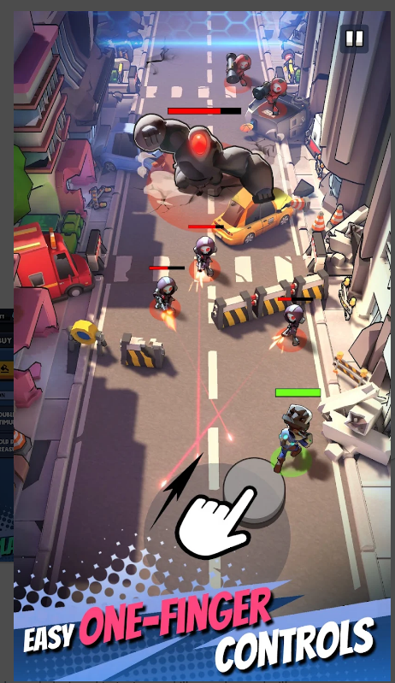.

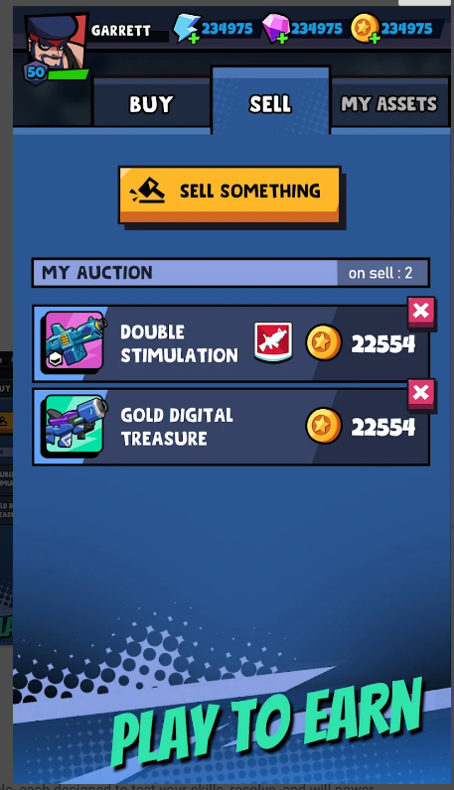 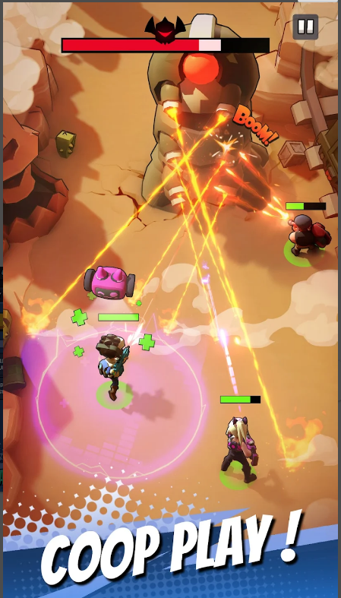

链游的下载地址如下：

https://play.google.com/store/apps/details?id=com.luckystar.x.shootmania&hl=zh-CN

该链游测试的关于钱包详细教程如下：

首先在chrome 上安装metamask的浏览器插件

https://chrome.google.com/webstore/detail/metamask/nkbihfbeogaeaoehlefnkodbefgpgknn

安装成功后打开,先随便创建一个钱包

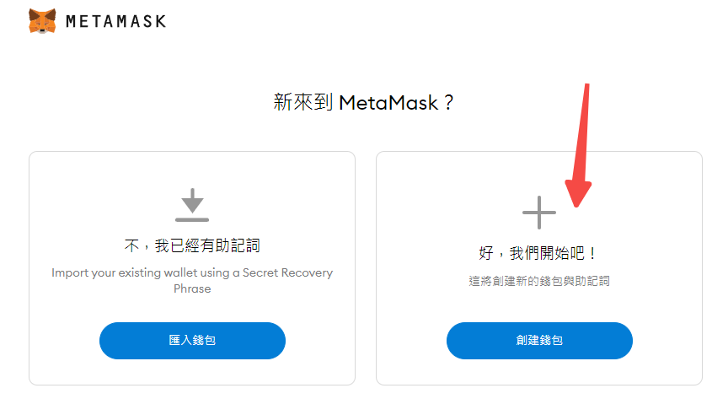

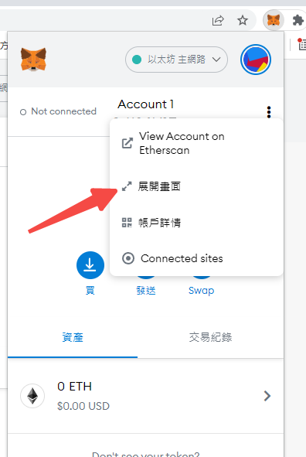

接下来导入我们游戏中钱包的私钥

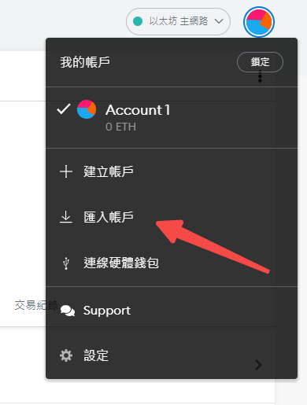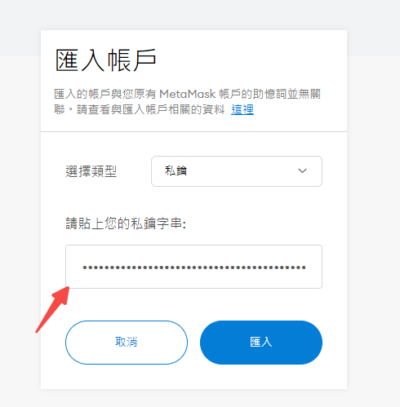

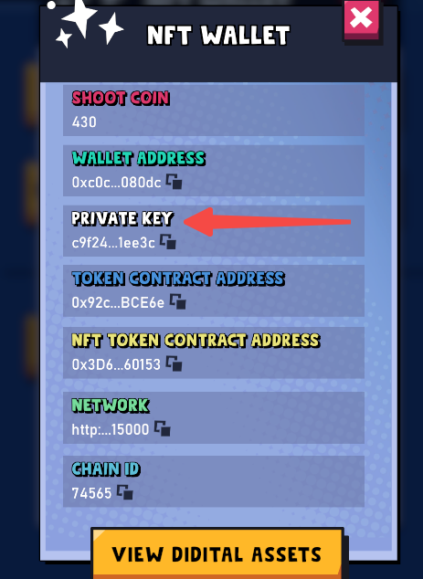

然后添加一个网络

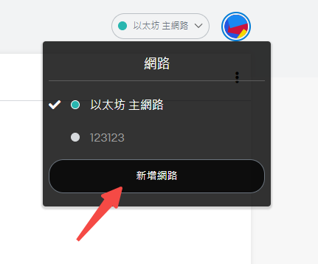

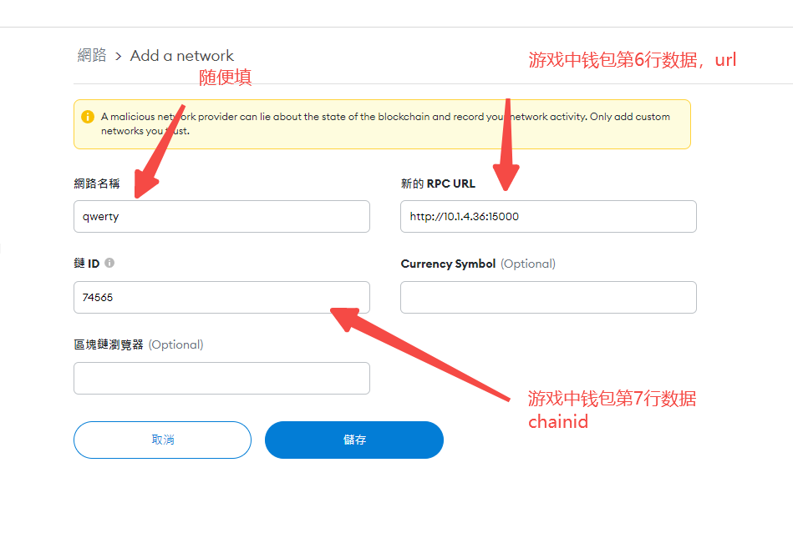

填入数据后，网络节点创建完成，确保右上角已经切换到了新网络节点

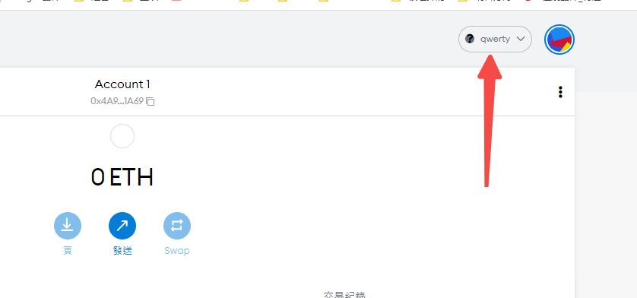

接下来导入货币，设置代币合同地址

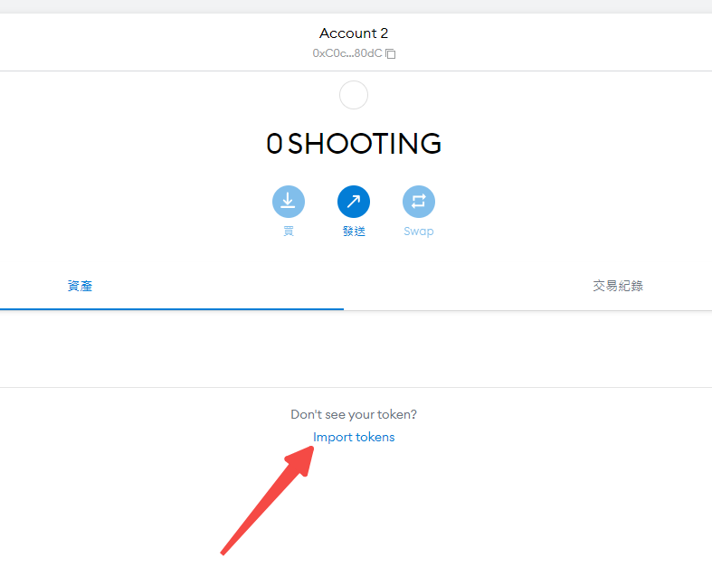

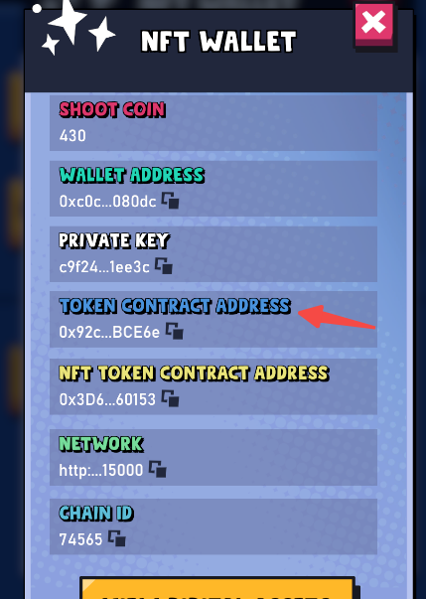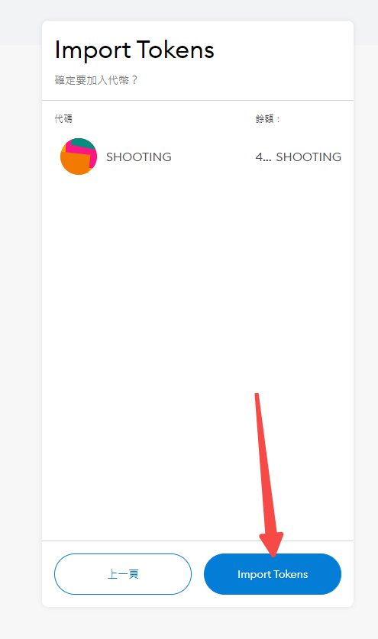

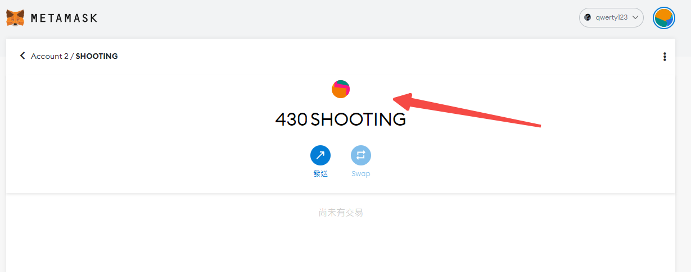

这样就导入同步成功了