Question 1 resume:

Code:

<!DOCTYPE html>

<html lang="en">

<head>

    <meta charset="UTF-8">

    <meta name="viewport" content="width=device-width, initial-scale=1.0">

    <title>My Resume</title>

</head>

<body bgcolor="#F0F0F0"><!-- using color code for light gray -->

    <h1 align="center">John Doe</h1>

    <p> <b>Email:</b> <a href="mailto:john@example.com" style="text-decoration: none;">john@example.com</a> </p><!-- email link using style to remove the underline -->

    <h2 style="color: #000080;">Education</h2> <!-- using style to color text navy blue -->

    <hr style="height: 1px; background-color: black; border: none;"><!-- horizontal line -->

    <ul>

        <li>

            <b>Univwesity Name - </b> Bachelor's Degree in Computer Science

        </li>

        <li>

            <b>Graduation Date : </b> May 20XX

        </li>

    </ul>

    <h2 style="color: #000080;">Work Experience</h2>

    <hr style="height: 1px; background-color: black; border: none;">

    <ul>

        <li>

            <b>Software Developer</b> at ABC Tech

        </li>

        <li>

            <b>Durq : </b> June 20XX - Present

        </li>

    </ul>

    <h2  style="color: #000080;">Skills</h2>

    <hr style="height: 1px; background-color: black; border: none;">

    <ul>

        <li>

            <b>Programming Languages : </b> Java,Javascript

        </li>

        <li>

            <b>Web Technologies : </b> HTML,CSS,React

        </li>

    </ul>

    <h2  style="color: #000080;">References</h2>

    <hr style="height: 1px; background-color: black; border: none;">

    <p>contact available upon request</p>

</body>

</html>

Output:

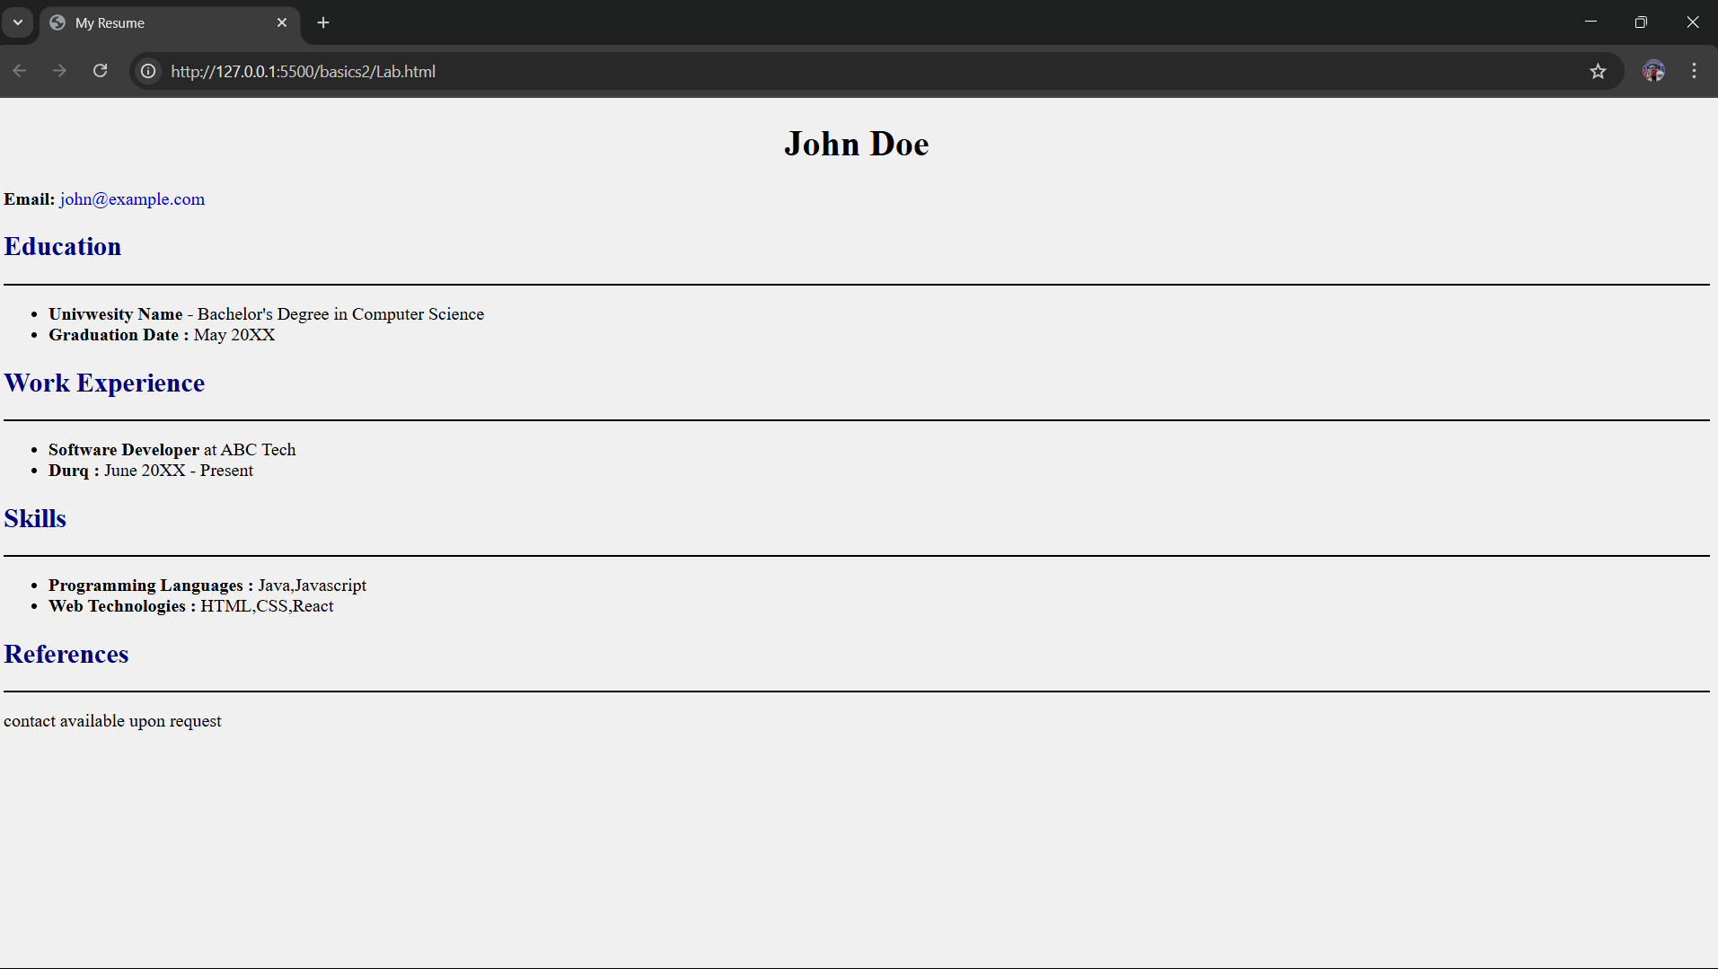

Question 2 Music Company:

<!DOCTYPE html>

<html lang="en">

<head>

    <meta charset="UTF-8">

    <meta name="viewport" content="width=device-width, initial-scale=1.0">

    <title>Your Music Company</title>

</head>

<body bgcolor="#F0F0F0"><!-- using color code for light gray -->

    <div style="color: azure;background-color: rgb(75, 75, 255); padding: 8px; top: 0px; position: sticky;"align="center">

        <!-- make it stick on top using sticky and top 0-->

        <!-- decorating the div according to requirements-->

        <h1 >Maharaja Music Company</h1>

        <p>connecting cultures through music</p>

    </div>

    <div style="background-color: white; padding: 10px;margin: 10px;" align="center">

        <h2>Featured Indian Album : "Raga Reverie"</h2>

        <p>

            Embark on a musical journey through the rich and soulful sounds of indian classical music with our featured album "Raga Reveire."

        </p>

    </div>

    <div style="background-color: white; padding: 10px;margin: 10px;">

        <h2>Explore Generes</h2>

        <ul>

            <li><a href="">Indian Classical</a></li>

            <li><a href="">Western Classical</a></li>

            <li><a href="">Bollywood</a></li>

            <li><a href="">Pop</a></li>

            <li><a href="">Jazz</a></li>

            <li><a href="">Rock</a></li>

        </ul>

    </div>

    <div style="background-color: white; padding: 10px;margin: 10px;">

        <h2>Featured Artists</h2>

        <ul>

            <li>Ravi Sitar Maestro</li>

            <li>Emily Violin Virtuoso</li>

            <li>AMit Bollywood Beats</li>

            <li>Sophia Jazz Sensation</li>

        </ul>

    </div>

    <div style="background-color: white; padding: 10px;margin: 10px; margin-bottom: 0px;">

        <h2>Contact Us </h2>

    </div>

    <div style="color: azure;background-color: rgb(75, 75, 255); padding: 10px;bottom: 0px; position: sticky;" align="center">

        <!-- make it stick on bottom using sticky and bottom 0-->

        <!-- decorating the div according to requirements-->

        <p>&copy; 2023 Maharaja Music Company.All rights reserved.</p>

    </div>

</body>

</html>

Output:

