Project B: Ray tracing geometric objects

YPK6670

Yipeng Pan

Instruction:

It is a ray tracing project based on week3 rescue. It have two viewports, preview port and ray-view port.

Drag your mouse to change the direction of the camera in preview port and use WASD to move the camera in preview port.

Click t to do ray tracing.

Use the button super-sampling and jitter to change the setting of Antialiasing from 1\*1 to 4\*4 and with or without jitter.

There are two lights in the view, one is a fixed light and the other one is a head light placed at the position of camera. You can change the head light by moving the camera in preview port and use keys IJKL to move fixed light. Change of light position will displayed immediately in preview port but you need to ray trace and get the result of change in ray tracing viewport.

You can click light1 and light2 button to switch on and off those two light, but the change will not display until you click t and do the ray trace for both viewports.

You can use button reflection to set the level of recursive reflection. The initial value is 0, which means no reflection, and the max value is 4.

You can use change scene button to change scenes, there are totally 4 scenes.

Pictures:

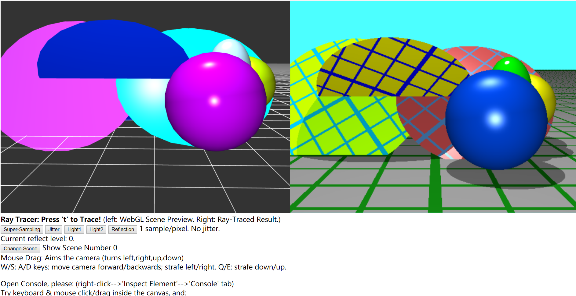

Figure Initial pic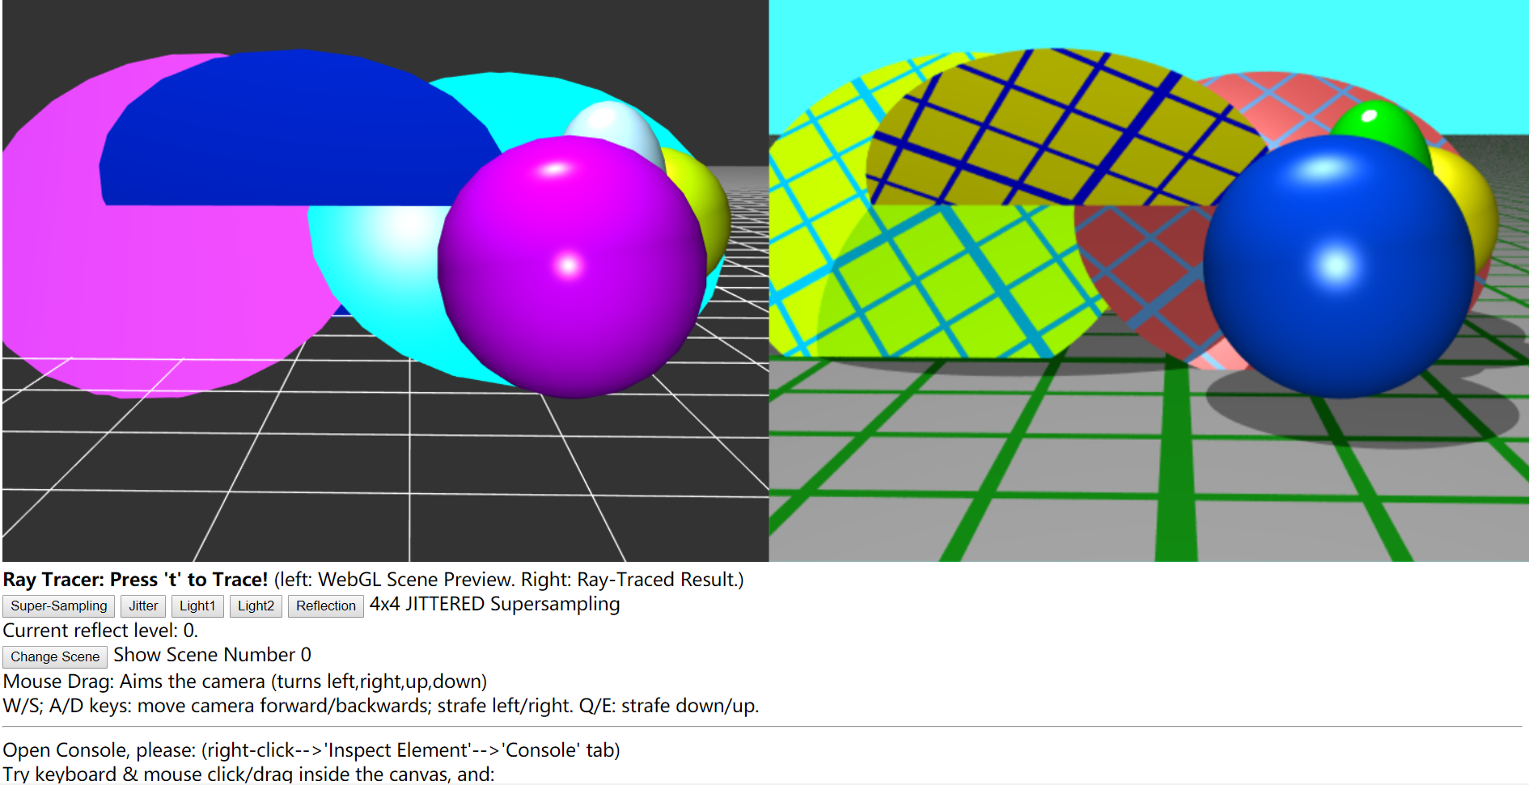

Figure Super Sampling is 4\*4 and jitter is on

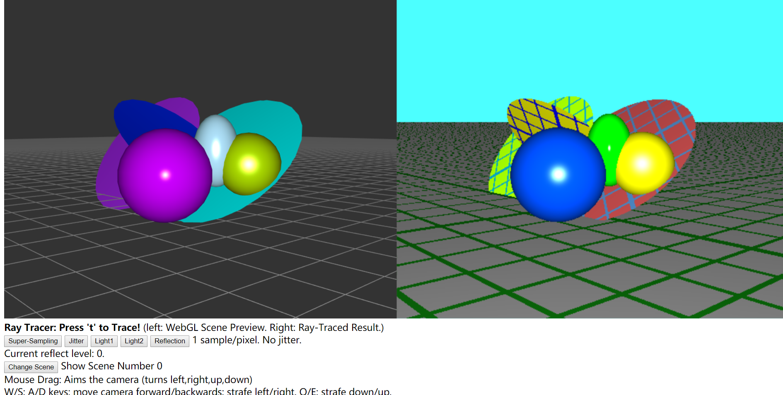

Figure A different direction with one light off

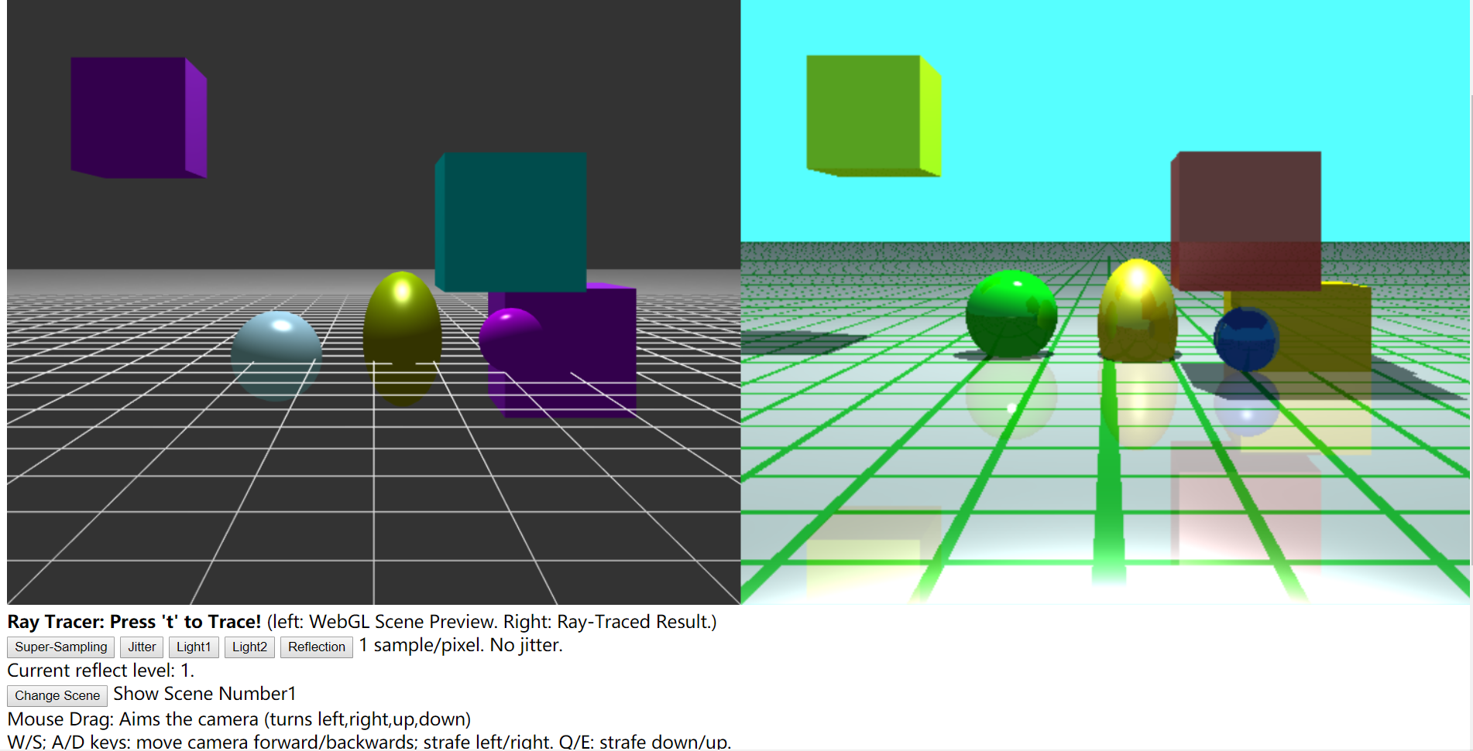

Figure Another scene, another light off, and reflection on

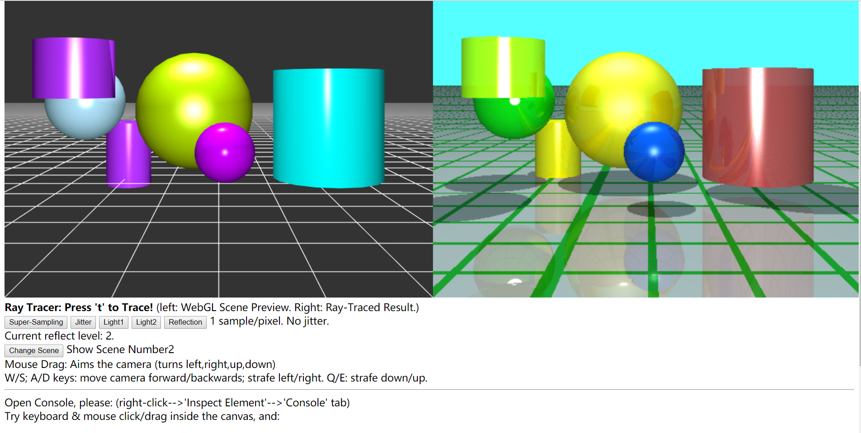

Figure 3rd scene and reflect level equals 2

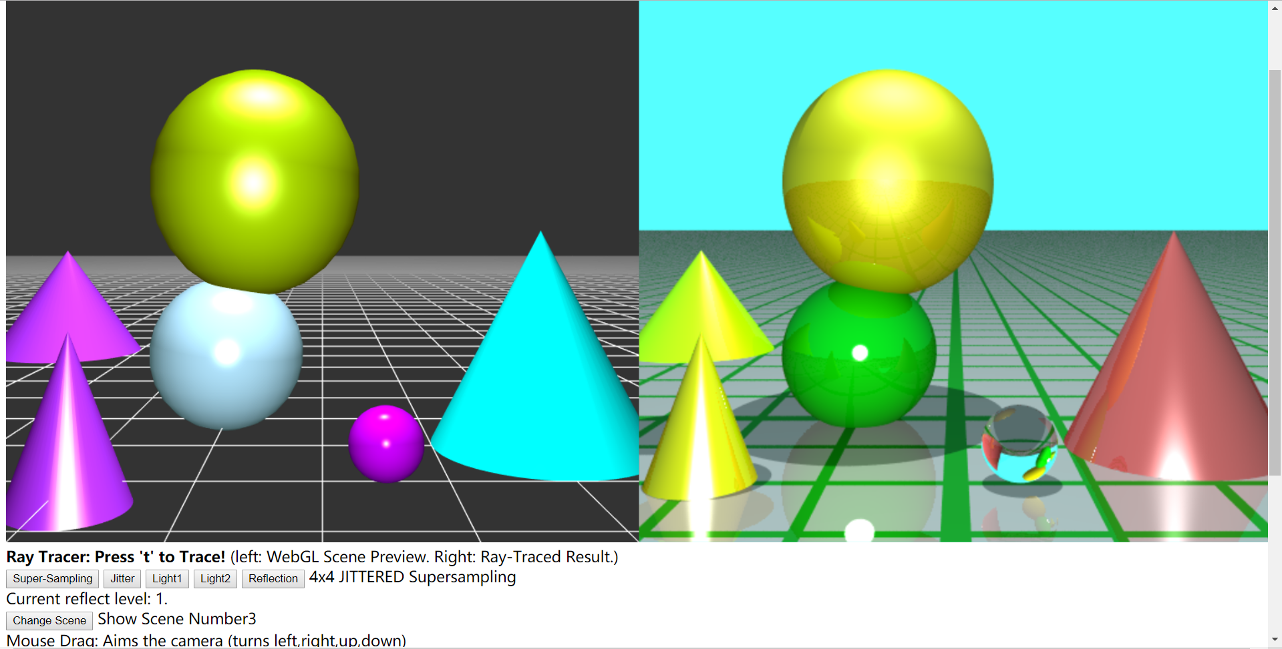

Figure The last scene, reflection with a transparency ball