Develop a web application using “JSF framework” to get the details from the client as shown below and to display the same.

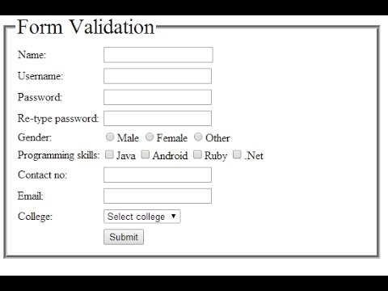

Note:

1. Based on the information create a Database.
2. While pressing Submit button, data should be added to a list. List the entire form data either in same JSP page or different JSP page. Ensure that the user can add more than one Student.
3. Validate all form fields while inserting the data.
4. Display all the data available in database taking username as reference.
5. Use Bootstrap, HTML5, CSS3.