学习笔记 2017/06/26
上午：学习了github的基本使用方法，下载了git的GUI，了解了git的branch的功能的作用，它能够实现多个用户同时分别对一个工程进行工作，并通过merge能总和所有人的成果。
下午：
Spring 框架学习：
Spring框架包含了大约20个模块，如下图所示。这些模块再细分成Core Container, Data Access/Integration, Web, AOP (Aspect Oriented Programming), Instrumentation, Messaging, and Test。
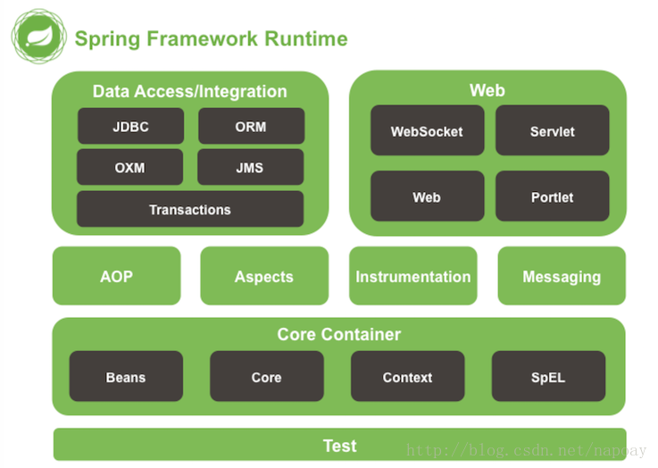

spring Boot:Spring Boot是由Pivotal团队提供的全新框架，其设计目的是用来简化新Spring应用的初始搭建以及开发过程。该框架使用了特定的方式来进行配置，从而使开发人员不再需要定义样板化的配置。通过这种方式，Spring Boot致力于在蓬勃发展的快速应用开发领域（rapid application development）成为领导者。

学习网址：https://spring.io/guides
Spring Boot makes it easy to create stand-alone, production-grade Spring based Applications that you can "just run". We take an opinionated view of the Spring platform and third-party libraries so you can get started with minimum fuss. Most Spring Boot applications need very little Spring configuration.
The Spring Boot Maven plugin provides many convenient features:
It collects all the jars on the classpath and builds a single, runnable "über-jar", which makes it more convenient to execute and transport your service.
It searches for the public static void main() method to flag as a runnable class.
It provides a built-in dependency resolver that sets the version number to match Spring Boot dependencies. You can override any version you wish, but it will default to Boot’s chosen set of versions.
通过学习，可以得知Spring Boot是一个简单易用十分方便的spring框架，我们可以从它开始来启动我们的项目。
了解了一下intellij idea。
用maven简单地配置了一个开发环境，成功地运行了demo.

