Requirements

Initial Conditions Requirements
IR-01 The initial temperature should be set on INITIAL TEMPERATURE
IR-02 The initial level should be set on INITIAL LEVEL
Recipe Requirements
RR-01 Only one product can be selected in the same time
RR-02 If recipe is selected while one is already executing, alarm should indicate conflict
RR-03 Manual controls are ignored during automatic production
RR-04 After Recipe is finished , system should return to initial conditions
Control requirements
CR-01 Next recipe and manual control should be available after previous task complete

Alarms
Alarm :
When max temperature sensor is triggered, alarm should activate
Operator response :
Check working conditions and acknowledge the alarm

Alarm :
When max level sensor is triggered, alarm should activate
Operator response :
Check working conditions and acknowledge the alarm

Controller architecture
Two recipes function block control sequence of actions. 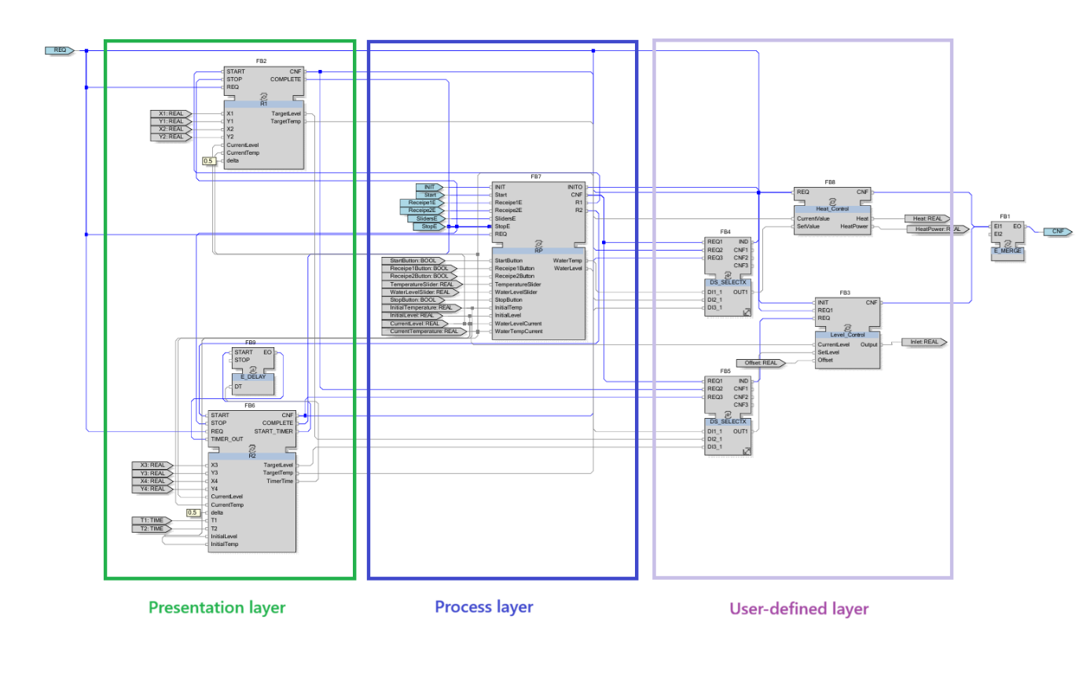
First Recipe block
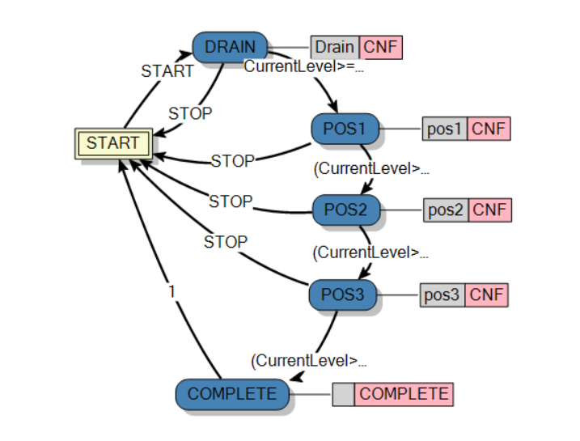
Transition condition (CurrentLevel>=X1-delta AND CurrentLevel<=X1+delta) AND (CurrentTemp>=Y1-delta AND CurrentTemp<=Y1+delta) checks if current level is near target value in range of delta

Second Recipe block
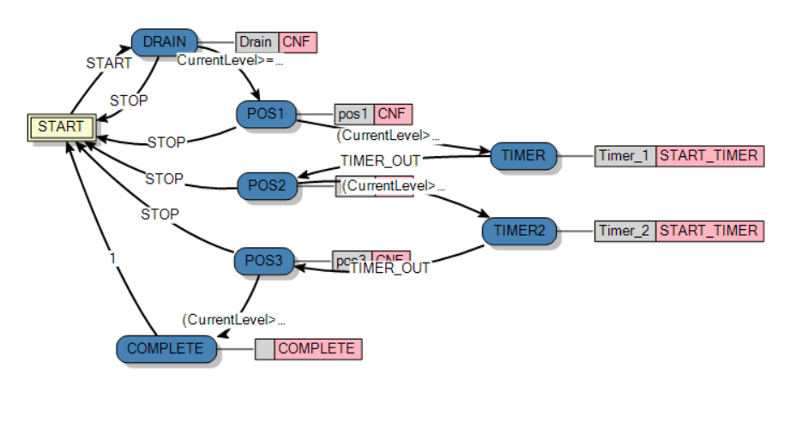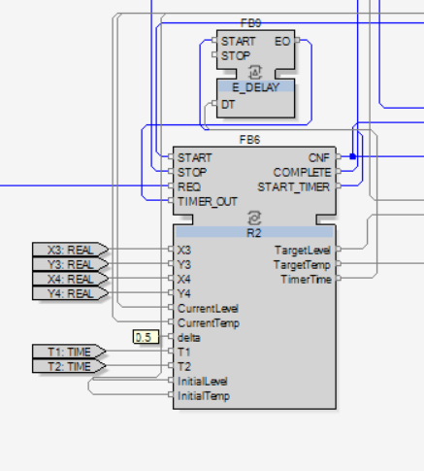

Alarm implementation
