2303A51357
BATCH-20
ASSIGNEMENT-04

PROBLEM:
Develop a basic ERC-20 token smart contract using Solidity that allows users to:
• Define token details such as name, symbol, decimals, and total supply
• Transfer tokens between Ethereum accounts
• Store and manage user token balances
• Emit events to record token transfer activities on the blockchain
This practical helps understand state variables, mappings, constructors, events, and functions in Solidity, as well as the basics of Ethereum token standards.
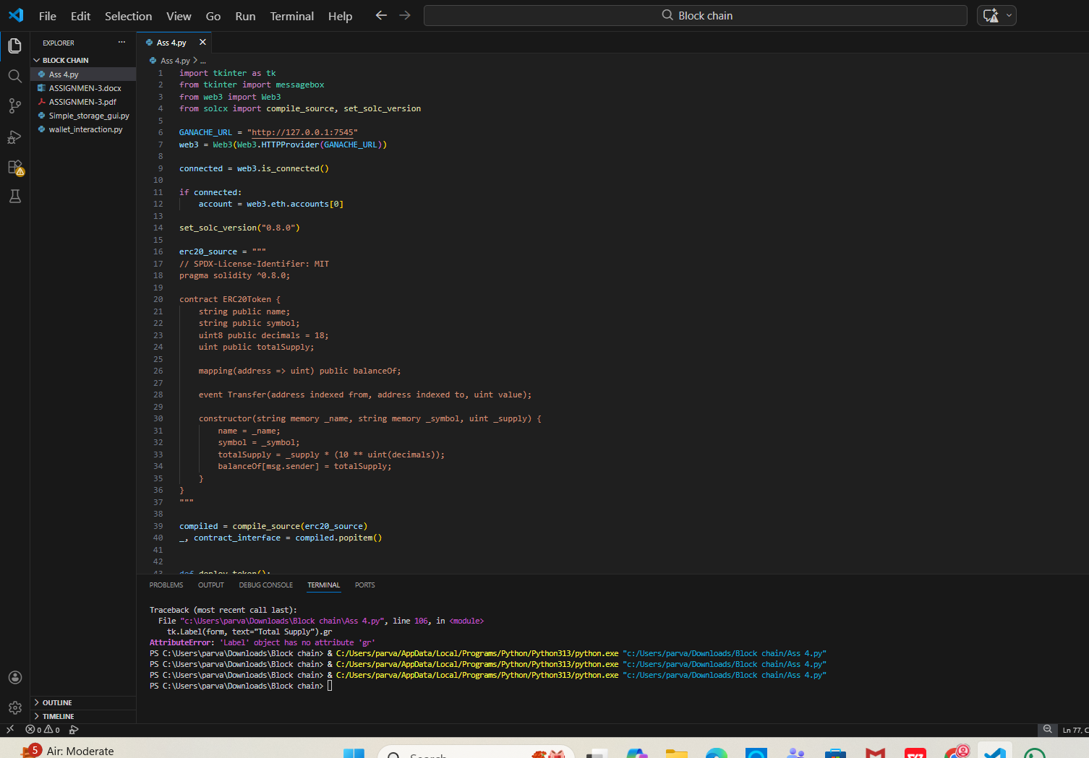
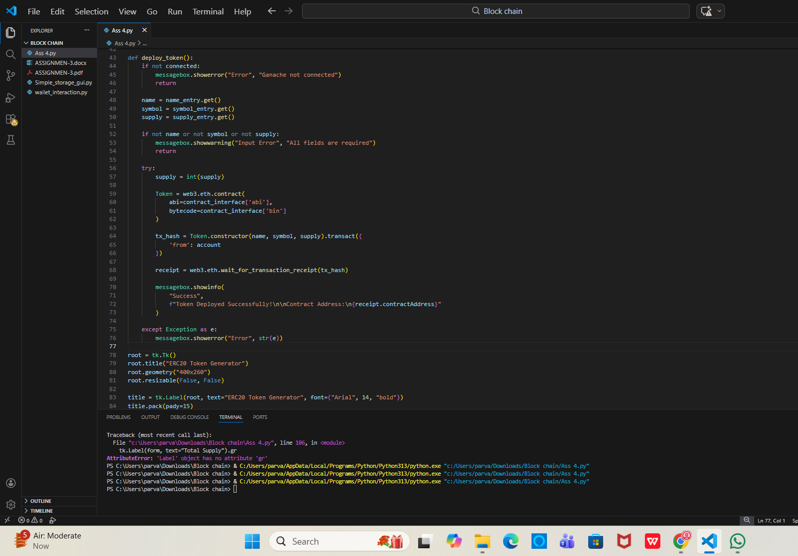
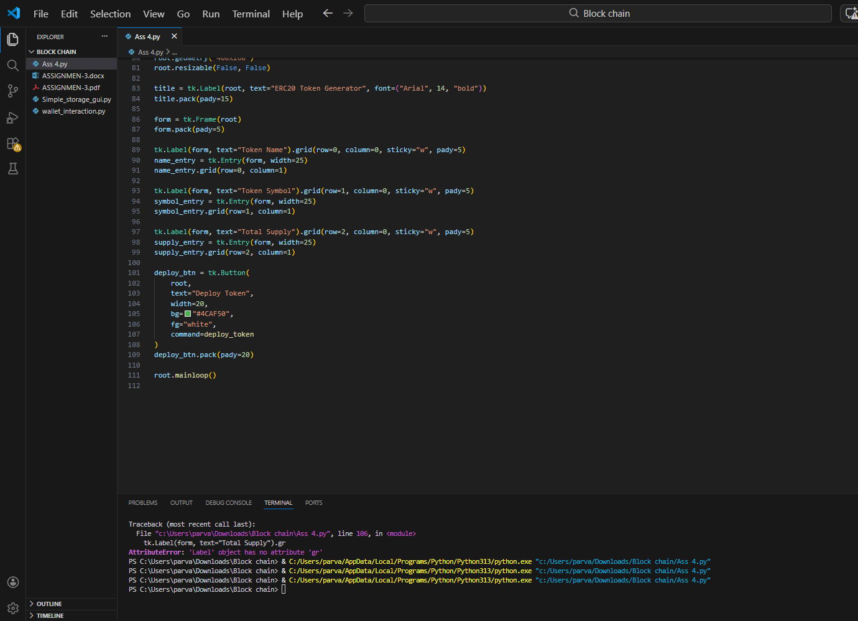
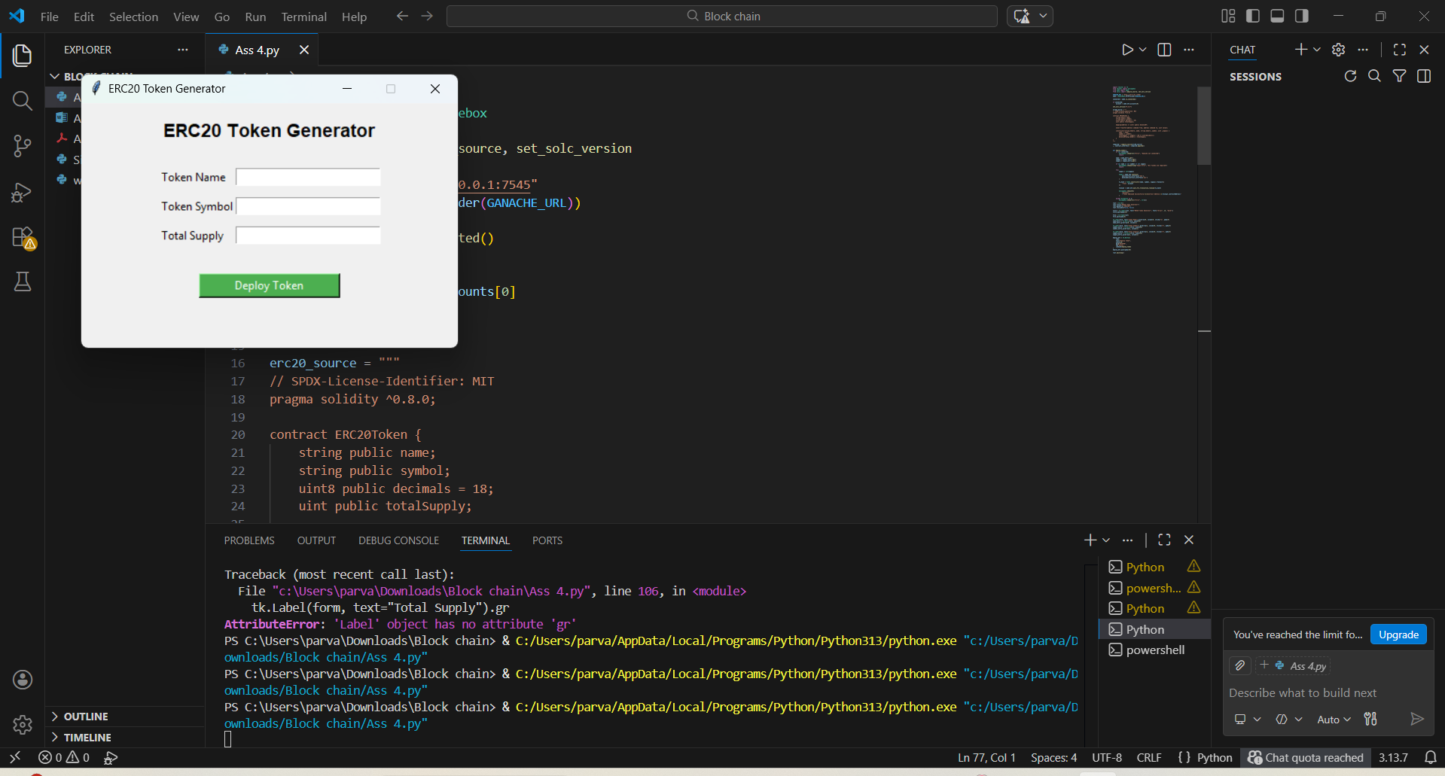
Observation:
- State variables = name, symbol, decimals, totalSupply, balanceOf
- Constructor = constructor(uint initialSupply)
- Token transfer function = transfer(address to, uint value)
- Balance storage = mapping(address => uint) balanceOf
- Event used = Transfer(address from, address to, uint value)

