1. Request:

SELECT COUNT(CustomerName) FROM Customers WHERE Country='Germany';

Response:

11

2. Request:

SELECT \* FROM Customers WHERE CustomerName LIKE '%e';

Response: 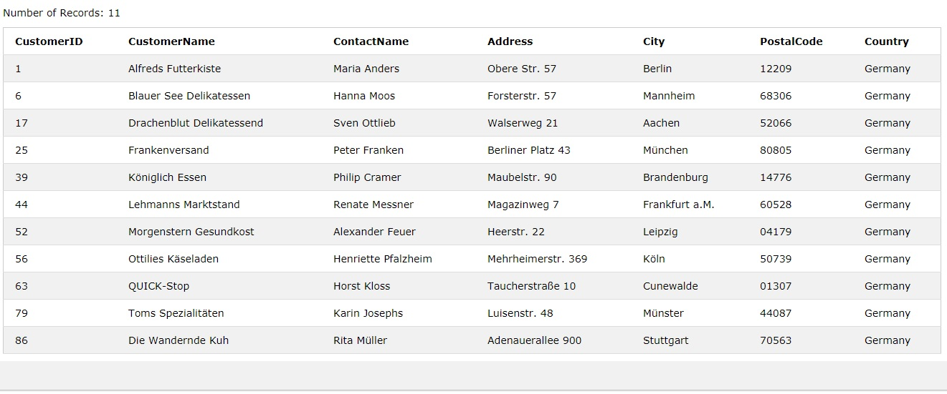

3. Request:

INSERT INTO Customers (CustomerName, ContactName, Address, City, PostalCode, Country)

VALUES ('YR','Yaroslav Romanyuk','Main St.','Novosibirsk','630055','Russia');

Result:

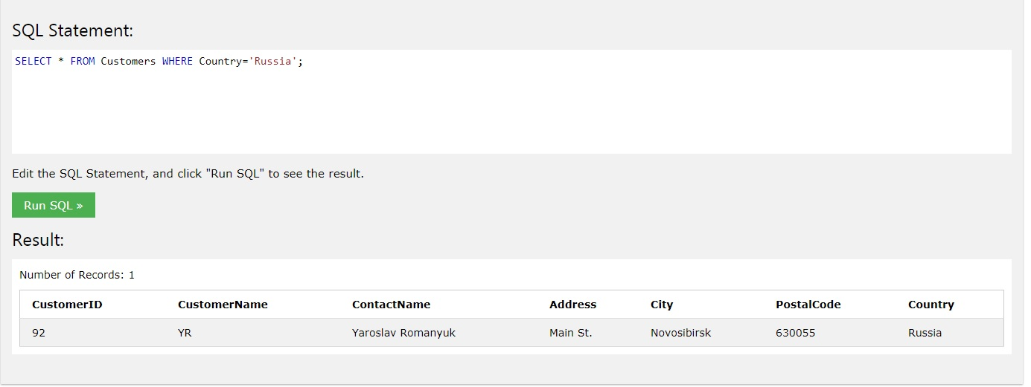

4. Request:

UPDATE Customers SET ContactName='Yaroslav I Romanyuk' WHERE CustomerID=92;

Result:

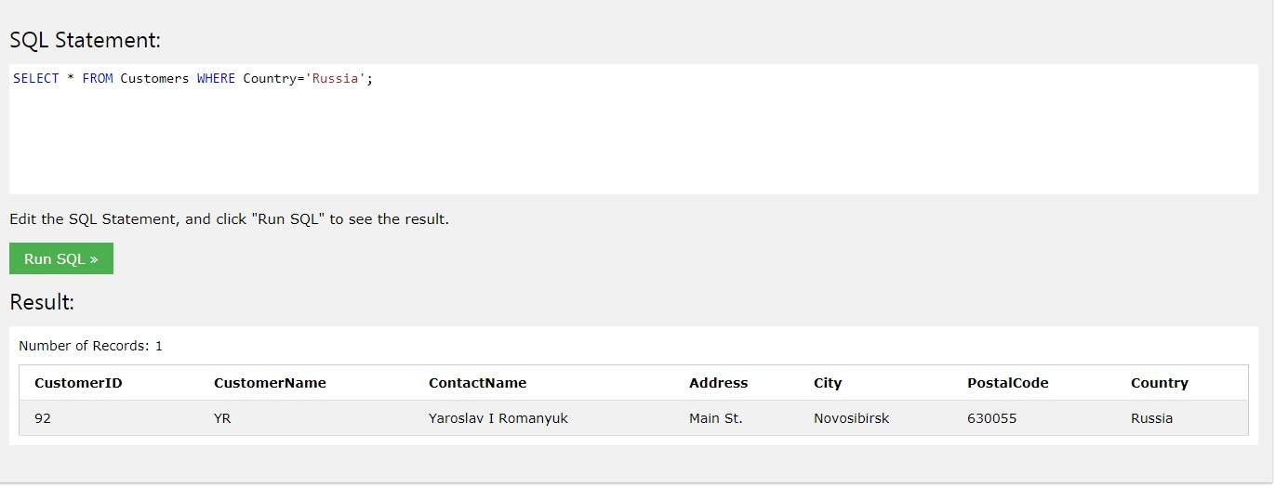

5. 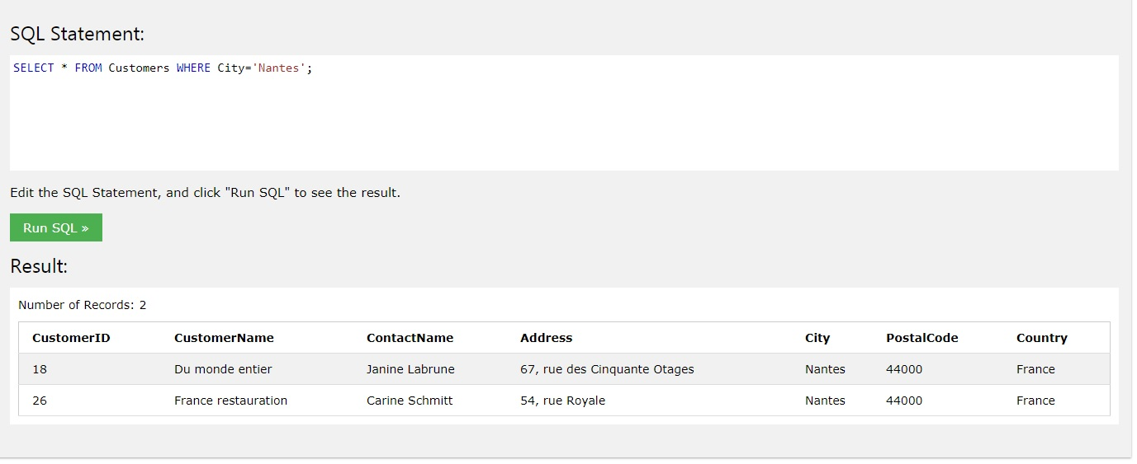

Request: DELETE FROM Customers WHERE City='Nantes';

Result:

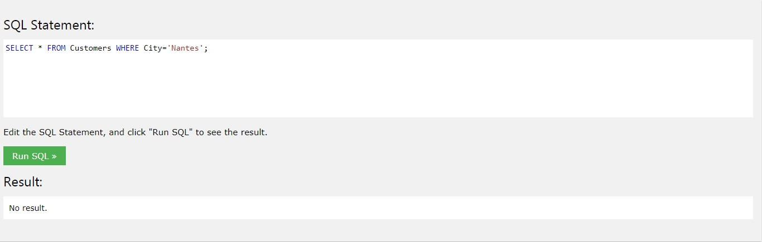

6. Request:

SELECT Orders.OrderID, Orders.EmployeeID FROM Orders

INNER JOIN Employees ON Orders.EmployeeID = Employees.EmployeeID WHERE Employees.FirstName='Steven';

Result:

