Optimized Route Planning for a Robot Visiting Random Points
Background
The project is inspired by the Traveling Salesman Problem (TSP), where the goal is to find a visiting order that minimizes the total travel distance. The project uses dynamic programming to achieve the optimized route and compare it with the greedy nearest-neighbor method.

Nearest-neighbor
A way of solving this problem is n_b.
However, this only considers the immediate cost for the next step, which sometimes may not be able to see far enough to minimize the total cost.
Every point will have the coordinate of (xi, yi). The cost for each movement would be the Euclidean distance traveled.
The cost will be stored in an N-by-N cost matrix, symmetry matrix with zeros at the diagonal. Row number as the current point, and column number as the next point

As a result, this project will take the future cost after each possible action into consideration and choose the action that minimizes the total remaining travel cost.

Dynamic programming
It chooses the next point by considering both:
$$\text{current travel cost}+\text{future remaining cost}$$It chooses the next point that gives the smallest total route cost after considering the rest of the route.

The state of the robot can be defined as s = (i,S) The action is to choose the next point j with a = j,j /∈ S.
The transition function would be… This means that after choosing point $j$, the robot moves to point $j$, and $j$is added to the visited set.

Modeling and simulation
The running example would be on a 2D space such as a grid. The robot will always start from point 0 while all target points are generated on the grid with number on each. The movement cost is expressed as the Euclidean distance between two target points. Under the fundamental circumstance, there is no obstacle for the robot to avoid, so it can move directly to the next point in a straight line.

Result
Three cases for testing, which are 5, 10, and 20 random points. Each with 3 trials
I pull out one trials for each.
…
In addition, it can be observed that sometimes the dynamic programming makes a trade-off in choosing the next point: it may choose a point that is a bit far from now (e.g., in Fig. 1, dynamic programming chooses point 16 instead of a nearer point 6 starting from point 12), but in the end, the total cost is still smaller than nearest-neighbor.

20 random points: curse of dimension
Time to generate varies.

Future
In the future, obstacles can be added so that the robot has to avoid these points and find the shortest route. In this case, the distance would no longer be simply Euclidean. In addition, the robot should no longer be a point, which means 2D shape may be used to represent the robot.

As the start for capstone project: domino player, it is foreseen that it should be able to achieve the expectations above. Moreover, playing dominoes doesn’t only require not to knock off the placed dominoes, but it also should avoid being trapped when trying to finish an enclosed shape of dominoes since if we want to place the dominoes in a circle, the most efficient way I can imagine is to stay at the center of the circle and place the dominoes.

===========================================================
Transition: The next would be a supplement literature I found that poses some similarities towards domino placement. The technique behind it can be possibly used as a reference on the capstone project.

Literature Review
Non-repetitive:
Unique Geometry: Every single beam (or domino in a custom shape) has a unique position and orientation.

Three methods for building up the structure are established earlier in previous paper.
Joint Clamping Method
First, the robotic arm attaches robotic clamps to the timber structure, one by one, at the location of the mating joints. Then, the robotic arm changes to a gripper tool to pick up a timber element and position it into the clamp jaws. Then, the robotic arm and the clamps move synchronously to close the joints. Finally, the robotic arm returns the gripper to storage and detaches the clamps, one by one, from the timber structure. The number of clamps used depends on the number of mating joints, and the clamp type (CL3 or CL3M) needs to match the joint’s intersecting angle.

Flowchart explanation
Convention planning is using a flowchart, which consists of actions and motion planning between targets. In this way, the sequence of the planning is fixed after finalized. The flowchart can be “optimized” to some extent manually.

Flowchart sample
At the leftmost part, these are actions involved if we want to use the clamps to assemble beam B1 and beam B2 to the structure. Actions are named by abbreviation. The general sequence of it is to take out the clamp 1 from storage, and attach it on a joint to the structure, and take out clamp 2 from storage, and attach it on the other joint to the structure. After the fixation, put the two clamps back to the storage. Repeat the actions for beam B2.

In the last slide, I mention that the action list can be somewhat optimized. In this case, the third col is much shorter since instead of putting back clamps every time a beam is finished, it leaves the clamps on the previous beam and take it direct to the next beam. It skips the process of retrieving and storing.

Problem
In practice, the direct transfer of clamps from the previous to the next is not always possible. The clamps may not be accessible due the built-up beam elements. In this case, the clamps are trapped and the rest of the action list are unable to proceed. In this case, the conventional flowchart planning will be suspended.

In order to resolve the issue, and make the planning and assembly more efficient, the author proposes TAMP.
TAMP integrates task planning (symbolic) and motion planning.
Symbolic planning
In PDDL, a problem is represented using a domain file and a problem file. The domain file contains the predicates and actions of the robotic process.

Predicate:
In symbolic planning, states are expressed symbolically, using relationships among objects instead of geometry (such as a transformation matrix). E.g. `(BeamAtStorage b1)`
The initial starting state is simply a list of predicates describing the system at that time
All unknown values are assumed to be false. That is to say that if we do not know the value of a predicate, then we assume it to be false.

Action:
Precondition:
a Boolean logical formula that allows the planner to decide if an action can be applied based on the current state. For example, a beam must be at the storage location for the “Assemble Beam” action to begin. This prevents the condition like assembling an already-assembled beam.
Effect of that action describes the addition and removal of predicates from the current state.
When a predicate is removed, it means that the statement is now false. For example, the effect of an “Assemble Beam” action should add the predicate `BeamAtAssembled b1` and remove `BeamAtStorage b1`. The symbolic planner can keep track of the changing states automatically and be smart about applying which actions to reach the goal state.

Parameter:
PDDL actions are parametrically defined, using variables to express their preconditions and effects

Explain the sample PDDL
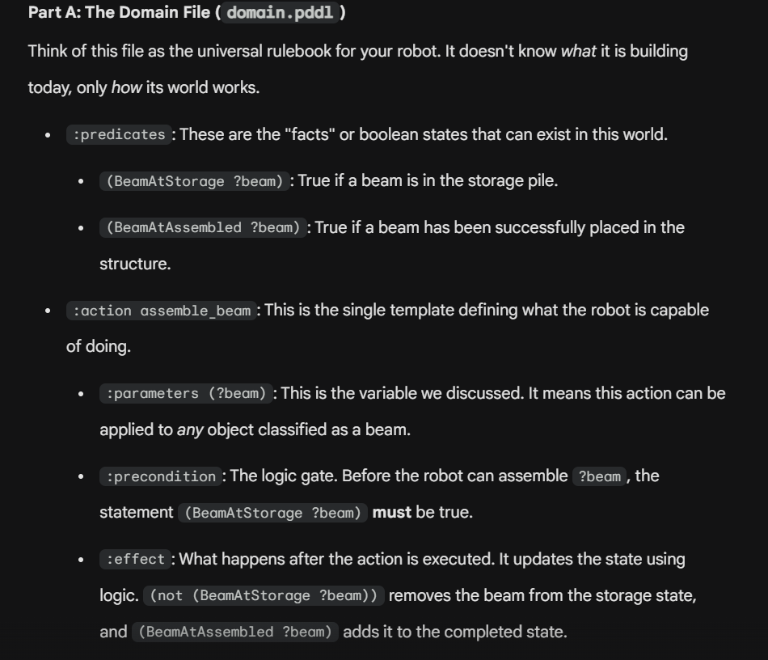

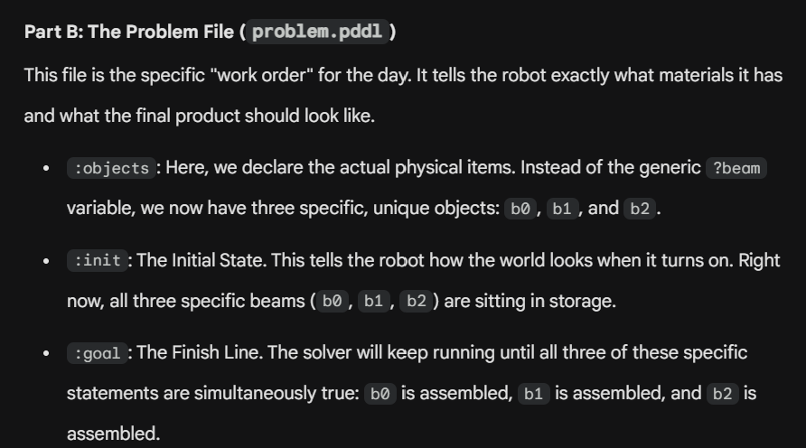

The TAMP implementation used in this paper is called PDDLStream. …, which combines symbolic PDDL solvers with robotic motion planners
It introduces the concept of stream, an external function that a symbolic planner can call to certify whether a predicate is true. For robotic assembly processes, it checks the reachability (certified by motion planners) and collision (certified by collision checkers).

========================================================
MP:
For example, a stream for the BeamAssembly action should accept the ?beam parameter as input and check whether a trajectory exists to move that beam to the final assembled location. If the robot can reach the targets, the generated trajectory is stored as a predicate to assert that the corresponding action has a trajectory. For example, `(BeamAssemblyTraj ?beam ?traj)` can represent the fact that trajectory ?traj is available for beam ?beam.

CC:
Collisions between the movable beams and tools and the robot are checked separately using a CC stream.
========================================================

Explanation of the TAMP process

The leftmost box is the input, consisting of …
Stream.pddl
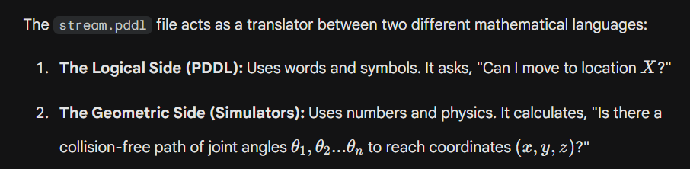
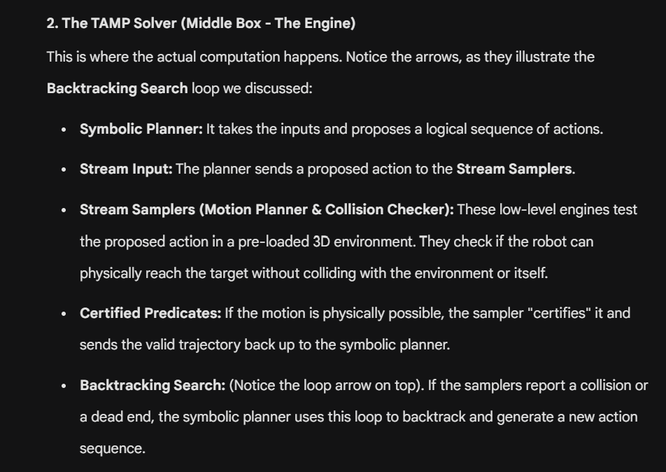
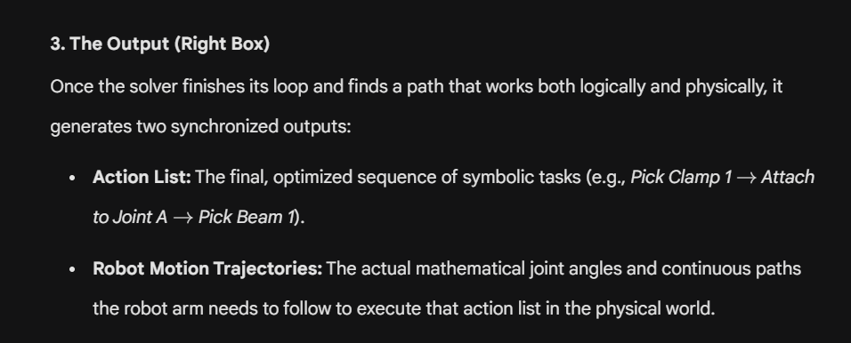

Conclusion:
Comparing the clamping case using TAMP with the case using conventional flowchart, the time of execution is reduced by 16%. The TAMP solver planning time is highly sensitive to the number of beams to be assembled, referring to a high branching factor (many possible actions at each step). In the paper, they already use partial ordering to reduce the branching factor. In the clamping case, they have to manually label the order of the 14 beams.

Q: how to know the angles?
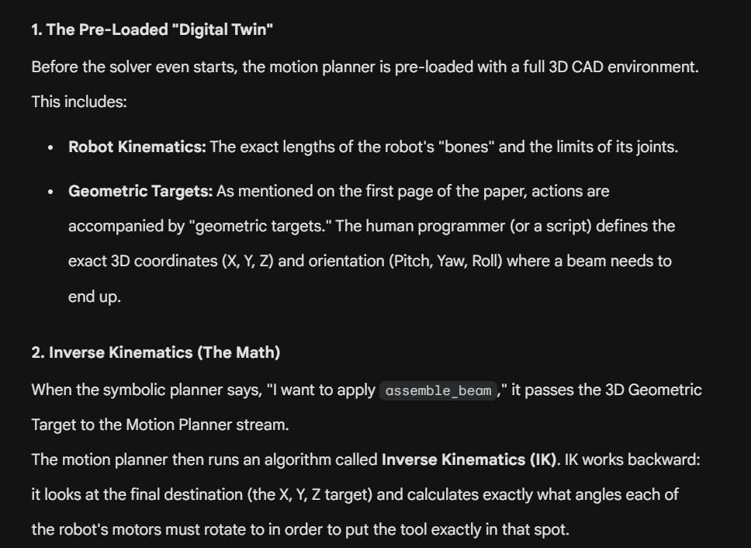
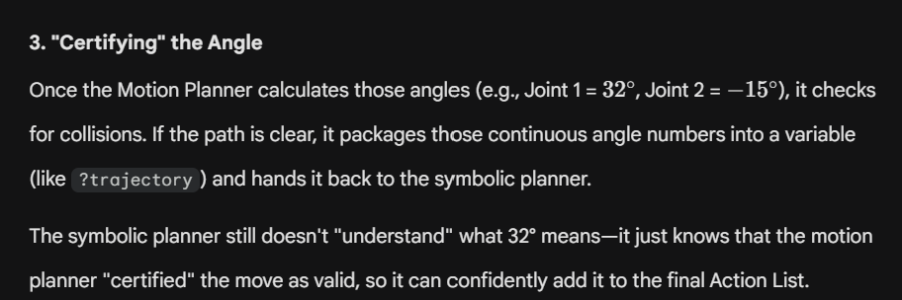

- Angle guess: if want to get to (x,zy), IK presumes angles first
- Go to 3D CAD simulation to physically reach the angle to check of collision happens
- Good, back to step 1
- Bad, back to IK for new angles only for a certain joint

