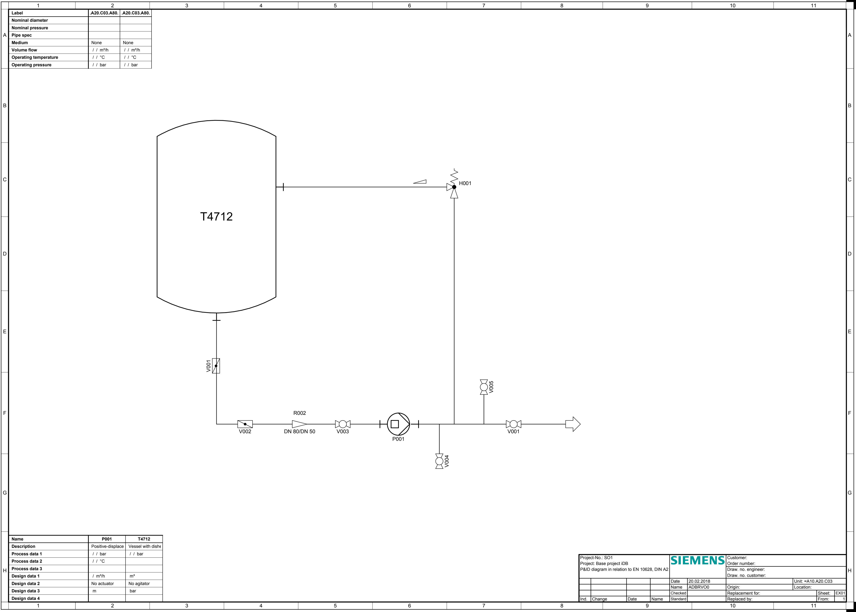
Pas o s o os ssted. The r t t o td t t s s e ig.
3
7
10
11
1
2
4
5
6
8
9
Label
A20.C03.A80.
.A20.C03.A80.
Nominal
diameter
Nominal
pressure
Pipe
spec
A
A
Medium
None
None
Volume
flow
/ /
m³/h
/ /
m^3/h
/ / ℃
/ / ℃
Operating
temperature
I/ /
bar
I/ /
bar
Operating
pressure
B
B
C
C
H001
T4712
D
D
E
E
V001
V005
F
R002
F
V002
DN 80/DN 50
V003
V001
P001
V004
G
G
Name
P001
T4712
Description
Positive-displace
Vessel with
dishe
Process
data 1
I/ bar
I/ /
bar
SIEMENS
Project-No.:
SO1
Customer:
/ / ℃
Process
data 2
Project: Base
project iDB
Order
number:
Process data
3
P&ID diagram in relation to EN
10628, DIN A2
Draw. no.
engineer:
H
H
Design data
1
m3
/
m³/h
Draw. no.
customer:
Date
Unit:
=A10.A20.C03
20.02.2018
Design
data 2
No
actuator
No
agitator
Name
Origin:
Location:
ADBRVO0
m
bar
Design
data 3
Replacement
for:
Checked
Sheet:
EX01
From:
Design
data 4
Ind.
Date
Name
Change
Standard
Replaced
by:
1
3
10
11
1
2
4
5
6
7
8
9

