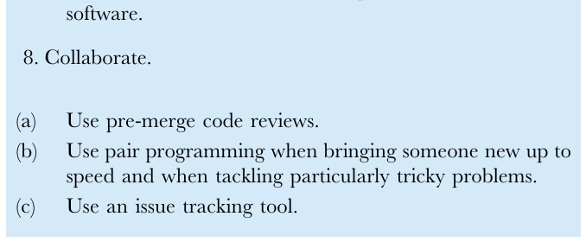
know that it is actually doing what it is intended to do.
To be
productive, software developers must therefore take
several aspects
of human cognition into account: in particular, that
human
working memory is limited, human pattern matching
abilities are
finely tuned, and human attention span is
short [33 37].
(a) A program should not require its readers to hold
more
First, a program should not require its readers to hold
than a handful of facts in memory at
once.
more than a handful of facts in memory at once (1a).
(b) Make names consistent, distinctive, and
meaningful. (c) Make code style and formatting
consistent.
Human working memory can hold only a handful of
items at a
time, where each item is either a single fact or a
"chunk"
2. Let the computer do the
work.
(a) Make the computer repeat
tasks.
aggregating several facts [33,34], so programs should
limit the total
number of items to be remembered to accomplish a
task. The
primary way to accomplish this is to break programs up
into easily
understood functions, each of which conducts a single,
easily
(b) Save recent commands in a file for
re-use. (c) Use a build tool to automate
workflows.
understood, task. This serves to make each piece of the
program
easier to understand in the same way that breaking up
a scientific
paper using sections and paragraphs makes it
easier to read.
3. Make incremental
changes.
(a) Work in small steps with frequent feedback and
course
Second, scientists should make names consistent,
distinctive, and meaningful (1b). For example, using
non-descriptive
names, like a and foo, or names that are very similar,
like results and
correction.
results2, is likely to cause
confusion.
(b) Use a version control system. (c) Put everything
that has been created manually in version
Third, scientists should make code style and
formatting
consistent (1c). If different parts of a scientific paper
used
control.
different formatting and capitalization, it would make
that paper
4. Don't repeat yourself (or
others).
(a) Every piece of data must have a single
authoritative
more difficult to read. Likewise, if different parts of a
program are
indented differently, or if programmers mix
CamelCaseNaming
and pothole_ case_ naming, code takes longer to read
and readers
make more mistakes
[35,36].
Let the Computer Do the Work
Science often involves repetition of computational
tasks such as
representation in the
system.
(b) Modularize code rather than copying and
pasting.
(c) Re-use code instead of
rewriting it.
5. Plan for
mistakes.
(a) Add assertions to programs to check their
operation.
processing large numbers of data files in the same way
or
regenerating figures each time new data are added to
an existing
analysis. Computers were invented to do these kinds of
repetitive
(b) Use an off-the-shelf unit testing
library.
tasks but, even today, many scientists type the same
commands in
(c) Turn bugs into test
cases.
over and over again or click the same buttons
repeatedly [17]. In
(d) Use a symbolic
debugger.
addition to wasting time, sooner or later even the most
careful
researcher will lose focus while doing this and
make mistakes.
6. Optimize software only after it works
correctly.
Scientists should therefore make the computer
repeat tasks
(2a) and save recent commands in a file for re-use (2b).
(a) Use a profiler to identify
bottlenecks.
For example, most command-line tools have a "history"
option
(b) Write code in the highest-level language
possible.
that lets users display and re-execute recent
commands, with
minor edits to filenames or parameters. This is often
cited as one
7. Document design and purpose, not
mechanics.
(a) Document interfaces and reasons, not
implementations.
remain
popular
command--line
interfaces
[38,39]: "do
this
reason
again" saves time and reduces
errors.
A file containing commands for an interactive system
is often
(b) Refactor code in preference to explaining how it
works.
called a script, though there is real no difference
between this and
(c) Embed the documentation for a piece of software
in that
a program. When these scripts are repeatedly used in
the same
way, or in combination, a workflow management tool
can be
used. The paradigmatic example is compiling and
linking
programs in languages such as Fortran, C++, Java, and
C#
[40]. The most widely used tool for this task is probably
Make
(http://www..gnu.org/software/make), although many
alterna-
tives are now available [41]. All of these allow people to
express
dependencies between files, i.e., to say that if A or B
has changed,
then C needs to be updated using a specific set of
commands.
These tools have been successfully adopted for
scientific work-
flows as well
[42].
To avoid errors and inefficiencies from repeating
commands
Write Programs for People, Not Computers
Scientists writing software need to write code that
both executes
manually, we recommend that scientists use a build
tool to
automate workflows (2c), e.g., specify the ways in
which
correctly and can be easily read and understood by
other
intermediate data files and final results depend on
each other, and
programmers (especially the author's future self). If
software
on the programs that create them, so that a single
command will
cannot be easily read and understood, it is much more
difficult to
regenerate anything that needs to be
regenerated.
PLOS Biology
www.plosbiology.org
January 2014 Volume 12 Issue 1|
e1001745
Box 1. Summary of Best Practices
1. Write programs for people, not
computers.
software.
8.
Collaborate.
(a) Use pre-merge code
reviews.
(b) Use pair programming when bringing someone
new up to
speed and when tackling particularly tricky
problems.
(c) Use an issue tracking
tool.

