**Sai Anirudh Y**

**18XJ1A0548**

**Machine Learning - Differential Evolution**

**Egg Holder and Holder Table Functions**

The 8 plots are provided in the submission folder named as <ObjFunction>_Population_<pop_size>_Generations_<gen_size>.png

**Egg Holder Function - Plot Data**

**Correct Solution for Egg Holder Function-**

**Global Minimum => -959.6407**

**Point at Minimum =>**

**x = 512**

**y = 404.2319**

**Population Size** - 20 - **Generations** - 200

Optimised Solution -

Global Minimum (Found by DE) => -930.47600

Point at Minimum (Found by DE) =>

x = 443.63359

y = 458.92374

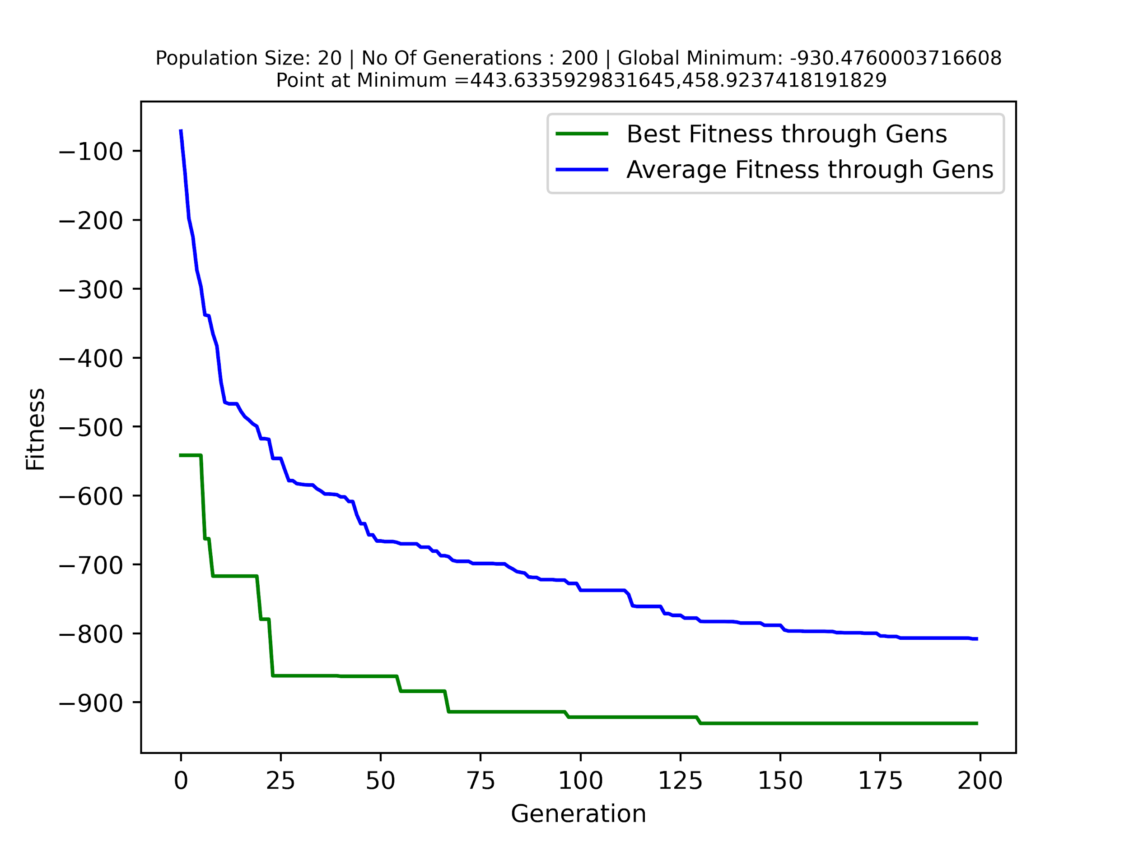

**Population Size** - 50 - **Generations** - 200

Optimised Solution -

Global Minimum (Found by DE) => -953.02320

Point at Minimum (Found by DE) =>

x = 510.88294

y = 401.70104

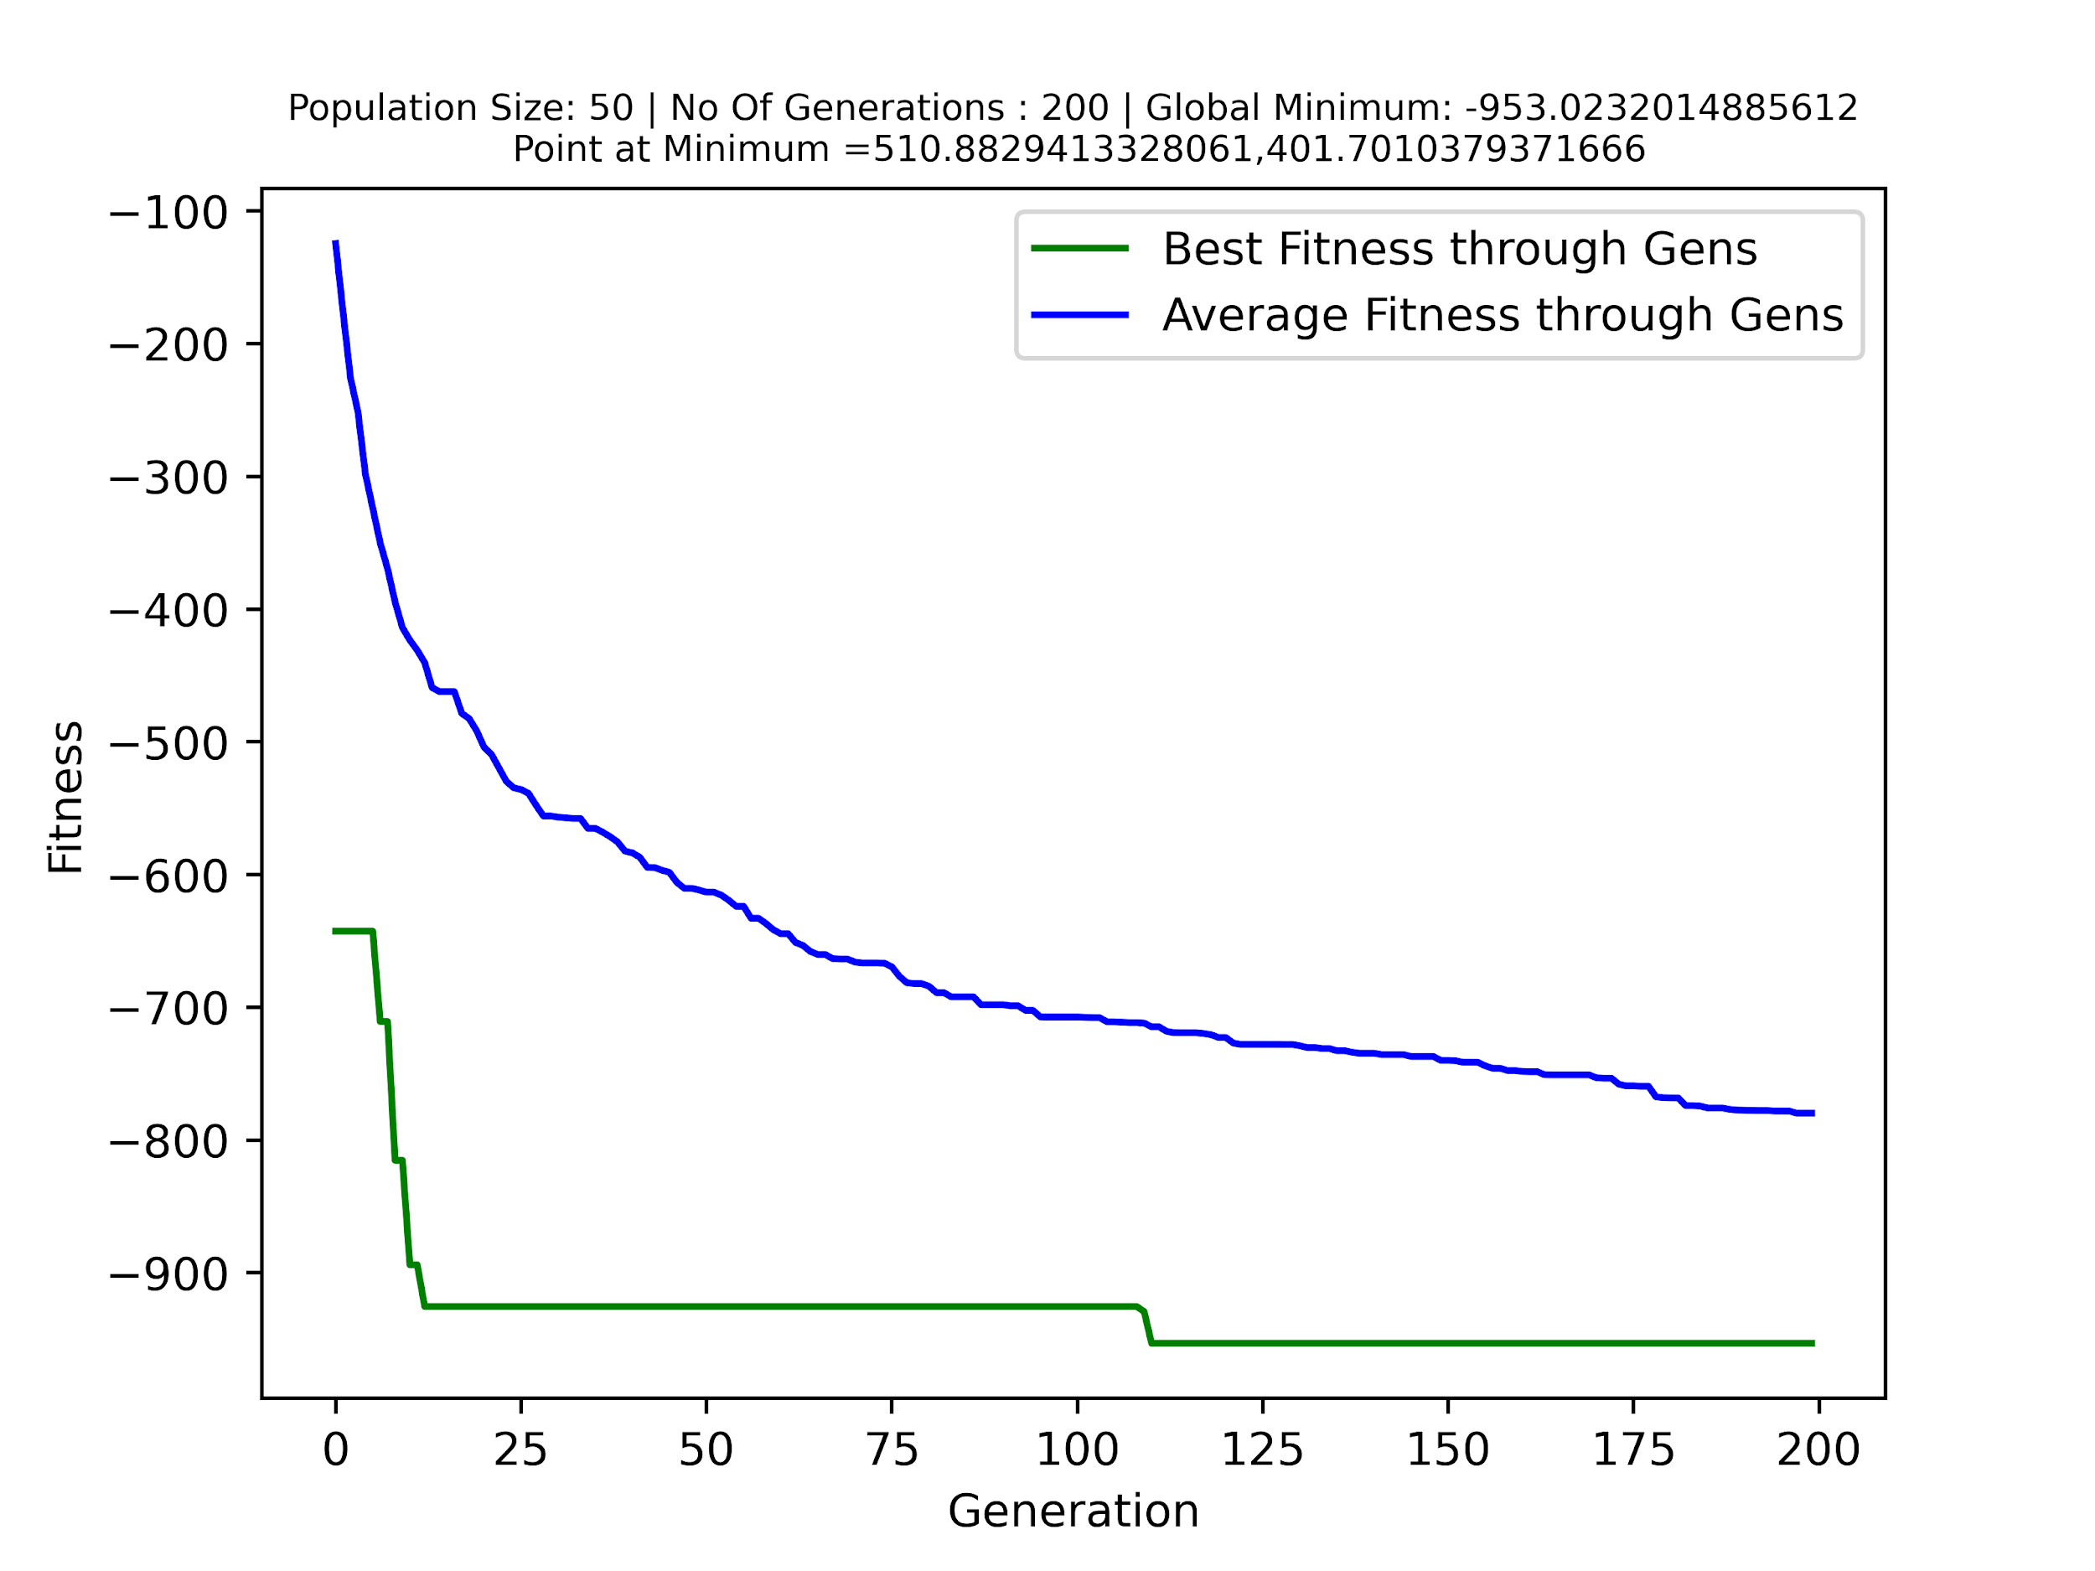

**Population Size** - 100 - **Generations** - 200

Optimised Solution -

Global Minimum (Found by DE) => -953.73236

Point at Minimum (Found by DE) =>

x = 481.08553

y = 436.71168

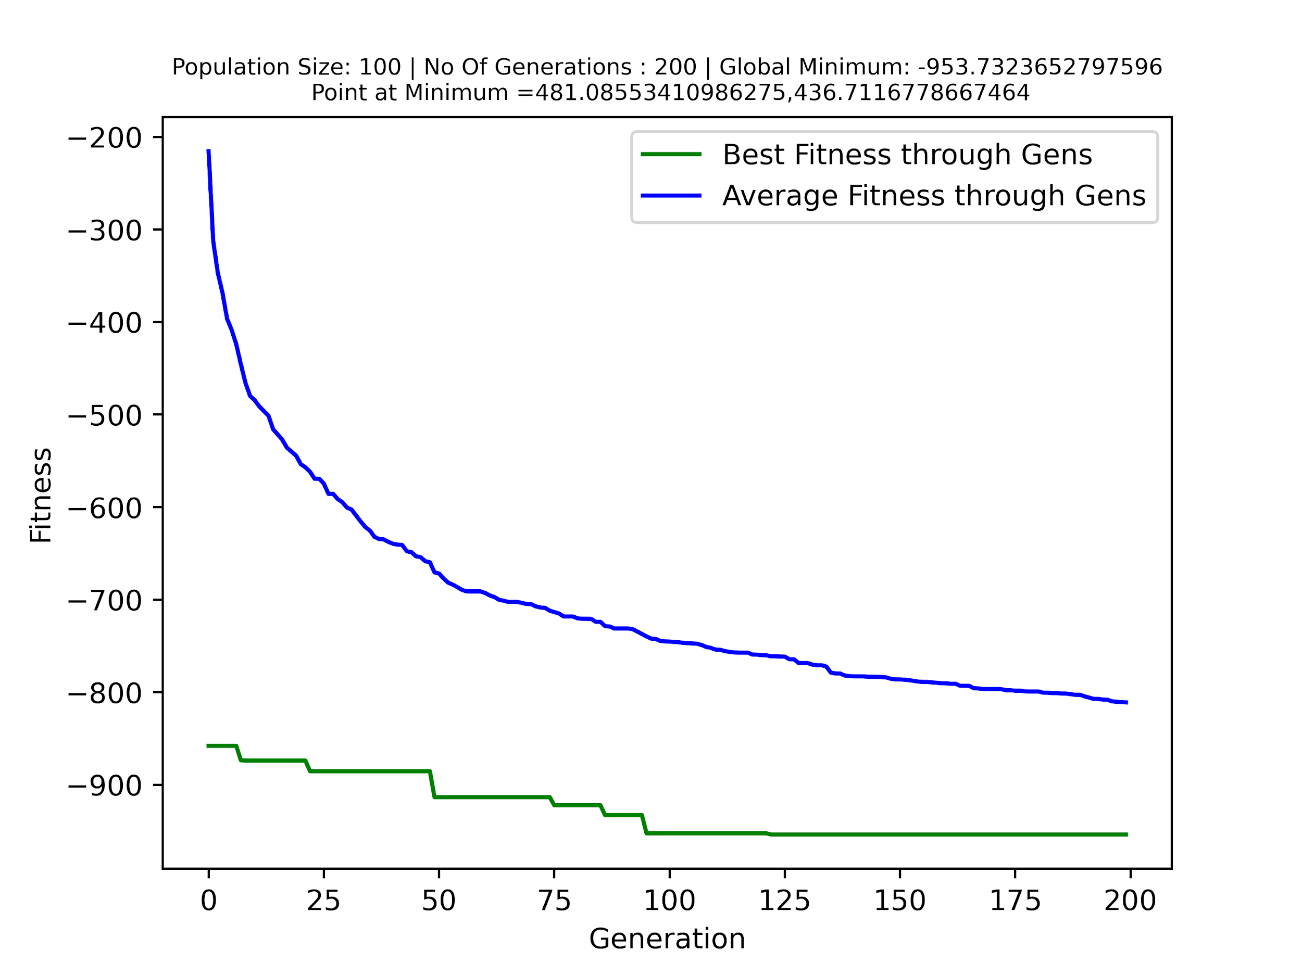

**Population Size** - 200 - **Generations** - 200

Optimised Solution -

Global Minimum (Found by DE) => -953.62464

Point at Minimum (Found by DE) =>

x = 510.36000

y = 402.91080

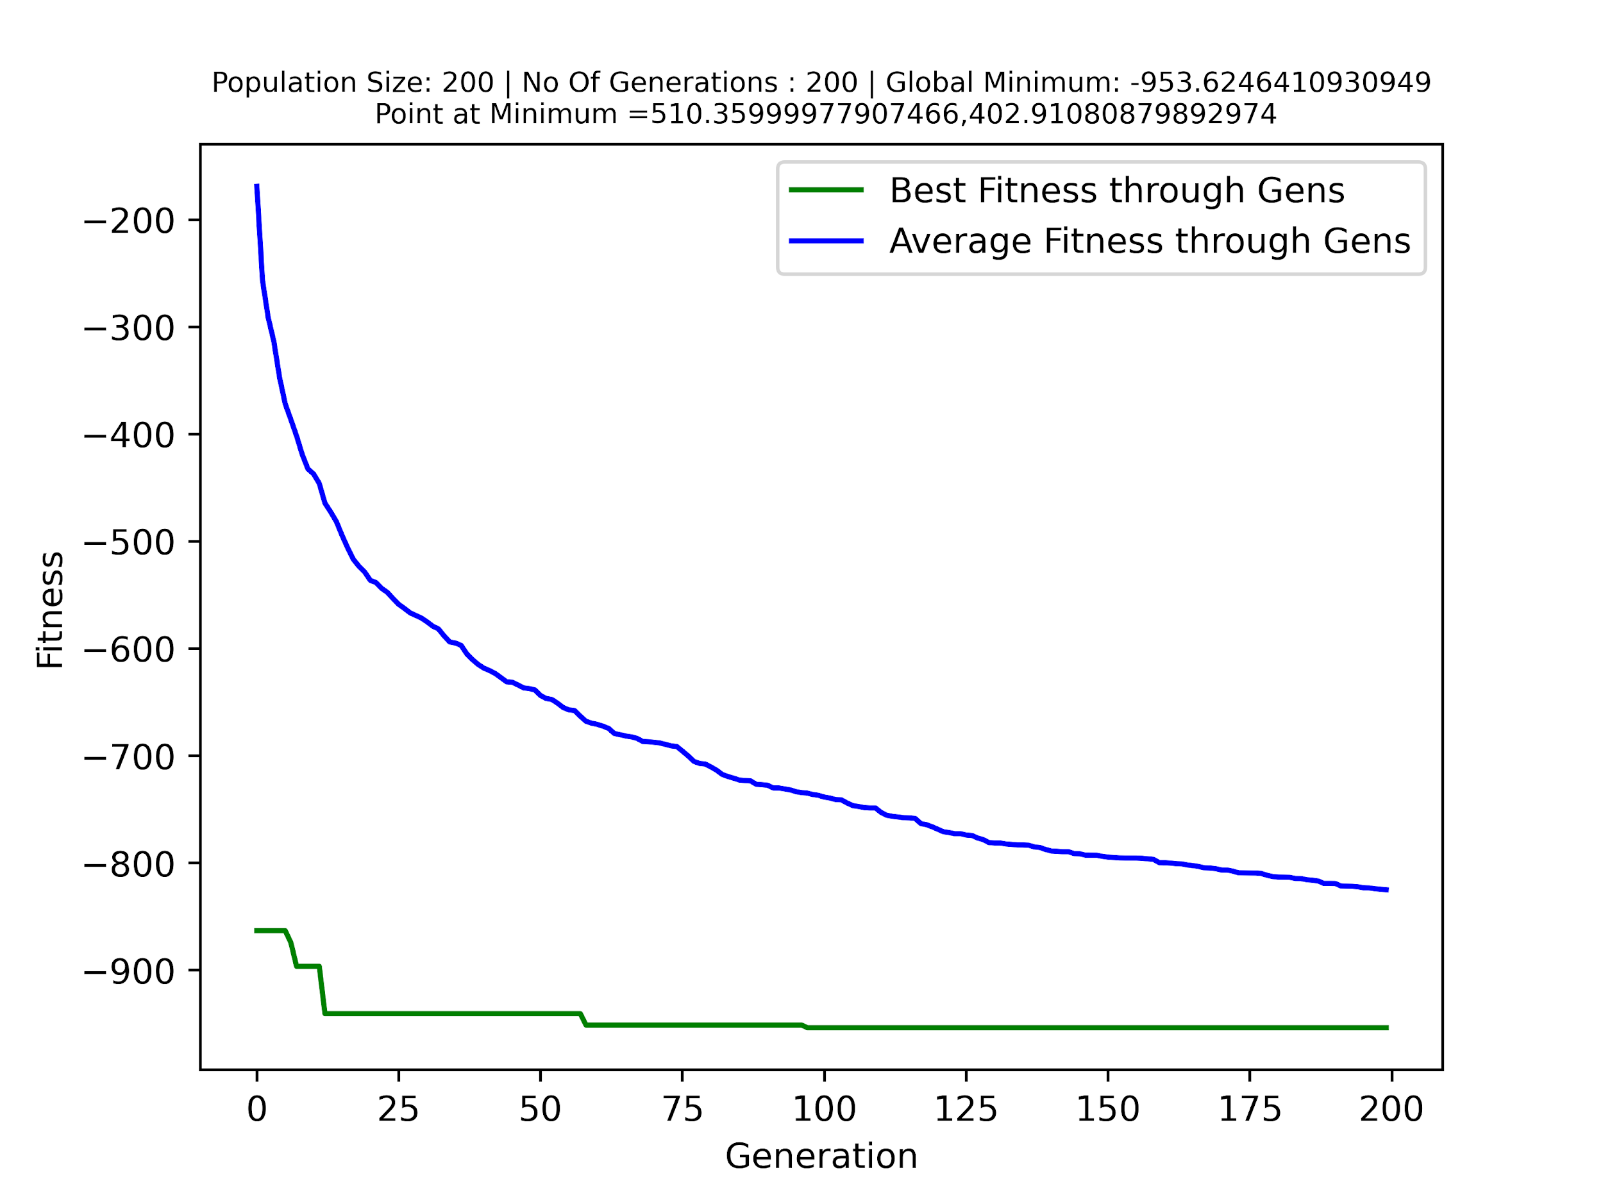

**Holder Table Function - Plot Data**

**Correct Solution for Egg Holder Function-**

**Global Minimum => -19.2085**

**Point at Minimum =>**

**x1 = -8.05502**

**y1 = 9.66459**

**x2 = 8.05502**

**y2 = 9.66459**

**x3 = -8.05502**

**y3 = -9.66459**

**x4 = 8.05502**

**y4 = -9.66459**

**Population Size** - 20 - **Generations** - 200

Optimised Solution -

Global Minimum (Found by DE) => -19.20850

Point at Minimum (Found by DE) =>

x = -8.05503

y = 9.66462

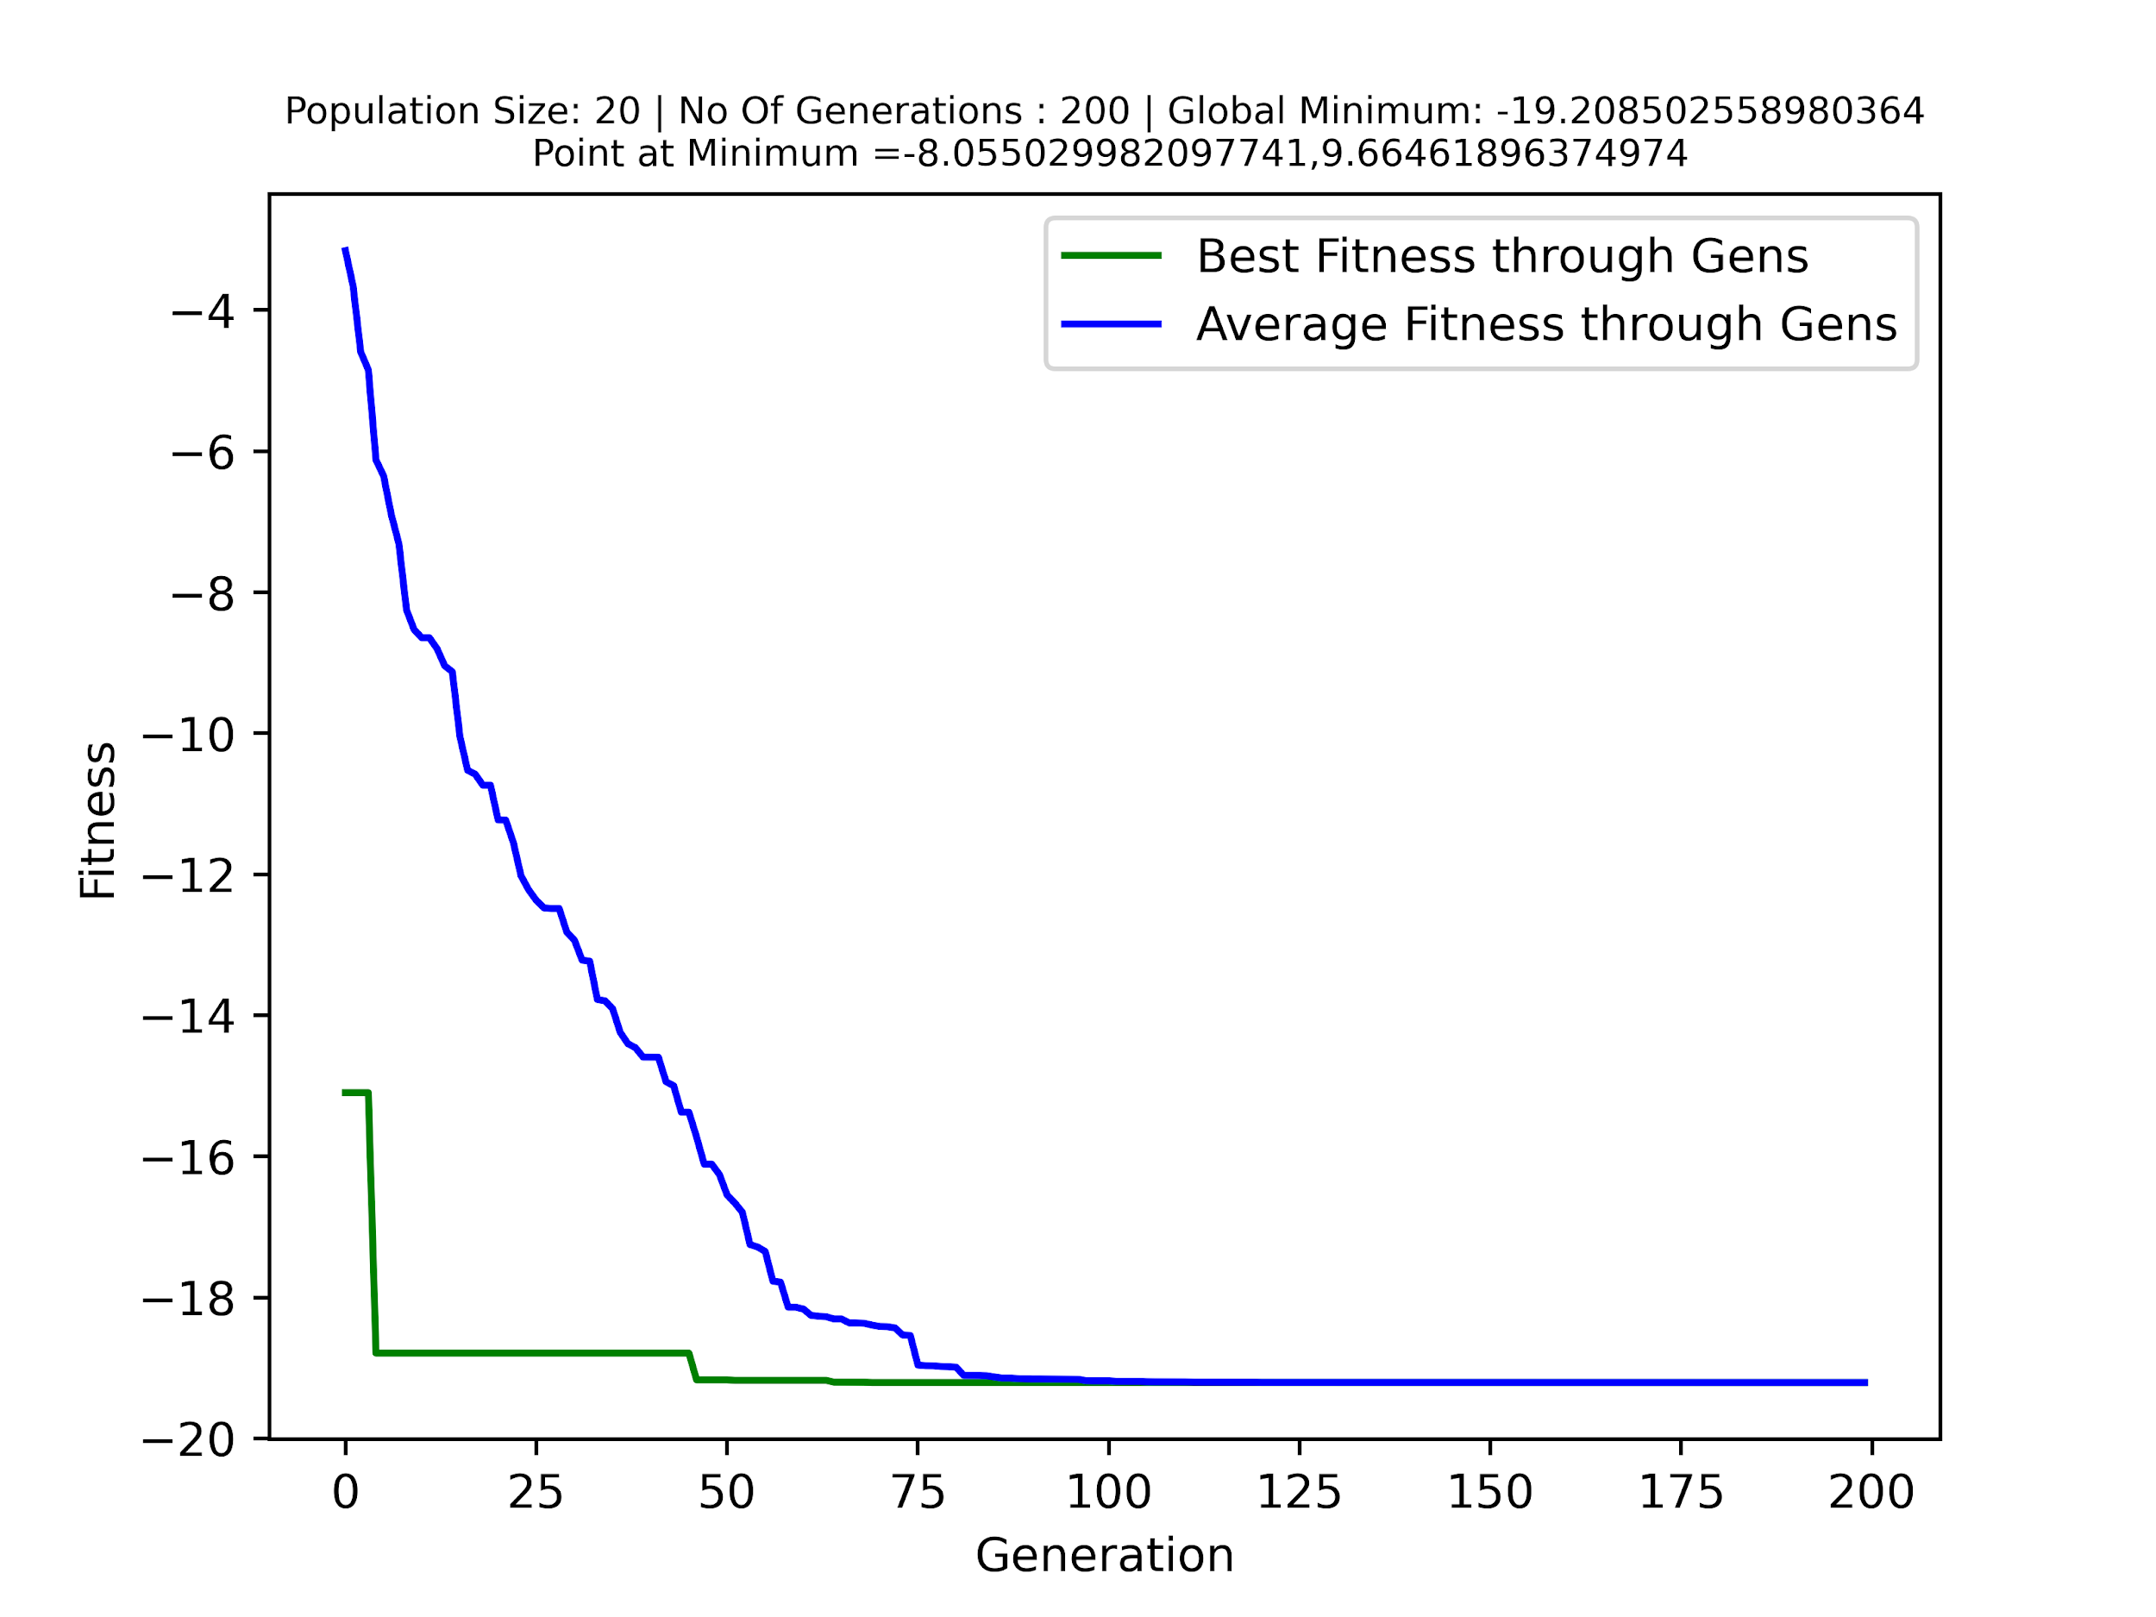

**Population Size** - 50 - **Generations** - 200

Optimised Solution -

Global Minimum (Found by DE) => -19.20850

Point at Minimum (Found by DE) =>

x = 8.05508

y = -9.66452

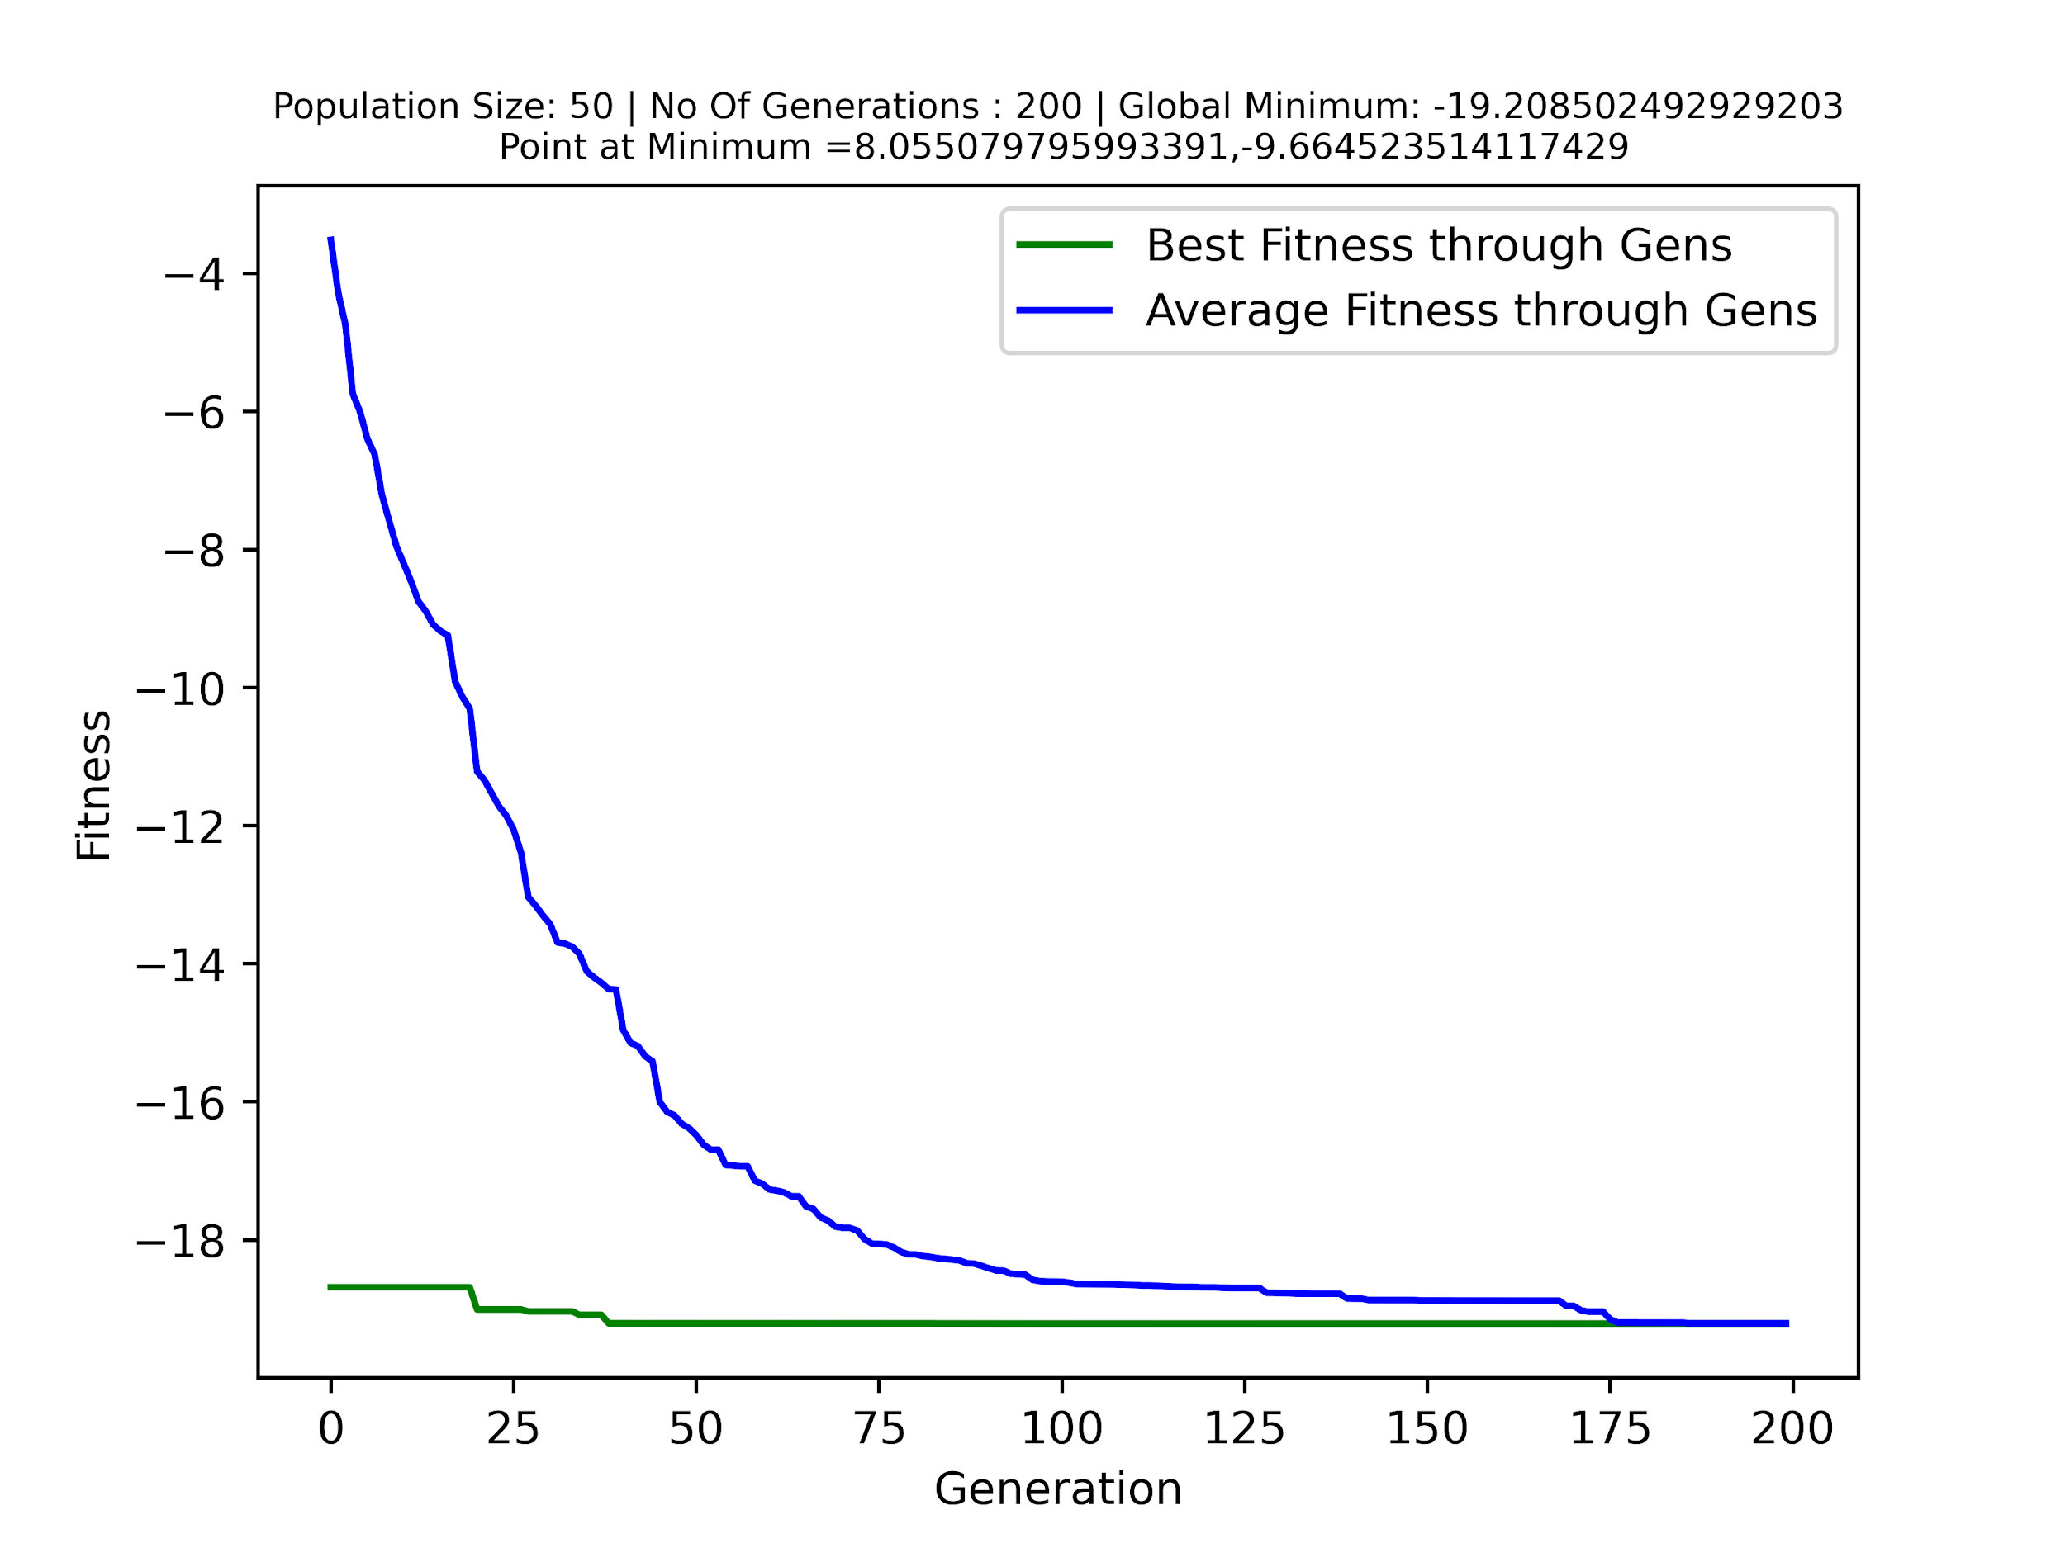

**Population Size** - 100 - **Generations** - 200

Optimised Solution -

Global Minimum (Found by DE) => -19.20850

Point at Minimum (Found by DE) =>

x = -8.05511

y = 9.66470

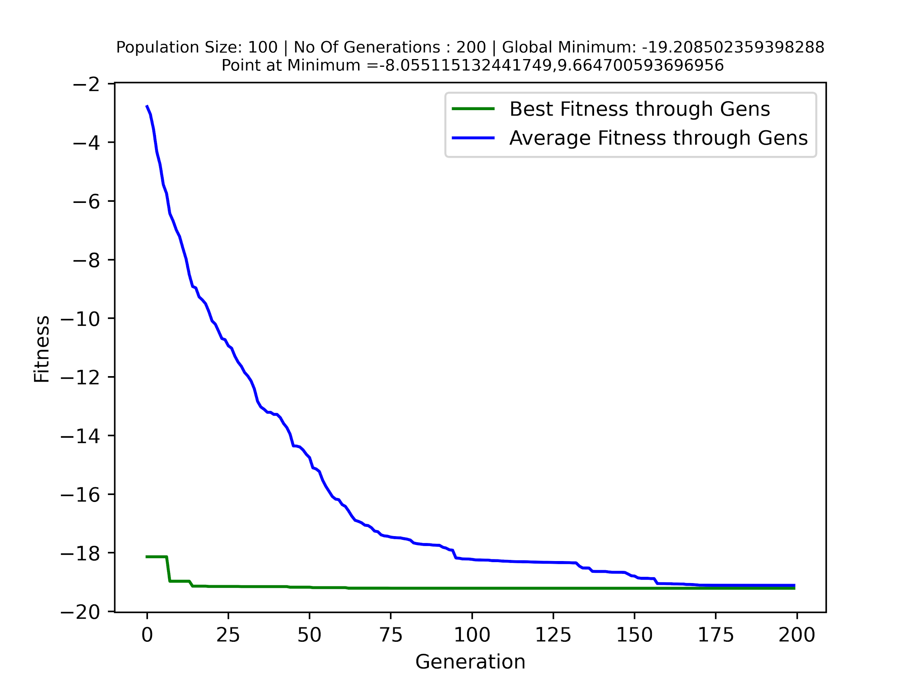

**Population Size** - 200 - **Generations** - 200

Optimised Solution -

Global Minimum (Found by DE) => -19.20850

Point at Minimum (Found by DE) =>

x = -8.05506

y = -9.66461

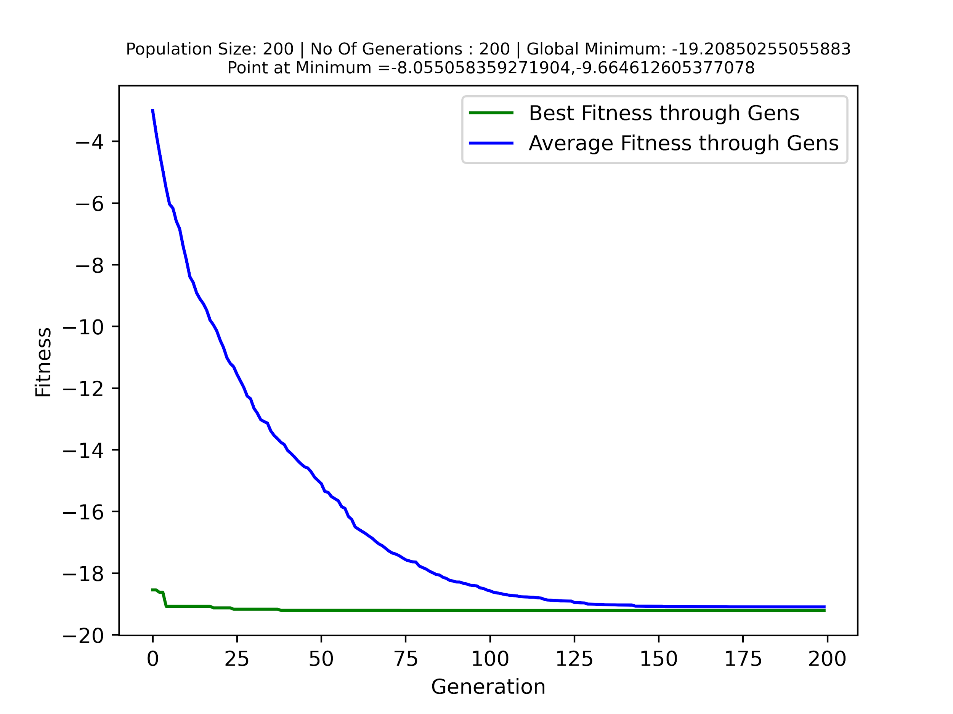

**Observations-**

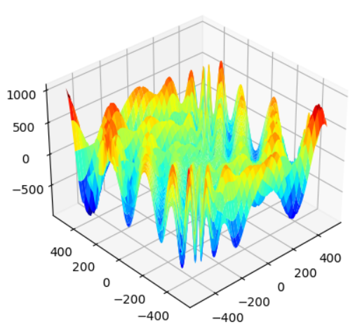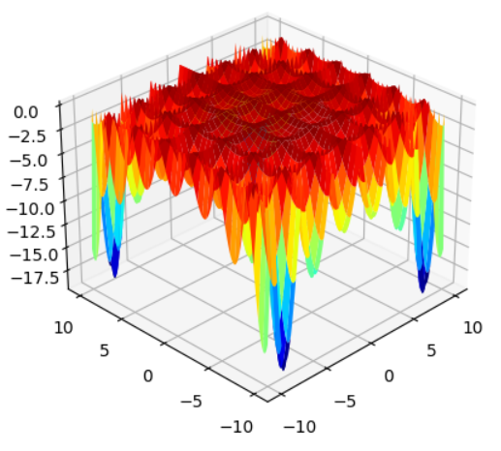

* For both functions for the given population sizes, the holder table has fewer local minimums near the global minimums but the egg holder function has a lot of local minimums which are very close to the global minimum so when a lower population size or lower no of generations is taken, it might not converge everytime. To look at this I plotted the graph for 500 population size and 500 generations, which had a really improved result.
  + For 500 population, 500 generations -
    - Global Minimum => -957.77316
    - Points at Minimum => x = 511.495

y = 403.4595

At 500,500

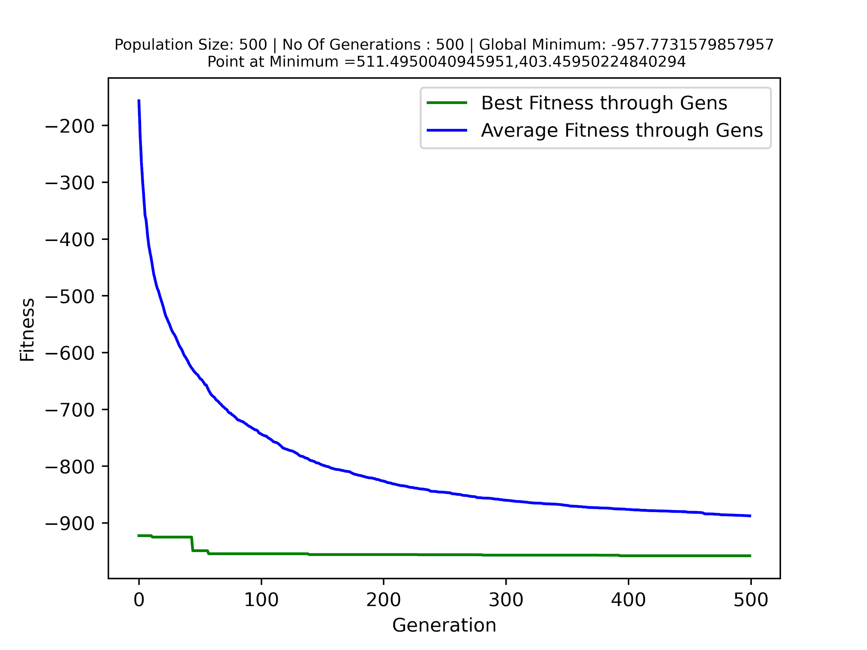

* So, With a lot of local minimums closer to the global minimum, it makes it harder for the egg holder function to converge
* When looking at the trends, they have similar trends as both converge to their global minimum as we increase the population size and generation size but as said before egg holder function is a lot harder to converge than the holder table function.