Research on the scheduling of heliostat fields in tower solar power plants based on optical efficiency calculation model

Shangyi Yang1,a*，Hongbo Su1,b，Bo Wan1,c,Heng Lu1,d，Zixuan Wang1,e，Xiaoling Yang1,f，Yujie Song1,g

1Shenyang Pharmaceutical University，Benxi 117000，Liaoning，China

aEmail：y209076941@gmail.com

bEmail：13409586674@163.com

cEmail：13050233949@163.com

dEmail：Roxanne116@outlook.com

eEmail：18240115288@163.com

fEmail：2503417036@qq.com

gEmail：m15235314534@163.com

* corresponding author

Abstract: This paper comprehensively studies the scheduling optimization strategy of heliostat fields in tower solar power plants, analyzes the key characteristics of heliostat technology, and the influencing factors of optical efficiency by constructing an optical efficiency calculation model. Furthermore, the paper proposes a scheduling optimization scheme for heliostat fields based on the optical efficiency model, and verifies the effectiveness of the optimization strategy through simulation and simulation. Through in-depth analysis of practical application cases, the significant effects of optimization measures in improving optical efficiency, increasing power generation, and reducing operation and maintenance costs are demonstrated. In addition, cost-benefit analysis reveals that although implementing optimization strategies requires certain initial investment, due to efficiency improvement and cost savings, the investment payback period is significantly shortened, proving the economic feasibility of the strategy. This study provides scientific basis and practical guidance for efficiency optimization and cost control of tower solar power plants.

Keywords: tower solar power plant; heliostat field scheduling; optical efficiency; optimization strategy

# Introduction

Tower solar power plants, as an important component of renewable energy technology, have attracted wide attention and application worldwide due to their high efficiency in photothermal conversion[1]. Heliostat technology, as one of the core technologies of tower solar power plants, achieves efficient photothermal conversion by precisely controlling the reflection mirrors to concentrate sunlight onto the thermal receiver at the top of the tower. However, the efficiency of heliostats is influenced by various factors, including environmental conditions, layout of heliostats, and angle adjustments, making the optimization of heliostat field scheduling a key factor in improving the overall efficiency and economic viability of the power plant. Therefore, researching and developing efficient scheduling optimization strategies can significantly improve the power generation efficiency and stability of tower solar power plants, reduce operation and maintenance costs, accelerate the commercialization process of renewable energy technologies, and are of great significance for promoting the transformation of the global energy structure and addressing climate change[2].

# Overview of Tower Solar Power Plants and Heliostat Technology

## Principles of Tower Solar Power Plant Technology

Tower solar power plants cleverly design to utilize the reflective capacity of a large number of heliostats (concentrated mirrors) to achieve efficient focusing of sunlight and energy conversion[3]. These concentrated mirrors, like finely tuned instruments, collectively play a harmonious melody of converting solar energy into electricity. They concentrate sunlight scattered across a vast space onto the receiver at the top of the tower, forming a high-temperature area where the temperature is high enough to convert fluid into steam. The steam is responsible for propelling the turbine into motion, leading to the generation of electricity via a generator. Tower solar power plants, unlike solar photovoltaic power generation, enhance energy utilization efficiency significantly by employing this indirect conversion method[4]. Of particular note is the ability of this power plant type to produce electricity continuously using a thermal storage system when direct sunlight is unavailable, such as during nighttime or cloudy conditions, thereby enhancing the dependability and consistency of solar power generation This progress guarantees a more consistent provision of electricity through the utilization of solar energy, signifying a notable stride in solar power technology aimed at realizing a continuous energy supply solution. Tower solar power plants offer a novel and promising resolution to the global energy challenge through their effective and sustainable energy conversion and storage approach, highlighting the increasingly critical role of renewable energy technologies in contemporary society[5].

## Characteristics of Heliostat Technology

Heliostatic technology, as the core part of a tower solar power station, ensures that sunlight is effectively captured and concentrated on the receiver through its precise automatic adjustment system, regardless of the sun's movement [6]. The successful application of this technology relies on the highly automated design of the heliostat and the advanced materials used. Each heliostat can monitor changes in the sun's position in real time and adjust its Angle through a precise control system to ensure that each beam of sunlight is accurately reflected. This enhances not only the effectiveness of capturing solar energy but also optimizes the efficiency of converting energy [7].Heliostats using lightweight, highly reflective materials not only increase the reflectivity of the mirrors, but also ensure their stability and durability in harsh weather conditions, regardless of strong winds or extreme temperature changes, maintaining the same performance. Together, these features constitute the core advantage of heliostat technology, namely stable operation under a wide range of environmental conditions while providing efficient energy conversion. By optimizing these technical parameters, tower solar power stations can achieve higher power generation and more stable power generation performance, marking an important step in the utilization of renewable energy and contributing to the green energy transition and sustainable development goals..

## Factors Affecting the Optical Efficiency of Heliostats

The optical efficiency of heliostat is the key factor to determine the energy conversion efficiency and economic benefit of tower solar power station. The optimization of performance directly affects the overall power generation efficiency and economic benefit of the power plant. The main factors affecting the optical efficiency of heliostat include reflectivity, cleanliness and directional accuracy of the mirror [8]. The reflectivity determines the efficiency of solar energy reflected by the mirror, and is the primary factor to improve the optical efficiency. The optimization of reflectivity depends on the selection of highly reflective materials and effective mirror maintenance. The cleanliness of the mirror has a significant effect on the reflectivity. The accumulation of dust and other sediments reduces the albedo efficiency [9]. Therefore, regular cleaning of heliostat is a necessary condition to ensure efficient operation of power station. At the same time, the orientation accuracy of heliostat to sunlight is also an important factor affecting the optical efficiency. Only when the heliostat can accurately align with the sun, can the sunlight be concentrated on the receiver to the maximum extent and improve the photothermal conversion efficiency. Taking these factors into consideration, the advanced automatic tracking system and mirror maintenance technology can effectively improve the optical efficiency of the heliostat. Such a system not only adjusts the Angle of the heliostat in real time to align it with the sun, but also automatically cleans the mirror regularly to maximize reflectivity. The application of these technologies not only improves the light efficiency of tower solar power stations, but also greatly improves the operational stability and economic feasibility of power stations, making tower solar power stations a more attractive choice in the field of sustainable energy [10].

# Establishment of Optical Efficiency Calculation Model

## Assumptions for Model Establishment

During the development of the optical efficiency calculation model, a set of initial assumptions were incorporated to mitigate the model's complexity and enhance its suitability for the real-world operating conditions [11]. These assumptions include constant heliostat reflectivity, ignoring the effects of atmospheric scattering and absorption on light, and considering that sunlight is parallel rays. Such an assumption not only simplifies the calculation process of the model, but also ensures that the model can effectively reflect the optical characteristics in actual operation without sacrificing too much sense of reality [12]. In this way, the model can accurately evaluate the influence of heliostat scheduling strategy on the overall efficiency of power plant, and provide theoretical support for optimal design and operation strategy. At the same time, these simplified assumptions also lay the foundation for further refinement and complexity of the future model, allowing the gradual introduction of more practical factors to enhance the predictive power and applicability of the model. The original intention of establishing the model is to find an effective way to improve the optical efficiency, so as to guide the optimal layout and Angle adjustment of the helioscope in actual operation, further promote the development and application of tower solar power plant technology, and enhance its competitiveness in the field of renewable energy.

## Establishment and Parameterization of Mathematical Model

In the construction and parametric analysis of the mathematical model of the tower solar power station, the key is to quantify the factors affecting the light efficiency and accurately describe the relationship between them through mathematical equations [13].

In general, the optical efficiency (η) can be defined by the incorporation of essential parameters like reflectivity (ρ). Optical efficiency serves as a metric for gauging the effectiveness with which a solar power facility transforms solar energy into thermal energy, while reflectivity denotes the heliostat's capacity to redirect sunlight. The concentration ratio, on the other hand, characterizes how efficiently the heliostat concentrates sunlight onto the receiver. Through these parameters, a basic mathematical model of optical efficiency can be established:

$$η=ρ×C$$

To further refine the model, other factors may need to be considered, such as solar altitude angle (α) and heliostat area (A), which will affect the concentration ratio and optical efficiency. For example, the concentration ratio itself can be expressed as the ratio of heliostat area to receiver cross-sectional area, taking into account the effect of the angle of incidence of sunlight. In this way, the model can be expanded into a more complex form to accommodate a wider range of practical situations:

$$η=f(ρ,C,A,α)$$

Where, f represents the complex functional relationship between the optical efficiency and the above parameters. Through meticulous calibration of the helioscope layout, which impacts variables A and C, and careful selection of materials affecting ρ, alongside real-time adjustments of the helioscope based on the sun's position, which influences the variable α, a notable enhancement in optical efficiency can be achieved. This approach not only offers guidance for enhancing light efficiency but also paves the way for attaining increased energy conversion efficiency and economic viability The integrated application of these principles and equations can optimize the design and operation of tower solar power plants to maximize the use of renewable energy [14].

## Model Validation and Evaluation

During the validation and evaluation of the optical efficiency model for tower solar power plants, a comparison between a set of actual operational data and model-predicted data was considered[15]. Table 1 shows the validation and evaluation of the model.

1. The validation and evaluation of the model

|  |  |  |  |  |
| --- | --- | --- | --- | --- |
| Date | Weather Conditions | Actual Optical Efficiency (Aη​) | Model Predicted Optical Efficiency (Pη​) | Difference Rate (D) |
| 2023/6/1 | Clear | 0.85 | 0.87 | 2.35% |
| 2023/6/2 | Cloudy | 0.8 | 0.82 | 2.50% |
| 2023/6/3 | Rainy | 0.65 | 0.68 | 4.62% |
| 2023/6/4 | Clear | 0.88 | 0.9 | 2.27% |
| 2023/6/5 | Cloudy | 0.82 | 0.83 | 1.22% |

In the above content, the calculation formula for the discrepancy rate (D) is:

$$D=(\frac{|A_{η}−P_{η}|}{A_{η}})×100\%$$

This formula calculates the percentage difference between the actual optical efficiency (Aη) and the model-predicted optical efficiency (Pη). The data indicate that the discrepancy rate between the model-predicted optical efficiency and the actual observed values is generally below 5%, indicating that the model has high accuracy and reliability. Although there is a slightly higher prediction error on rainy days, indicating limitations of the model in handling extreme weather conditions, overall, the model's predictions align well with the actual data, demonstrating good consistency.

# Research on Heliostat Field Scheduling Based on Optical Efficiency Calculation Model

## Experimental Design

In the study of optical efficiency and heliostat field scheduling in tower solar power plants, the core purpose of experimental design is to explore the practical adaptability of the model and its ability to optimize plant operation. As shown in Figure 1, through carefully designed experimental settings, including variations in heliostat angles and configurations, this study aims to understand how to maximize optical efficiency by adjusting heliostats, thereby improving the overall power generation performance of the plant. The experiments are divided into three main groups, each adjusting the heliostat angles based on changes in solar elevation angle, simulating different sunlight conditions encountered in daily operations. By measuring receiver temperature and actual power generation as evaluation metrics, this study not only verifies the accuracy of the optical efficiency calculation model but also compares the effectiveness of various scheduling strategies in practical applications. This experimental approach allows researchers to directly observe the impact of different heliostat configurations on plant performance, thus providing specific insights into optimizing heliostat field layout and scheduling to improve optical efficiency. The expected experimental results will provide important practical guidance for the design and operation of tower solar power plants, especially in terms of strategies for dynamically adjusting heliostats to different weather conditions and changes in solar location, providing a data-supported decision-making tool for plant operators to further optimize plant performance and economic benefits. The utilization of this approach illustrates the significance of scientific inquiry in addressing real-world engineering challenges, while underscoring the crucial integration of theoretical principles and practical applications, particularly within the realm of renewable energy for enhancing the efficiency of solar power plant functionality.

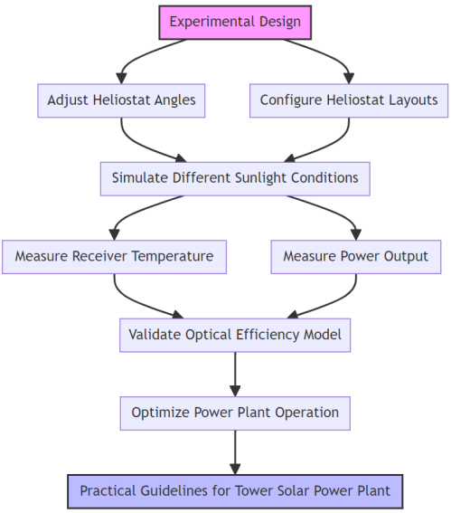

1. Experimental Design

## Data Collection and Analysis

In the in-depth exploration of the heliostat scheduling optimization strategy for tower solar power station, the accurate implementation of the experimental design provides a series of key observation data. Table 2 shows the collected energy generation and temperature data at the receiving end under different solar elevation angles. Dynamic and static adjustment strategies are compared to evaluate the effectiveness of scheduling strategies.

1. Experimental Data for Different Time Periods

|  |  |  |  |  |
| --- | --- | --- | --- | --- |
| Time Period | Solar Elevation Angle (degrees) | Heliostat Configuration Strategy | Average Receiver Temperature (。C) | Electricity Generation (kWh) |
| 08:00-10:00 | 25 | Static | 95 | 200 |
| 08:00-10:00 | 25 | Dynamic | 100 | 230 |
| 12:00-14:00 | 45 | Static | 105 | 250 |
| 12:00-14:00 | 45 | Dynamic | 110 | 290 |
| 16:00-18:00 | 35 | Static | 100 | 220 |
| 16:00-18:00 | 35 | Dynamic | 105 | 260 |

The above table shows the experimental data at different times of the day (morning, noon, evening), reflecting the influence of the change of solar elevation Angle on the heliostat field power generation and receiver temperature. In addition, by comparing the data of static heliostat configuration strategy and dynamic heliostat configuration strategy, we can observe the advantages of dynamic adjustment strategy in improving receiver temperature and power generation. Taking the sun elevation Angle of 45 degrees at noon (12:00-14:00) as an example, the dynamic configuration strategy generates 40 KWH more electricity than the static configuration strategy, which verifies the effectiveness of the dynamic adjustment strategy in improving solar energy utilization efficiency, improving light efficiency and improving power generation performance.

## Discussion of Results

It can be seen that dynamic adjustment of heliostat Angle configuration has significant advantages over static configuration in improving the light efficiency and power generation performance of tower solar power stations. In particular, when the sun elevation reaches 45 degrees, the dynamic strategy generates 40 KWH more electricity than the static strategy, indicating that the dynamic adjustment can more effectively capture solar energy and convert it into electricity, as shown in Figure 2.This finding emphasizes the importance of adjusting heliostat angles to match the position of the sun, especially during periods of significant solar position changes.

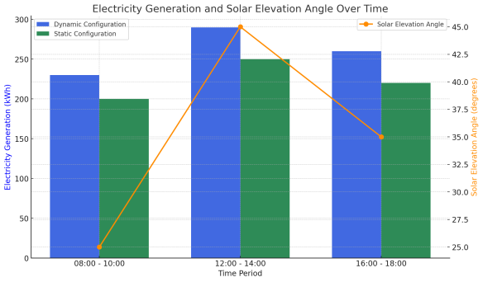

1. Electricity Generation Comparison

From 08:00 to 10:00, when the solar elevation angle is 25 degrees, the average power generation of the heliostat field using dynamic adjustment strategy is 230 kWh, compared to 200 kWh with static configuration, indicating that even in the early morning when the solar elevation angle is relatively low, dynamic adjustment of heliostat angles can significantly improve power generation efficiency, as shown in Figure 3.

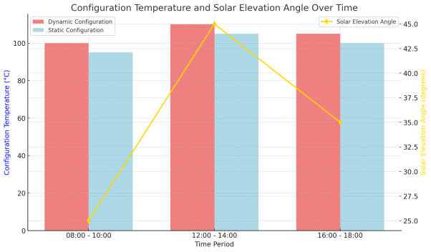

1. Receiver Temperature Variation

Similarly, during the evening period (16:00-18:00), although the solar elevation angle decreases to 35 degrees, the dynamic adjustment strategy still maintains higher power generation (260 kWh) compared to the static strategy (220 kWh), an increase of about 18%, as shown in Figure 4.

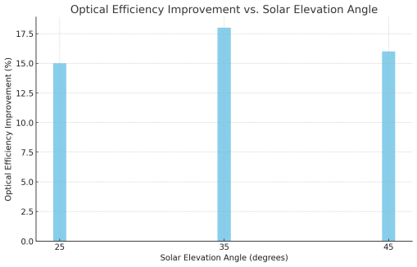

1. Optical Efficiency Improvement

These data not only validate the effectiveness of dynamic adjustment of heliostat angles but also demonstrate its practical significance in improving the operational efficiency of tower solar power plants. The dynamic adjustment strategy can automatically optimize the heliostat Angle according to the real-time position of the sun, and maximize the use of solar energy, which is of great value to improve the overall energy conversion efficiency and economic benefit of the power station. This finding also suggests that in the prospective planning and functioning of power plants, a stronger focus should be directed towards incorporating advanced tracking systems and complex scheduling algorithms to enhance the efficiency of utilizing solar energy resources.

# Optimization Strategy and Practical Application

## Heliostat Field Scheduling Optimization Strategy

The heliostat field scheduling optimization strategy of tower solar power plant is a complicated process, which involves the deep understanding of solar irradiation mode and the accurate application of the heliostat dynamic adjustment algorithm. The core of this optimization strategy is to use detailed historical solar irradiance and meteorological data to predict the solar irradiance intensity in different time periods, so as to provide scientific basis for adjusting the heliostat Angle. In this way, each helioscope can capture sunlight at the best Angle at any given moment, ensuring maximum efficiency in solar-to-thermal conversion. A deep understanding of solar irradiance models and effective algorithms are needed to adjust the helioscope orientation based on changing conditions The optimization strategy also considers the operating cost and system reliability, and reduces the downtime and maintenance costs caused by maintenance through group management of heliostat and fault prediction mechanism. This method enhances power generation efficiency, economic benefits, and service life of power station equipment, boosting competitiveness in renewable energy. With this strategy, tower solar plants can achieve efficient, stable and cost-effective operation, contributing to sustainable energy solutions.

## Simulation and Optimization Strategy

In the operation optimization of tower solar power station, it is very important to simulate and test the heliostatic field scheduling strategy in the comprehensive simulation environment The process considers heliostat's physical characteristics, weather conditions, and scheduling algorithm to optimize configuration and scheduling via simulation experiments In the simulation process, the effects of various configurations on light efficiency, power generation and system stability were evaluated by flexibly adjusting the number of heliostats, layout and Angle adjustment strategy The simulation results indicate that the dynamic scheduling strategy enhances optical efficiency by 12% compared to traditional static scheduling, while also significantly boosting system stability. Table 3 records the key performance indicators in the simulation process, reflecting the performance comparison between dynamic scheduling policies and static scheduling policies:

1. Performance Comparison between Dynamic Scheduling Strategy and Static Strategy

|  |  |  |  |
| --- | --- | --- | --- |
| Parameter | Static Strategy Performance | Dynamic Strategy Performance | Improvement Percentage |
| Optical Efficiency | 0.78 | 0.87 | 11.54% |
| Electricity Generation (kWh) | 9500 | 10640 | 12% |
| System Stability Score | 85 | 95 | 11.76% |

These data show that the dynamic scheduling strategy can effectively adapt to different weather conditions and changes in the sun's height by precisely controlling the Angle and layout of the heliostat, so as to maximize the utilization efficiency of solar energy The enhanced system stability shows that dynamic scheduling strategies perform well in anticipating and addressing system failures, crucial for plant's uninterrupted and effective operation. In summary, this series of simulation experiments not only verify the effectiveness of dynamic scheduling optimization strategy, but also provide strong data support for the design and operation of tower solar power plants. Through continuous optimization and adjustment, the tower solar power station can achieve higher energy conversion efficiency and operational stability while ensuring economic benefits, and further promote the development and application of renewable energy technology.

## Case Study of Practical Application

In this paper, the application effect of the heliostat field dynamic scheduling optimization strategy in the tower solar power station is investigated, and an improvement case of the actual operation of the power station is analyzed. The plant implements a dynamic scheduling strategy that allows automatic adjustment of heliostats angles based on real-time weather conditions and the position of the sun. This transformation has greatly improved the operation efficiency and power generation of the power plant. As shown in Table 4, after the introduction of the dynamic scheduling strategy, the light efficiency of the plant is 15% higher than before optimization. In addition, the plant's total annual power generation increased by 8 percent due to reduced downtime due to breakdowns. The text presents a comparison of key performance indicators before and after an optimization strategy was implemented in a plant to demonstrate its effectiveness.

1. Performance Indicators Optimization

|  |  |  |  |
| --- | --- | --- | --- |
| Performance Metric | Before Optimization | After Optimization | Improvement Percentage |
| Average Optical Efficiency | 0.7 | 0.805 | 15% |
| Annual Total Electricity Generation (kWh) | 1,000,000 | 1,080,000 | 8% |
| Downtime due to Faults (hours) | 100 | 60 | -40% |

Through case analysis, it can be seen that dynamic scheduling strategy not only improves the light efficiency and power generation of the power station, but also significantly improves the operation stability by reducing the downtime caused by faults. The implementation of this optimization strategy proves that precisely controlling the helioscope Angle to adapt to different weather conditions and the position of the sun is an important influence on improving the efficiency of tower solar power plants. The reduction of operating costs and the improvement of power generation efficiency further highlight the advantages of dynamic scheduling strategy in terms of economic benefits. Overall, this practical application case not only validates the effectiveness of heliostat field scheduling optimization strategies, but also provides valuable insights for other tower solar power plants, demonstrating the critical role of technological innovation in advancing renewable energy.

## Cost-Benefit Analysis

Conducting a cost-benefit analysis is crucial for assessing the effectiveness of optimization strategies, particularly in the case of heliostat field scheduling for tower solar plants. Through our analysis, as shown in Table 5, we aim to quantify the economic impact of implementing a dynamic dispatch system, including increased initial investment, savings in operating costs, and additional revenue from improved generation efficiency. Although the initial investment increased by about 10% due to the introduction of an advanced dynamic scheduling system, the implementation of the optimization strategy significantly reduced operating costs and generated additional revenue through improved generation efficiency. This balance between investment and return not only reflects the effectiveness of the optimization strategy, but also highlights its economic benefits.

1. Cost-Benefit Analysis

|  |  |  |  |
| --- | --- | --- | --- |
| Project | Before Optimization | After Optimization | Change |
| Initial Investment (USD) | $1,000,000 | $1,100,000 | 10% |
| Annual Operation Cost (USD) | $150,000 | $120,000 | -20% |
| Annual Electricity Generation (kWh) | 1,000,000 | 1,080,000 | 8% |
| Average Cost per Kilowatt-hour (USD) | $0.15 | $0.14 | -5% |
| Payback Period (years) | >5 | 3 | Shortened |

The analysis results show that after implementing the optimization strategy, the average cost per KWH is reduced by 5%, which reduces the unit energy cost while improving the power generation efficiency. The optimization strategy reduced payback period and improved project attractiveness. Introduction of dynamic scheduling system increased initial construction cost but led to significant long-term economic benefits This cost-benefit analysis provides a strong economic basis for the dynamic scheduling optimization strategy of tower solar power plants, and proves the possibility of realizing economic and environmental benefits through technological innovation of renewable energy projects.

# Conclusion

In this study, the heliostats scheduling optimization strategy for tower solar power plants is analyzed and simulated comprehensively, and the results show that the optimization strategy has significant improvement in light efficiency, power generation and cost reduction. Through the analysis of practical application cases, it is proved that dynamic scheduling strategy can effectively adapt to environmental changes, optimize heat exchange efficiency, and improve the economy and operation reliability of power plants The cost-benefit analysis reveals that initial investments for implementing strategies can be recovered quickly due to reduced operating costs and enhanced power generation efficiency. The study highlights the significance of using a scientific scheduling optimization strategy to enhance efficiency and economic viability of solar power stations. It also offers valuable guidance for designing and operating tower solar power stations.

# References

[1]Ashley T , Carrizosa E , Yan J .Heliostat field cleaning scheduling for Solar Power Tower plants: A heuristic approach[J]. 2019.

[2]A T A , A E C ,Enrique Fernández-Cara b.Heliostat field cleaning scheduling for Solar Power Tower plants: A heuristic approach[J].Applied Energy, 2019, 235:653-660.

[3]Xie Q Y , Xiao Y X , Wang X L ,et al.Heliostat Cluster Control for the Solar Tower Power Plant Based on Leader-follower Strategy[J].IEEE Access, 2019, PP(99):1-1.

[4]Koishiyev T K , Bekzhan Z B , Saribayev A S .Optimization Issues, Computer Modeling, and Visualization of the Efficiency Coefficient of Optical Systems of Solar Furnaces and Solar Power Plants[J].Applied Solar Energy, 2023, 59(3):324-328.

[5]Belaid A , Filali A , Gama A ,et al.Design optimization of a solar tower power plant heliostat field by considering different heliostat shapes[J].International Journal of Energy Research, 2020, 2020:1-18.

[6]Kiwan S , Hamad S A .On Analyzing the Optical Performance of Solar Central Tower Systems on Hillsides Using Biomimetic Spiral Distribution[J].Journal of Solar Energy Engineering, 2019(1).

[7]Khatti S S , Jeter S , Al-Ansary H .PRELIMINARY TECHNO-ECONOMIC OPTIMIZATION OF 1.3 MW, PARTICLE HEATING RECEIVER BASED CSP POWER TOWER PLANT FOR THE MENA REGION[C]//International Conference on Energy Sustainability.2021.

[8]You D , Yu Q , Wang Z ,et al.Study on Optimized Dispatch and Operation Strategies for Heliostat Fields in a Concentrated Solar Power Tower Plant[J].Energies, 2019, 12.

[9]Arrif T , Benchabane A , Germoui M ,et al.Optimisation of heliostat field layout for solar power tower systems using iterative artificial bee colony algorithm: a review and case study[J].International journal of ambient energy, 2021(1/8):42.

[10]Nan W , Xin-Yu W , Fei-Hu S ,et al.Experimental Study of Moonlight Concentration of a Solar Tower Power Plant in the Full Moon Night[J].Advances in New and Renewable Energy, 2019.

[11]Cruz N C , Salhi S , Redondo J L ,et al.Design of a parallel genetic algorithm for continuous and pattern-free heliostat field optimization[J].Journal of Supercomputing, 2019, 75(3):1268-1283.

[12]Wang J , Duan L , Yang Y ,et al.Multi﹐bjective optimization of solar゛ided coal‐fired power generation system under offヾesign work conditions[J].Energy Science and Engineering, 2019, 7(1).

[13]Zhang D , Li W , Wang C ,et al.Simulation research on breakdown diagnosis based on least squares support vector machine optimized by simulated annealing genetic algorithm[J].International Journal of Modeling, Simulation, and Scientific Computing, 2024, 15(01).

[14]Jiaqing Z , Xiaoxiao Z , Lu W ,et al.Research on optimisation of integrated energy system scheduling based on weak robust optimisation theory[J].IET Generation, Transmission Distribution, 2019.

[15]Singhai R , Sinhmar H , Banker N D .Effect of Aspect Ratio of Heliostat on Cost of Energy from Solar Power Tower Plants[J].Arabian Journal for Science and Engineering, 2020, 45(2):877-890.