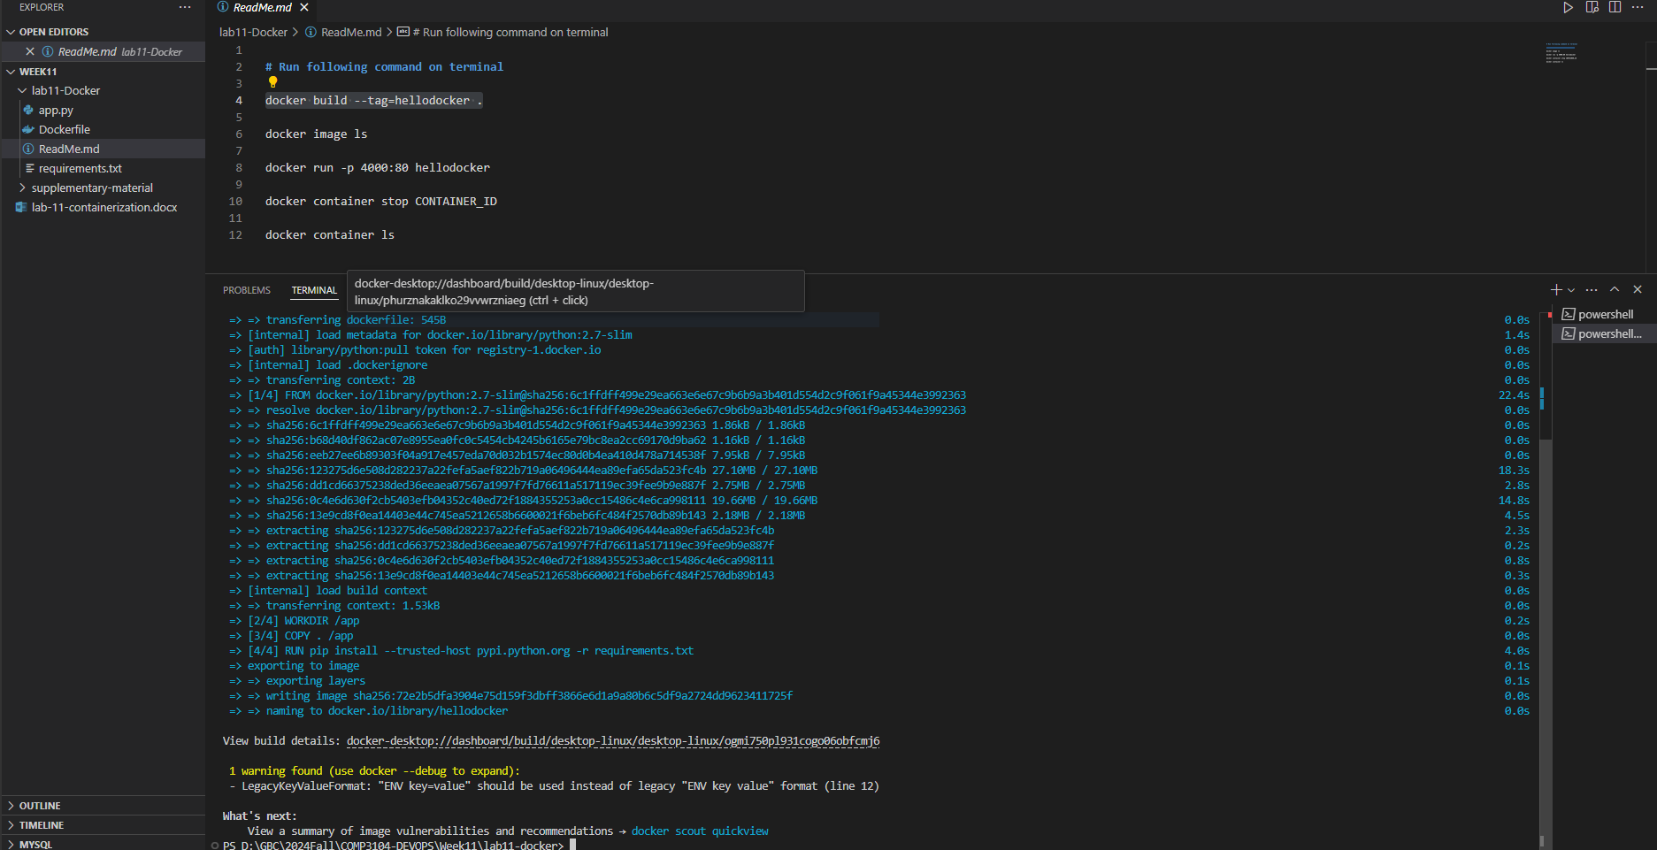

Figure

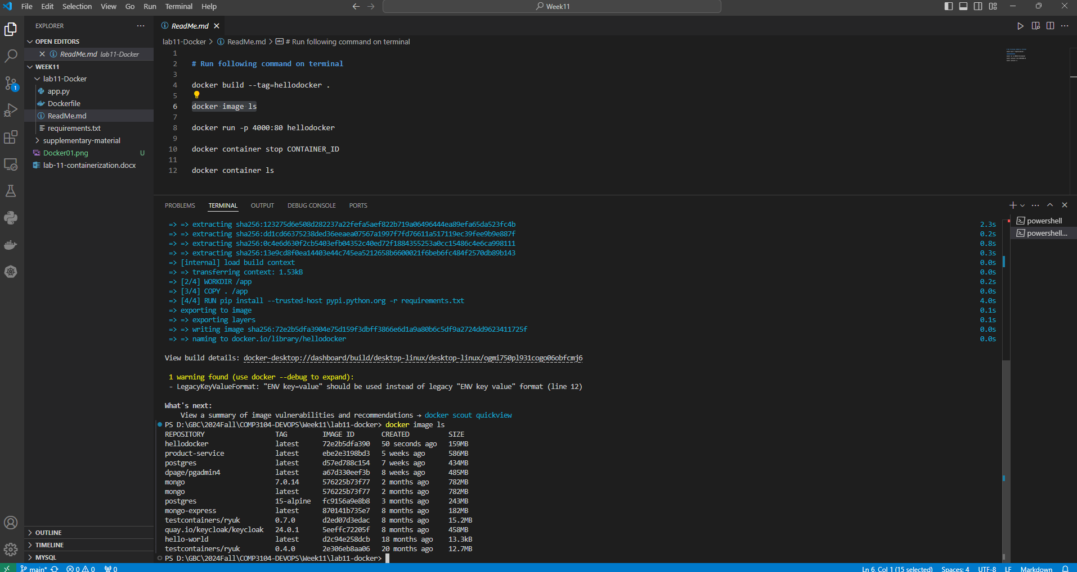

Figure

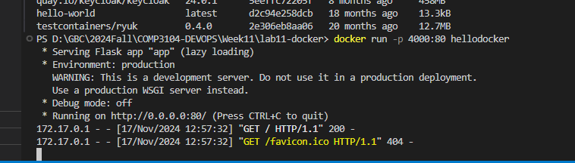

Figure

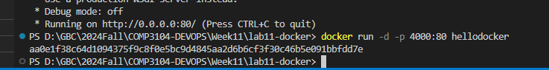

Figure

Figure

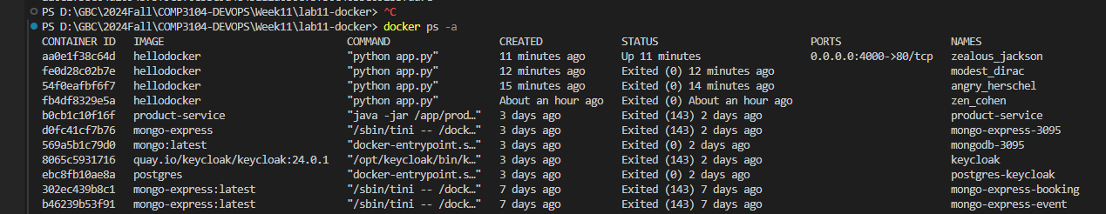

Figure



Figure



Figure