Figure

Figure

Figure

Figure

Figure

Figure

Figure

Figure

Figure

Figure

Figure

Figure

Figure

Figure

Figure

Figure

Figure MONGO

Figure POSTMAN

Figure Search

Figure Create

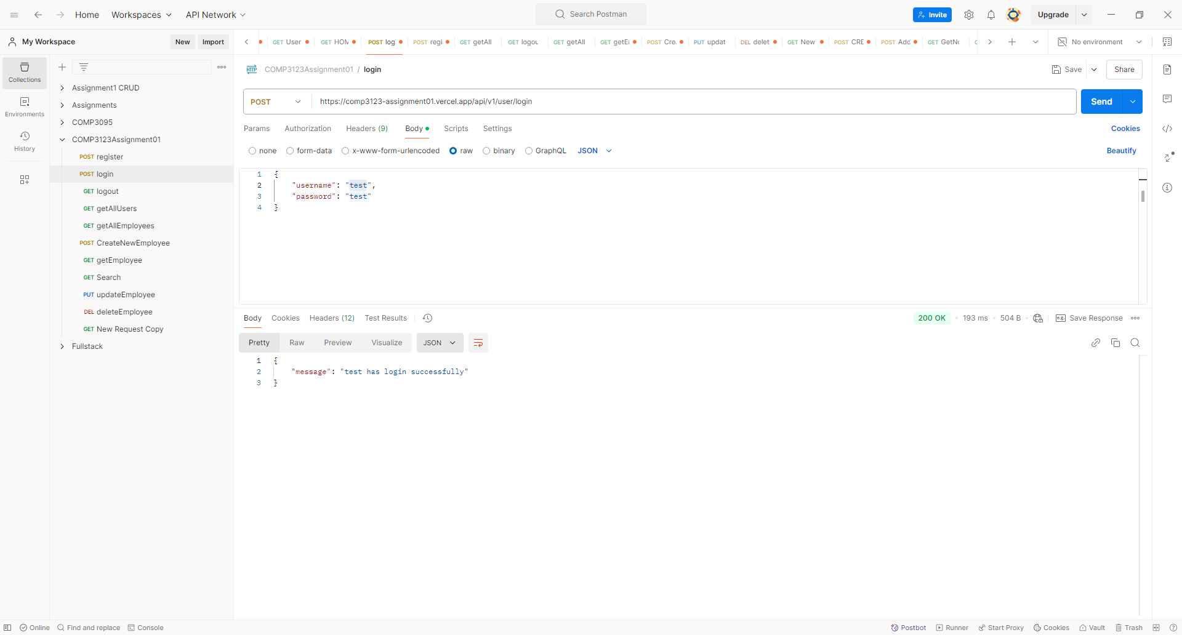

Figure login

Figure register