SOLUTION
IMPLEMENTATION PLAN
University Shortlisting Tool for Indian Master’s Applicants
A practical, evidence-first blueprint for discovering programs, validating eligibility, modelling affordability and ROI, and producing explainable shortlists.
Document version 1.0 — Proposed architecture
Prepared 17 October 2026
Product audience Indian students planning international Master’s study
Status Implementation blueprint — design decisions still to be validated
Design principle: every important recommendation should be explainable, traceable to evidence, and honest about uncertainty.

Document guide
This document consolidates the two supplied design documents — “Overall shortlisting tool structure” and “How to build the university database” — and extends them into an implementation plan. The proposed technology choices are recommendations, not constraints already approved by the project owner.
Section | What it covers
1. Executive summary | Product objective, solution principle and decisions that matter most.
2. Problem statement and success criteria | Users, jobs-to-be-done, five student pain areas and measurable quality gates.
3. Scope and release boundaries | MVP, next increments and non-goals.
4. Product features and requirements | Student journey, country/program search, eligibility, shortlist, affordability, ROI, quality, living and trust.
5. Architecture | Recommended technology stack, system context, modules, deployment view and repository layout.
6. Data architecture | Core entities, relationships, evidence/provenance and minimum records.
7. Data acquisition and verification | Source hierarchy, ingestion pipeline, review queues, data freshness and source-use rules.
8. Eligibility and recommendation engines | Deterministic rules, hard filters, scoring, ambitious/target/safe portfolio and admission-likelihood guardrails.
9. Money, jobs/ROI, quality and destination models | Formulae, fields, assumptions, edge cases and user-facing outputs.
10. Backend API contract | Recommended route inventory and representative request/response shapes.
11. Frontend experience | Pages, results cards, admin/researcher console and interaction states.
12. Security, privacy and operations | Access control, observability, tests, recovery and auditability.
13. Delivery roadmap | Implementation phases, acceptance criteria, risk register and open decisions.
Appendix A | Starter source registry with official links and intended use.
Appendix B | Example recommendation response and terminology.

Important limitation
No product can guarantee that all external information is 100% true forever. The system should instead show where each fact came from, when it was checked, which intake it applies to, and whether it is verified, uncertain, stale or missing.

1. Executive summary
The product is a profile-driven decision-support tool for Indian students considering a Master’s degree abroad. It should recommend a defensible portfolio of programs by combining student academics and goals, program data, deterministic eligibility checks, total cost and funding context, education-quality evidence, career outcomes and destination information.
The project is not merely a university directory. Its value is the structured reasoning that connects an individual applicant to program requirements and then explains both fit and trade-offs. The university/program database and the student profile must be modelled separately, while shared source evidence supports each fact and decision.

1.1 Recommended architecture decision
Start as a modular monolith
Use one versioned FastAPI application with clearly separated domains, one PostgreSQL system of record, object storage for original evidence/documents, and a background-worker queue for ingestion and refresh. This keeps development manageable while preserving boundaries that can later be split if scale demands it.

1.2 Product pillars
Pillar | User question | Product response
Eligibility and fit | Can I apply, and does this course suit my background? | Program-specific rules, transcript-course mapping, eligibility status, missing requirements and explanation.
Affordability | Can my family realistically afford the full degree? | Full-course cost estimate, living-cost scenarios, verified scholarships, loan assumptions and funding gap.
Career and ROI | What evidence exists about work and earnings after graduation? | Program-specific outcomes where available, otherwise clearly labelled subject/country benchmarks; scenario-based payback, not promises.
Education quality | Is the institution/program credible and relevant to my goals? | Recognition/accreditation checks, curriculum relevance, teaching/student feedback data where available, and dated evidence.
Living abroad | What will day-to-day life cost and what rules apply? | City-level estimates, accommodation guidance, official visa/work rules and source dates.
Trust and freshness | Why should I believe this result? | Clickable source per fact, applicable period, verification status, data gaps, and auditable rule/score versions.

1.3 Non-negotiable design principles
- Eligibility is different from admission likelihood; neither is the same as an overall match score.
- Hard constraints are applied before soft-preference ranking. A program outside a strict budget or mandatory country set must not quietly rank above compatible options.
- AI may discover, extract, normalize and explain; structured validated records and deterministic rules make eligibility decisions.
- Unknown is a legitimate status. Missing evidence must not be converted into “eligible,” “ineligible,” a fabricated cost or an invented salary.
- Every material external fact carries its own source, effective/applicable period, retrieved/verified dates and verification state.
- The system must disclose when outcomes are only country-wide, institution-wide or subject-level rather than specific to the exact program and Indian student cohort.
- Use an explainable portfolio, not only a single ranked list: ambitious, target and safer-fit options with clear caveats.
- Collect only the personal data needed for recommendations. Uploaded transcripts and resumes require explicit purpose, access control and deletion support.

2. Problem statement and success criteria

2.1 Problem statement
Indian applicants face a fragmented decision process. Program pages describe academic requirements, universities publish fees in different places, scholarship rules live on separate sites, lender terms are published independently, and employment or student-experience evidence is often not comparable. Students and families must manually assemble these facts and judge their reliability.
The tool should bring these questions into one auditable workflow: Which destinations and Master’s programs fit the student? Is the student eligible based on explicit evidence? What is the full expected cost and potential funding gap? What credible career-outcome evidence exists? What will living abroad involve? Why is each recommendation being made, and what could change it?

2.2 Primary user profile
User / actor | Needs | Important constraints
Indian applicant | Explore countries/programs, understand eligibility, cost, scholarships, job outcomes and lifestyle. | Usually needs understandable explanations; can have Indian CGPA/percentage, mixed transcripts or limited funds.
Parent / financial decision-maker | Compare all-in cost, loan burden, funding uncertainty and downside cases. | Needs cautious assumptions, not promotional salary promises.
Data researcher / counsellor | Review sources, resolve conflicting facts and validate rules. | Needs queue, evidence snippets, history and corrections.
Product administrator | Manage source policy, users, refresh jobs, monitoring and audit logs. | Needs role-based access and safe operations.

2.3 Product success criteria
ID | Success criterion | Initial acceptance target
SC-01 | A student can complete a profile and receive a shortlist. | Core journey works end-to-end with persisted profile and recommendation run.
SC-02 | Mandatory eligibility checks are reproducible. | Same profile, same active rule version, same output; every rule outcome has a reason.
SC-03 | Recommended program facts are traceable. | 100% of displayed critical facts have a source or are explicitly labelled unavailable/estimated.
SC-04 | Budget filtering is honest. | All-in estimate separates tuition, living, one-time, recurring and contingent costs.
SC-05 | Admission assessment does not mislead. | No numeric probability unless a validated model and relevant data exist; unknowns are displayed.
SC-06 | Data freshness is visible. | Every critical record includes last-verified date and relevant intake/year.
SC-07 | Reviewers can correct the system. | A correction updates the active fact version, stores history and triggers impact review where needed.
SC-08 | The product respects student privacy. | Private profile/files are access-controlled, deletion is supported and sensitive fields are not logged.

These are proposed acceptance gates. Numeric completeness targets for the pilot should be confirmed after the initial countries, disciplines and data sources are selected.

3. Scope and release boundaries

3.1 MVP — required for the first useful release
- Student account and editable profile: degree, institution, major, CGPA/percentage plus scale, graduation year, backlogs, tests, experience, projects, career objectives, preferred countries, intake, budget and priorities.
- Program catalogue: country, university, campus/city, degree level, subject/specialization, delivery language, duration, intake, tuition, program URL and requirement records.
- Search, filters and saved/compared programs.
- Hard-constraint processing and explicit eligibility states: Eligible, Conditionally eligible, Ineligible, and Unknown / Needs review.
- A rule-based eligibility engine for published academic, language, test and course prerequisite requirements.
- Explainable fit scoring with score breakdown, reasons, concerns, data freshness and source links.
- A shortlist portfolio labelled Ambitious, Target and Safer-fit using a documented initial heuristic; use “Safer-fit,” not “guaranteed safe admission.”
- Full-degree estimated cost view, living-cost estimate, scholarship matches and user-entered loan scenarios.
- Career outcome display that distinguishes exact-program data from university, subject or country-level benchmarks.
- Admin/researcher console for reviewing and verifying the first catalogue records.
- Source/evidence management, audit logs, tests, backups and basic monitoring.

3.2 Phase 2 and later
- Resume and transcript extraction with user confirmation and normalized-course suggestions.
- Automated source-change detection, notifications, expanded country coverage and scalable ingestion.
- Admission-likelihood model calibrated on legitimate, permissioned and sufficiently representative historical outcomes.
- What-if simulator for budget, countries, tests, course duration and academic improvements.
- Employment/ROI scenarios, user-adjustable financial assumptions, accommodation insights, alumni Q&A and application tracker.
- Institutional/counsellor workflows, exportable reports and student-facing deadline reminders.

3.3 Explicit non-goals for the MVP
- Guaranteeing admission, visa approval, scholarship awards, job placement, salary or investment return.
- Building a complete global dataset before validating the decision logic with a smaller, reviewed catalogue.
- Automatically scraping websites without checking terms, access restrictions, licensing and rate limits.
- Giving legal, immigration, tax, lending or financial advice as if the tool were a qualified professional.
- Using a general LLM response as the database of record or as the final authority on eligibility.

4. Functional product requirements

4.1 Student onboarding and profile
Field group | Minimum fields | Validation / implementation notes
Identity and study plan | Applicant country/nationality as needed, intended intake, degree level, target start year. | Do not ask for unnecessary sensitive identity fields. Intake is required to evaluate deadlines and rules.
Academic record | Bachelor degree, institution, major, duration, graduation date, grade value, grading scale, backlog/arrears history. | Keep raw grade and declared scale; convert only using explicit supported conversion guidance.
Courses/transcript | Course name/code, credits or hours, grade, semester/year; optional syllabus. | A course name alone is not enough to prove prerequisite equivalence. Preserve student confirmation and source document reference.
Tests | IELTS/TOEFL/PTE/GRE/GMAT or other relevant test, score, subscore, test date, expiry if applicable. | Requirement records must identify min overall and sectional scores where published.
Experience and capability | Employment, internships, industry, role, months, skills, leadership, projects, research, certifications. | Separate self-reported data from document-verified data.
Career goals | Target roles, industry, specialization, preferred research/employment balance, career-change intent. | Use explicit career-to-program taxonomy; allow free text and user correction.
Constraints/preferences | Mandatory/preferred countries, degree budget, preferred city size, program duration, tuition ceiling, language, rankings/quality priorities, risk tolerance. | Each value must be typed as hard constraint or soft preference, never inferred solely from phrasing without user confirmation.

4.2 Country discovery and program discovery
Implement country discovery only when the student has not fixed a mandatory country or has explicitly said they are open to alternatives. Then discover programs based on career objective and specialization, not only bachelor’s major. A Mechanical Engineering graduate targeting robotics could be shown AI, Robotics, Computational Engineering or other relevant programs only where prerequisites and program design make sense.
- Country engine: compare academic/program fit, affordability, career evidence, post-study rules, language/lifestyle preferences and application practicality. Every country result should show why it ranks well and its main trade-off.
- Program engine: retrieve by normalized subject taxonomy, target roles, destination, intake, language, budget and duration; include both exact degree title and standardized specialization.
- Filters are not admission decisions. Search facets narrow candidates; the eligibility engine applies program-specific rules to the selected student.
- Show total result counts and explain why results were removed by hard constraints where practical.

4.3 Eligibility engine
Each program/intake may have multiple requirements combined with explicit ANY/ALL logic. The rules structure needs requirement type, subject taxonomy, operator, value, unit, mandatory status, rule group, notes, applicable dates and supporting evidence.
Eligibility status | Meaning | Required product behaviour
Eligible | All known mandatory rules are satisfied using adequate evidence. | Show rules passed, evidence and last-verified details.
Conditionally eligible | A fixable or conditional item remains, or published wording makes the outcome conditional. | Name the condition (e.g., a test or prerequisite) and avoid presenting it as full eligibility.
Ineligible | At least one reliable mandatory rule is not satisfied. | Show the disqualifying requirement, student evidence and official source.
Unknown / Needs review | Data is absent, stale, ambiguous, conflicting or not sufficiently mapped. | Do not silently count as eligible. Ask for confirmation or send the fact for review.

4.4 Overall fit score and shortlist portfolio
A fit score answers “How well does this program suit the student’s objectives and constraints?” It does not answer “What percentage chance do I have of admission?” Hard constraints should eliminate or flag incompatible programs before soft scoring. Dynamic weights may reflect cost sensitivity, career focus or research preference, but the user-facing system must show the weights or the reasons behind changes.
Fit dimension | Example starting weight | Evidence / notes
Academic and prerequisite alignment | 20% | Subject fit, academic background, evidence completeness; mandatory requirements remain gate checks.
Career and specialization fit | 20% | Course modules, project/research areas, target-role relevance and verified employer links.
Affordability and funding fit | 20% | Total cost and budget fit, funding gap, verified/conditional scholarship status.
Education quality and recognition | 15% | Institutional status, program accreditation where relevant, curriculum, teaching/outcome evidence.
Career outcomes and ROI context | 15% | Outcome evidence at the strongest available granularity; cohort size and time period.
Destination and student preferences | 10% | Country priority, city/language preferences, duration, housing/lifestyle evidence.

Weights above are a starting hypothesis for testing, not validated universal weights. They should be configurable and versioned. If evidence is missing for a dimension, the engine should either reduce confidence, renormalize transparently or leave the result unscored; it must not assign an implicit “good” score to missing data.

4.5 Portfolio categories
Portfolio group | Definition | User-facing disclaimer
Ambitious | Strong overall relevance but admission appears more competitive relative to available evidence. | Worth considering; admission is uncertain.
Target | Good fit and plausible competitiveness, subject to the program’s actual selection process. | A balanced option; not an admission guarantee.
Safer-fit | Lower estimated competitiveness barrier or a more forgiving documented requirement profile compared with the rest of the user’s list. | Not “safe” in an absolute sense; unexpected decisions remain possible.

4.6 “Why this result?” and “What changes my shortlist?”
- Every result must provide the three strongest positive reasons, important concerns, hard-constraint status, evidence freshness and a concise “why this is here” narrative.
- What-if runs should use immutable run inputs and the same versioned rule/scoring configuration for replay; changing a budget or country triggers a new run with a comparison against the previous run.
- Explain constraint impact: e.g., no matches due to a strict total-cost ceiling, an unmet required prerequisite, or a mandatory country that has few English-taught options.
- Offer actionable paths but do not overstate their effect: “Completing a recognized linear algebra course may allow the rule to be re-evaluated” is safer than “This will get you admitted.”

5. End-to-end architecture

5.1 Student journey
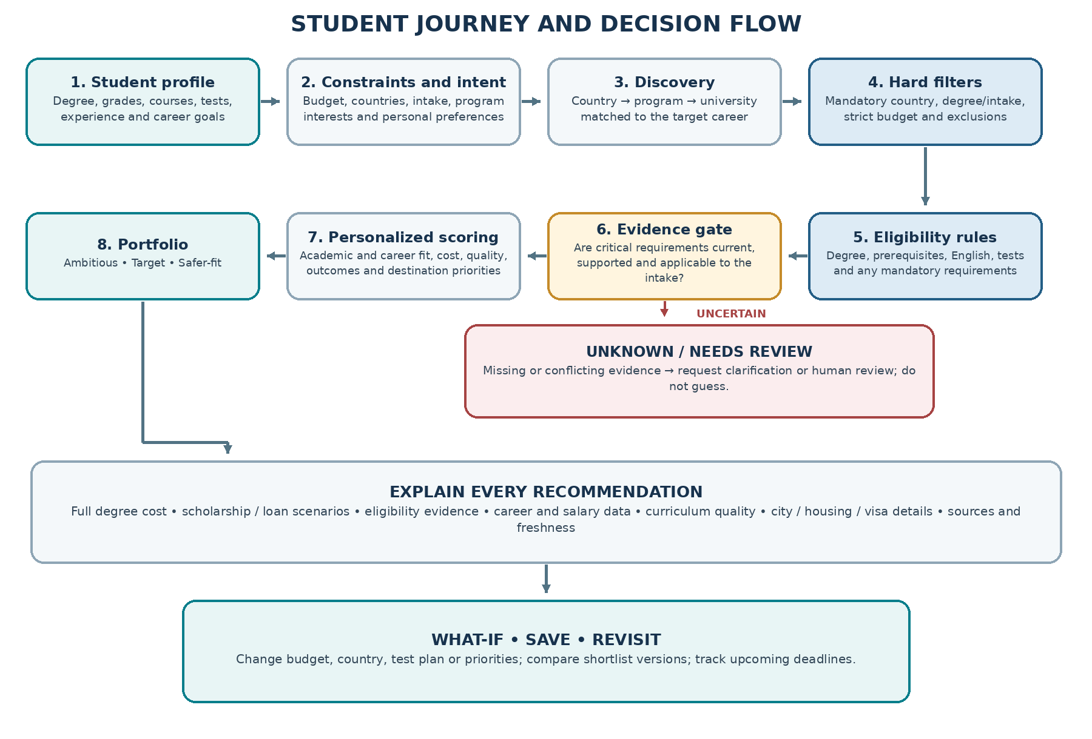
Figure 1. Student journey: the system filters, evaluates, scores and explains in separate steps.

5.2 System context
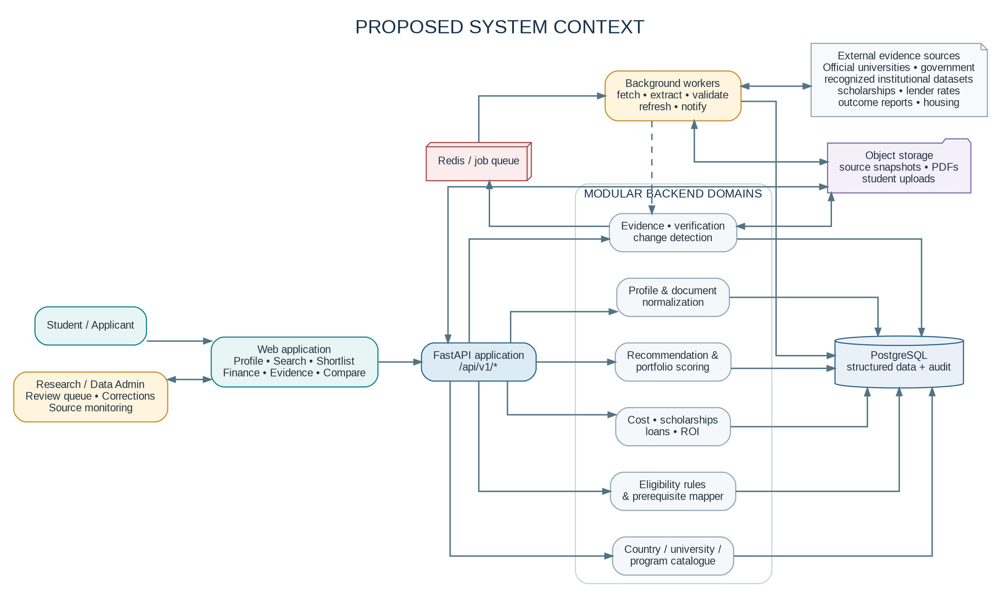
Figure 2. System context: a modular backend uses PostgreSQL for structured truth and object storage for raw evidence.

5.3 Recommended technology stack
Layer | Recommendation | Reason / constraint
Web frontend | Next.js + React + TypeScript; accessible component system. | Works well for search, authenticated student space, compare views and an admin console. Equivalent frontend is acceptable if project constraints differ.
API/backend | Python + FastAPI + Pydantic; SQLAlchemy ORM; Alembic migrations. | Typed request/response models and a clear way to keep eligibility, financial formulas and source services in testable modules.
Primary database | PostgreSQL 16+ (version to be selected). | Relational consistency for institutions, programs, rules, costs, users, provenance and audit history.
Search | Start with PostgreSQL indexes/full-text search. Add dedicated search only when query relevance or catalogue scale proves the need. | Avoid running Elasticsearch/OpenSearch prematurely.
Evidence/document storage | S3-compatible object storage; local MinIO for development if useful. | Store source snapshots, permitted documents, uploaded transcripts and extraction artifacts outside relational tables.
Background work | Redis queue plus ARQ/Celery/RQ worker; choose one after a small spike. | Run source fetches, extraction, refreshes, batch recalculations and notifications outside HTTP requests.
LLM / extraction | Provider-agnostic extraction interface; optional LLM for parsing/normalization with schema validation. | Avoid binding product truth to one model/provider. All extracted facts need evidence and validation.
Authentication | Established auth/session library or OIDC provider; secure cookies/session where feasible. | Do not hand-roll password storage, refresh-token rotation or access-control primitives.
Deployment | Docker for repeatability; managed PostgreSQL/object storage in production. | Begin with a simple deployable unit; do not introduce Kubernetes until operational scale requires it.
Observability | Structured logs, error reporting, metrics, health endpoints and audit events. | Investigate failed ingestion/recommendation decisions without exposing uploaded PII in logs.

5.4 Architecture style
Use a modular monolith first. Every business domain has a clear service boundary and owns its validation and tests, while the application ships as one API service and one or more worker processes. The database remains the system of record. This is simpler to operate than microservices and supports later extraction of source ingestion or recommendation computation if a real bottleneck appears.

5.5 Deployment view
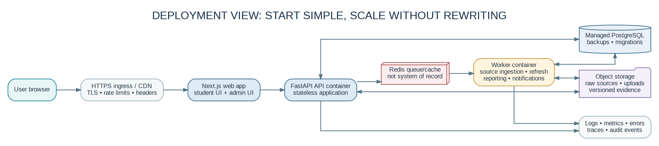
Figure 3. Initial production deployment: separate stateless API and worker processes, but shared managed data services.

6. Backend design and repository structure

6.1 Suggested repository layout
university-shortlisting-tool/
├── frontend/
│ ├── app/ components/ features/ # onboarding, search, shortlist, finance, outcomes
│ ├── lib/ # typed API client, auth, validation
│ └── tests/ # UI and end-to-end tests
├── backend/
│ ├── app/main.py # app factory, middleware, lifecycle
│ ├── app/api/v1/ # router.py and endpoints/*.py
│ ├── app/core/ # config, security, errors, permissions, logging
│ ├── app/db/ # session, base models, Alembic migrations
│ ├── app/models/ schemas/ repositories/
│ ├── app/services/ # profile, catalogue, evidence, ingestion, recommendations
│ ├── app/engines/ # eligibility, scoring, finance, normalization
│ ├── app/integrations/ # source adapters, LLM adapter, FX provider
│ ├── app/workers/ tasks/ # refresh, extraction, notification jobs
│ └── tests/ # unit, integration, contract, evaluation fixtures
├── infra/ # Docker, deployment, monitoring
└── docs/ # architecture, data dictionary, source policy, API, runbooks

6.2 Backend domain responsibilities
Module | Responsibilities | Must not do
Identity / profile | Accounts, student profile, academic records, goals, preferences, consent and profile version. | Must not store private transcript content in application logs.
Catalogue | Countries, institutions, campuses, programs, intakes, specializations and search queries. | Must not hardcode facts in frontend components.
Evidence / source registry | Source authority metadata, raw source references, fact provenance, verification state, history and correction workflow. | Must not treat a URL alone as proof that every field is verified.
Eligibility engine | Rule groups, operators, prerequisite mapping, student evidence mapping, status and explanation. | Must not make an LLM the final decision-maker.
Recommendation engine | Hard filters, fit dimensions, versioned weights, category allocation and reasons. | Must not combine fit score with admission chance as if they were equivalent.
Finance engine | Cost breakdowns, FX conversions, scholarship conditions, loan scenarios, family contribution and sensitivity analysis. | Must not show loans/awards as approved unless confirmed.
Outcomes / ROI | Employment and earnings statistics, cohort metadata, scenarios and methodological caveats. | Must not relabel national/subject-wide results as exact program or Indian-cohort outcomes.
Destination information | City living costs, housing resources and dated official visa/work rules. | Must not offer visa approvals or legal guarantees.
Admin / ingestion | Fetch jobs, extraction, validation, review queue, publication, change alerts and job status. | Must not publish high-impact uncertain data automatically without defined checks.

7. Data architecture and schema

7.1 Core model
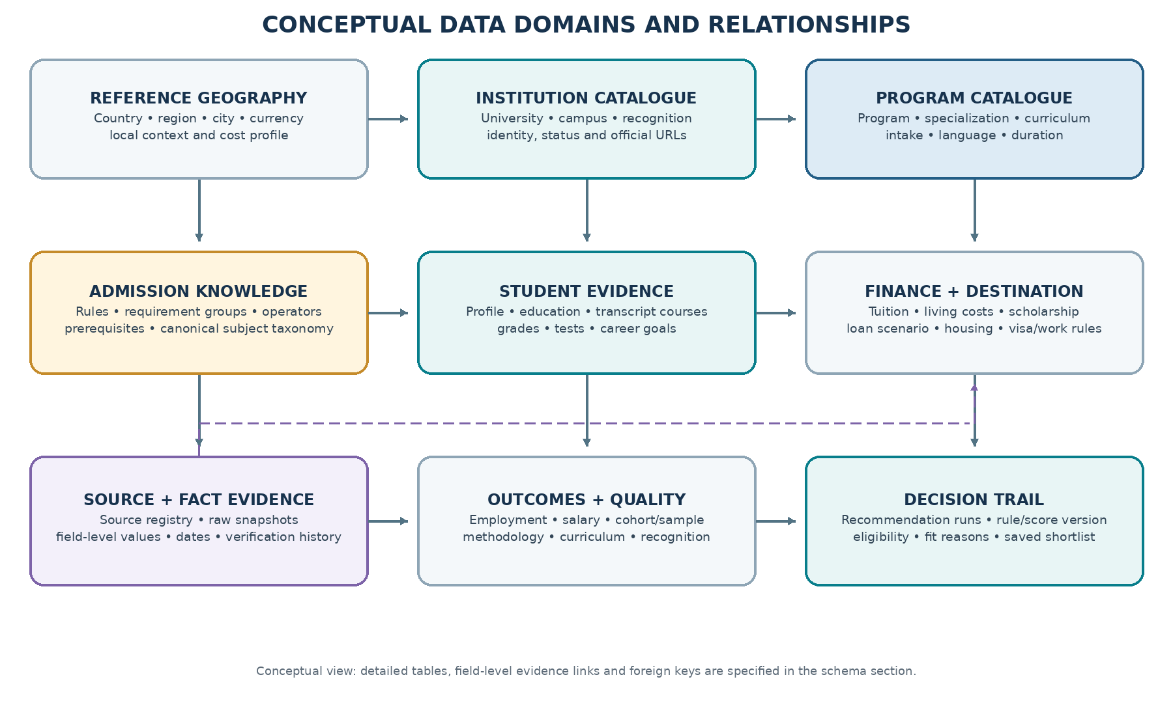
Figure 4. Simplified conceptual data model. Production schema should include foreign keys, uniqueness constraints and version history.

7.2 Core entities and key fields
Entity/table | Key fields (illustrative) | Purpose / relationship
country | id, name, ISO code, currency, region, language notes | Parent for institutions, cities and destination rules.
city / destination | id, country_id, name, region, living_cost_profile_id | Local housing/cost estimates and campus location.
university | id, country_id, name, official_domain, recognition_status, global_whed_id optional | Institution identity, not program requirements.
campus | id, university_id, city_id, address, campus_url | Campus-level location where meaningful.
program | id, university_id, campus_id optional, title, degree level, field, mode, language, official_url | Core program catalogue record.
program_intake | id, program_id, intake label, start/end dates, application deadline, availability status, academic_year | Intake-specific facts; do not overwrite one intake with another.
program_requirement | id, program_id/intake_id, group_id, type, operator, normalized_value, unit, mandatory, validity dates | Structured rules for admissions, tests, experience and prerequisites.
subject_taxonomy | id, canonical subject, parent_id, aliases, taxonomy version | Normalize transcript courses and university prerequisite terminology.
student_profile / academic_record | student_id, profile_version, degree, institute, grading_scale, GPA/percentage, graduation year, backlogs | Student academic and career baseline.
student_course | id, student_id, original_title, credits, credit_unit, grade, term, mapped_subject_id, mapping_status, evidence_id | Normalized course-level evidence for prerequisites.
cost_estimate | id, program/intake/city_id, cost_type, amount, currency, period, included/excluded notes | Tuition, fees, living costs, insurance and one-time costs.
scholarship | id, provider, title, eligible nationalities, program/field scope, amount, currency, coverage, conditions, deadlines | Matchable funding opportunities; award status remains separate.
loan_product_snapshot | id, lender, scheme, rate/rate_type, collateral rules, amount range, fees, moratorium, repayment terms, effective date, source_id | Dated lender terms; never present as approval or personalized quote.
outcome_statistic | id, provider, scope type, country/program/subject, metric, value, period, cohort, sample size, response rate, source_id | Graduation employment, salary, satisfaction and career outcome evidence.
student_experience_review | id, program_id, current_student/alumni status, study/graduation cohort, self-declared Indian-student context where volunteered, structured ratings, narrative, verification_status, moderation_status | Firsthand student experience; keep subjective reviews separate from verified employment/fee facts, protect identity and disclose verification level.
destination_rule | id, country, rule type, nationality/context, value, effective_from/to, source_id, review state | Student visa, work while studying, post-study route and other official rules.
source_registry | id, source name, source type, owner, base_url, jurisdiction, terms reviewed, permitted method, refresh policy | Controls how sources may be used.
source_document | id, source_id, canonical_url, fetched_at, content_hash, storage_uri, parser version, fetch outcome | Original evidence snapshot or document reference.
fact_evidence | id, entity/table/key, field path, extracted value, source_document_id, page/section/snippet, status, verified_at, valid dates, reviewer_id | Connects each important fact to the exact supporting evidence.
recommendation_run | id, student_id, profile_version, intake, rule_version, scoring_version, created_at, inputs_snapshot | Reproducible recommendation computation.
recommendation_item | id, run_id, program_id, eligibility status, fit score, admission band optional, category, reasons_json, caveats_json | One result row per candidate program.
score_dimension | id, recommendation_item_id, dimension, score, weight, evidence coverage, explanation | Transparent score breakdown.
shortlist | id, student_id, name, run_id, created_at | Saved list of chosen options with notes and status.

7.3 Provenance is a first-class data model
The system should not store only “tuition = 18,000 EUR.” It should store the value, its currency and period, applicable academic year/intake, whether it includes mandatory fees, the exact supporting URL or document excerpt, the date retrieved and verified, and the status of the record. Source versions and fact versions must be retained so past recommendation runs can be explained accurately.
Provenance field | Meaning
source_id / source_document_id | Which registered source and captured page/document support the fact.
field_path / evidence span | The field this evidence supports and the relevant page, heading, table row or text snippet.
retrieved_at | When the system collected the source.
verified_at / verified_by | When and by whom the fact was checked, where review is required.
valid_from / valid_to / intake / academic_year | The period and cohort to which the fact applies.
verification_status | Extracted, pending review, verified, disputed, stale, superseded or rejected.
parser_version / transformation_version | How the raw information was extracted, normalized and transformed.
confidence / quality flags | Internal review signal based on source authority, evidence completeness and ambiguity; not an assertion of mathematical truth.
history / supersedes_id | Which previous fact version was replaced and why.

7.4 Important schema constraints
- Use stable internal IDs; do not use program names or URL slugs as primary keys.
- Use unique constraints for institution/program identity carefully; program titles can change, and the same program may have campuses or different intakes.
- Store money as decimal values with currency code and period, never as a formatted string only.
- Store times in UTC with the source or destination local timezone explicitly known for deadlines.
- Use status and nullable data deliberately: unknown, not applicable, not published and zero are different states.
- Keep rule, scoring and taxonomy versions linked to each recommendation run.
- Keep raw source material in object storage; store its URI, content hash and key metadata in PostgreSQL.
- Use soft deprecation and version history for facts; do not overwrite changed admissions requirements without retaining previous versions.

8. Data acquisition, verification and refresh

8.1 Data pipeline
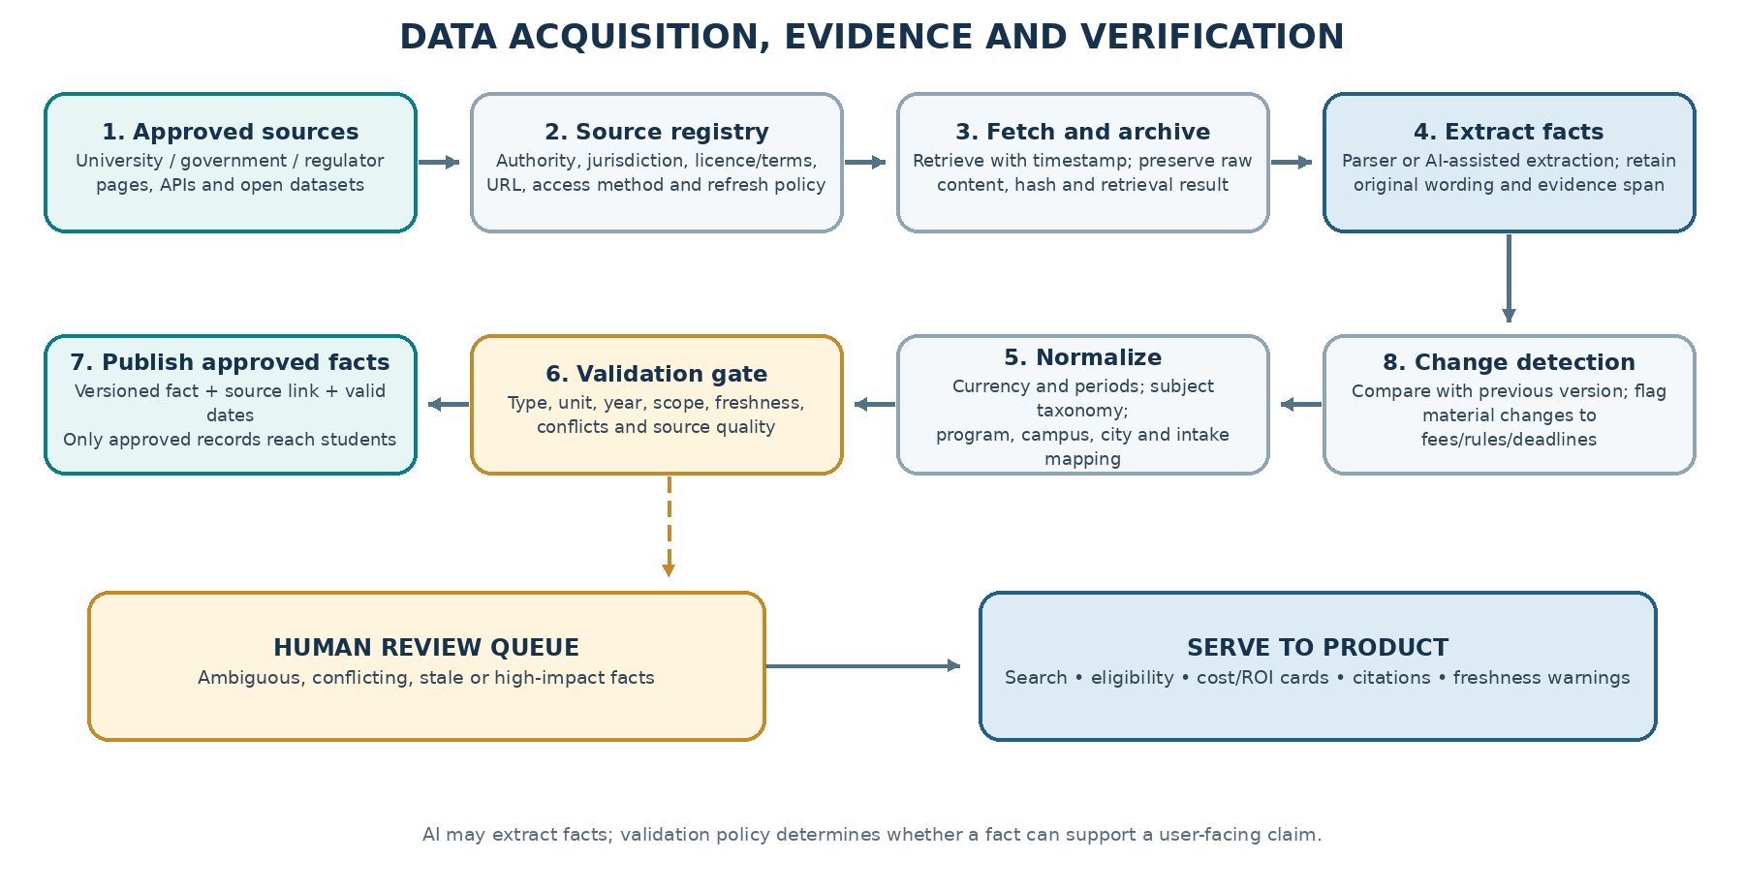
Figure 5. Pipeline from approved sources to published facts; uncertain facts enter a review queue.

8.2 Source hierarchy and acquisition policy
Priority | Source type | Best use | Required guardrail
Tier 1 | Official university/program pages and official downloadable documents | Admission requirements, tuition, fees, deadlines, curriculum, intake, language/test requirements and scholarship conditions. | Capture exact page/document and applicable intake/year; official does not mean the page is current or unambiguous.
Tier 2 | Government, regulator, recognized institutional or national datasets | Institution recognition, visa/work rules, national education statistics, published graduate outcomes and country requirements. | Respect scope. Institution-level recognition does not establish program-specific quality.
Tier 3 | Recognized aggregators / licensed data providers | Program discovery, cross-country catalogue metadata and initial coverage. | Use for discovery unless data rights and quality support more. Verify material admission/cost facts from official sources.
Tier 4 | University reports, student surveys and alumni reports | Program-level placement/career information, student experience and qualitative context. | Record cohort, sample size, survey method, response rate and promotional/selection bias.
Tier 5 | Student reviews, forums and informal community posts | Generate questions, identify issues to investigate and show clearly labelled anecdotal perspectives. | Never use as the only basis for a factual eligibility, safety, salary or visa claim.

8.3 Recommended initial data strategy
- Select a small pilot: a few destination countries and high-demand subject groups relevant to Indian Master’s applicants. Make coverage and depth explicit.
- Build a priority list of programs; verify required fields thoroughly before expanding the catalogue size.
- Use an approved source adapter per provider rather than one generic scraper. Each adapter records terms reviewed, allowed fetch method, rate limit and expected content format.
- Prefer official APIs, open/downloadable datasets and licensed feeds where available. For webpages, check terms, robots directives and applicable law/policy before collection; do not bypass logins, CAPTCHAs or technical restrictions.
- Preserve original accessible evidence and content hashes. An LLM extraction result must point back to the corresponding source text; schema validation and deterministic checks run before publication.
- Route high-impact or ambiguous facts to human review. Conflicting sources must be visible as a conflict until resolved.
- Collect Indian-student experience through an explicit, consent-based review flow or a licensed/authorized source. Do not scrape private communities or republish third-party reviews without checking terms, permissions and privacy.
- Publish only records that meet the minimum field requirements for the particular user-facing feature. A program can appear in discovery with partial data but should not receive a misleading precise cost/eligibility conclusion.

8.4 Data freshness policy — proposed starting point
Data type | Suggested recheck starting policy | Trigger for urgent review
Deadlines / intake availability | Every 7–14 days during an active application window; less often outside it. | Deadline within configured alert window, page changes or intake closed.
Eligibility requirements / English tests | Every 30–60 days for priority programs; recheck on official page change where possible. | Changed mandatory requirement or conflicting admissions page.
Tuition / mandatory fees | Every 30–60 days for active intake; confirm at intake cycle transition. | Price change, academic year rolls over, source page updated.
Scholarships | Weekly/biweekly during application season; otherwise monthly. | Deadline approaching, funding exhausted or criteria changed.
Visa / work rights | Monitor official update channels at least weekly or monthly by destination, with explicit effective dates. | Government announces a policy/rule change.
Living-cost estimates | Quarterly or annually depending on source; publish period and range. | Source methodology change or large inflation/currency movement.
Graduate outcomes / salary | On publication of the source's annual release or when new cohort data appears. | New cohort release or method revision.
Lender interest rates and fees | Check the lender's official rate page before displaying as current; schedule regular retrieval and show effective date. | Rate/effective-date change; avoid relying on cached old values.
Currency conversion | Refresh according to provider policy, typically daily for illustrative conversions. | Rate provider failure or stale timestamp.

These are suggested operational starting points, not universal standards. The refresh scheduler should support source-specific policies and escalation based on data volatility and application urgency.

8.5 Source conflict and publication policy
- If two official pages disagree, retain both evidences and mark the field disputed; do not select the more convenient value automatically.
- Prefer intake-specific and program-specific pages over general university pages; log why a source was chosen.
- For changing legal/visa rules, show the government source and effective date and link out; avoid translating it into individualized legal advice.
- For each field, define a display gate: verified, recent enough for this field, correct scope, usable evidence and no unresolved material conflict.
- When evidence is missing, display “Not published / not verified” with a next step. Do not hallucinate a value to complete a card.
Publication status | Can it support a student-facing claim? | Allowed action / state transition
Extracted | No. Internal candidate only. | Validate structure, capture evidence span and run unit/scope checks.
Pending review | Only low-risk preview with an explicit pending label, if product policy permits. Never for a decisive eligibility claim. | Route to a reviewer when ambiguity, conflict or high impact is detected.
Verified | Yes, within stated scope and validity dates. | Publish with source link, verified date, academic year/intake and version.
Disputed | Not as a single definitive value. | Retain both sources; show a caveat or suppress the precise claim until resolved.
Stale | Not for time-sensitive high-risk claims. | Refresh or suppress current-state language; preserve historical version for audit.
Rejected / superseded | No for current display. | Retain decision history; the newer accepted version may become active after review.

Publication rule
The system may show incomplete coverage honestly, but it must not silently upgrade an extracted value into a verified fact. Every review action should record who acted, when, what changed and why.

9. Eligibility, scoring and admission assessment

9.1 Engine sequence
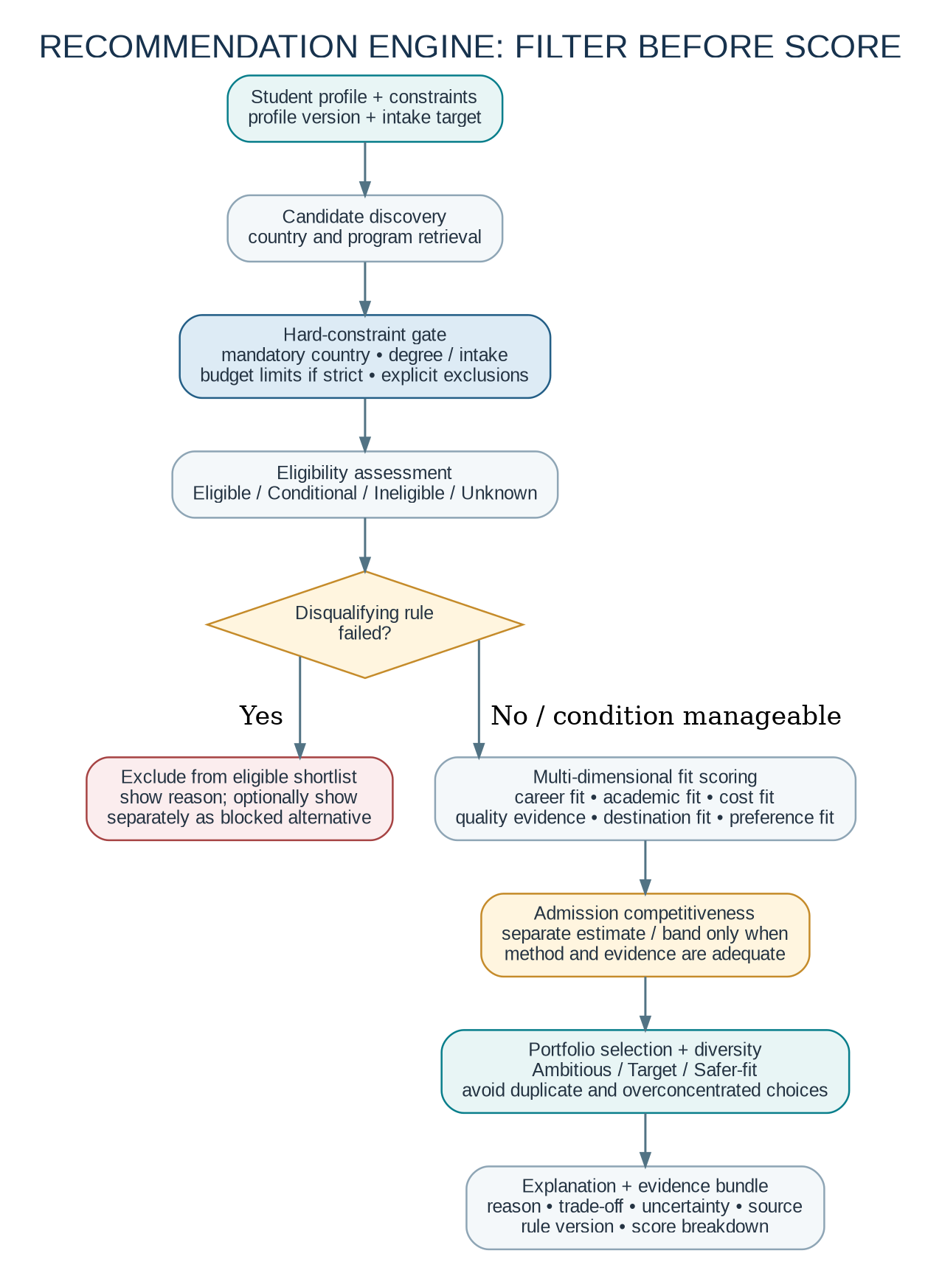
Figure 6. Apply hard constraints and eligibility rules before scoring. Admission competitiveness remains separate.

9.2 Rule representation
A structured rule should support single values and grouped conditions. Example: “Bachelor in CS, engineering, mathematics or statistics” can be represented as an ANY group; “IELTS overall ≥ 6.5 and no band below 6.0” is an ALL group with two separate conditions. The original wording must be preserved alongside normalized rules and the source evidence.
{
"program_id": "program_internal_id",
"intake_id": "intake_internal_id",
"requirement_group": "english_language",
"group_operator": "ALL",
"conditions": [
{
"field": "student.test.ielts.overall",
"operator": ">=",
"value": 6.5,
"unit": "band",
"mandatory": true,
"evidence_id": "fact_evidence_internal_id"
},
{
"field": "student.test.ielts.each_band",
"operator": ">=",
"value": 6.0,
"unit": "band",
"mandatory": true,
"evidence_id": "fact_evidence_internal_id"
}
],
"source_wording": "Retain official published wording here",
"verified_for_intake": "intake_internal_id",
"rule_version": "2026.10.1"
}

9.3 Transcript-course normalization
- Keep the original course title, code, credits, grade and any syllabus evidence. Map it to a versioned canonical taxonomy such as Calculus, Linear Algebra, Probability, Programming, Data Structures or Algorithms.
- Use a deterministic taxonomy lookup and synonyms first; let an LLM suggest mappings only when needed.
- Classify every mapping as automatic high-confidence, user-confirmed or human-reviewed. Low-confidence mappings cannot independently satisfy critical prerequisites.
- Normalize credit units only when the source provides a defensible conversion rule. Do not assume Indian credits, ECTS credits, semester hours and contact hours are equivalent.
- If a program requirement says “substantial background” or is qualitative, store the original phrase and use a reviewable interpretation instead of pretending a precise threshold exists.

9.4 Admission likelihood methodology
MVP recommendation
Launch with evidence-based competitiveness bands only where the method is defensible, and otherwise show “Insufficient data to estimate admission likelihood.” Do not display a made-up 73% chance because a user expects a number.

A future admission model needs permissioned historical applicant outcomes with meaningful fields: course/program and intake, applicant profile, academic scale, relevant subject preparation, test scores, experience, application outcome and cohort context. Model development requires data quality checks, leakage prevention, calibration, cohort-level evaluation, drift monitoring and an explanation of what the estimate does and does not represent.
Phase | Method | User-facing representation
MVP | Rule-based comparative heuristic using requirements, published selectivity indicators where available and profile fit; do not claim probability. | Ambitious / Target / Safer-fit with explicit “heuristic, not a guarantee” wording.
Data-building phase | Collect legitimate historical data and define consistent program/intake/cohort labels. | Show coverage and warn where sample is insufficient.
Validated model phase | Train and calibrate separate model(s) only where cohort size, representativeness and performance support it. | Probability range or band with cohort/context, calibration date and limitations.
Ongoing operation | Monitor calibration, distribution shift, model version and population differences. | Revert to “not enough evidence” if data/model quality falls below defined gate.

10. Student-facing decision modules

10.1 Money: total cost of degree and affordability
The finance module must make the total cost understandable to a family in India. It should show each component, its source, time period and currency, rather than compressing everything into one unsupported number.
Cost component | Data and calculation | Display treatment
Tuition | Official program/intake tuition; model recurring annual/semester amount and study duration. | Official quoted amount; indicate if fees may increase by year.
Mandatory university fees | Enrollment, semester, lab, student-service or other mandatory fees if published. | Separate line items; do not duplicate costs included in tuition.
Living expenses | Housing + food + transport + utilities + phone + personal expenses, from city/university/public estimates. | Low / typical / high scenario if methodology supports it; label estimates.
Insurance / healthcare | Required health cover or university/visa-linked costs. | Show jurisdiction and coverage period; source official requirements.
One-time costs | Visa, application, tests, travel, initial deposit, setup and document costs. | Clearly separate pre-departure cash need from ongoing costs.
Currency movement | Display source currency and converted INR estimate with FX source/time. | Always show original amount; explain that conversion can move.
Contingency | Optional adjustable buffer configured transparently. | Make it a user-adjustable planning amount, not an externally reported fee.
Scholarship deduction | Subtract only a confirmed award from committed funding; conditional awards shown separately. | Display gross cost, confirmed funding and conditional potential in separate lines.
Funding gap | Estimated total cost − family contribution/savings − confirmed funding/approved funds. | Unapproved loan amount must remain “potential funding,” not guaranteed coverage.

Important for “free education” searches
A program may advertise no tuition or low tuition while still charging semester contributions, student-service fees, insurance, deposits or other mandatory costs. Keep tuition, mandatory fees, living costs and one-time costs as separate line items; never label the full degree free unless the evidence supports all relevant cost components.

10.2 Scholarships
A scholarship record should include award provider, country/nationality eligibility, target degree/field, university/program scope, award amount/currency, expenses covered, whether it is automatic or separate-application, deadline, duration, renewal conditions, required documents and official source. Match status is “Potential match” until the student’s details and every published criterion are verified; “Awarded” is a separate user-reported/document-verified status.

10.3 Education loans and repayment scenarios
The system can compare published lender schemes and run user-selected scenarios; it must not claim that a lender has pre-approved the applicant. Each lender snapshot should record source URL, rate effective date, fixed/floating nature, amount limits, collateral/co-applicant constraints, processing fee, moratorium and whether interest accrues during study/moratorium.
Estimated EMI (standard amortizing repayment):
monthly_rate = annual_interest_rate / 12
EMI = principal * monthly_rate * (1 + monthly_rate)^n
/ ((1 + monthly_rate)^n - 1)

Where n is the number of monthly repayments. This formula alone is not enough
when interest accrues during study, repayment starts after a moratorium, fees
are financed, rates float, or the lender uses a non-standard schedule. Model
those terms explicitly or label the calculation as simplified.
The loan view should show principal, upfront fees, interest assumption, interest accrued before EMI starts, monthly installment, total repayment and rate-change sensitivity. Any interest rate displayed as current must be sourced from the lender’s official page and carry the page’s effective date.

10.4 Jobs, salary and return on investment
The biggest risk in this module is false precision. “Indian graduates from this exact program earn X and Y% get jobs” can be shown only when the evidence genuinely measures that cohort with an understandable definition and sample. Where that data is not available, the page must clearly fall back to broader evidence, such as all graduates from the institution, a subject-level group or national/country data.
Evidence level | Example display | Permitted conclusion
A — Exact program/cohort | Program placement report for a named graduation cohort, with sample and employment definition. | Describe the reported result for that cohort; not a personal guarantee.
B — Institution + subject | Official university outcome for a related degree family. | Useful proxy with explicit scope label; not exact program outcome.
C — National subject/education level | Official government/statistical outcome for a country, field or degree level. | Context only; cannot be presented as the university’s placement rate.
D — Third-party salary surveys | Published salary data with methodology, geography and sample disclosed. | Use cautiously and identify survey source and caveats.
E — User scenario | Student enters expected starting salary or employment delay for a what-if calculation. | Scenario only; it is not sourced market evidence.

ROI model
Do not estimate payback by dividing total tuition by a gross annual salary. A more defensible model uses the full cost of the degree, any relevant loan interest, time before paid employment, estimated take-home income, living expenses after graduation, and a baseline scenario for the student who does not pursue the degree. Show a range and the assumptions.
Study cost (net) = tuition + mandatory fees + living during study
+ travel/setup/visa/insurance + loan costs
- confirmed scholarship funding

Annual post-study savings scenario = estimated take-home income
- living costs after graduation
- debt payments and other stated costs

Simple savings-based payback is the first period in which cumulative
incremental savings exceed the net study cost. The stronger “incremental ROI”
comparison also estimates what the student might have earned without the
Master's. Both are scenarios, not a promise of future employment or earnings.

10.5 Education quality, program evidence and Indian student experience
- Show the actual curriculum and map modules to target skills or job roles; distinguish published curriculum information from inferred skill mapping.
- Distinguish institution recognition, program-specific accreditation and professional licensing requirements.
- Show faculty/research information, internships, capstones and employer partnerships only where supported by evidence and scoped to the correct program or institution.
- Offer a structured student-experience module with dimensions such as teaching/support, practical work, internship access, career services, housing, cost-versus-expectation and adjustment to life abroad. Let reviewers optionally identify as current students or alumni and self-identify Indian-student context only when they choose to.
- Use a clear review trust label: self-reported; enrollment/program affiliation checked; or outcome independently substantiated. Do not reveal identity documents, student IDs or private details. Verification means a specific check was completed, not that every opinion is objectively true.
- Moderate abuse, personal data, fake/duplicated reviews, coordinated manipulation and undisclosed incentives. Keep a report/appeal path, date submitted, moderation status and audit log. Do not sell a higher ranking or suppress a review because it is negative.
- Keep review opinions separate from measured outcome statistics. Label the cohort, response count, sample size, data year, question wording and whether a metric measures satisfaction, employment or earnings.
- Use rankings as one optional signal rather than a hidden universal quality score; rankings across different fields and methodologies are not interchangeable.

10.6 Living abroad and destination rules
The destination module links the program’s campus to a city-level planning view: low/typical/high living-cost scenarios, housing and university residence information, transport, insurance/healthcare context, student language needs and official study/work/post-study rules. It must show the jurisdiction, effective date and the government source for legal/visa facts.

10.7 Institution trust and legitimacy
Use recognized institutional databases (such as WHED where applicable) and the relevant national competent authority to verify institutional identity/status. Keep a separate check for program-specific accreditation and any professional qualification requirements. “University exists / is recognized” must not automatically be translated into “this program is high quality” or “this qualification guarantees recognition for every purpose.”

11. Backend API design
Use a versioned REST API under /api/v1. The list below is a proposed contract map; exact request fields should be specified in Pydantic schemas and OpenAPI once MVP scope and authentication method are approved. Use pagination, filtering, consistent errors and authorization checks on every user-specific resource.

11.1 Core route inventory
Method | Path | Purpose | Access
POST | /api/v1/auth/register | Create account; validate email and password policy. | Public
POST | /api/v1/auth/login | Authenticate and establish session/access token. | Public
POST | /api/v1/auth/refresh | Rotate/refresh session credentials if supported. | Authenticated
POST | /api/v1/auth/logout | Revoke current session/refresh token. | Authenticated
GET | /api/v1/auth/me | Current account and permitted profile metadata. | Authenticated
GET | /api/v1/profile/me | Read profile and current version. | Student
PUT | /api/v1/profile/me | Update student profile/preferences; validate hard-vs-soft constraints. | Student
POST | /api/v1/profile/me/documents | Upload resume/transcript to controlled object storage. | Student
GET | /api/v1/profile/me/documents | List user-owned documents and extraction state. | Student
POST | /api/v1/profile/me/documents/{document_id}/extract | Queue optional parsing; do not silently overwrite profile. | Student
GET | /api/v1/countries | Search countries and discovery metadata. | Public
GET | /api/v1/countries/{country_id} | Country profile and current evidence. | Public
GET | /api/v1/universities | Paginated university search and verified identity fields. | Public
GET | /api/v1/universities/{university_id} | University detail, campuses, recognition and source cards. | Public
GET | /api/v1/programs | Search programs using country/field/degree/language/budget/intake filters. | Public
GET | /api/v1/programs/{program_id} | Program detail, requirements, curriculum and provenance. | Public
GET | /api/v1/programs/{program_id}/intakes | Intakes, application dates and current availability. | Public
GET | /api/v1/programs/{program_id}/costs | Itemized program and destination cost estimate. | Public
GET | /api/v1/programs/{program_id}/requirements | Requirement groups and source evidence. | Public
GET | /api/v1/programs/{program_id}/outcomes | Outcome statistics with cohort/scope metadata. | Public
GET | /api/v1/programs/{program_id}/student-experiences | Moderated student feedback with self-reported/verified labels and sample context. | Public
POST | /api/v1/student-experiences | Submit a structured student review; user must consent to display terms. | Authenticated
GET | /api/v1/profile/me/student-experiences | List own review submissions and moderation state. | Student
POST | /api/v1/student-experiences/{review_id}/report | Report a review for privacy, abuse, fraud or factual concerns. | Authenticated
GET | /api/v1/programs/{program_id}/evidence | Evidence bundle for visible facts and current status. | Public
POST | /api/v1/recommendations/runs | Create recommendation run from profile version and preferences. | Student
GET | /api/v1/recommendations/runs/{run_id} | Retrieve shortlist and run metadata. | Owner / admin
GET | /api/v1/recommendations/runs/{run_id}/explanations | Per-program reasons, caveats, status and score breakdown. | Owner / admin
POST | /api/v1/recommendations/runs/{run_id}/what-if | Create a new run with changed preferences; retain prior run. | Student
POST | /api/v1/shortlists | Create a named saved shortlist from a run. | Student
GET | /api/v1/shortlists | List current user’s saved shortlists. | Student
GET | /api/v1/shortlists/{shortlist_id} | Read shortlist and selected programs. | Owner / admin
PATCH | /api/v1/shortlists/{shortlist_id}/items/{item_id} | Add/remove/annotate a shortlist item. | Owner / admin
POST | /api/v1/comparisons | Compare selected programs on normalized fields. | Student
GET | /api/v1/finance/loan-products | List dated lender schemes and published terms with official sources. | Public
POST | /api/v1/finance/loan-scenarios | Calculate repayment under explicit assumptions. | Student
GET | /api/v1/scholarships/matches | Return potential scholarship matches for profile/program. | Student
GET | /api/v1/destinations/{country_id}/cities/{city_id} | City costs, housing resources and dated destination rules. | Public
GET | /api/v1/evidence/{evidence_id} | Read allowed evidence metadata/snippet and verification status. | Public / restricted based on record
GET | /api/v1/admin/sources | List source registry and policy state. | Research admin
POST | /api/v1/admin/ingestion-jobs | Queue authorized ingestion or refresh job. | Research admin
GET | /api/v1/admin/review-queue | List extracted facts requiring human review. | Research admin
GET | /api/v1/admin/student-experiences/review-queue | List student reviews awaiting moderation or verification. | Review moderator
POST | /api/v1/admin/student-experiences/{review_id}/decision | Approve, reject, redact or request edits; record reason. | Review moderator
POST | /api/v1/admin/facts/{fact_id}/decision | Approve/reject/correct a proposed fact with reason. | Research admin
GET | /api/v1/admin/jobs/{job_id} | Job status, retries, source and error code. | Research admin
GET | /api/v1/health/live | Process liveness. | Internal
GET | /api/v1/health/ready | Dependency/readiness status, without leaking secrets. | Internal

11.2 API conventions
- Paginate catalogue endpoints using limit/cursor or page/limit; set a maximum page size. Return total counts only if affordable and stable.
- Use query parameters for filters and explicit enums for fields such as degree level, intake status and eligibility state.
- Use consistent error objects: code, message, field errors, request_id and whether retry is appropriate. Never return stack traces to clients.
- Use idempotency keys for job submissions or other operations where duplicate requests would create duplicate work.
- Apply object-level authorization: a student may only read/edit their own profile, uploaded documents, runs and shortlists.
- Expose source/evidence metadata with every critical fact; do not require the frontend to make separate unbounded calls for each small data item.
- Use ETags/updated_at for cacheable public catalogue records, but set policy based on data freshness requirements.

11.3 Representative create-shortlist request
POST /api/v1/recommendations/runs
Authorization: authenticated student session
Content-Type: application/json

{
"profile_version": 7,
"intake_id": "2027-fall",
"country_mode": "open_to_recommendations",
"mandatory_constraints": {
"total_budget_inr": 3500000,
"degree_level": "masters",
"teaching_language": ["English"]
},
"preferences": {
"career_goal": "AI/ML engineering",
"target_roles": ["ML Engineer", "Data Scientist"],
"weights_profile": "career_and_affordability",
"risk_tolerance": "balanced"
},
"portfolio_size": {"ambitious": 3, "target": 5, "safer_fit": 3}
}

Response (illustrative shape; values are not real admissions data):
{
"run_id": "run_123",
"profile_version": 7,
"rule_version": "eligibility-2026-10-01",
"scoring_version": "fit-v1",
"status": "complete_with_data_gaps",
"summary": {
"programs_considered": 420,
"removed_by_hard_constraints": 260,
"eligible_or_conditional": 54,
"unknown_due_to_evidence": 12,
"returned": 11
},
"warnings": ["Some program-level employment outcomes are unavailable."],
"items_url": "/api/v1/recommendations/runs/run_123"
}

11.4 Example program card response
{
"program_id": "prog_456",
"university": {"name": "Example University", "country": "Example Country"},
"program": {"title": "MSc Applied Data Science", "duration_months": 24},
"eligibility": {
"status": "conditional",
"reason_codes": ["MISSING_REQUIRED_ENGLISH_SCORE"],
"source_evidence_ids": ["ev_101", "ev_102"]
},
"fit": {
"score": 82,
"dimensions": {"academic": 85, "career": 91, "cost": 72, "quality_evidence": 78},
"score_version": "fit-v1"
},
"admission_competitiveness": {
"band": "not_estimated",
"reason": "Insufficient validated program/cohort outcomes"
},
"cost": {
"amount": 3200000,
"currency": "INR",
"type": "planning_estimate",
"as_of": "2026-10-17",
"source_ids": ["ev_205"]
},
"data_status": {"overall": "partial", "last_verified_at": "2026-10-10"},
"reasons": ["Relevant AI curriculum", "Within stated budget under typical-cost scenario"],
"caveats": ["Employment data is available at subject level, not exact program level."]
}

12. Frontend pages and presentation
Page / view | Primary purpose | Required UI elements
Landing / explainer | Set expectations and start discovery. | What tool does, limitations of admission/ROI estimates, start/profile CTA.
Onboarding wizard | Collect student profile and constraints without overwhelming user. | Step progress, save/resume, inline help, hard-vs-preference toggle, validation summary.
Profile dashboard | Review all stored profile data. | Editable academic/career/finance sections, source of uploaded info, completeness indicators.
Country discovery | Show best-fit destination options. | Country scores, cost context, career evidence, language/work trade-offs and sources.
Program search | Discover and filter programs. | Faceted filters, search, pagination, program results and missing-data warnings.
Shortlist results | Explain final Ambitious/Target/Safer-fit portfolio. | Filters, comparison selections, reasons, concerns, evidence freshness and status badges.
Program detail | Provide detailed university/program facts. | Overview, curriculum, requirements, cost, funding, outcomes, quality, destination and evidence tabs.
Cost and funding | Help family understand affordability. | Itemized total, INR/original currency, low/typical/high scenarios, scholarship matches, loan calculator and funding gap.
Career and ROI | Show what evidence exists about employment and earnings. | Scope labels, cohorts, sample sizes, salary definitions, scenario assumptions and source links.
Student experience | Let prospective students learn from current Indian students/alumni where they voluntarily identify that context. | Structured review dimensions; self-reported vs verified label; anonymity, consent, moderation, report/appeal and sample caveats.
Compare programs | Compare choices side-by-side. | Comparable rows for total cost, duration, eligibility, curriculum, evidence coverage, jobs and visa/work info.
What-if simulator | Expose impact of changed choices. | Controls for budget/countries/tests/risk; old/new result delta; explanation of new/removing programs.
Research/admin console | Maintain database and sources. | Source registry, ingestion jobs, candidate facts, page excerpts, diff view, approve/reject, correction history.

12.1 Program detail page layout
- Header: program, institution, country/city, study level, intended intake, overall data status, last verified date.
- Eligibility: each mandatory requirement, student evidence, status, source and missing action.
- Cost & funding: official tuition, one-time fees, living range, FX timestamp, scholarships, dated lender terms, loan scenario and funding gap. If tuition is zero/low, still show mandatory fees and living cost; “tuition-free” does not mean “cost-free”.
- Career: job roles mapped to curriculum, evidence scope, placement/employment and earnings statistics with cohort definition; explain missing evidence.
- Quality and student experience: curriculum modules, faculty/research/practical components, recognition/accreditation and structured feedback. Clearly distinguish anonymous self-report from checked student affiliation and keep subjective reviews separate from measured placement/salary statistics.
- Destination: housing resources, city costs, transport, student-work and post-study official rules with effective dates.
- Actions: save, compare, see evidence, start what-if, export a shareable report, create application checklist.

12.2 Source presentation rules
Make source evidence usable without overwhelming the result card. Each fact should have a “Source and last checked” affordance that opens the exact official page and, where possible, a captured relevant excerpt. Label facts as Official, Estimated, User-provided, Reported by university, Third-party or Anecdotal. Show the academic year and intake near fees and admissions rules. A “verified” label should describe the tool’s process and date, not imply eternal truth.

13. Security, privacy, reliability and monitoring

13.1 Security and privacy requirements
Area | Baseline requirement
Authentication | Use proven auth/session primitives, strong password hashing if local credentials are used, safe session expiry, secure cookies and rate limiting.
Authorization | Enforce student ownership in server-side queries. Separate student, researcher/reviewer and administrator roles.
Data minimization | Collect only information needed for product functions; make resume/transcript upload optional and purpose-specific.
Encryption | TLS for transit; managed encryption for databases and object storage; secret manager/environment injection rather than committed secrets.
File safety | Validate file type/size, scan uploads, store outside public web roots, use short-lived signed URLs, and prevent cross-user access.
Logging | Never log passwords, access tokens, full transcript text, passport numbers or unnecessary PII. Use request IDs and redacted errors.
Retention/deletion | Document retention rules for uploads/raw evidence; provide profile and document deletion workflows where applicable.
Audit | Record source publication/correction, reviewer decision, recommendation version, user export and administrative changes.
Legal/policy review | Before launch, review privacy obligations, data-provider licences, copyright, scraping terms and consumer-protection claims for target markets.

13.2 Observability
- Application logs: request_id, route, status code, latency, actor type, error code and safe entity IDs.
- Metrics: API p95 latency, error rate, database pool saturation, worker queue depth, ingestion success rate, retry count, review backlog and stale critical facts.
- Business quality metrics: evidence coverage, percentage of critical facts current, unresolved source conflicts, percentage of eligibility decisions with complete provenance, missing outcome coverage and correction rate.
- Health endpoints: liveness checks process health; readiness checks essential dependencies without revealing secrets.
- Alerts: repeated ingestion failures, source layout changes, queue build-up, stale deadline/fee fields, failed database backups and abnormal error increases.

13.3 Backup and recovery
- Use automated PostgreSQL backups and test restore procedures, not merely backup creation.
- Enable object versioning or equivalent protection for source artifacts and uploaded documents where justified.
- Keep schema migrations reviewed and reversible where practical; production migrations should be separate from normal request handling.
- Define retention and deletion together: do not keep personal uploads forever merely because raw evidence archives are useful.

14. Testing and validation strategy

14.1 Test layers
Test layer | What it verifies | Examples
Unit tests | Small rules and calculations are correct. | ANY/ALL rule groups; grade scale handling; cost calculation; currency and period normalization; loan amortization; stale-date state.
Contract/schema tests | Incoming/outgoing payloads obey versioned API schema. | Invalid currency, malformed deadline, missing mandatory request field, enum validation.
Integration tests | Database, source adapter, worker and API work together. | Ingest a fixture page, store evidence, approve a fact, expose it through the program endpoint.
Golden eligibility set | Known synthetic/approved student profiles produce expected rule outcomes. | One satisfied, one violated, one conditional and one unknown case per rule pattern.
Recommendation evaluation | Ranking respects constraints and explanations. | Strict country never leaks another country; strict budget is enforced; scores have traceable dimensions.
Data QA tests | Facts are complete, non-contradictory and provenance-linked. | No current fee without currency/year/source; no published rule without evidence; no expired intake marked open.
Security tests | Private data remains private. | Cross-user document/run access, upload abuse, injection, rate limits and reviewer role boundaries.
End-to-end tests | Critical user journey works visually and functionally. | Create profile → run shortlist → inspect cost/source → compare → change budget → new run.
Model evaluation (future) | Admission model is reliable for its intended cohort. | Calibration, discrimination, cohort slices, sample-size checks, drift and human review.
Usability checks | Students understand the result. | Can they explain total cost, funding gap, eligibility gaps and why a recommendation appeared?

14.2 Release gates
- Gate A: no program may be labelled eligible if mandatory rules are unknown or unsupported by current evidence.
- Gate B: every critical displayed value is traceable or clearly labelled estimated/user-provided/unavailable.
- Gate C: total-cost calculations reconcile from line items to total and preserve original currencies/periods.
- Gate D: salary and employment displays show population scope, time period, source and sample/coverage where published.
- Gate E: hard constraints are tested against regression fixtures; changes to scoring/rules require a version bump and repeatable evaluation.
- Gate F: uploaded files and student-specific records pass access-control tests before release.
- Gate G: a human reviewer samples real published records before pilot users receive the shortlist.

15. Implementation roadmap
The phases below are capability milestones, not commitments to a fixed calendar. Start each phase only when the preceding phase passes its quality gates.
Phase | Build scope | Deliverables / exit criteria
0. Decisions and pilot design | Confirm target countries/disciplines, intake(s), applicant profile, MVP boundaries, data use policy and first source list. | Product requirements, decision log, initial data dictionary, source-policy checklist, 20–30 representative eligibility cases.
1. Data foundation | PostgreSQL schema, source registry, source_document/fact_evidence records, migrations, admin review basics, seed/import mechanism. | Fact-level provenance works; versions/history retained; data can be reviewed and corrected.
2. Catalogue and search | Country/university/program/intake catalogue, API, public search and filters, program detail. | A reviewed pilot catalogue is searchable with source/status indicators.
3. Student profile and eligibility | Profiles, academic records, subject taxonomy, rule schema/evaluator and eligibility explanations. | Golden eligibility set passes; Unknown is distinct from failed; mandatory rules are traceable.
4. Recommendation and shortlist | Hard filters, fit scoring, portfolio categories, saved shortlist, compare and what-if run versioning. | Results respect constraints and display reasons/trade-offs; same inputs and versions reproduce the run.
5. Money, scholarship and loan scenarios | Cost estimates, FX timestamp, scholarship records, funding gap, loan assumptions and repayment calculations. | Finance tests pass; no conditional award is displayed as guaranteed; each value has a source/assumption label.
6. Outcomes, quality and destination | Outcomes datasets, cohort metadata, curriculum mapping, recognition, housing/city costs and official rule links. | Outcome scope labels and missing-data presentation pass review; destination facts show effective dates.
7. Automation and hardening | Scheduled refreshes, change diffs, admin queues, alerts, backups, monitoring, access-control tests. | Worker retries and failure handling work; restore tested; stale/changed facts are surfaced.
8. Pilot and calibration | Counsellor/subject-matter comparison, user feedback, scoring adjustments and decision quality review. | Measured known errors documented and fixed; feature gaps prioritized; model-based admission claims remain disabled until validated.

15.1 Proposed workstreams
Workstream | Primary owner type | Main dependencies
Product and decision rules | Product lead / admissions domain reviewer | Country scope, intended user, approved requirements and success criteria.
Data acquisition and verification | Data researcher / data engineer | Source registry, access policy, schema, pilot program priorities.
Backend and rules engine | Backend engineer | Data model, rule semantics, API contract and test fixture set.
Frontend and UX | Frontend engineer / designer | Profile schema, API contracts, result explanation language and accessibility.
Finance and outcome methodology | Product/data analyst with financial domain review | Current source snapshots, units/definitions, legal disclaimers and model assumptions.
QA and security | QA engineer / reviewer | Test fixtures, threat model, access roles, source quality criteria.

16. Risks and mitigations
Risk | Impact | Mitigation
Incomplete or outdated university data | Wrong eligibility, budget and deadline guidance. | Fact-level source links, freshness policy, stale-state gate, change detection and human review.
False admission probability | Students or families make high-cost decisions based on misleading precision. | No numeric likelihood before data validation; show cohort scope, calibration, uncertainty and fallback-to-unknown.
National data mislabelled as Indian applicant outcomes | A misleading impression that a specific salary/job rate applies to Indian graduates from a program. | Outcome scope taxonomy and mandatory visible labels for program, institution, subject, nationality and country coverage.
Scholarship treated as guaranteed | Family underestimates funding gap. | Separate potential match, applied, offer and awarded states; count only confirmed funding in committed-cost calculation.
Loan terms become stale or incomplete | Wrong EMI, repayment or affordability decision. | Timestamp all rate/scheme data; link lender terms; model floating rates/moratorium and mark illustrative calculations.
Unauthorized or noncompliant data collection | Legal, contractual and reputational risk. | Per-source terms review, official APIs/licences where possible, transparent rate limits, no access bypassing.
LLM extraction mistakes | Incorrect program facts enter database. | Schema validation, source span retention, rule checks, sampling and human review for high-impact fields.
Scoring biases against non-standard profiles | Applicants from less familiar institutions/scales may be ranked unfairly. | Preserve original scale, avoid unsupported conversions, test cohort differences and expose missing evidence rather than penalty without reason.
Feature overload before core works | Project scope expands and no reliable end-to-end result ships. | Pilot scope, phase gates, P0 vs P1 separation and a documented non-goal list.
Conflicts of interest from lead generation | Rankings may appear commercially influenced. | Publish ranking methodology; disclose sponsorship/referral relationships; do not let commission silently alter eligibility or fit.
Sensitive applicant documents exposed | Privacy and trust damage. | Private object storage, least privilege, signed URLs, malware scans, retention/deletion controls and access testing.

17. Decisions to lock before implementation
The following items are intentionally shown as decisions rather than being silently assumed. The two source documents propose an initial scale and general architecture, but they do not finalize all operational parameters.
Decision | Recommendation | Why it matters
Initial countries | Pick a small group based on student demand, data availability and policy/data-maintenance capacity. | Each country adds different grading, visa, cost and outcome definitions.
Priority fields | Start with a manageable number of subjects and program families. | Course prerequisite normalization is resource intensive; depth beats nominal breadth.
Pilot catalogue size | A few hundred carefully sourced programs is a reasonable working pilot; tune based on actual review capacity. | A smaller, verified catalogue can test the system better than a much larger weakly verified one.
Admission probability | Do not expose numeric probabilities at MVP launch unless a validated outcome dataset already exists. | Avoids false precision and reputation risk.
Student documents | Decide whether transcript/resume parsing is MVP or phase 2; if included, require user confirmation. | Document parsing adds privacy, extraction accuracy and retention work.
Cost model | Decide how to define budget: tuition only, annual total, or full-degree total. Default recommendation: full-degree total with an explicit toggle. | Budget comparisons are otherwise inconsistent and can mislead.
Outcome data scope | Define labels for program-level, institution-level, subject-level, country-level and India-specific cohorts. | Prevents broad statistics from being represented as exact outcomes.
Business model | If affiliate/counselling/referral revenue is possible, define disclosure and ranking independence upfront. | Preserves trust in recommendations.
Data licences/terms | Approve per-source ingestion policy and data retention terms. | A public web page is not automatic permission to bulk scrape or republish its data.
Target architecture | Confirm stack and deployment based on team skills and environment. | The stack in this document is a recommended baseline, not the only valid implementation.

18. Worked example: from student profile to an explainable shortlist
Illustrative example only
The program names, numbers and results below are synthetic examples to show the intended product behaviour. They are not claims about a real university, its fees or its graduate outcomes.

18.1 Example student profile
Input | Illustrative value
Academic background | BTech in Computer Science; CGPA 8.1/10; selected mathematics/programming courses.
Tests | IELTS 7.5; GRE not yet taken.
Career goal | Machine Learning Engineer or Data Scientist.
Budget | INR 35 lakh all-in across the degree; family funding and loan needs entered separately.
Country mode | Open to recommendations, English-taught programs preferred.
Risk preference | Balanced; wants a mix of ambitious, target and safer-fit options.

18.2 Example candidate evaluation
Candidate | Eligibility result | Cost / funding result | Fit / competitiveness outcome | Explanation
Example Program A | Eligible; all known mandatory rules satisfied. | Typical total-cost estimate within the INR 35 lakh budget; scholarship remains conditional. | High career fit; labelled Ambitious because verified selection evidence suggests stronger competition. | Strong curriculum match; admission uncertainty remains; scholarship not counted as confirmed funding.
Example Program B | Conditional; transcript mapping for one prerequisite needs review. | Low scenario fits, typical scenario slightly exceeds budget. | Good career fit; Target pending course-mapping review. | Ask student to upload syllabus or confirm course credits; show how cost changes if housing is higher.
Example Program C | Unknown; current intake requirement is not sufficiently verified. | Tuition is published, but mandatory fees and current living estimate are incomplete. | Not ranked as a trusted eligible recommendation yet. | Keep visible only in a “needs verification” area or exclude from final shortlist until review.

18.3 What the result should enable
- The student can see which published academic rule they meet and which prerequisite needs validation.
- The family can compare full-degree cost and funding gap without treating a potential scholarship or unapproved loan as guaranteed.
- The student can inspect career data and see whether it belongs to the exact program, a related subject or a national cohort.
- The system can explain why a program appears in Ambitious, Target or Safer-fit categories without claiming a guaranteed admission.
- Changing the budget from INR 35 lakh to INR 40 lakh creates a new auditable recommendation run and explains which programs entered or left the shortlist.

19. Definition of done for the first release
- Product scope, initial countries, fields, intake and source policy are approved.
- Program, intake, requirement and fact-evidence models are in PostgreSQL with migrations and data dictionary.
- A reviewed pilot catalogue can be searched, viewed, compared and saved.
- Eligibility tests cover pass, fail, conditional and unknown states; course normalization preserves original transcript data.
- Hard constraints are enforced before scores, and score dimensions/explanations are persisted.
- Cost calculations reconcile from line items; scholarship/loan statuses are not conflated with approved/awarded funding.
- Career outcome cards show source, cohort, time period, metric definition, sample/response information when available, and scope labels.
- Critical facts have source URLs, intake/year applicability and verification status; stale or conflicted records cannot appear as fully verified.
- User-owned documents, profile and recommendation runs are protected by authorization tests.
- Automated tests pass; an independent reviewer samples eligibility decisions and user-facing financial explanations.
- Backup restoration, ingestion failure handling and admin correction history are tested.
- UI content clearly states that admission, employment, visa outcomes, scholarship awards and financial returns are not guaranteed.

Appendix A. Starter source registry
These are useful starting points for the initial source registry. They illustrate the kind of source that can feed the system; they do not constitute a complete global database or guarantee that every data point is available for every program. Review each source’s licensing, terms of use, update frequency and field-level scope before ingestion. URLs were checked on 17 October 2026.
[S1] IAU World Higher Education Database (WHED) — About. Recognized higher-education institution identity and country/system context; institution-level evidence, not a substitute for program admissions requirements. https://whed.net/About.html
[S2] DAAD — Degree programmes in Germany. Official starting point for German program discovery and metadata such as degree, language, location, duration and deadlines; verify critical facts on university pages. https://www.daad.de/en/studying-in-germany/universities/all-degree-programmes/
[S3] DAAD — Admission requirements database. Orientation for admission eligibility based on prior qualification; page notes its output is non-binding, so it should not replace a specific program’s official requirement. https://www.daad.de/en/studying-in-germany/requirements/admission-database/
[S4] DAAD — Costs of education and living. Country-level financial guidance and examples; use current official rules and program/city-specific values when calculating an applicant’s budget. https://www.daad.de/en/studying-in-germany/living-in-germany/finances/
[S5] Discover Uni — About the data. UK course/student-experience and graduate outcomes data; includes cohort definitions, employment timing, earnings and limitations. Scope differs by course/subject and publication availability. https://www.discoveruni.gov.uk/about-our-data/
[S6] Eurostat — Employment rates of recent graduates (dataset TPS00053). Comparable EU-level recent graduate employment statistics; contextual country evidence, not Indian-specific or individual-program placement rates. https://ec.europa.eu/eurostat/databrowser/view/TPS00053/default/table?lang=en
[S7] UK Government — Student visa: money you need. Official UK student visa financial evidence rules. Store effective dates and use as a visa requirement, not as the only estimate of real living costs. https://www.gov.uk/student-visa/money
[S8] UK Government — Graduate visa overview. Official UK post-study work-route information; rules and eligibility may change and must be date-stamped. https://www.gov.uk/graduate-visa
[S9] State Bank of India — Education loan scheme interest rates. Official lender scheme/rate page example. Capture effective date, floating/fixed terms, collateral conditions, fees and scheme eligibility; re-check before displaying current rates. https://sbi.bank.in/web/interest-rates/interest-rates/loan-schemes-interest-rates/education-loan-scheme
[S10] British Council Study UK — Scholarships and funding. Scholarship discovery and official scholarship-program information; check each award’s nationality/course eligibility, deadline and covered expenses. https://study-uk.britishcouncil.org/scholarships-funding
[S11] British Council Study UK — GREAT Scholarships. Example of a scholarship program with country, course, award and application-specific criteria; only use in the years for which the official page says it is available. https://study-uk.britishcouncil.org/scholarships-funding/great-scholarships

A.1 Source registration checklist
- Who owns the source and what authority does it have for this particular field?
- What source terms, robots directives, copyright/database rights or API licence apply?
- Can the data be retained, transformed, displayed and redistributed for this product?
- What is the source’s scope (institution, program, subject, country or cohort) and update cadence?
- Can the content be captured as a stable snapshot? Are source excerpts permissible to store/display?
- What is the failure policy when a page moves, a schema changes or a source becomes unavailable?
- What data should be validated by a human before publication?

Appendix B. Key terminology
Term | Definition in this project
University / institution | The higher-education provider. It is a different entity from a specific degree program.
Program | A named Master’s course or degree with curriculum, duration, entry criteria and related outcomes.
Intake | The start cycle (e.g., semester/year) whose deadline, fees and requirements may differ from other cycles.
Hard constraint | A requirement the student has said must be satisfied, such as a mandatory country or maximum total budget.
Soft preference | A ranking preference such as city size or university ranking; it should influence ordering rather than silently eliminate all alternatives.
Eligibility | Whether the student satisfies documented admission requirements based on available evidence.
Conditional eligibility | A known condition remains, or a documented review/criterion needs to be satisfied.
Unknown / Needs review | Evidence is missing, stale, ambiguous or conflicting; the system cannot responsibly decide.
Admission competitiveness | A separate assessment of how competitive the student may be, requiring suitable evidence and clear limitations.
Fit score | An explanation of how well the program matches the student’s academic, career, financial and personal priorities; not admission probability.
Evidence record | A link between a displayed fact/decision and its original supporting source, applicable time period and verification status.
Graduate outcome | A measured result for a defined cohort and period (e.g., employment status 15 months after graduation); not necessarily a result for this exact student.
Planning estimate | A calculation or range using disclosed assumptions, such as living costs or currency conversion; not an official invoice.
Confirmed funding | Scholarship award, approved loan or other funding supported by a confirmed status; potential matches are not treated as guaranteed cash.

Appendix C. First implementation checklist
- [ ] Approve pilot countries, subjects, intake and the source-policy rules.
- [ ] Define the profile schema and which constraints are strict versus preferences.
- [ ] Agree eligibility status semantics and grouped-rule schema.
- [ ] Design source_registry, source_document and fact_evidence before importing large volumes of data.
- [ ] Select a pilot list of programs and manually verify its critical fields.
- [ ] Build rules and cost calculation unit tests before generating live recommendations.
- [ ] Confirm API route contracts and user/admin access roles.
- [ ] Implement core student journey and an evidence-rich program detail page.
- [ ] Test budget/cost, scholarships and loan scenarios with independently calculated examples.
- [ ] Add outcome scope labels and suppress unsupported admission probability or placement claims.
- [ ] Complete privacy/security review for profile documents and source terms.
- [ ] Run a small user pilot and record every incorrect/misleading output as an actionable test case.
Final implementation principle
Build the trust/evidence layer and deterministic eligibility foundation before scaling the catalogue or adding more complex AI. The product becomes defensible when its claims are traceable, its assumptions are visible, and its unknowns are handled honestly.

