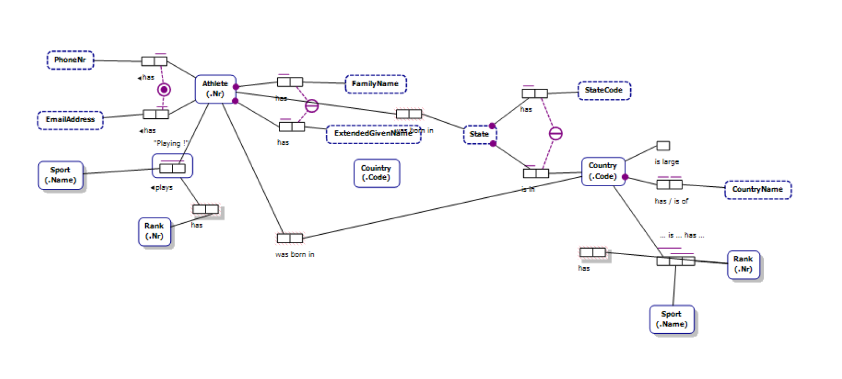

Fact Types:  
 Athlete has FamilyName

Each Athlete has exactly one FamilyName

It is possible that more than one Athlete has the same FamilyName

Athlete has ExtendedGivenName.

Each Athlete has exactly one ExtendedGivenName

It is possible that more than one Athlete has the same ExtendedGivenName.

Athlete has PhoneNr.

Each Athlete has at most one PhoneNr.

It is possible that more than one Athlete has the same PhoneNr.

Athlete has EmailAddress.

Each Athlete has at most one EmailAddress.

It is possible that more than one Athlete has the same EmailAddress.

For each FamilyName and ExtendedGivenName,

At most one Athelete has that FamilyName and has that ExtendedGivenName.

**Primary Keys:** Primary keys are unique identifiers for each record in a database table. It ensures that each record can be uniquely identified and retrieved. Primary keys have the following properties: They must contain distinctive values, meaning no two records can have the same primary key value. They cannot contain null values. They provide a way to efficiently locate and access specific records.

**Foreign Keys:** The foreign key in a table serves to link two tables together. It connects two tables by referencing their primary keys. The keys ensure referential integrity, ensuring consistency among related data. Their advantages include creating connections between tables through primary key references, ensuring data integrity with specific rules, and enabling seamless data retrieval.