Capstone Planning Document

## Description:

For my Capstone Project, I will be building a the player tries to find a truck toy in the store and gives it to the kid for him to stop crying and become happy during 3 minutes.

:

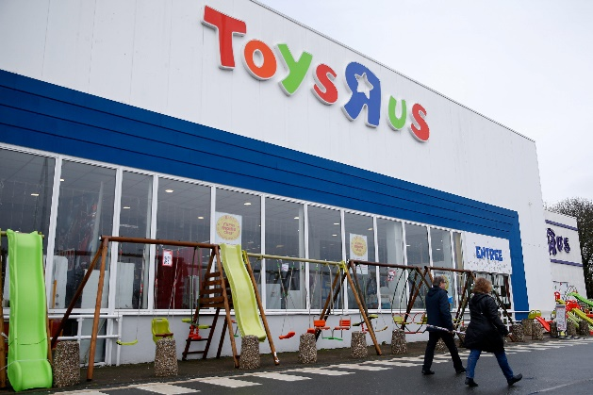

a game for fun to make a little boy stop crying

## Features And Dependencies:

### 3D Models + Animations

* 1. Chris Toys R Us Parking Lot
  2. Shelf
  3. Toys & Trees
  4. Chris Toys R Us new exit sign

### Game Loop

* 1. The player entrance to the shop
  2. Speak Recognition for player the boy is crying for help
  3. Game Mechanic for player to try to make the boy stop crying
     1. Gridlines of where to find the toy for the boy
     2. The player clicks and drags them back to the boy.
  4. Fading to black and restarting
  5. Hints to guide player towards the right areas

### Other Effects

* 1. Cartoon Lighting to make the experience feel more like Mother Goose
  2. Particle Effects to reward users for doing a correct action
  3. Procedural navigation mesh to have army walk around objects
  4. Spatial Sound effects for the playing video (1985 - Toys R Us - Toys R Us Kid Jingle), child Laughs, Crying Sound, London Street Sound
  5. Light cues to make sure that players find where the toy
  6. Compute shader in exit door

Example Capstone Scoping

## Features and Dependencies:

### 3D Models + Animations

* 1. Chris Toys R Us Parking Lot
     1. **Revised: Will start with a basic model “** [**Parking Lot**](https://sketchfab.com/3d-models/chris-toys-r-us-parking-lot-14e6bd6a839641f9afa33cfc058b3d26)**” and then from there begin working on modeling and animating.**
  2. Shelf
     1. **Revised: Will use one model “[Shelf](https://sketchfab.com/3d-models/shelf-8fca9c232fa04a6eab082be3ca52c201)”and duplicate that to form the shop shelfs.**
  3. Toys & Trees
     1. **Revised: Will not be making this and will instead use the one provided by Unity.**
  4. Chris Toys R Us new exit sign
     1. **Revised: Will use brick wall provided in this “**[Chris Toys R Us](https://sketchfab.com/3d-models/chris-toys-r-us-new-exit-sign-b0524806c978470eb2001dbcfb8e7443)”

### Game Loop

* 1. The player entrance to the shop
     1. **Still planning this!**
  2. Speak Recognition for player crying for help
     1. **Revised: although this is a bit complicated in scope, will do this for the Speech Recognition achievement.**
  3. Game Mechanic for player to try to make the boy stop crying
     1. Gridlines of where to find the toy for the boy
     2. The player clicks and drags them back to the boy.
     3. **Revised: although a great mechanic to add interactivity, to scope down, I will remove the interactivity as it is inaccurate the storyline.**
  4. Fading to black and restarting
     1. **Revised: Still a go!**
  5. Hints to guide player towards the right areas
     1. **Revised: Still planning this!**

### Other Effects

* 1. Cartoon Lighting to make the experience feel more like Mother Goose
     1. **Revised: To scope down, will have to forgo this requirement**
  2. Particle Effects to reward users for doing a correct action
  3. Procedural navigation mesh to have army walk around objects
     1. **Revised: Will use Unity Navigation to simplify this effect**
  4. Spatial Sound effects for the playing video (1985 - Toys R Us - Toys R Us Kid Jingle), child Laughs, Crying Sound, London Street Sound
     1. **Revised: Still a go!**
  5. Light cues to make sure that players find where the toy
     1. **Revised: Relates to the guide players and this will be done with simple lighting (non volumetric)**
  6. Compute shader in exit door
     1. **Revised: Still planned to do.**