## 4 Interpolation

The curve of the data in in_interp.csv and the cubic spline interpolation with nature ends are as follows:

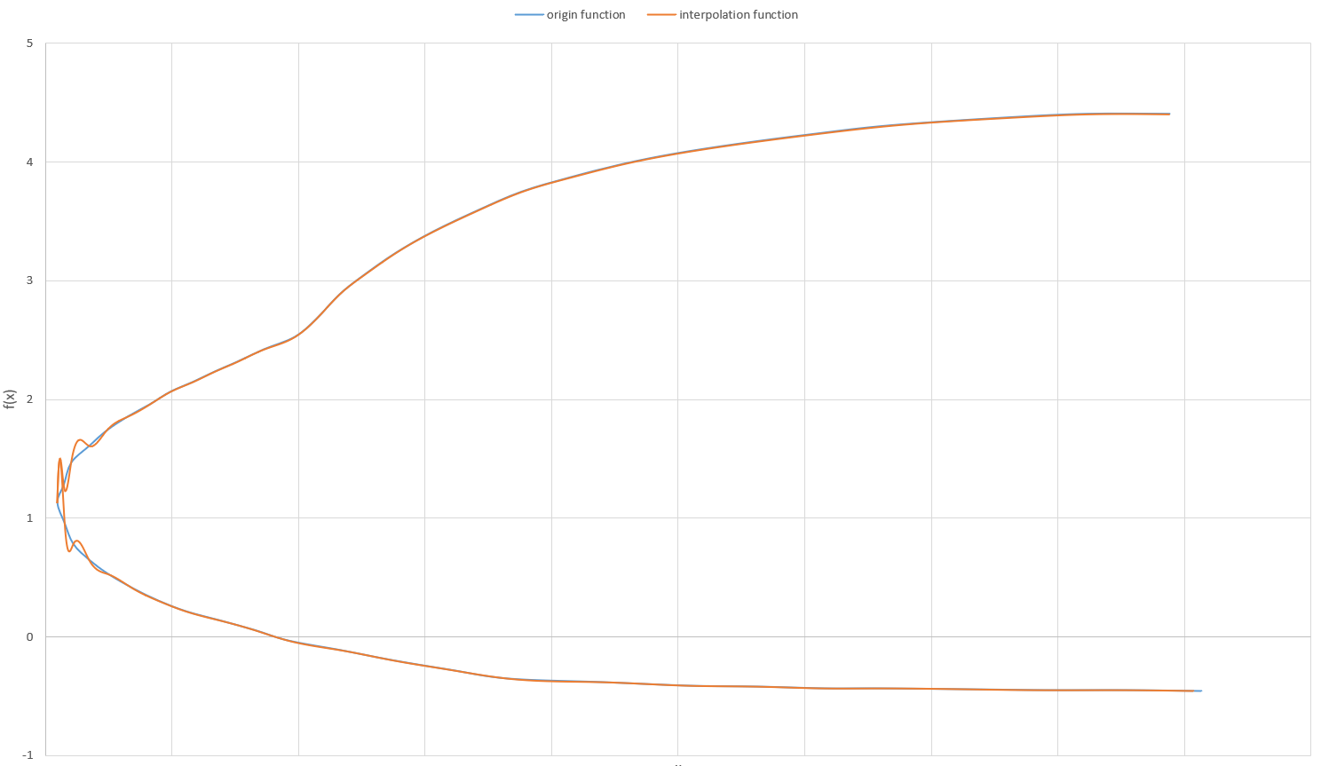

From the above figure we can see, the more horizontal the origin function is, the closer the interpolation function is to it.

And there maybe more than one interval for a xo to compute the interpolated value.

When xo is 3.5, we get the interpolated values:

xo,f(xo)

3.500000,4.334902

3.500000,-0.435119

## 5 Differentiation, differential equations

a).

For the first time iteration(n=0),

$ϕ_{i}^{1}=ϕ_{i}^{0}-\frac{CFL}{2}(ϕ_{i+1}^{0}-ϕ_{i-1}^{0} )$ for i=1,…,Nx-1

$ϕ_{i}^{1}=ϕ_{i}^{0}-\frac{CFL}{2}(ϕ_{1}^{0}-ϕ_{N_{x}-1}^{0} )$ for i=0,Nx

For the subsequent time iterations(n=1,…,Nt)

$ϕ_{i}^{n+1}=ϕ_{i}^{n-1}-CFL(ϕ_{i+1}^{n}-ϕ_{i-1}^{n} )$ for i=1,…,Nx-1

$ϕ_{i}^{n+1}=ϕ_{i}^{n-1}-CFL(ϕ_{1}^{n}-ϕ_{N_{x}-1}^{n} )$ for i=0,Nx

Where $CFL=u\frac{Δt}{Δx}≤1$

b).

When Nx=200 with different CFLs:

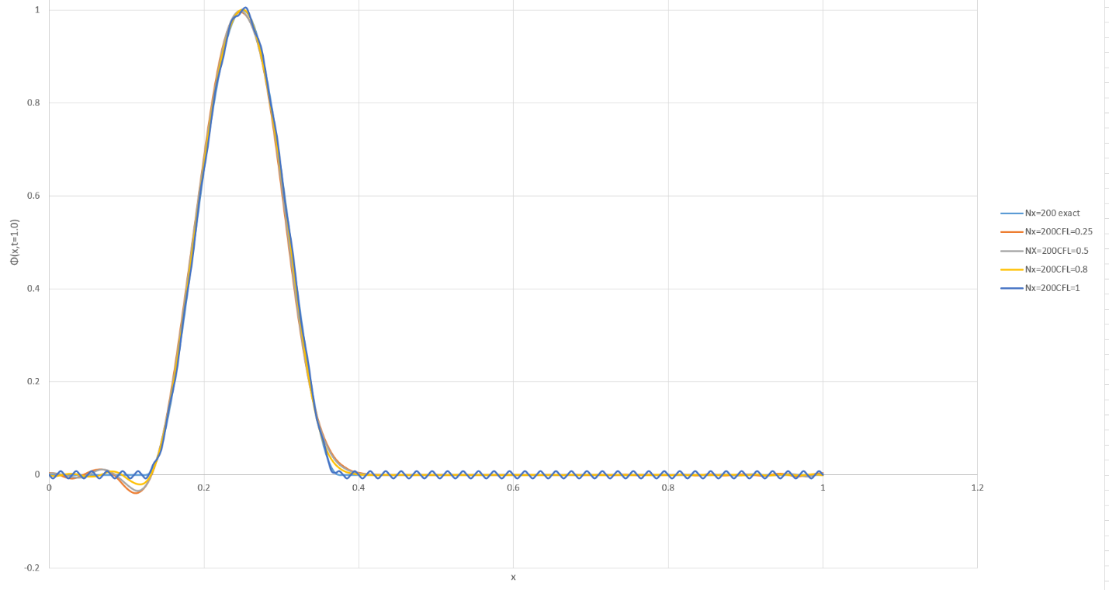

When Nx=100 with different CFLs:

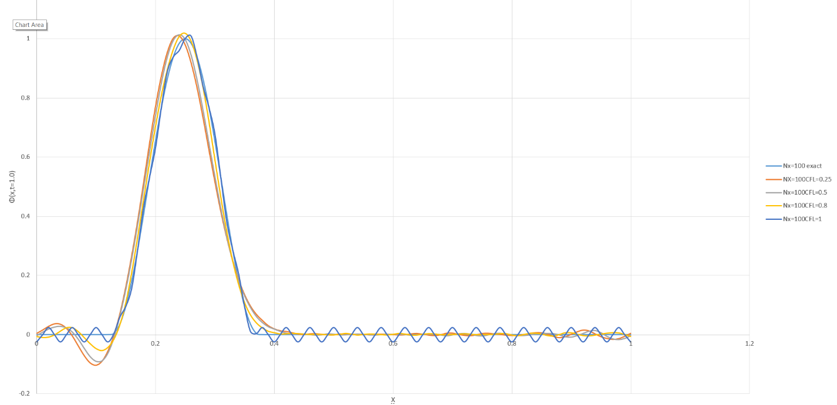

1. The $Δx$ depends on Nx, the larger Nx is, the smaller $Δx$ is, and the phase has a fluctuation.
2. The CFL will also affect the curve as the Nx, when CFL change, there is a small shift.
3. When CFL is 1.002, even little larger than 1.0, the curve will “blow up” towards infinity, and the shape is just like sine or cosine wave, as follows:

