VULNERABILITY ASSESSMENT REPORT
IDOR — Insecure Direct Object Reference
Employee Profile Access Control Vulnerability — SecureCorp Portal

Student | Farhan
Institution | Tutedude
Platform / Room | TryHackMe — tutedude-cybersec
Target Application | SecureCorp Portal (192.168.155.129)
Date | August 2026
1. Objective
Identify an access control (IDOR) flaw in the profile page of the SecureCorp employee portal, use it to view the profile page of the admin account, and capture the resulting flag.
2. Finding Summary
Vulnerability | Insecure Direct Object Reference (IDOR)
CWE | CWE-639 — Authorization Bypass Through User-Controlled Key
OWASP Category | A01:2021 – Broken Access Control
Severity | High
Affected Endpoint | profile.php?id=
Root Cause | Client-controlled object reference + missing server-side authorization

3. Methodology
Per the task brief, valid credentials were first recovered by inspecting the login page's client-side source code. The exploitation itself combines two pages: an internal directory search that discloses a target EmpID, and a profile page that trusts a client-supplied ID with no ownership check.
Step 1 — Authenticated directory search
Logged in with the recovered credentials and opened the Directory tab (search.php) — an internal employee search facility.
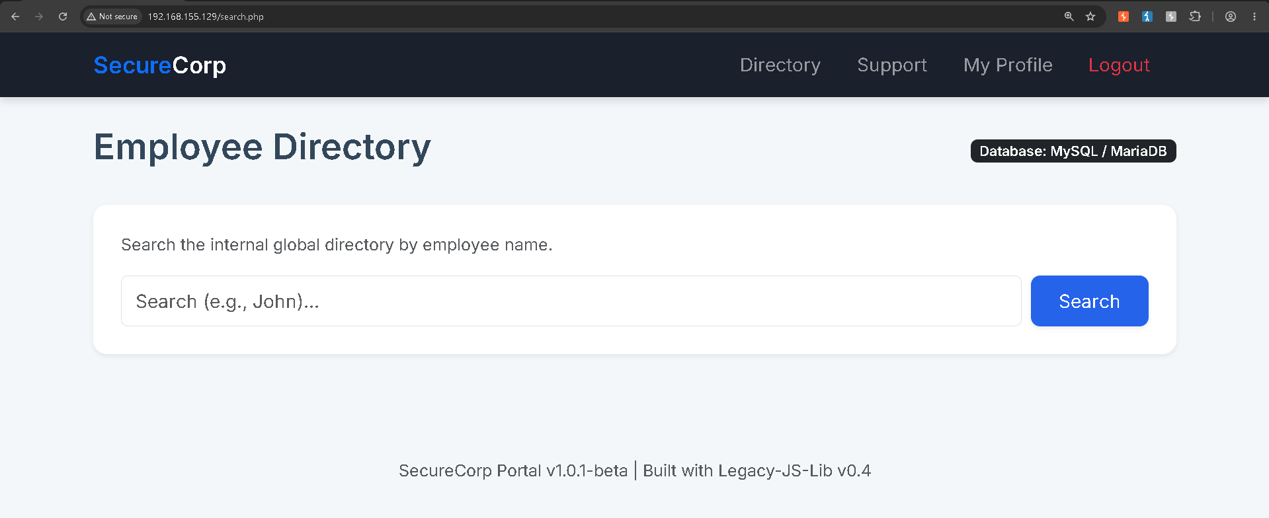
Fig. 1 — Employee Directory search page, unauthenticated-looking but reachable only post-login.
Step 2 — Enumerating the admin account
Searched the directory for “admin”. The result card revealed the account's job title (CEO) and, critically, its internal identifier — EmpID SID10001.
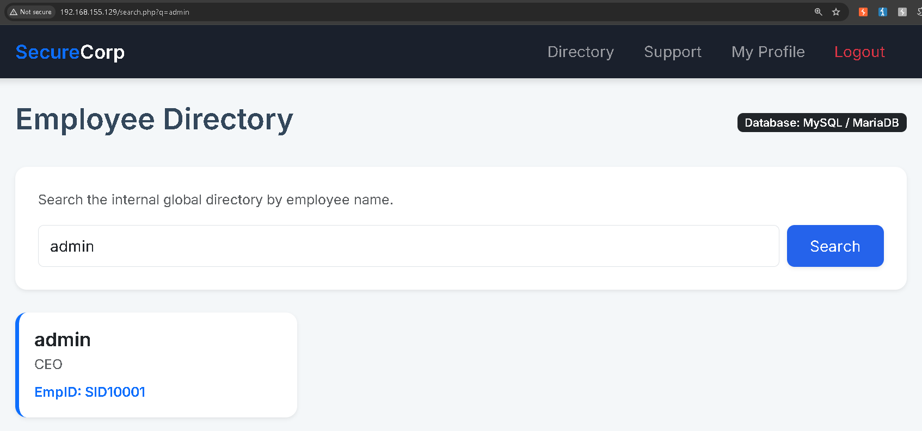
Fig. 2 — Admin located via directory search; EmpID exposed directly in the result card.
Step 3 — IDOR exploitation via URL parameter tampering
On my own “My Profile” page, the URL followed the pattern profile.php?id=<MyEmpID>. Replacing the EmpID in that URL with the admin's EmpID (SID10001) from Step 2 returned the admin's (“Akshay Admin”) complete profile — including Payroll Information (Current Salary: $500,000) and an Internal Security Notes panel — with no authorization check performed by the server.
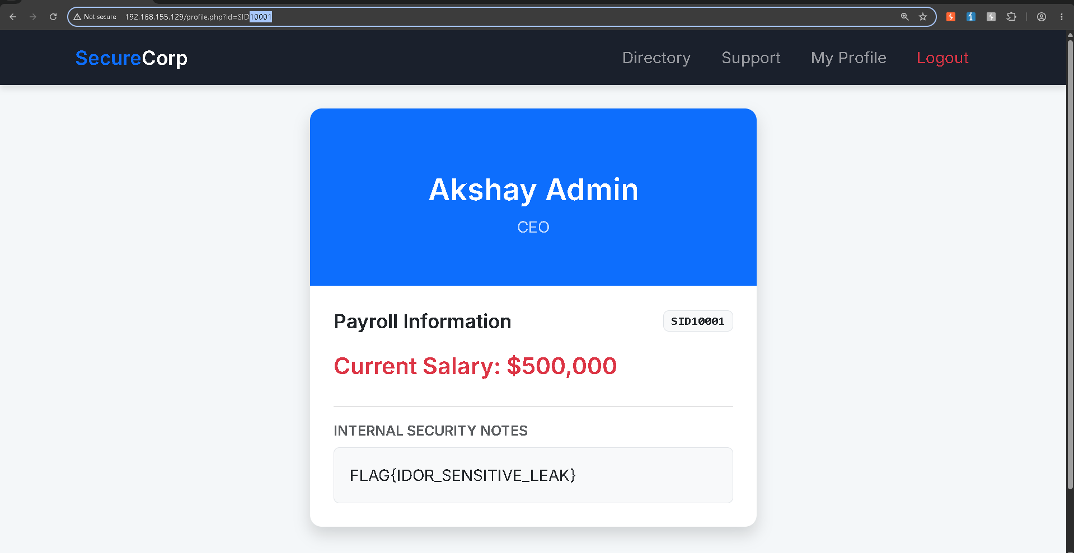
Fig. 3 — Admin profile rendered via a tampered id parameter, exposing salary data and the flag.
Step 4 — Flag capture
Submitted the captured flag on the TryHackMe room.
Fig. 4 — Flag accepted as the correct answer.
4. Root Cause Analysis
- Sensitive identifier disclosure — the directory search returns each employee's EmpID in plain, copyable text, including for privileged accounts. This hands an attacker the exact key needed to target another user's record; if the admin's EmpID weren't surfaced here, the IDOR would be significantly harder to pull off.
- Client-controlled object reference — profile.php decides whose data to render purely from a client-supplied id parameter in the URL, with no indirection (session-bound token, opaque reference) tying the request back to the logged-in user.
- Missing server-side authorization — the backend never verifies that the requested EmpID belongs to, or is permitted for, the current session before returning the record.
- Client-side checks aren't a fix — even a JavaScript-only check would be trivially bypassable by replaying the request through Burp Suite's Repeater, since the server itself doesn't enforce ownership.
5. Impact
Any authenticated employee, regardless of privilege level, can view another employee's full profile — including salary and internal security notes — by supplying their EmpID. Because EmpIDs follow a predictable sequential format (SID#####), an attacker could enumerate the entire employee database by iterating the identifier directly, without even relying on the directory search feature.
6. Remediation Recommendations
- Enforce server-side authorization on profile.php and every similar endpoint: confirm the session user matches the requested record, or holds an explicit admin/HR role, before returning another user's data.
- Avoid exposing internal identifiers in a guessable, sequential format on client-visible surfaces. Resolve “My Profile” from the session itself rather than a client-supplied ID, or use non-sequential opaque identifiers.
- Restrict the fields returned by directory search (e.g. name and title only); don't surface an identifier that's also used as an authorization key elsewhere.
- Apply authorization checks consistently across UI and API — never rely on a client-side control alone.
- Add logging and rate-limiting for repeated or sequential profile-ID access attempts to catch enumeration in progress.
7. Captured Flag
FLAG{IDOR_SENSITIVE_LEAK}

8. Conclusion
This exercise demonstrates a textbook Broken Access Control (IDOR) vulnerability caused by the combination of a disclosed, predictable identifier and the total absence of a server-side ownership check. It reinforces that access control must be enforced on every request, server-side, regardless of what the UI does or doesn't show.

