PERSONAL DATA

|  |  |
| --- | --- |
| **Name:** | Viktor Zhmurenko |
| **Date of Birth:** | 29/04/2000 |
| **Location:** | Russia, Moscow |
| **Mobile:** | +7 (915) 184-54-05 |
| **E-mail:** | vzhmurenko00@mail.com |
| **LinkedIn:** | [**https://www.linkedin.com/in/vzhmurenko**](https://www.linkedin.com/in/vzhmurenko) |
| **Telegram:** | [**https://t.me/l_TypucT_l**](https://t.me/l_TypucT_l) |

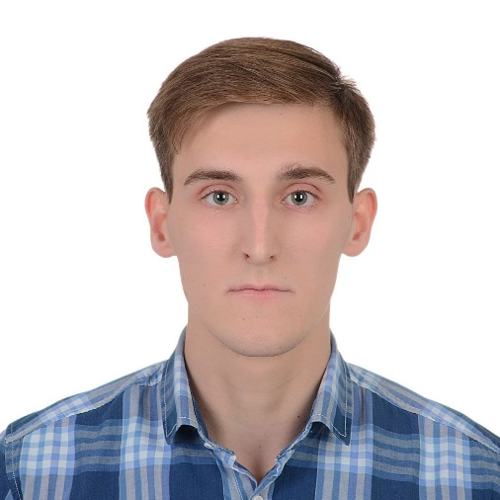

OBJECTIVE

|  |  |
| --- | --- |
| **Desired Position:** | Java Software Developer |

SUMMARY OF QUALIFICATION

|  |
| --- |
| I am working with Java starting from the **begin of 2021**.  My current stack of technologies is: **Java SE, SQL (PostgeSql, MSSQL), Spring Framework, Hibernate, REST.** |

TECHNICAL SKILLS

* Java SE, Spring Framework, Hibernate
* MVC, API(REST), console applications
* PostgreSQL, MSSQL
* Python, C#
* HTML, CSS, JQuery, Bootstrap
* GitHub
* Docker
* IntelliJ IDEA

SOFT SKILLS

* Time management
* Communication
* Adaptability
* Teamwork
* Problem-solving
* Interpersonal skills

LANGUAGES

* English – Intermediate
* Russian – Native Speaker
* Czech - Basic

EDUCATION

* 2018 – until now /Moscow State Technological University «STANKIN» / Information systems and technologies/ Moscow, Russia

SEVERAL FACTS ABOUT ME

|  |
| --- |
| In a few months I will finish my education at the university. And i'm going to come to the Czech Republic for work.  I want to grow in development, and besides, I want to see the world, so I'm going to Europe.  I prefer a healthy lifestyle like traveling, biking, jogging and so on.  I am free of the bad habits.  I am interested in economic theory, the mathematical sciences and fiction literature.  I can find the optimal way from difficult situation by myself in short time period.  I have an experience in teaching other people by programming skills and not only.  Also, I am interested in extreme sports, traveling and photography. |

PROFESSIOANL EXPERIENCE

|  |  |
| --- | --- |
| **“Course "Java for beginners"”** | |
| **Company:** | “Skillbox” |
| **Company Location:** | Russia, Moscow |
| **Project Location:** | Russia, Moscow |
| **Duration:** | 01/2022 – present time |
| **Description:** | Teaching java to students |
| **Position:** | Mentor of the course "Java for beginners" |
| **Responsibilities:** | * Teaching java to students * Verification of practical projects |
| **Tools & Technologies:** | Java SE, Spring Framework |

|  |  |
| --- | --- |
| **“Freelance”** | |
| **Company:** | Freelance |
| **Company Location:** | Russian, Moscow |
| **Project Location:** | Russian, Moscow |
| **Duration:** | 03/2021 – present time |
| **Description:** | Development for private customers, small companies |
| **Position:** | Java developer |
| **Responsibilities:** | * Desktop application development * Simple web application development * Server application development |
| **Tools & Technologies:** | Java SE, Spring Framework, Hibernate, SQL, GitHub |