结合能：-3.54405 kcal/mol | 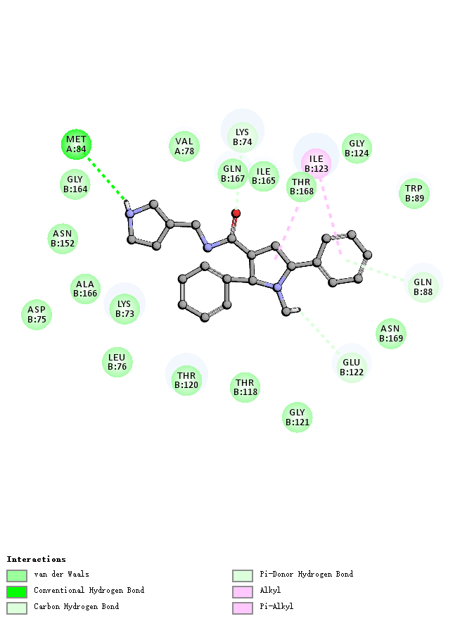
结合能：12.68 kcal/mol | 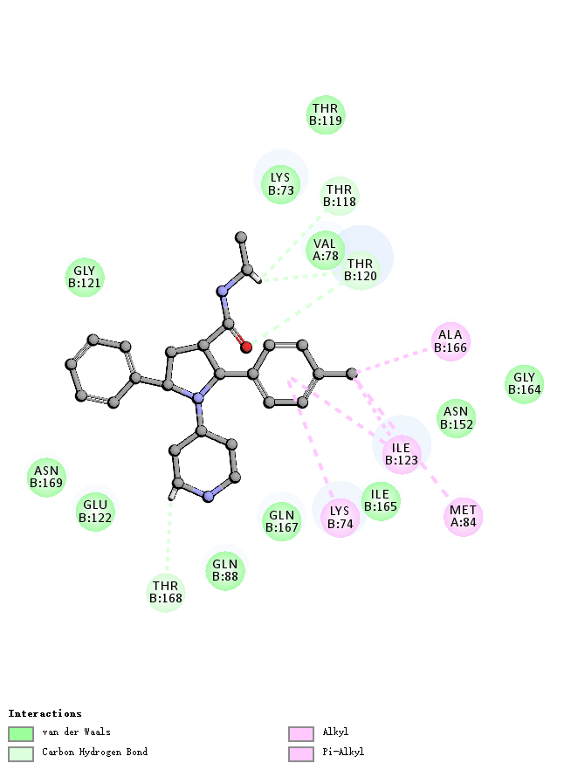
结合能：-4.56524 kcal/mol | 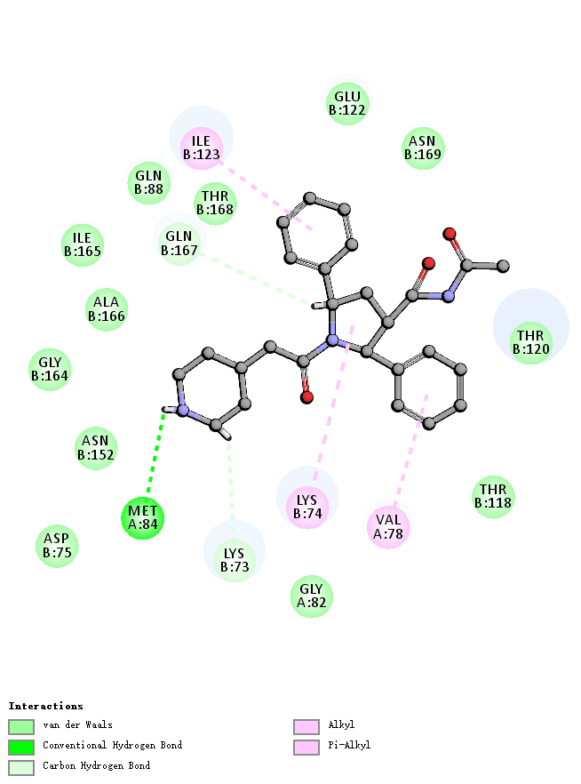
结合能：1.04077 kcal/mol | 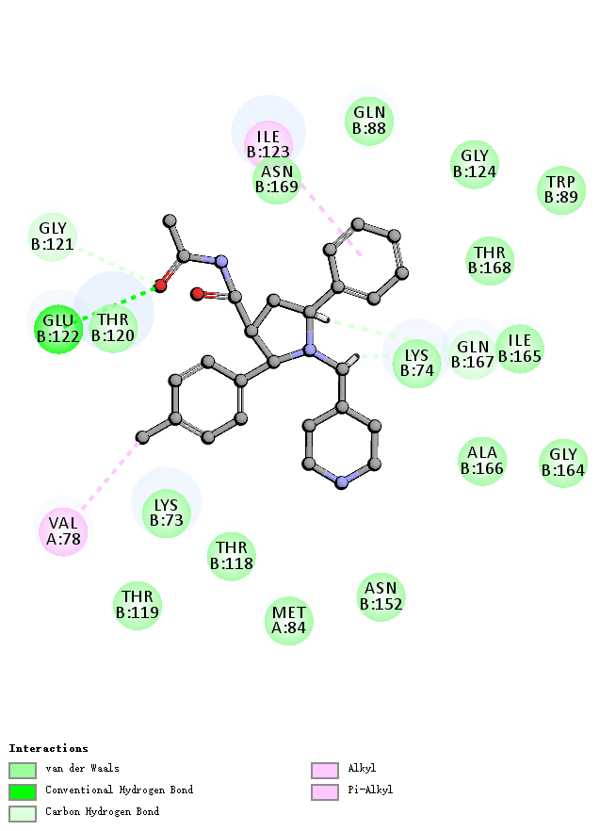
结合能：-2.25581 kcal/mol | 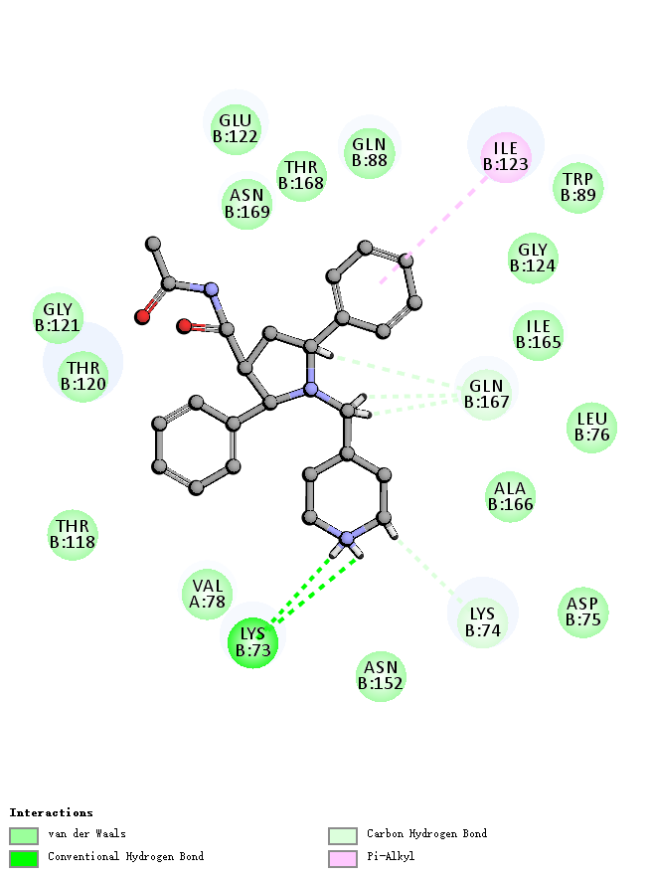
结合能：-16.8943 kcal/mol | 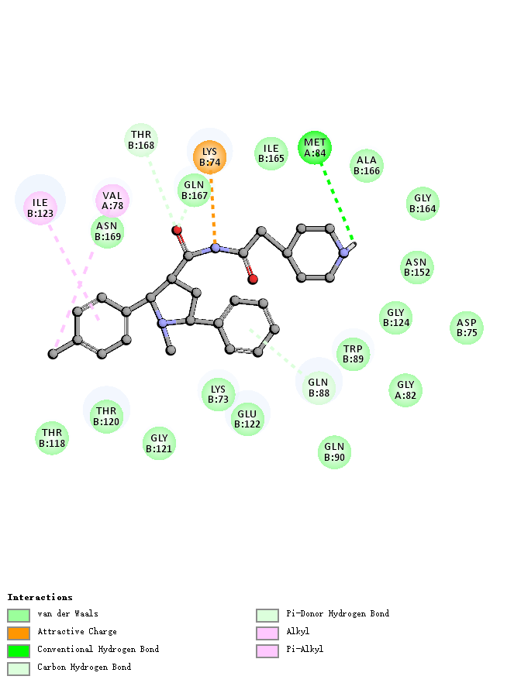
结合能：-8.42402 kcal/mol | 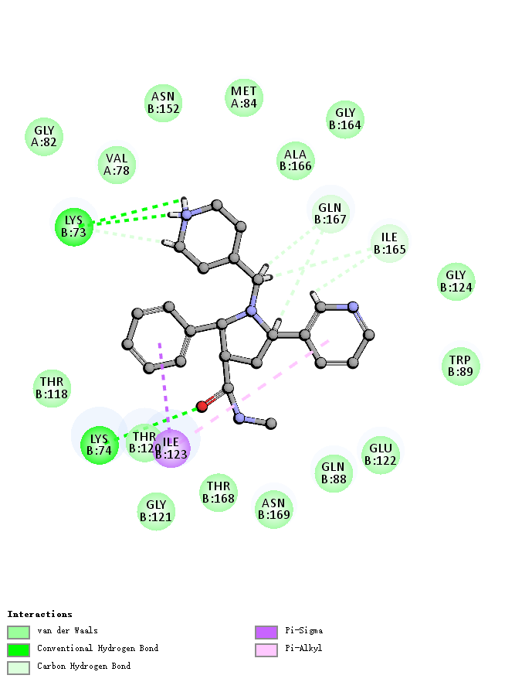
结合能：-0.763748 kcal/mol | 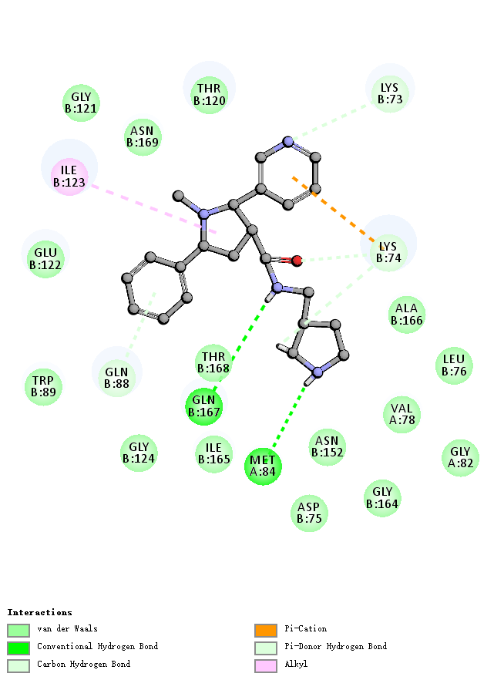
结合能：-1.08184 kcal/mol | 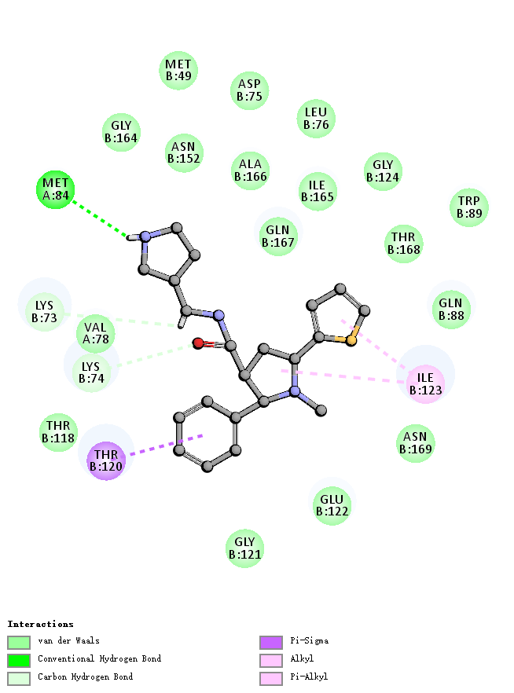
结合能：-27.3335 kcal/mol | 