# 快速做一个SUMO仿真

## 安装SUMO、Python，并配置好环境

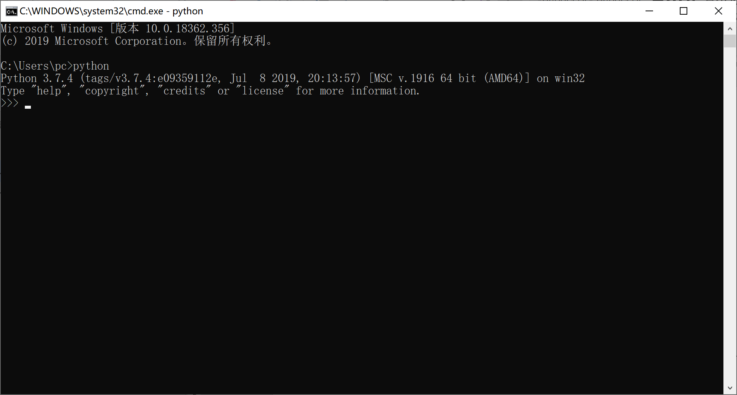

1、2部分命令可参考“GEN-NET+TRIPS-EXAMPLE.bat”

## 生成一个路网

netgenerate --grid --grid.number=4 --grid.length=400 --output-file= MySUMOFile_grid.net.xml

可用NetEdit打开MySUMOFile_grid.net.xml查看

## 生成该路网的Trips

python randomTrips.py -n MySUMOFilegrid2.net.xml -o map.rou.xml -e 1800 -l

## 配置tetst.sumocfg文件

<?xml version="1.0" encoding="UTF-8"?>

<!-- generated on Tue Apr 16 00:19:19 2019 by Eclipse SUMO Version 1.2.0

This data file and the accompanying materials

are made available under the terms of the Eclipse Public License v2.0

which accompanies this distribution, and is available at

http://www.eclipse.org/legal/epl-v20.html

SPDX-License-Identifier: EPL-2.0

-->

<configuration xmlns:xsi="http://www.w3.org/2001/XMLSchema-instance" xsi:noNamespaceSchemaLocation="http://sumo.dlr.de/xsd/sumoConfiguration.xsd">

<input>

<net-file value="MySUMOFile_grid3.net.xml"/>

<route-files value="map3.rou.xml"/>

</input>

<output>

<write-license value="true"/>

<vehroute-output value="vehroutes.xml"/>

</output>

<processing>

<default.speeddev value="0"/>

</processing>

<report>

<duration-log.disable value="true"/>

<no-step-log value="true"/>

</report>

</configuration>

## 运行仿真

用SUMOGUI打开tetst.sumocfg，开始仿真