**<Game Hub>**

**Software Requirement Specification (SRS)**

**<Version #2.0>**

**<2019.05.20>**

**<Marcus 1730026073**

**Scott 1730026090**

**Alan 1730026006**

**Lawrence 1730026045>**

**Computer Science and Technology Program**

**United International College**

1. Table of Contents

1. Table of Contents 2

2. Introduction 3

2.1. Purpose 3

2.2. Document Conventions 3

3. System Features 4

3.1. User login and registration – REQ1 4

3.2. Customer buy game and the order information – REQ2 5

3.3. Personal center – REQ3 7

3.4. Admin Center – REQ4 8

3.5. Games comment– REQ5 9

3.6. Searching function– REQ6 10

4. External Interface Requirements 12

4.1. User Interfaces 12

4.2. Hardware Interfaces 17

4.3. Communications Interfaces 17

5. Other Nonfunctional Requirements 18

5.1. Performance Requirements 18

5.2. Security Requirements 18

5.3. Software Quality Attributes 18

1. Introduction

## Purpose

***2.1*** *Vision Statement*

*The aim of this product is to create a game platform which can buy games, download games, share games, comment games, share games and other software. Let more people experience the fun of the games. Let more players find their game partners. Play, share, competition in the game world.*

***2.2*** *Scope*

*The scope of this project includes the development the update and maintain after the user bought the games. The platform will release related games information before the games publish. After the user bought the game, we can provide refund service if the player does not like this game in two hours. We do not develop the games, the Gamehub is platform let all the game makers sell their games. If the games have some bug or something need update. It also the thing the game developer should do, and the Gamehub will update the game information in the first time when the developer update*

***2.3*** *Background*

*Now there are many online games, console games, stand-alone games, VR games, etc. on the market. However, players sometimes want to download and purchase games from different developers. It is very inconvenient to create a game platform to integrate different games, which is convenient for players to purchase and download, and also enhance the competitiveness of small developers.*

***2.4*** *Client*

*For all game lovers and game developers*

## Document Conventions

The main body of this SRS document uses the font Calibri with size 11, italic. The main title of each parts uses the font Arial with size 12, bold.

In each main part, if the content is large and hierarchical, we use some sub-titles and sub-sub-titles to contain every small part. Each sub-title is indented one place below its parent-title. The serial number of every title is bold but the words of title may not which is decided by the importance of the title content. There is an empty line between paragraphs of each sub-title but the sub-sub-title and others does not.

Some parts that are not strongly hierarchical do not use sub-titles. These contents are divided into some paragraphs. Each paragraph is indented. If the first sentence of one paragraph is topic sentence or categorized sentence it is bold.

1. System Features

## User login and registration – REQ1

***System Design:*** *In the conceptual design phase, the designer views the data and processing requirements and constraints from the user's perspective, producing a conceptual model that reflects the user's perspective. Then convert the conceptual mode to logical mode. Separate conceptual design from the design process, making the tasks of each stage relatively singular, and the design complexity is greatly reduced, which is not limited by specific DBMS.*

*DBMS is generally relational, so the logical design process of the database is the process of transforming the ER diagram into a relational schema. Due to the advantages of the relational model, the logical design can make full use of the relational database normalization theory to make the design process formally. The design result is similar to the definition of a set of relational patterns. Such as the data dictionary.*

***System Development Environment:*** *Choosing a good programming language is very important. And we chose the MySQL language in this system. The MySQL language was chosen because of its powerful features that make it easy to separate the interface display from the business logic.*

*The running operate system can use Windows OS, the client connects to the local server, and the server system and client are updated regularly.*

***Connect to the Server:*** *Connect to the localhost (XAMMP), import data into the local database.*

***Data Transmission:*** *The client connects to the service, change and update data in the localhost.*

***3.1.1 Objective****: The purpose of the REQ1 is let visitor who want to browse the games, buy games , download games, comment on the game, in community comments and so on to registered and be a customer of product. And let customer who has already registered to login in.*

***3.1.2. Priority*** *– This requirement is high priority*

***3.1.3 Source*** *– The source of this use case is the customer*

***3.1.4 Actors*** *– An end user of the device (a customer) would be the relevant actor for this use case*

***3.1.5*** *Flow of events-*

***3.1.5.1 Basic Flow –***

***3.1.5.1.2*** *Visitor enter the website and browse the website, if he do not log in. Then click any icon will pop up login interface.*

***3.1.5.1.3*** *After pop up the login interface, if the visitor has already register, then he can input his account to login, if not the visitor can click the register icon to register*

***3.1.5.2 Alterative Flow – At step 3.1.5.1.3, the visitor decides not to login***

***3.1.5.2.1*** *Visitor presses cancel button*

***3.1.5.2.2*** *Website exits*

***3.1.5.3 Exception Flow – At step 3.1.5.1.3, the device encounters a problem***

***3.1.5.3.1*** *Website provide error message indicating need for repair*

***3.1.5.3.2*** *Website exits*

***3.1.6 Includes – None***

***3.1.7 Requirements –***

***3.1.7.1*** *The system shall provide the hint when the user register or login*

***3.1.7.2*** *The system shall display the account information and hide the password information when user register and login*

***3.1.7.3*** *The system shall store the account information of the user after they finish the register.*

***3.1.7.4*** *The system shall the error message if the user registers not according to the requirement*

***3.1.7.5*** *The system will correspond the user after register and login successful.*

***3.1.8 Preconditions*** *– Users click any icon in the website or click the top right corner “register” or “login” or “Personal center”*

***3.1.9 Post conditions – None***

***3.1.10 Nonfunctional requirements***

***3.1.10.1.1*** *Maximum allowed execution time for REQ1 use case is 3 seconds, starting at the time when the user presses the “register” or “login” button and ending when the user account information has been saved and displayed.*

***3.1.11*** *Notes/Issues – REQ1 is precondition about the buy, download games and so on*

***3.1.12*** *Special requirements – Always keep enough memory available so that the current customers account information be saved*

## Customer buy game and the order information – REQ2

***3.2.1 Objective****: When the user wants to buy some games and then pop up a window show the information about the games*

*the custom wants to buy, there are some pictures, word and videos information, And the customer can add this game to the shopping cart or buy this game directly.*

***3.2.2. Priority*** *– This requirement is medium priority*

***3.2.3 Source*** *– The source of the game developer*

***3.2.4 Actors*** *– An end user of the device (a customer) would be the relevant actor for this use case*

***3.2.5*** *Flow of events-*

***3.2.5.1 Basic Flow –***

***3.2.5.1.2*** *Visitor after the login, they can browse the game list and relevant games, if they want to know more about this game, then click the game picture. Then pop up a window about this game*

***3.2.5.1.3*** *After pop up the window, users can browse the game information, when the games interface pop up， it will play the video automatic, and user can click the video to stop and adjust the voice and rate of progress. User can roll the mouse to see the more information*

***3.2.5.1.4*** *User can click add to the shopping cart and buy the game directly, then will pop up window contain the interface of the order of the game*

***3.2.5.2 Alterative Flow – At step 3.2.5.1.3, the visitor decides not to buy***

***3.2.5.2.1*** *Visitor presses cancel button*

***3.2.5.2.2*** *Website exits*

***3.2.5.3 Exception Flow – At step 3.1.5.1.3, the device encounters a problem***

***3.2.5.3.1*** *Website provide error message when fail to buy game*

***3.2.5.3.2*** *Website exits*

***3.2.6 Includes – None***

***3.2.7 Requirements –***

***3.2.7.1*** *The system shall provide the game information interface*

***3.2.7.2*** *The system shall display the video information automatic*

***3.2.7.3*** *The system shall display the order information when user want to add or buy a game*

***3.2.7.4*** *The system shall the error message if the user buys a game without pay*

***3.2.7.5*** *The system will correspond the user after buy or add order successful*

***3.2.8 Preconditions*** *–User can browse the game information without login, but if the User want to add game or buy game, then he must login*

***3.2.9 Post conditions – None***

***3.2.10 Nonfunctional requirements***

***3.2.10.1.1*** *Maximum allowed execution time for REQ2 use case is 3 seconds, starting at the time when the user presses the “Game picture“ or “Game name” button*

***3.2.11*** *Notes/Issues – REQ2 can realize part of the function although the user not logged yet (Not depend on the REQ1).*

***3.2.12*** *Special requirements – Always keep enough memory available so that the current customers order information be saved*

## Personal center – REQ3

***3.3.1 Objective****: The requirement to show the information about the user which the user can see*

***3.3.2. Priority*** *– This requirement is medium priority*

***3.3.3 Source*** *– The source of this use case is the customer*

***3.3.4 Actors*** *– An end user of the device (a customer) would be the relevant actor for this use case and managers*

***3.3.5*** *Flow of events-*

***3.3.5.1 Basic Flow –***

***3.3.5.1.2*** *Visitor after finish the REQ1, then it will show the user head portrait, and user can click head portrait to enter to the personal center*

***3.3.5.1.3*** *After enter into the personal center, the user can see his game he has already bought, if no game will show “you hub has no game”*

***3.3.5.1.4*** *The personal center can also show the user order information*

***3.3.5.1.5*** *The personal center also can enter the community which the user can publish a blog or post a message.*

***3.3.5.1.6*** *In the personal center user can edit their own information like change the ID, head portrait, the label of the games which user like and so on*

***3.3.5.2 Alterative Flow –*** *The user can cancel the account and login another account.*

***3.3.5.2.1*** *Visitor presses cancel button*

***3.3.5.2.2*** *After close the website directly, the account will not keep.*

***3.3.5.3 Exception Flow – Personal center through the exception***

***3.3.5.3.1*** *Website provide error message indicating need for repair*

***3.3.6 Includes – None***

***3.3.7 Requirements –***

***3.3.7.1*** *The system shall provide the user personal center*

***3.3.7.2*** *The system shall display the account information and the user data.*

***3.3.7.3*** *The system shall display the game and game information the user has already bought*

***3.3.7.4*** *The system shall the error message if the user login failure or already change the password and need to login again*

***3.3.7.5*** *The game library can download the game you have ever bought*

***3.3.7.6*** *The personal center provides any kind of link to connect other interface.*

***3.3.8 Preconditions*** *– Users have already login*

***3.3.9 Post conditions – None***

***3.3.10 Nonfunctional requirements -None***

***3.3.11*** *Notes/Issues – REQ1 is precondition which users buy，download games and so on*

***3.3.12*** *Special requirements – Always keep enough memory available so that the current customers account information be saved*

## Admin Center – REQ4

***3.4.1 Objective****: Admin Center allow administrator to view the data of website, manage the website, see the user information, orders information and refund information, edit the game information which show in the homepage*

***3.4.2. Priority*** *– This requirement is high priority (miscellaneous function)*

***3.4.3 Source*** *– The source of this use case is the user*

***3.4.4 Actors*** *– An end user of the device (a customer, a player) would be the relevant actor for this use case and managers*

***3.4.5*** *Flow of events-*

***3.4.5.1 Basic Flow –***

***3.4.5.1.2****. Administrator input the admin account in login page and skip to the admin center*

***3.4.5.1.3 .*** *Administrator can see the data of website and user in the admin center*

***3.4.5.1.4*** *Any player comment or reply the information the publisher will have the message in Personal center to hint (REQ3)*

***3.4.5.2 Alterative Flow – The user can remove the message he has publish or comment in Personal center***

***3.4.5.2.1*** *The information removes cancel button*

***3.4.6 Includes – None***

***3.4.7 Requirements –***

***3.4.7.1*** *The system shall display update data when the website update*

***3.4.7.2*** *The system shall display update information when the administrator update the information in the admin center*

***3.4.7.3*** *The ordinary user can not enter into the admin center*

***3.4.8 Preconditions*** *– Users have already login (REQ1) and publish the message*

***3.4.9 Post conditions – None***

***3.4.10 Nonfunctional requirements -Users should edit the article and message by themselves***

***3.4.11******Notes/Issues – REQ1 is precondition when users want to publish articles***

***3.4.12 Special requirements – Always keep enough memory available so that the current message information be saved***

## Games comment– REQ5

***3.5.1 Objective****: Let player to comment the games, express their feel about this game, and they can also mark the game according to the game experience*

***3.5.2. Priority*** *– This requirement is medium priority (miscellaneous function)*

***3.5.3 Source*** *– The source of this use case is the player and managers*

***3.5.4 Actors*** *– An end user of the device (a customer, a player)*

***3.5.5*** *Flow of events-*

***3.5.5.1 Basic Flow –***

***3.5.5.1.2*** *The users click any game (specific game information interface) and find area of the comment (In the bottom of the game information interface)*

***3.5.5.1.3*** *The user can click “publish” button to publish some information (word, video, sound, picture and so on)*

***3.5.5.1.4*** *The other player can see this comment and support this comment; the greatest number of support comment will reveal to the users first.*

***3.5.5.1.5*** *Any users comment or reply the comment the commenter will have the message in Personal center to hint (REQ3)*

***3.5.5.2 Alterative Flow – The user can remove the comment he has publish or comment in Personal center***

***3.5.5.2.1*** *The comment removes cancel button*

***3.5.5.3 Exception Flow – If the comment publish fail, will pop up the error hint***

***3.5.5.3.1 The comment will not publish without the internet***

***3.5.6 Includes – None***

***3.5.7 Requirements –***

***3.5.7.1*** *The system shall provide area of the game information interface and let user to comment*

***3.5.7.2*** *The system shall display update comment when the user updates the interface*

***3.5.7.3*** *The system shall send hint when players are replied or commented by others player*

***3.5.7.4*** *The system shall the error message if the user publishes the comment failed or comment the message failed.*

***3.5.8 Preconditions*** *– Users have already login (REQ1) and*

***3.5.9 Post conditions – None***

***3.5.10 Nonfunctional requirements -Users should edit the comment by themselves***

***3.5.11******Notes/Issues – REQ1 is precondition when users want to publish comments***

***3.5.12 Special requirements – Always keep enough memory available so that the current message information be saved***

## Searching function– REQ6

***3.6.1 Objective****: The search function can use in any interface like main game interface, community, order interface and so on except personal interface. The purpose users more convenient to browse the website and search the game or message they want faster.*

***3.6.2. Priority*** *– This requirement is medium priority (miscellaneous function)*

***3.6.3 Source*** *– The game message and community message store in the database,*

***3.6.4 Actors*** *– An end user of the device (a customer, a player) and manager*

***3.6.5*** *Flow of events-*

***3.6.5.1 Basic Flow –***

***3.6.5.1.2*** *The search message input field show in the top right corner of the interfaces, the user can click the field and input the message their want to search*

***3.6.5.1.3*** *When the user input the message their can click search button to search the information*

***3.6.5.1.5*** *After the user click the search button, the interface will show the relevant information the user input or skip to other interface the relevant information show.*

***3.6.5.2 Alterative Flow – The input field can show the history search information when users click.***

***3.6.5.2.1*** *The history will show if the user not remove*

***3.6.5.3 Exception Flow – If there are no relevant message matching will show nothing***

***3.5.5.3.1 It will show nothing when there is no relevant message exist***

***3.6.6 Includes – None***

***3.6.7 Requirements –***

***3.6.7.1*** *The system shall provide search function for any interface except personal center*

***3.6.7.2*** *The system shall link the database with search result (The database is invisible for the users)*

***3.6.7.3*** *The system shall show the relevant message when finish the searching*

***3.6.7.4*** *The system shall should nothing when there is no relevant message matching*

***3.6.8 Preconditions*** *– Users do not need to login in some interface when they want to search some information like main interface to search the game*

***3.6.9 Post conditions – The relevant search information should match the database***

***3.6.10 Nonfunctional requirements -Users should search the information by themselves***

***3.6.11******Notes/Issues – If there are no relevant message will show nothing***

***3.6.12 Special requirements – The result of the searching can only search the message in the database***

1. External Interface Requirements

## User Interfaces

*The user interface has been specifically designed for our customers and make them have a comfortable, relaxed and wonderful feeling when they browsing the shop page, buy and get their favorite games. It allows our customers to directly get and enjoy what they really want without wasting time on pointless pages and features.*

***Program interface:***

*Browser: Google Chrome, Safari, Opera.*

*System: Windows, Linux, macOS.*

***Graphics Interface:***

***For a customer who has already had an account****. He or she can login in in the login page like Figure – 4 – 1 – 1. The user can choose whether to remember this account.*

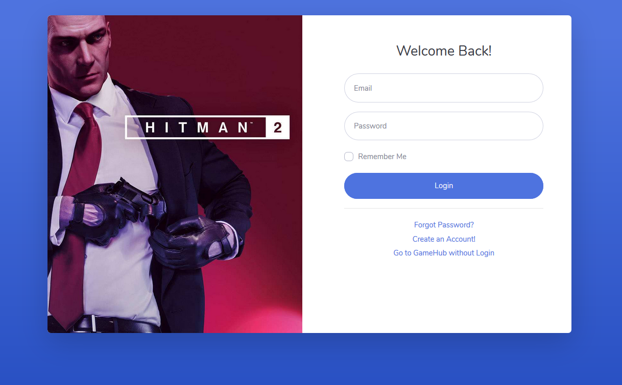

*Figure – 4 – 1 – 1*

*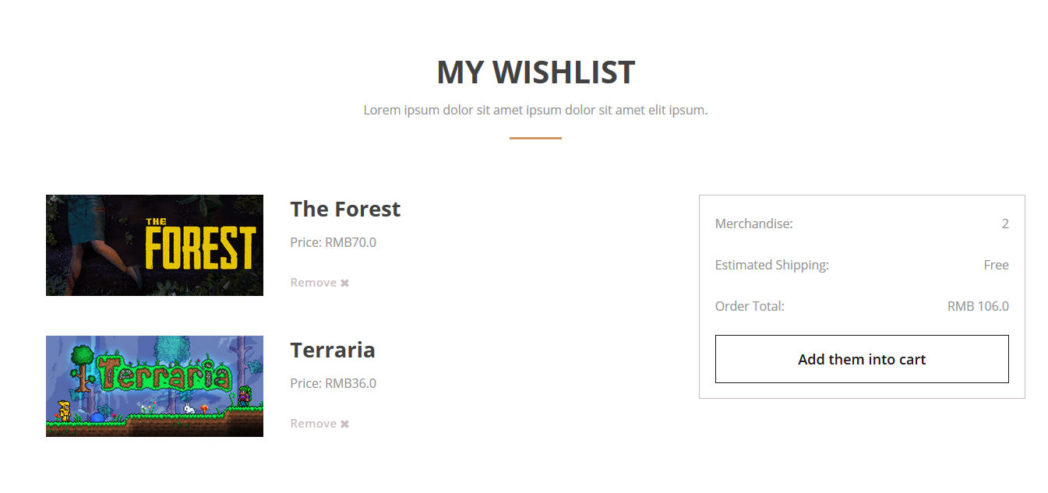Users can view their wish list in this page like Figure – 4 – 1 – 2. User can click the Add them into Cart button to add the games to their cart. User can click the remove button to delete this game from his/her wish list.*

*Figure – 4 – 1 – 2*

*Customers can also see the shopping cart like Figure – 4 – 1 – 3. Consumers can click the Proceed to cheque out button to check out these games in their carts. User can click the remove button to delete this game from his/her cart.*

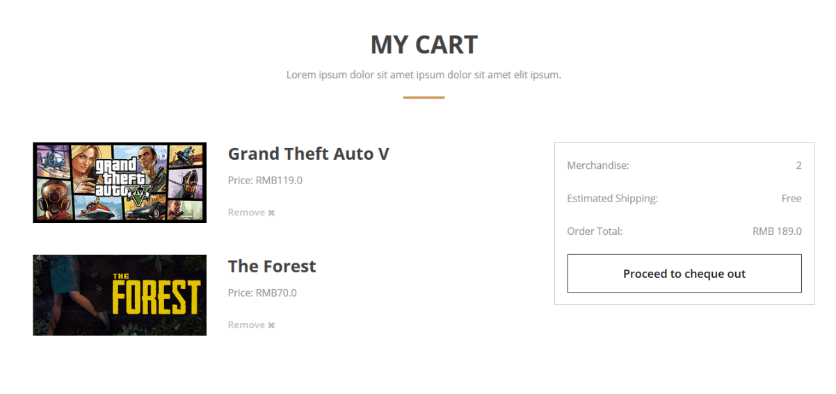

*Figure – 4 – 1 – 3*

*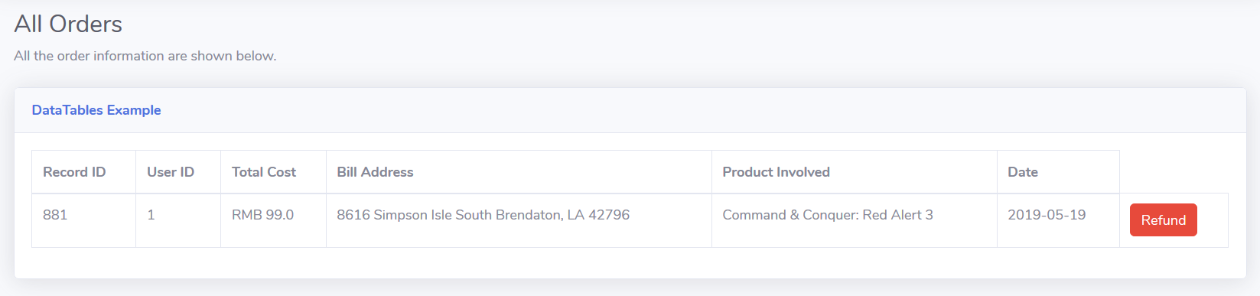In this page users can see their orders in a table like Figure – 4 – 1 – 4. If they want to refund some games just click the Refund button and it will show some details like Figure – 4 – 1 – 5 for the users if they clearly want to refund the games they want.*

*Figure – 4 – 1 – 4*

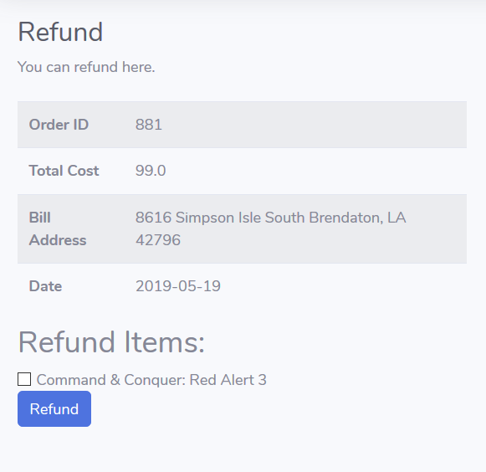

*Figure – 4 – 1 – 5*

***For a customer who has not already had an account****. He or she can register in in the register page like Figure – 4 – 1 – 6. The user has to use his/her real e-mail address to create a new account.*

*For a customer who has already had an account but forget the password. He or she can use the reset page like Figure – 4 – 1 – 7. The user has to use his/her real e-mail address to reset a new password.*

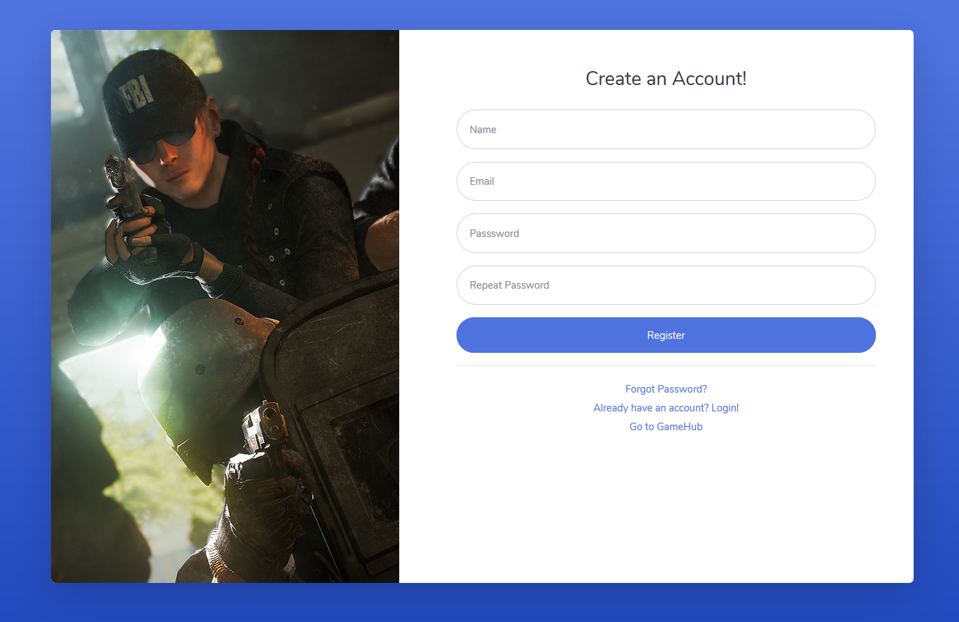

*Figure – 4 – 1 – 6*

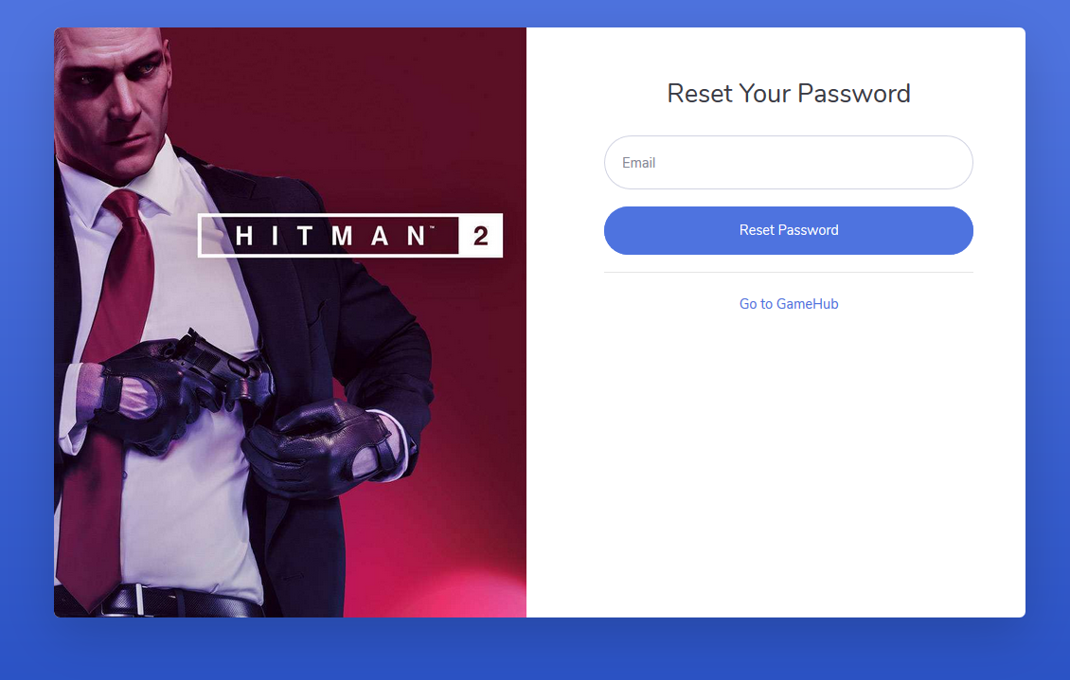

*Figure – 4 – 1 – 7*

*Customers can find and edit some personal information in the My Account page like Figure – 4 – 1 – 8. Some detailed operations will be written in the Manual.*

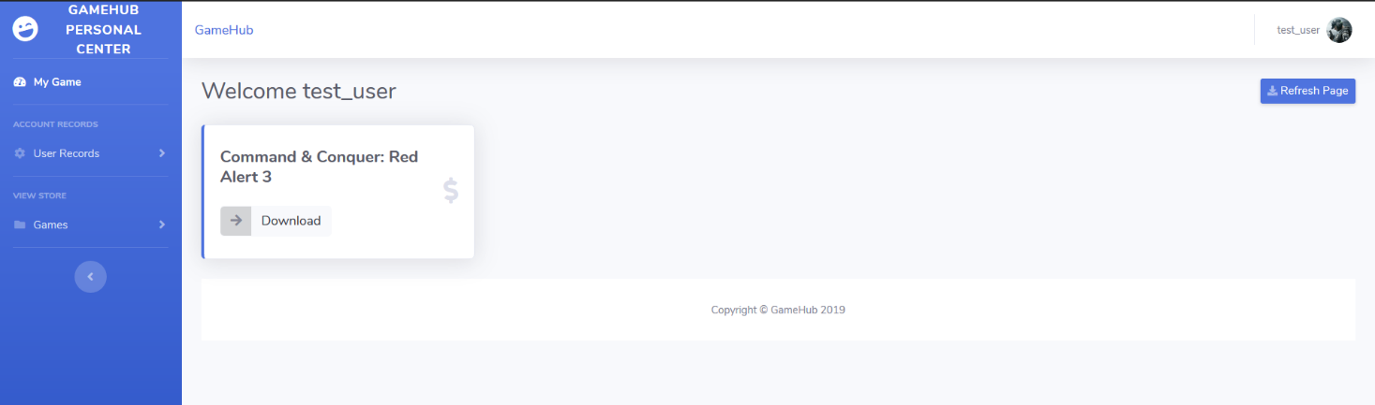

*Figure – 4 – 1 – 8*

## Hardware Interfaces

***USB/USB2.0 interface.*** *Customers need USB or USB2.0 cable to connect their devices like mouse and keyboard.*

***Type-C/Lightning.*** *Some laptop and mobile devices need these two interfaces to connect their devices like mouse, keyboard and earphone.*

***TRRS interface.*** *Some devices need headset interface to display the sounds of videos.*

## Communications Interfaces

***Ethernet.*** *Including SC, RJ-45 and others which can get information from LAN (Local Area Network).*

***USB.*** *Using USB interface to upload or download information between portable storage devices and website or database information.*

***Wireless.*** *The devices can be connected to the wireless router or connected to the WIFI hotspot of the mobile phone to form a network.*

1. Other Nonfunctional Requirements

## Performance Requirements

**5.1.1** Requirements for time:

Response time: instant

The frequency of the data update: larger data changes will be made at the right time

Data conversion and transfer time: instant

Problem solving time: no more than 0.5 minutes

The system must perform as what every user expects. There will be no immediate delays in the every action response. In case of opening windows forms, of popping error messages and saving the settings or sessions there is delay much below 2 seconds. In case of opening databases, sorting questions and computing, there should be no delays and all the operations are performed in less than 2 seconds for opening, computing and sorting processes > 95% of the files. Also when connecting to the server the delay is based on the distance of the two systems and the configuration between them so there is high probability that there will be or not a successful connection in less than 20 second.

**5.1.2** Requirements for handling user access

The system is required to support multiple terminals simultaneously. The system should handle reasonable number of users without break or inconsistency.

## Security Requirements

**5.2.1** Authentication specifications for products:

Each user has a unique and compliant username (Email address), and has a compliant password (which can be the same as other users’). Username (Email address) and password matching is the only way to authenticate.

**5.2.2** Prevent unauthorized access to system functions:

The development member will specify some pages that can be accessed directly via the URL (E.X. such as login page, re-login interface, etc.). When the user does not attempt to access the protected URL by logging in, the filter will intercept the request and access it. The URL is redirected to the login page. At any time, the administration system should be accessed only by the authenticated users. Network communications should use cryptographic protocols such as SSL. Automated responses should be restricted using CAPTCHA.

**5.2.3** If data loss occurs, the user is required to re-identify:

When the cookie temporarily stored in the browser and the login information such as the session are lost, the user needs to be forced to re-authenticate the identity required for login. The system is required to end the session automatically, when an open session is not used for a specific period of time.

**5.2.4** Backup of website data:

The source code of the website and the information of the users, orders, and products stored in the database will be backed up regularly.

***5.2.5*** *Data encryption of the website:*

*The data transmission of the website and the database will be encrypted.*

## Software Quality Attributes

***5.3.1*** *adaptability*

*The interface of the system should be not complicated for the users. And all the functions of the system should also be easy enough to access to for the users*

***5.3.2*** *availability & correctness*

*The every function of the system should have past complete and enough tests to make sure that they can operate successfully. The entire system should be available round the year, except for a periodic maintenance. The maintenance period should be scheduled ahead of time and short. The users should be reminded of the unavailability period, well in advance*

***5.3.3*** *interoperability*

*The structure of the codes of the system should be carefully developed to make sure that it can be clear enough for the programmer team to edit when the work need to be divided into parts.*

***5.3.4*** *reusability*

*If possible, there should be appropriate encapsulation of the original codes. The functions should be designed to be possible to be reused or easily edited to be applied in the development of*

***5.3.5*** *Portability*

*The system should support new versions of the related browsers. The administrative and server*

*technologies should be standard and supported by most platform*

***5.3.6*** *flexibility*

*The web should be designed to be easy to be transferred from windows operation system to Linux, mac OS, Android and so on.*

***5.3.7*** *Maintainability*

*The document should be designed to be easy for the users of this system, for the developers who wish to edit or develop further, and for the personnel who is in charge of the maintenance.*

***5.3.8*** *Usability*

*The GUI should be easy to learn and use by users of any technical background. A built-in help feature should be available in all pages, to guide the users with the available functions on that page. An easy to understand documentation should be provided with the system. System should support several languages.*

***5.3.9*** *Reliability*

*The system should work reliably, with automatic backup and recovery features. In case of unexpected termination of a session, the unsaved data should be recovered without loss and displayed to the respective users for saving into the system or continuing with the work. At any time, audit file and all databases and mailing information are required to be updated in the backup.*