Problem 4
- SQL:
SELECT
Ssn,
Fname,
Lname,
Salary
FROM EMPLOYEE
WHERE Sex = 'F'
AND Salary >= 25000
ORDER BY
Salary DESC,
Lname ASC;

Result:
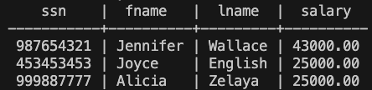
(b) SQL:
SELECT
Fname,
Lname,
Bdate,
Address
FROM EMPLOYEE
WHERE Bdate < DATE '1965-01-01'
AND Lname LIKE '%e';

Result:
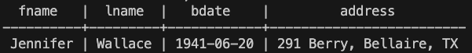
(c) SQL:
SELECT
P.Pnumber,
P.Pname,
P.Plocation,
D.Dname,
D.Mgr_ssn
FROM PROJECT P
JOIN DEPARTMENT D
ON P.Dnum = D.Dnumber
WHERE D.Mgr_start_date >= DATE '1980-01-01';

Result:
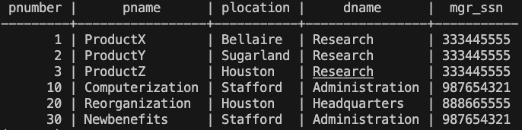

(d) SQL:
SELECT
P.Pnumber,
P.Pname,
COUNT(W.Essn) AS EmployeeCount,
SUM(W.Hours) AS TotalHours
FROM PROJECT P
JOIN WORKS_ON W
ON P.Pnumber = W.Pno
GROUP BY
P.Pnumber,
P.Pname
HAVING COUNT(W.Essn) >= 2;

Result:
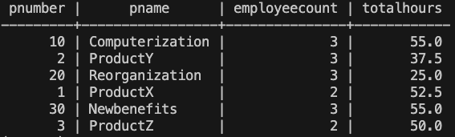

(e) SQL:
SELECT DISTINCT
E.Ssn,
E.Fname,
E.Lname,
D.Dname
FROM EMPLOYEE E
JOIN WORKS_ON W
ON E.Ssn = W.Essn
JOIN PROJECT P
ON W.Pno = P.Pnumber
JOIN DEPARTMENT D
ON E.Dno = D.Dnumber
WHERE E.Dno <> P.Dnum;

Result:
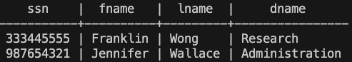

(f) SQL:
SELECT
S.Ssn,
S.Fname,
S.Lname,
COUNT(E.Ssn) AS DirectReportCount,
AVG(E.Salary) AS AverageSalary
FROM EMPLOYEE S
JOIN EMPLOYEE E
ON S.Ssn = E.Super_ssn
GROUP BY
S.Ssn,
S.Fname,
S.Lname
ORDER BY
DirectReportCount DESC,
S.Ssn ASC;

Result:
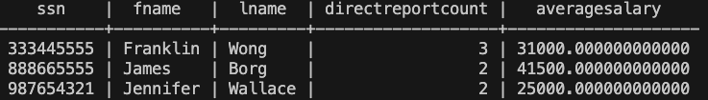

(g) SQL:
SELECT
D.Dnumber,
D.Dname,
COUNT(E.Ssn) AS EmployeeCount,
AVG(E.Salary) AS AverageSalary
FROM DEPARTMENT D
JOIN EMPLOYEE E
ON D.Dnumber = E.Dno
GROUP BY
D.Dnumber,
D.Dname
HAVING COUNT(E.Ssn) >= 3
ORDER BY
AverageSalary DESC;

Result:
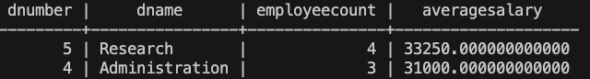

(h) SQL:
SELECT
E.Ssn,
E.Fname,
E.Lname,
COUNT(W.Pno) AS ProjectCount,
SUM(W.Hours) AS TotalHours
FROM EMPLOYEE E
JOIN WORKS_ON W
ON E.Ssn = W.Essn
GROUP BY
E.Ssn,
E.Fname,
E.Lname
HAVING COUNT(W.Pno) >= 2
ORDER BY
ProjectCount DESC,
E.Ssn ASC;

Result:
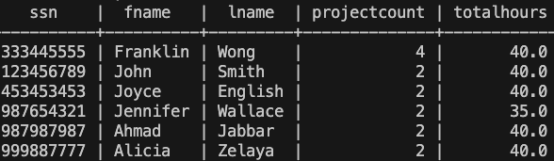

Problem5
Table 1: Data Dictionary for EMPLOYEE

Column Name | Meaning | Data Type | Key | Constraint | Domain
Fname | Employee's first name | VARCHAR(50) |  | NOT NULL | String
Minit | Employee's middle initial | CHAR(1) |  |  | Single character
Lname | Employee's last name | VARCHAR(50) |  | NOT NULL | String
Ssn | Employee's social security number | CHAR(9) | PK | NOT NULL, UNIQUE | 9-character SSN
Bdate | Employee's birth date | DATE |  |  | Valid date
Address | Employee's address | VARCHAR(255) |  |  | String
Sex | Employee's sex | CHAR(1) |  |  | M, F
Salary | Employee's salary | NUMERIC(10,2) |  |  | Numeric value
Super_ssn | Supervisor's SSN | CHAR(9) | FK: EMPLOYEE(Ssn) |  | Existing employee SSN
Dno | Department number | INTEGER | FK: DEPARTMENT(Dnumber) | NOT NULL, Default (1) | Existing department number

Referential Triggers
Foreign Key | On Delete | On Update
Super_ssn: EMPLOYEE(Ssn) | SET NULL | CASCADE
Dno: DEPARTMENT(Dnumber) | SET DEFAULT | CASCADE

Table 2: Data Dictionary for DEPARTMENT
Column Name | Meaning | Data Type | Key | Constraint | Domain
Dname | Department name | VARCHAR(50) |  | NOT NULL, UNIQUE | String
Dnumber | Department number | INTEGER | PK | NOT NULL, UNIQUE | Integer
Mgr_ssn | Department manager's SSN | CHAR(9) | FK: EMPLOYEE(Ssn) | NOT NULL, Default ('888665555') | Existing employee SSN
Mgr_start_date | Manager's start date | DATE |  |  | Valid date

Referential Triggers
Foreign Key | On Delete | On Update
Mgr_ssn: EMPLOYEE(Ssn) | SET DEFAULT | CASCADE

Table 3: Data Dictionary for DEPT_LOCATIONS
Column Name | Meaning | Data Type | Key | Constraint | Domain
Dnumber | Department number | INTEGER | PK, FK: DEPARTMENT(Dnumber) | NOT NULL | Existing department number
Dlocation | Department location | VARCHAR(50) | PK | NOT NULL | String

Primary Key: (Dnumber, Dlocation)

Referential Triggers
Foreign Key | On Delete | On Update
Dnumber: DEPARTMENT(Dnumber) | CASCADE | CASCADE

Table 1: Data Dictionary for PROJECT
Column Name | Meaning | Data Type | Key | Constraint | Domain
Pname | Project name | VARCHAR(50) |  | NOT NULL, UNIQUE | String
Pnumber | Project number | INTEGER | PK | NOT NULL, UNIQUE | Integer
Plocation | Project location | VARCHAR(50) |  |  | String
Dnum | Controlling department number | INTEGER | FK: DEPARTMENT(Dnumber) | NOT NULL | Existing department number

Referential Triggers
Foreign Key | On Delete | On Update
Dnum: DEPARTMENT(Dnumber) | CASCADE | CASCADE

Table 5: Data Dictionary for WORKS_ON
Column Name | Meaning | Data Type | Key | Constraint | Domain
Essn | Employee's SSN | CHAR(9) | PK, FK: EMPLOYEE(Ssn) | NOT NULL | Existing employee SSN
Pno | Project number | INTEGER | PK, FK: PROJECT(Pnumber) | NOT NULL | Existing project number
Hours | Hours worked on the project | NUMERIC(5,1) |  |  | Numeric value

Primary Key: (Pno, Essn)

Referential Triggers
Foreign Key | On Delete | On Update
Essn: EMPLOYEE(Ssn) | CASCADE | CASCADE
Pno: PROJECT(Pnumber) | CASCADE | CASCADE

Table 6: Data Dictionary for DEPENDENT
Column Name | Meaning | Data Type | Key | Constraint | Domain
Essn | Employee's SSN | CHAR(9) | PK, FK: EMPLOYEE(Ssn) | NOT NULL | Existing employee SSN
Dependent_name | Dependent's name | VARCHAR(100) | PK | NOT NULL | String
Sex | Dependent's sex | CHAR(1) |  |  | M, F
Bdate | Dependent's birth date | DATE |  |  | Valid date
Relationship | Relationship to employee | VARCHAR(100) |  |  | String

Primary Key: (Essn, Dependent_name)

Referential Triggers
Foreign Key | On Delete | On Update
Essn: EMPLOYEE(Ssn) | CASCADE | CASCADE

