- Usage Environment
1.1 System:
Ubuntu 22.04
1.2 Ros2 version:
humble

- CAN Adapter Connection Method
2.1 Connection between CAN adapter and Chassis:
The CAN-H of the chassis is connected to the CANH of the CAN adapter’s wire, and the CAN-L of the chassis is connected to the CANL of the CAN adapter’s wire, as shown in the diagram below:
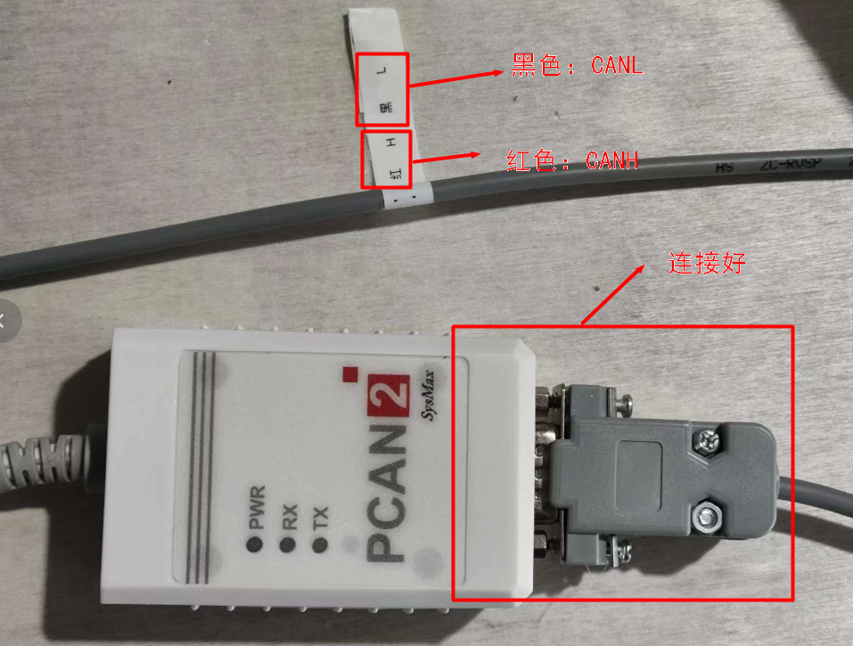
2.2 Connection between CAN Adapter and Computer:
One end of the USB cable is directly plugged into the computer's USB port.

- CAN Adapter Configuration:
  - After connecting the CAN adapter to the computer, the PWR light is on.
  - Open a terminal and enter "lsusb". You will see: "PEAK System PCAN-USB".

3.3 Then enter "sudo ip link set can0 up type can bitrate 500000". At this point, with the chassis powered on, the blue RX light will blink, and the red TX light will also be on. Blinking of the RX light indicates that the CAN adapter is receiving data, and blinking of the TX light indicates data transmission.

- Data Viewing
4.1 Installation of Tools:
4.2 Viewing

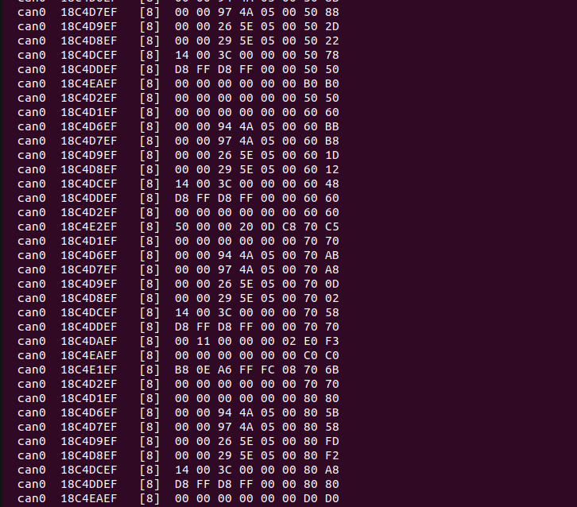

- Program Execution
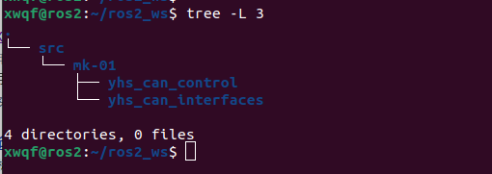
5.1 File Storage:

5.2 Compile:
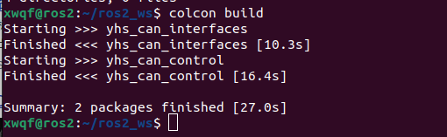
5.3 Setting Environment Variables:
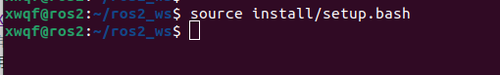
5.4 Running:
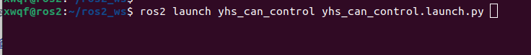
After printing this line in the terminal, there is no further output, indicating that data reception is normal:

- Data Transmission
6.1 Using the rqt_publisher tool, switch the remote controller to command control mode. It is recommended to lift the chassis for testing.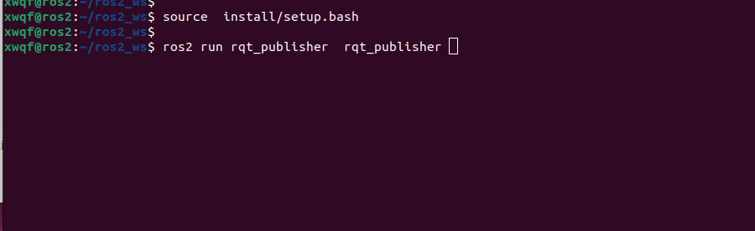

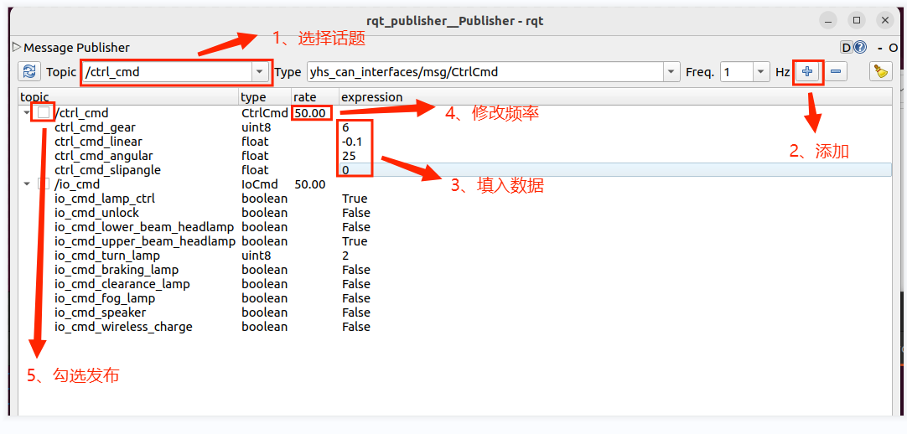

- Topic Description
7.1 Speed control, the publishing frequency should be above 30Hz.
Message Type | yhs_can_interfaces/msg/CtrlCmd
Topic Name | ctrl_cmd
Variable | Type | Description
ctrl_cmd_gear | uint8 | Target Gear  00: disable  01: Gear Parking  02: Gear Neutral  06: Gear 4T4D  08: Gear Parallel Moving
ctrl_cmd_x_linear | float32 | Target vehicle X-axis linear velocity  Unit: m/s
ctrl_cmd_z_angular | float32 | Target vehicle Z-axis angular velocity  Unit: °/s
ctrl_cmd_y_linear | float32 | Target vehicle Y-axis linear velocity  Unit: m/s

7.2 Speed control, the publishing frequency should be above 30Hz.
Message Type | yhs_can_interfaces/msg/SteeringCtrlCmd
Topic Name | steering_ctrl_cmd
Variable | Type | Description
ctrl_cmd_gear | uint8 | Target Gear  00: disable  01: Gear Parking  02: Gear Neutral  05: Gear 4T4D  07: Gear Parallel Moving
steering_ctrl_cmd_velocity | float32 | Target vehicle steering wheel’s velocity  Unit: m/s
steering_ctrl_cmd_steering | float32 | Target vehicle steering wheel’s angle  Unit: °

7.3 IO Control, some are reserved, the chassis may not have this function.
Message Type | yhs_can_interfaces/msg/IoCmd
Topic Name | io_cmd
Variable | Type | Description
io_cmd_lamp_ctrl | bool | Lamp control  0 = automatic control according to status  1 = free control
io_cmd_unlock | bool | Safety parking unlock switch  0 = invalid  1 = unlock enable
io_cmd_lower_beam_headlamp | bool | Lower beam switch  0 = off  1 = on
io_cmd_upper_beam_headlamp | bool | Upper beam switch  0 = off  1 = on
io_cmd_turn_lamp | uint8 | Steering lamp switch  0 = off  1 = left steering lamp on  2 =right steering lamp on
io_cmd_braking_lamp | bool | Braking lamp switch  0 = off  1 = on
io_cmd_clearance_lamp | bool | Clearance lamp switch  0 = off  1 = on
io_cmd_fog_lamp | bool | Fog lamp switch  0 = off  1 = on
io_cmd_speaker | bool | Speaker switch  0 = off  1 = on
io_cmd_wireless_charge | bool

7.4 Chassis Data Subscription, some are reserved, the chassis may not have this data feedback.
Message Type | yhs_can_interfaces/msg/ChassisInfoFb
Topic Name | chassis_info_fb
Variable | Type | Description
ctrl_fb.ctrl_fb_gear | uint8 | Current gear feedback  00: disable  01: Gear Parking  02: Gear Neutral  06: Gear 4T4D  08: Gear Parallel Moving
ctrl_fb.ctrl_fb_x_linear | float32 | Current linear X-axis linear velocity feedback  Unit: m/s
ctrl_fb.ctrl_fb_z_angular | float32 | Current Z-axis angular velocity feedback  Unit: °/s
ctrl_fb.ctrl_fb_y_linear | float32 | Current Y-axis linear velocity feedback  Unit: m/s
steering_ctrl_fb.steering_ctrl_fb_gear | uint8 | 00：disable  01：Gear Parking  02：Gear Neutral  05：Gear 4T4D  07：Gear Parallel Moving
steering_ctrl_fb.steering_ctrl_fb_velocity | float32 | Current steering wheel’s velocity feedback  Unit: m/s
steering_ctrl_fb.steering_ctrl_fb_steering | float32 | Current steering wheel’s angle feedback  Unit: °
io_fb.io_fb_lamp_ctrl | bool | Light control status feedback  0 = automatic control according to status  1 = free control
io_fb.io_fb_unlock | bool | Unlock status  feedback  0 = invalid  1 = Unlock succeeded
io_fb.io_fb_lower_beam_headlamp | bool | Lower beam status switch feedback  0 = off  1 = on
io_fb.io_fb_upper_beam_headlamp | bool | Upper beam status switch feedback  0 = off  1 = on
io_fb.io_fb_turn_lamp | uint8 | Steering lamp power switch status feedback  0 = off  1 = left steering lamp on  2 = right steering lamp on
io_fb.io_fb_braking_lamp | bool | Braking lamp power switch status feedback  0 = off  1 = on
io_fb.io_fb_clearance_lamp | bool | Clearance lamp switch status feedback  0 = off  1 = on
io_fb.io_fb_fog_lamp | bool | Fog lamp switch status feedback  0 = off  1 = on
io_fb.io_fb_speaker | bool | Speaker switch status feedback  0 = off  1 = on
io_fb.io_fb_fl_impact_sensor | bool | Front left anti-collision strip switch status feedback  0 = off  1 = on
io_fb.io_fb_fm_impact_sensor | bool | Front central anti-collision strip switch status feedback  0 = off  1 = on
io_fb.io_fb_fr_impact_sensor | bool | Front right anti-collision strip switch status feedback  0 = off  1 = on
io_fb.io_fb_rl_impact_sensor | bool | Rear left anti-collision strip switch status feedback  0 = off  1 = on
io_fb.io_fb_rm_impact_sensor | bool | Rear central anti-collision strip switch status feedback  0 = off  1 = on
io_fb.io_fb_rr_impact_sensor | bool | Rear right anti-collision strip switch status feedback  0 = off  1 = on
io_fb.io_fb_fl_drop_sensor | bool | Front left drop sensor status feedback  0 = off  1 = on
io_fb.io_fb_fm_drop_sensor | bool | Front central drop sensor status feedback  0 = off  1 = on
io_fb.io_fb_fr_drop_sensor | bool | Front right drop sensor status feedback  0 = off  1 = on
io_fb.io_fb_rl_drop_sensor | bool | Rear left drop sensor status feedback  0 = off  1 = on
io_fb.io_fb_rm_drop_sensor | bool | Rear central drop sensor status feedback  0 = off  1 = on
io_fb.io_fb_rr_drop_sensor | bool | Rear right drop sensor status feedback  0 = off  1 = on
io_fb.io_fb_estop | bool | Emergency stop status feedback  0 = off  1 = on
io_fb.io_fb_joypad_ctrl | bool | Remote controller status feedback  0 = off  1 = on
io_fb.io_fb_charge_state | bool | Charging station status feedback  0 = off  1 = on
lr_wheel_fb.lr_wheel_fb_velocity | float32 | Current front left wheel speed feedback  Unit: m/s
lr_wheel_fb.lr_wheel_fb_pulse | int32 | Current left front wheel pulse feedback  N pulses for single wheel per turn,N = encoder lines * reduction ratio
rr_wheel_fb.r_wheel_fb_velocity | float32 | Current right rear wheel velocity feedback  Unit: m/s
rr_wheel_fb.r_wheel_fb_pulse | int32 | Current right rear wheel pulse feedback  N pulses for single wheel per turn,N = encoder lines * reduction ratio
lf_wheel_fb.lf_wheel_fb_velocity | float32 | Current left front wheel velocity feedback  Unit: m/s
lf_wheel_fb.lf_wheel_fb_pulse | int32 | Current left front wheel pulse feedback  Each wheel has 200,000 pulses per revolution, encoder with 2500 lines, 4x frequency, and a gear reduction ratio of 20.  Unit: 1
rf_wheel_fb.rf_wheel_fb_velocity | float32 | Current right front wheel velocity feedback  Unit: m/s
rf_wheel_fb.rf_wheel_fb_pulse | int32 | Current right front wheel pulse feedback  Each wheel has 200,000 pulses per revolution, encoder with 2500 lines, 4x frequency, and a gear reduction ratio of 20.  Unit: 1
front_angle_fb.front_angle_fb_l | float32 | Left front servo joint angle feedback  Unit: °
front_angle_fb.front_angle_fb_r | float32 | Right front servo joint angle feedback  Unit: °
rear_angle_fb. rear_angle_fb_l | float32 | Left rear servo joint angle feedback  Unit: °
rear_angle_fb.rear_angle_fb_r | float32 | Right rear servo joint angle feedback  Unit: °
bms_flag_fb.bms_flag_fb_soc | uint8 | Current percentage of remaining power
bms_flag_fb.bms_flag_fb_single_ov | bool | Single cell overvoltage protection  0 = off  1 = on
bms_flag_fb.bms_flag_fb_single_uv | bool | Single cell undervoltage protection  0 = off  1 = on
bms_flag_fb.bms_flag_fb_ov | bool | Whole group overvoltage protection  0 = off  1 = on
bms_flag_fb.bms_flag_fb_uv | bool | Whole group undervoltage protection  0 = off  1 = on
bms_flag_fb.bms_flag_fb_charge_ot | bool | High temperature protection during charging  0 = off  1 = on
bms_flag_fb.bms_flag_fb_charge_ut | bool | Low temperature protection during charging  0 = off  1 = on
bms_flag_fb.bms_flag_fb_discharge_ot | bool | Over-temperature protection during discharge  0 = off  1 = on
bms_flag_fb.bms_flag_fb_discharge_ut | bool | Low temperature protection during discharge.  0 = off  1 = on
bms_flag_fb.bms_flag_fb_charge_oc | bool | Over current protection during charging  0 = off  1 = on
bms_flag_fb.bms_flag_fb_discharge_oc | bool | Over current protection during discharging  0 = off  1 = on
bms_flag_fb.bms_flag_fb_short | bool | Short circuit protection  0 = off  1 = on
bms_flag_fb.bms_flag_fb_ic_error | bool | Front-end detection IC error.  0 = off  1 = on
bms_flag_fb.bms_flag_fb_lock_mos | bool | Software lock MOS  0 = off  1 = on
bms_flag_fb.bms_flag_fb_charge_flag | bool | Charging flag bit  0 = off  1 = on
bms_flag_fb.bms_flag_fb_hight_temperature | float32 | The highest temperature of battery
bms_flag_fb.bms_flag_fb_low_temperature | float32 | The lowest temperature of battery
bms_fb.bms_fb_voltage | float32 | Current battery voltage  Unit: V
bms_fb.bms_fb_current | float32 | Current battery current  Unit: A
bms_fb.bms_fb_remaining_capacity | float32 | Current battery remaining capacity  Unit: Ah

