NLP TO SQL CONVERTER

Overview
This project converts simple natural language employee queries into SQL SELECT statements for a fixed employee database.
The goal is to allow users to query employee data using plain English-like commands instead of writing SQL manually.

Database Schema
The system targets a dedicated employee table with the following columns:
id, name, department, salary, hire_date, city, age
Sample data is provided in database/employees.csv.
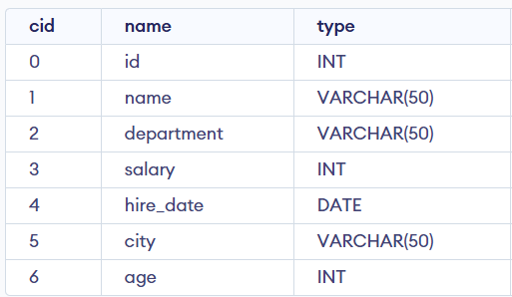

Approach
The converter uses token-based parsing method. It normalizes the user input, identifies the query structure, extracts conditions, validates columns against the employee schema, and constructs the equivalent SQL statement.
Condition Handling
The converter reads filtering conditions from the WHERE part of the query using a simple column operator value pattern.
It supports operators such as is, =, >, <, >=, <=, !=, not, and is not.
If multiple conditions are joined using “and”, each condition is parsed
separately and combined using SQL AND. If an ORDER BY clause is present, the converter also detects the column to sort by and the optional direction (asc or desc).

SQL Construction
After parsing the query and validating columns against the employee schema, the final SQL query is built step by step:
1. Start with: SELECT * FROM employees
2. Add WHERE clause if conditions exist
3. Add ORDER BY clause if sorting is requested

Design Decisions
The system is built around a fixed schema to keep parsing simple and predictable.
Rule-based parsing avoids ambiguity and ensures only valid columns are used.
No external NLP libraries or models are required, so the program stays lightweight and easy to run.

Limitations
The converter only works for the employee table and supports SELECT queries.
More complex SQL features such as JOIN, GROUP BY, aggregates, or flexible free-form language are not supported.

