Cannizzaro Reaction
Cannizzaro Reaction is a base-catalyzed redox reaction in which aromatic aldehydes, formaldehyde, or other aliphatic aldehydes lacking α-hydrogen are converted into the corresponding alcohols and carboxylic acids. Cannizzaro reaction is a named reaction in organic chemistry. Here, we will explore the Cannizzaro Reaction and its mechanism, accompanied by some interesting examples.
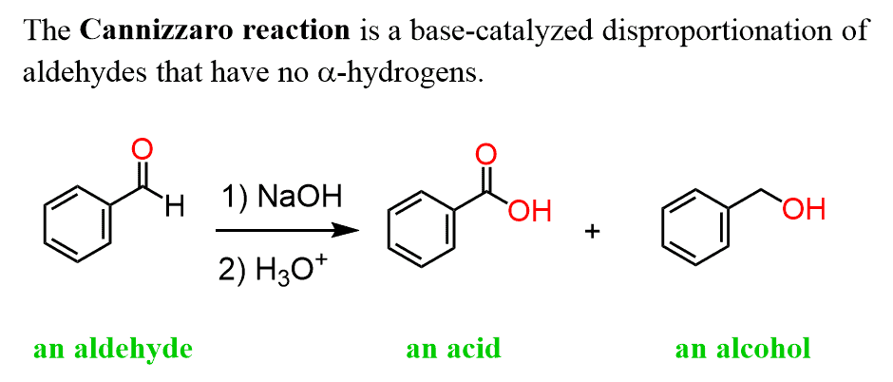
Cannizzaro Reaction Mechanism:
Several mechanisms have been proposed; the hydride transfer mechanism is most widely accepted.
- 1. OH⁻ attacks the carbonyl carbon of the aldehyde.
- The adduct is deprotonated under basic conditions to form a dianion.
- The dianion enables hydride (H⁻) transfer from the aldehydic carbon.
- The hydride attacks another aldehyde molecule (rate-determining step), forming an alkoxide.
- The alkoxide is protonated by water to give a primary alcohol.
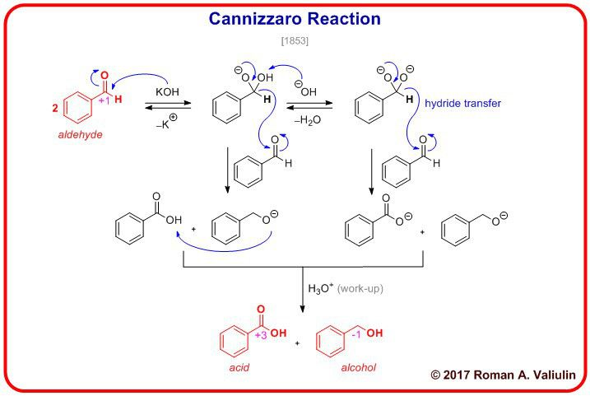

Aldol Reaction
The Aldol reaction is a versatile carbon-carbon bond-forming reaction in organic chemistry. It involves the condensation of an enol or enolate (derived from a carbonyl compound) with another carbonyl compound, forming a β-hydroxy carbonyl compound, known as an aldol product.
The reaction takes its name from the combination of "aldehyde" and "alcohol," as the aldol product contains both aldehyde (or ketone) and alcohol functional groups. The Aldol reaction can be classified into two main types: the crossed Aldol reaction, which involves the reaction between two different carbonyl compounds, and the self-Aldol reaction, which occurs when a carbonyl compound reacts with itself.
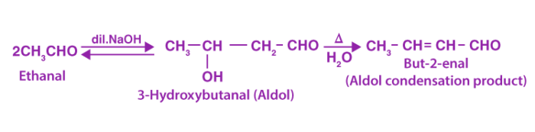
The Mechanism of the Aldol Reaction Involves the Following Steps:
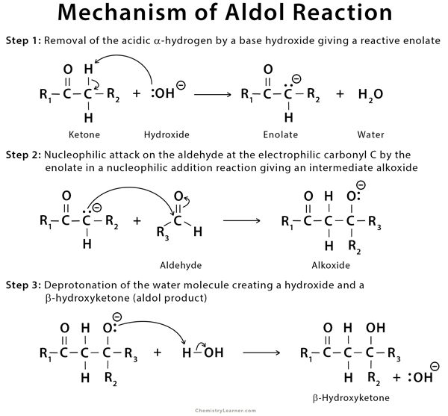

Perkin Reaction
The Perkin reaction (or Perkin condensation) is a condensation of aromatic aldehydes and the anhydrides of aliphatic carboxylic acids in the presence of a weak base to obtain α,β-unsaturated carboxylic acids.
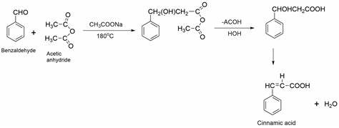
Mechanism of Perkin Reaction
The mechanism goes through numerous steps, including several additions and eliminations. Formation of anhydride enolates and aldol type condensation provides the alkoxide anhydride. Intermolecular acylation generates an acetoxy carboxylate, which forms a mixed anhydride. On elimination of acetic acid and subsequent hydrolysis gives the unsaturated acid.
