Customer Churn Root Cause Analysis
Tool Used – SQL, Power BI

Project Overview
This project focuses on building an end-to-end telecom customer churn analysis solution using SQL and Power BI. SQL is used for data exploration, data cleaning, transformation, and creation of analysis-ready tables and views. Power BI is then used to develop an interactive dashboard that visualizes key churn metrics and customer behavior across multiple dimensions such as demographics, geography, payment methods, contracts, tenure, services, and revenue, enabling business users to explore churn trends and support data-driven retention decisions.
Problem Statement
The objective of this project is to analyze customer churn in a telecom business by building an end-to-end data analysis solution using SQL and Power BI. The goal is to understand customer churn patterns across demographics, geography, payment methods, contracts, tenure, and services, and enable stakeholders to identify key factors contributing to customer attrition and revenue loss.
1. Data Exploration – Check Distinct Values
# Gender-wise customer distribution and percentage contribution
SELECT Gender, Count(Gender) as TotalCount,
Count(Gender) * 1.0 / (Select Count(*) from customer_data ) as Percentage
from customer_data
Group by Gender;
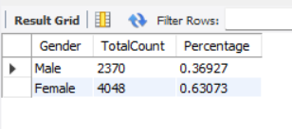

# Contract-wise customer count and percentage distribution
SELECT Contract, Count(Contract) as TotalCount,
Count(Contract) * 1.0 / (Select Count(*) from customer_data) as Percentage
from customer_data
Group by Contract;
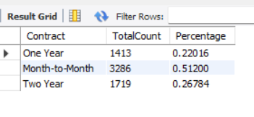

# Customer status-wise customer count and revenue contribution
SELECT Customer_Status, Count(Customer_Status) as TotalCount, Sum(Total_Revenue) as TotalRev, Sum(Total_Revenue) / (Select sum(Total_Revenue)
from customer_data) * 100 as RevPercentage from customer_data
Group by Customer_Status;
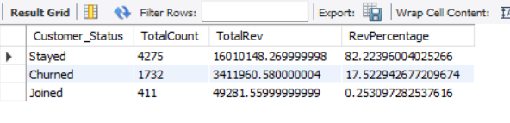

# State-wise customer distribution and ranking by percentage
SELECT State, Count(State) as TotalCount,
Count(State) * 1.0 / (Select Count(*) from customer_data) as Percentage
from customer_data
Group by State
Order by Percentage desc;
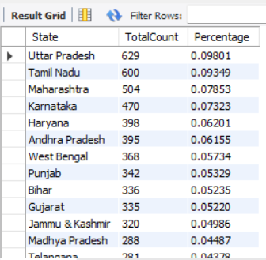

# Distinct internet service types used by customers
Select distinct Internet_Type
from customer_data;
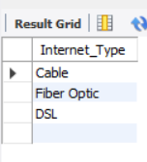

2. Data Exploration – Column-wise NULL and blank value analysis
SELECT
SUM(CASE WHEN Customer_ID IS NULL OR TRIM(Customer_ID) = '' THEN 1 ELSE 0 END) AS Customer_ID_Missing_Count,
SUM(CASE WHEN TRIM(Gender) = '' OR Gender IS NULL THEN 1 ELSE 0 END) AS Gender_Missing_Count,
SUM(CASE WHEN Age IS NULL THEN 1 ELSE 0 END) AS Age_Missing_Count,
SUM(CASE WHEN TRIM(Married) = '' OR Married IS NULL THEN 1 ELSE 0 END) AS Married_Missing_Count,
SUM(CASE WHEN TRIM(State) = '' OR State IS NULL THEN 1 ELSE 0 END) AS State_Missing_Count,
SUM(CASE WHEN Number_of_Referrals IS NULL THEN 1 ELSE 0 END) AS Number_of_Referrals_Missing_Count,
SUM(CASE WHEN Tenure_in_Months IS NULL THEN 1 ELSE 0 END) AS Tenure_in_Months_Missing_Count,
SUM(CASE WHEN TRIM(Value_Deal) = '' OR Value_Deal IS NULL THEN 1 ELSE 0 END) AS Value_Deal_Missing_Count,
SUM(CASE WHEN TRIM(Phone_Service) = '' OR Phone_Service IS NULL THEN 1 ELSE 0 END) AS Phone_Service_Missing_Count,
SUM(CASE WHEN TRIM(Multiple_Lines) = '' OR Multiple_Lines IS NULL THEN 1 ELSE 0 END) AS Multiple_Lines_Missing_Count,
SUM(CASE WHEN TRIM(Internet_Service) = '' OR Internet_Service IS NULL THEN 1 ELSE 0 END) AS Internet_Service_Missing_Count,
SUM(CASE WHEN TRIM(Internet_Type) = '' OR Internet_Type IS NULL THEN 1 ELSE 0 END) AS Internet_Type_Missing_Count,
SUM(CASE WHEN TRIM(Online_Security) = '' OR Online_Security IS NULL THEN 1 ELSE 0 END) AS Online_Security_Missing_Count,
SUM(CASE WHEN TRIM(Online_Backup) = '' OR Online_Backup IS NULL THEN 1 ELSE 0 END) AS Online_Backup_Missing_Count,
SUM(CASE WHEN TRIM(Device_Protection_Plan) = '' OR Device_Protection_Plan IS NULL THEN 1 ELSE 0 END) AS Device_Protection_Plan_Missing_Count,
SUM(CASE WHEN TRIM(Premium_Support) = '' OR Premium_Support IS NULL THEN 1 ELSE 0 END) AS Premium_Support_Missing_Count,
SUM(CASE WHEN TRIM(Streaming_TV) = '' OR Streaming_TV IS NULL THEN 1 ELSE 0 END) AS Streaming_TV_Missing_Count,
SUM(CASE WHEN TRIM(Streaming_Movies) = '' OR Streaming_Movies IS NULL THEN 1 ELSE 0 END) AS Streaming_Movies_Missing_Count,
SUM(CASE WHEN TRIM(Streaming_Music) = '' OR Streaming_Music IS NULL THEN 1 ELSE 0 END) AS Streaming_Music_Missing_Count,
SUM(CASE WHEN TRIM(Unlimited_Data) = '' OR Unlimited_Data IS NULL THEN 1 ELSE 0 END) AS Unlimited_Data_Missing_Count,
SUM(CASE WHEN TRIM(Contract) = '' OR Contract IS NULL THEN 1 ELSE 0 END) AS Contract_Missing_Count,
SUM(CASE WHEN TRIM(Paperless_Billing) = '' OR Paperless_Billing IS NULL THEN 1 ELSE 0 END) AS Paperless_Billing_Missing_Count,
SUM(CASE WHEN TRIM(Payment_Method) = '' OR Payment_Method IS NULL THEN 1 ELSE 0 END) AS Payment_Method_Missing_Count,
SUM(CASE WHEN Monthly_Charge IS NULL THEN 1 ELSE 0 END) AS Monthly_Charge_Missing_Count,
SUM(CASE WHEN Total_Charges IS NULL THEN 1 ELSE 0 END) AS Total_Charges_Missing_Count,
SUM(CASE WHEN Total_Refunds IS NULL THEN 1 ELSE 0 END) AS Total_Refunds_Missing_Count,
SUM(CASE WHEN Total_Extra_Data_Charges IS NULL THEN 1 ELSE 0 END) AS Total_Extra_Data_Charges_Missing_Count,
SUM(CASE WHEN Total_Long_Distance_Charges IS NULL THEN 1 ELSE 0 END) AS Total_Long_Distance_Charges_Missing_Count,
SUM(CASE WHEN Total_Revenue IS NULL THEN 1 ELSE 0 END) AS Total_Revenue_Missing_Count,
SUM(CASE WHEN TRIM(Customer_Status) = '' OR Customer_Status IS NULL THEN 1 ELSE 0 END) AS Customer_Status_Missing_Count,
SUM(CASE WHEN TRIM(Churn_Category) = '' OR Churn_Category IS NULL THEN 1 ELSE 0 END) AS Churn_Category_Missing_Count,
SUM(CASE WHEN TRIM(Churn_Reason) = '' OR Churn_Reason IS NULL THEN 1 ELSE 0 END) AS Churn_Reason_Missing_Count
FROM customer_data;
3. Remove null and insert the new data into Prod table
CREATE TABLE prod_Churn AS
SELECT Customer_ID, Gender, Age, Married, State, Number_of_Referrals, Tenure_in_Months,
CASE
WHEN Value_Deal IS NULL OR TRIM(Value_Deal) = '' THEN 'None'
ELSE Value_Deal
END AS Value_Deal,Phone_Service,
CASE
WHEN Multiple_Lines IS NULL OR TRIM(Multiple_Lines) = '' THEN 'No'
ELSE Multiple_Lines
END AS Multiple_Lines,Internet_Service,
CASE
WHEN Internet_Type IS NULL OR TRIM(Internet_Type) = '' THEN 'None'
ELSE Internet_Type
END AS Internet_Type,
CASE
WHEN Online_Security IS NULL OR TRIM(Online_Security) = '' THEN 'No'
ELSE Online_Security
END AS Online_Security,
CASE
WHEN Online_Backup IS NULL OR TRIM(Online_Backup) = '' THEN 'No'
ELSE Online_Backup
END AS Online_Backup,
CASE
WHEN Device_Protection_Plan IS NULL OR TRIM(Device_Protection_Plan) = '' THEN 'No'
ELSE Device_Protection_Plan
END AS Device_Protection_Plan,
CASE
WHEN Premium_Support IS NULL OR TRIM(Premium_Support) = '' THEN 'No'
ELSE Premium_Support
END AS Premium_Support,
CASE
WHEN Streaming_TV IS NULL OR TRIM(Streaming_TV) = '' THEN 'No'
ELSE Streaming_TV
END AS Streaming_TV,
CASE
WHEN Streaming_Movies IS NULL OR TRIM(Streaming_Movies) = '' THEN 'No'
ELSE Streaming_Movies
END AS Streaming_Movies,
CASE
WHEN Streaming_Music IS NULL OR TRIM(Streaming_Music) = '' THEN 'No'
ELSE Streaming_Music
END AS Streaming_Music,
CASE
WHEN Unlimited_Data IS NULL OR TRIM(Unlimited_Data) = '' THEN 'No'
ELSE Unlimited_Data
END AS Unlimited_Data,Contract,Paperless_Billing,Payment_Method,Monthly_Charge,Total_Charges,Total_Refunds,Total_Extra_Data_Charges,
Total_Long_Distance_Charges,Total_Revenue,Customer_Status,
CASE
WHEN Churn_Category IS NULL OR TRIM(Churn_Category) = '' THEN 'Others'
ELSE Churn_Category
END AS Churn_Category,
CASE
WHEN Churn_Reason IS NULL OR TRIM(Churn_Reason) = '' THEN 'Others'
ELSE Churn_Reason
END AS Churn_Reason
FROM customer_data;
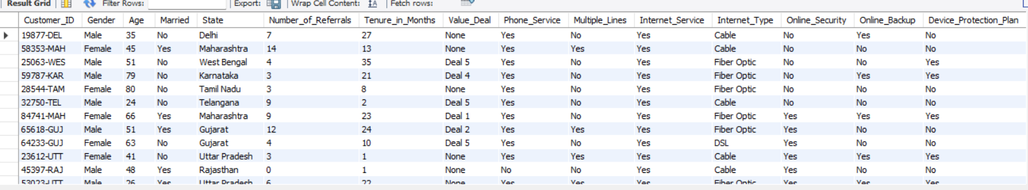

4. Create View for Power BI
# Segmenting Customer Data Using SQL Views Based on Customer Status
Create View vw_ChurnData as
select * from prod_Churn where Customer_Status In ('Churned', 'Stayed');
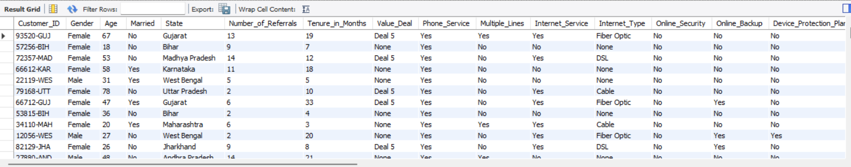

Create View vw_JoinData as
select * from prod_Churn where Customer_Status = 'Joined';
