**Findingbugs**

**运行结果**

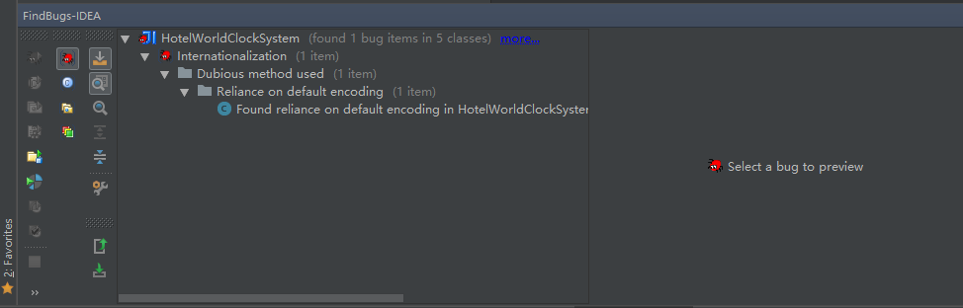

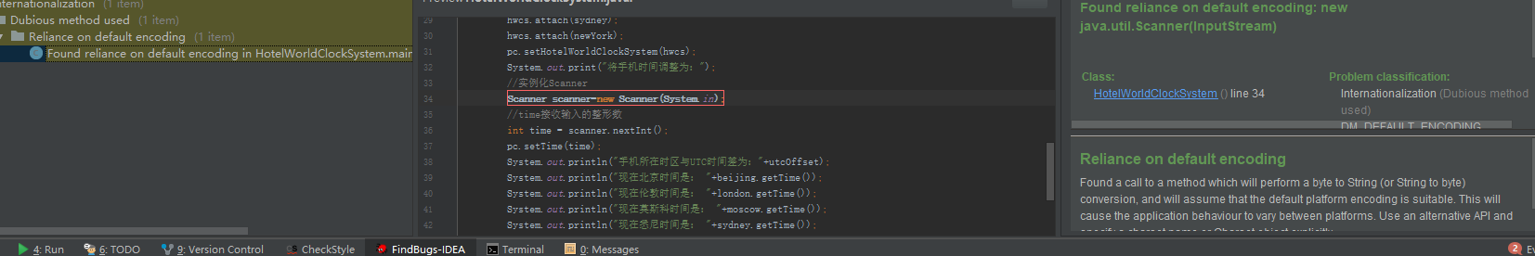

**P3c运行结果**

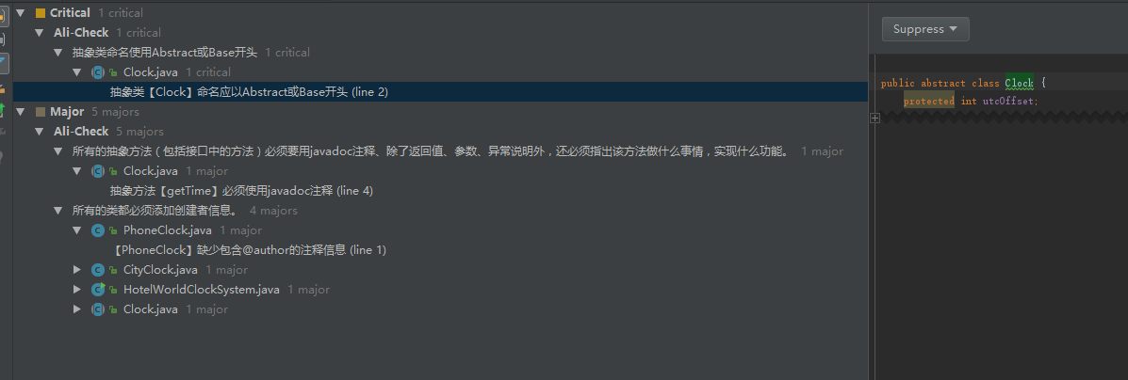

**Happypath测试**

