**ASSIGNMENT**

* **EXERCISE=3.17**

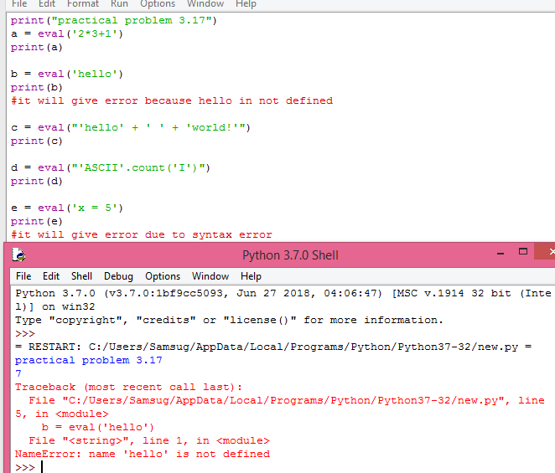

* **EXERCISE=3.18**

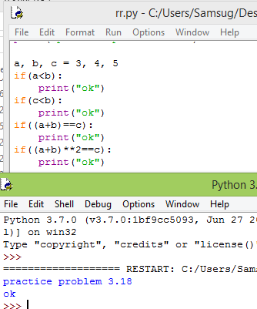

* **EXERCISE=3.19**
* 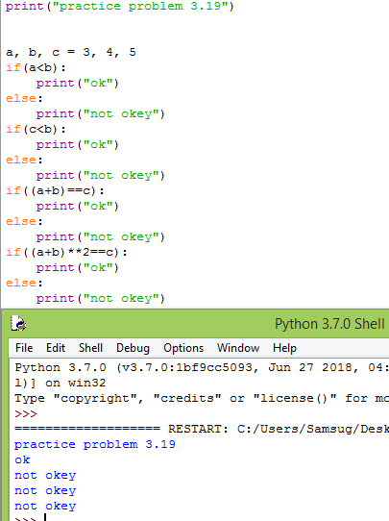
* **EXERCISE-3.20**

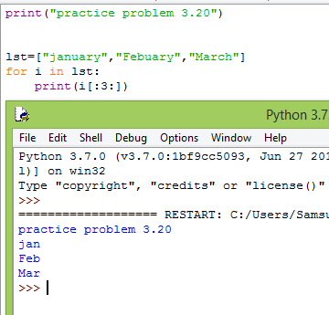

* **EXERCISE=3.21**

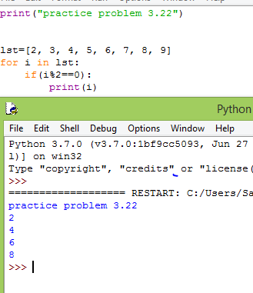

* **EXERCISE=3.22**

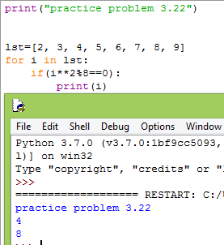

* **EXERCISE=3.23**

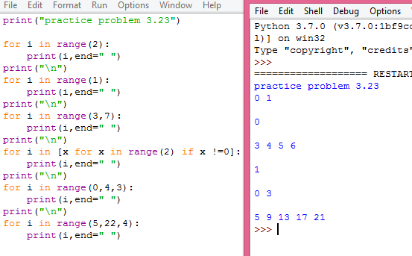

* **EXERCISE=3.24**

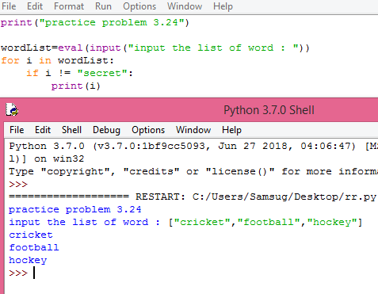

* **EXERCISE=3.25**

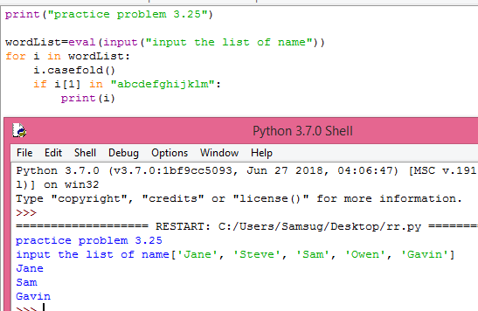

* **EXERCISE=3.26**

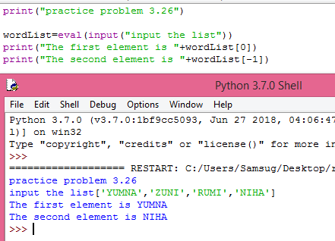

* **EXERCISE=3.27**

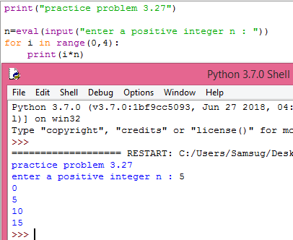

* **EXERCISE=3.28**

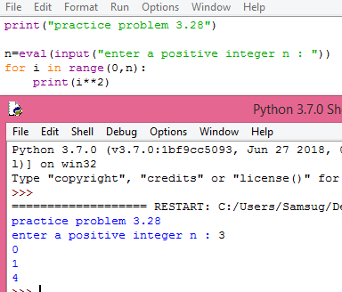

* **EXERCISE=3.29**

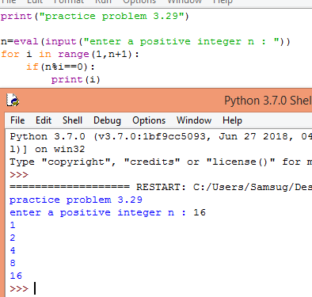

**EXERCISE=3.30**

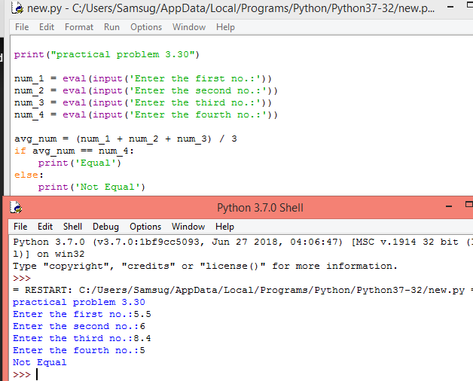

* **EXERCISE=3.31**

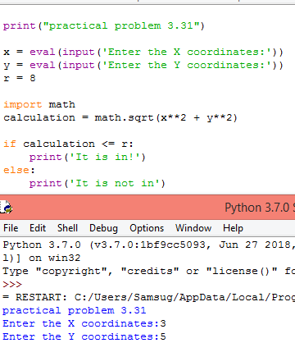

**EXERCISE=3.32**

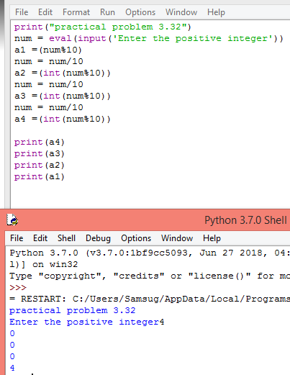

* **EXERCISE=3.33**

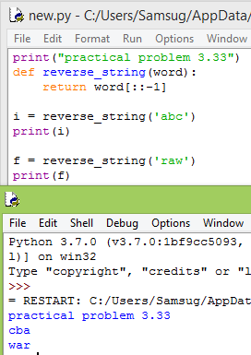

* **EXERCISE=3.34**

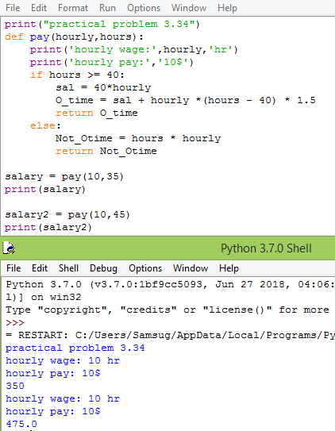

* **E** **XERCISE=3.35**

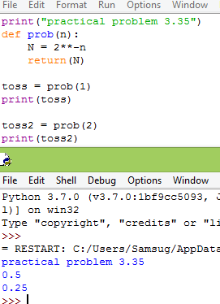

* **EXERCISE=3.36**

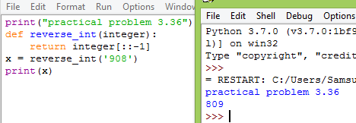

* **EXERCISE=3.37**

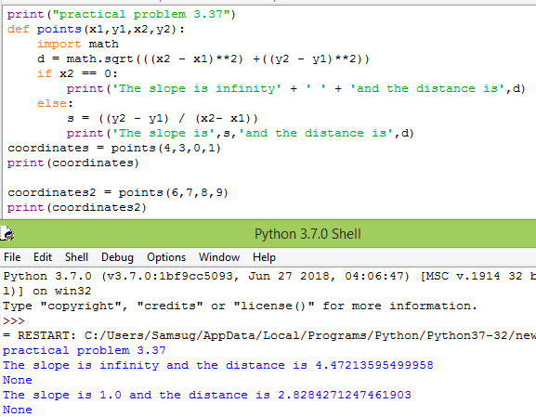

* **EXERCISE=3.38**

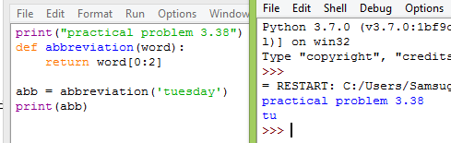

* **EXERCISE=3.39**

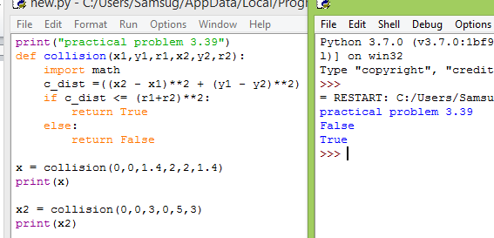

**EXERCISE=3.40**

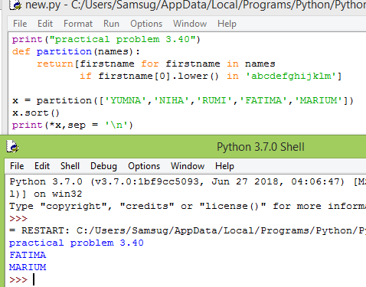

* **EXERCISE=3.41**

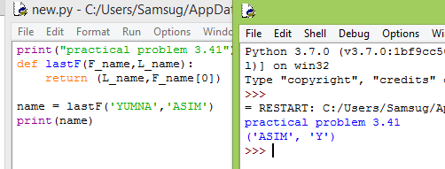

* **EXERCISE=3.42**

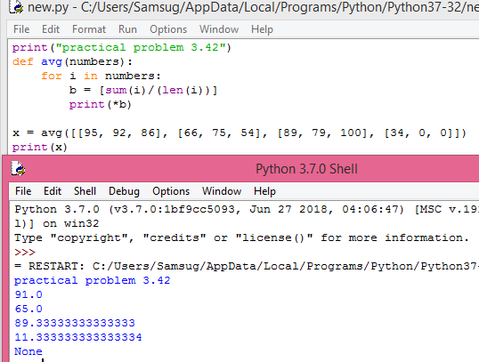

**EXERCISE=3.43**

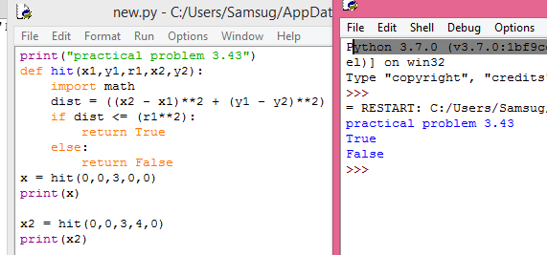

* **EXERCISE=3.44**

