**“IaaS” & “PaaS”:Explaining CSP Provides For The User**

Yuna Nawahda1

1Faculty of Computer Science, Birzeit University, Palestine,1211524

**Introduction:**

Distributed cloud computing innovation is the best approach to provide everything to customers as services through a web association. Utilizing this innovation, the customers would have the option to lease the necessary services through internet browsers. Cloud computing is aimed mainly at delivering customer services on demand. Cloud computing is a general concept that provides a wide range of infrastructure-based services, through platform as a production tool, via software as a service providing customers with the licenses of an application as an on-demand service. Various service models such as IaaS, PaaS, and SaaS, and many more are used in Cloud Computing [1].The paper focuses on Two of the three service delivery models, Infrastructure-as-aService(IaaS) and Platform-as-a-Service (PaaS).The Infrastructure-as-a-Service (IaaS) model of cloud computing is a promising approach towards building elastically scaling systems. Unfortunately, building such applications today is a complex, repetitive and error-prone endeavor, as IaaS does not provide any abstraction on top of naked virtual machines[2]. PaaS offers a resourceful and agile approach to develop, operate and deploy applications in a cost-effective manner. It is now turning out to be one of the preferred choices throughout the world, especially for globally distributed development environment[3].

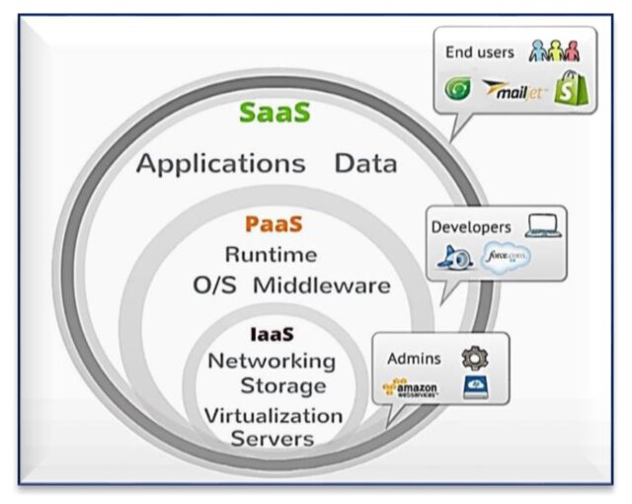

Fig1:[4] Cloud computing services (IaaS, PaaS, and SaaS).

In this article,two key service models are compared and discussed, i.e. platform as a service, Infrastructure as a service,and also explaining what the Cloud Service Providor(CSP) provides for their users.

**Keywords**:

Infrastructure as a Service (IaaS),Platform as a Service(Paas),Cloud Services Providor(CSP),TATA,Amazon,Netmagic,Rack space,Force,Joynet,Azure.

**Method**:

**-What is IaaS:**

IaaS, or Infrastructure as a Service, is a cloud computing model that provides on-demand access to computing resources such as servers, storage, networking, and virtualization.[5]

## **-How does it work:**

IaaS in cloud computing is when you rent access to cloud infrastructure resources as individual services from a cloud service provider (CSP), including servers, virtual machines, networking resources, and storage. IaaS helps eliminate much of the complexity and costs associated with building and maintaining physical infrastructure in an on-premises data center. [5]The CSP is responsible for managing and maintaining the infrastructure, so you can concentrate on installing, configuring, and managing software and keeping your data secure. IaaS providers also offer additional services, such as detailed billing management, logging, monitoring, storage resiliency, and security. [5]You can access IaaS resources using a pay-as-you-go basis, allowing you to only pay to consume the resources that you need. In other words, you can easily increase or decrease resources, allowing you to pay less when needed or instantly provision and scale out resources to meet new demand.[5]

**Examples: what does CSP provides:**

**-TATA:**Tata Communications IZO™ Cloud platform and services help build an agile IT ecosystem with hybrid multi-cloud environments, security and network you need globally[6].Manufacturing companies rely on us to enable them to conceptualize, develop and realize better products that are safer, cleaner, and improve the quality of life for all the stakeholders[7].

**-Amazon Web Services:**

Amazon Web Services offers a broad set of global cloud-based products including compute, storage, databases, analytics, networking, mobile, developer tools, management tools, IoT, security, and enterprise applications.[8]

**-Netmagic:**

Netmagic uses a combination of self-developed and open-source tools to provide advanced data storage and management services to its customers. Netmagic needs a highly-available, scalable and dynamic IT infrastructure, so when the company decided to renew its datacenter networks in Bangalore and Mumbai, only a feature-rich, cutting-edge solution would do. [9]

**-Rackspace:**

Rackspace Modern Operations. Consulting & Advisory Services. Professional Services. Managed Services.Consulting & Advisory Services. Professional Services. Managed Services.Data Modernization. Generative AI. Databases. Next-Gen Data Platforms.Cloud Native Security. Data Protection. Consulting & Advisory Services.[10]

**-What is PaaS:**

Platform as a Service, also known as PaaS, is a [type of cloud computing service model](https://cloud.google.com/discover/types-of-cloud-computing) that offers a flexible, scalable cloud platform to develop, deploy, run, and manage apps. PaaS provides everything developers need for application development without the headaches of updating the operating system and development tools or maintaining hardware. Instead, the entire PaaS environment—or platform—is delivered by a third-party service provider via the cloud. PaaS helps businesses avoid the hassle and cost of installing hardware or software to develop or host new custom applications. Development teams simply purchase pay-as-you-go access to everything they need to build custom apps, including infrastructure, development tools, operating systems, and more. The result is simpler, faster, and secure app development that gives developers the freedom to focus on their application code.[11]

## **-How does it work:**

Unlike IaaS or SaaS service models, PaaS solutions are specific to application and software development and typically include:Cloud infrastructure: Data centers, storage, network equipment, and serversMiddleware software: Operating systems, frameworks, development kits (SDK), libraries, and moreUser interface: A graphical user interface (GUI), a command line interface (CLI), an API interface, and in some cases, all three Platform as a Service is typically delivered as a secure online platform that developers can access over the internet, allowing them to work on projects from anywhere and collaborate freely with other members of their team. Applications are built directly on the PaaS system and can be immediately deployed once they are completed.[11]

**Examples: what does CSP provides:**

**-Google App Engine:**

App Engine is a fully managed, serverless platform for developing and hosting web applications at scale. You can choose from several popular languages, libraries, and frameworks to develop your apps, and then let App Engine take care of provisioning servers and scaling your app instances based on demand.[12]

**-Force.com:**

the Force.com platform has various features to automate your business process such as reporting, workflow and approvals, e-mail, user authentication, and integrations. These services are common to many software projects.[13]

**-Joyent:**

This hosting business was used for online [social network gaming](https://en.wikipedia.org/wiki/Social_network_game),[[4]](https://en.wikipedia.org/wiki/Joyent#cite_note-4) where it provides services to companies such as [THQ](https://en.wikipedia.org/wiki/THQ),[[5]](https://en.wikipedia.org/wiki/Joyent#cite_note-5) Social Game Universe, and Traffic Marketplace.[14]

**-Azure:**

Currently, Azure provides more than 200 cloud services, mainly as Platform as a service (PaaS), Software as a service (SaaS), and Infrastructure as a service (IaaS) solutions. In addition to those core services, Azure offers many additional services including: [Machine Learning (ML)](https://www.splunk.com/en_us/data-insider/ai-and-machine-learning.html),Analytics,IoT ,Migration,[Data management](https://www.splunk.com/en_us/blog/learn/data-management.html) and [governance](https://www.splunk.com/en_us/blog/learn/data-governance-vs-data-management.html),Security,Development and integration.[15]

**References:**

[1]<https://www.researchgate.net/publication/348962439_Sufficient_Comparison_Among_Cloud_Computing_Services_IaaS_PaaS_and_SaaS_A_Review> .

[2]<https://www.researchgate.net/publication/268155818_JCloudScale_Closing_the_gap_between_IaaS_and_PaaS> .

[3]<https://www.researchgate.net/publication/323945987_PaaS_Cloud_The_Business_Perspective> .

[4]<https://www.researchgate.net/publication/342492294_Cloud_Computing_Virtualization_of_Resources_Allocation_for_Distributed_Systems/figures> .

[5]<https://cloud.google.com/learn/what-is-iaas#:~:text=IaaS%2C%20or%20Infrastructure%20as%20a,storage%2C%20networking%2C%20and%20virtualization>.

[6]<https://www.tatacommunications.com/solutions/cloud/> .

[7]<https://www.tatatechnologies.com/en/about-us/> .

[8]<https://docs.aws.amazon.com/whitepapers/latest/aws-overview/introduction.html#:~:text=Amazon%20Web%20Services%20offers%20a,as%2Dyou%2Dgo%20pricing>.

[9]<https://www.alliedtelesis.com/sites/default/files/documents/success-stories/ati-netmagic-ss.pdf> .

[10]<https://www.rackspace.com/services/professional-services> .

[11]<https://cloud.google.com/learn/what-is-paas> .

[12]<https://cloud.google.com/appengine/docs#:~:text=App%20Engine%20is%20a%20fully,app%20instances%20based%20on%20demand>.

[13]<https://subscription.packtpub.com/book/programming/9781782172796/1/ch01lvl1sec08/introduction-to-the-force-com-platform#:~:text=For%20example%2C%20the%20Force.com,common%20to%20many%20software%20projects>.

[14]<https://en.wikipedia.org/wiki/Joyent> .

[15]<https://www.splunk.com/en_us/blog/learn/microsoft-azure-services.html> .