Software Set-Up for Labs

**Downloading MATLAB**

Follow the instructions provided by Duke IT to create a MathWorks account and then download and install MATLAB 2020.

<https://oit.duke.edu/help/articles/kb0023255>

When you begin the install, select only the following toolboxes (some may already be selected):

* MATLAB
* Statistics and Machine Learning Toolbox
* Signal Processing Toolbox

Do not select any additional toolboxes, as they will take up too much space on your computer.

**Downloading EEGLAB**

Once MATLAB is installed, go to:

<https://sccn.ucsd.edu/eeglab/downloadtoolbox.php/download.php>

Click the “Click here” link to begin downloading EEGLAB. EEGLAB will download as a compressed folder.

**On Windows:** Once the folder is downloaded, Extract the files by right clicking on the folder in your downloads and selecting Extract.

Extract the files directly into MATLAB by locating the MATLAB folder under Documents.

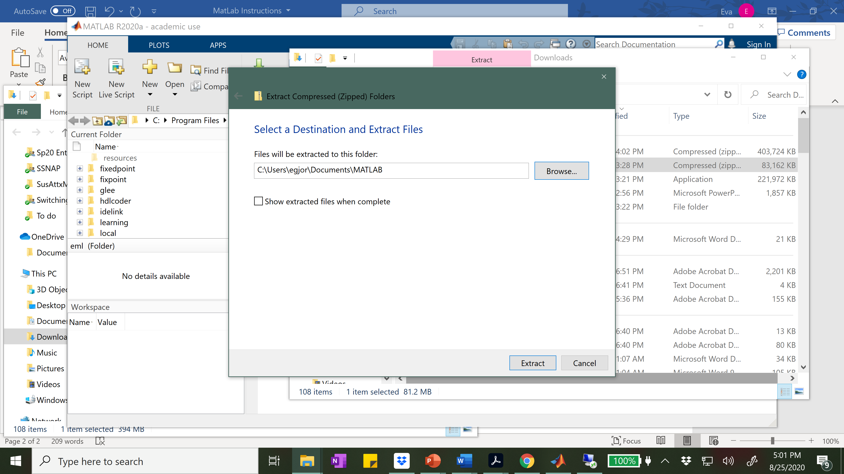

**On Mac:** Extract files by double clicking on .zip. Manually move extracted folder to your MATLAB folder under Documents. Example path (i.e., directory for a file or folder): /Users/audreyliu/Documents/MATLAB/.

**Downloading ERPLAB**

After EEGLAB has been downloaded into MATLAB, you’ll download [ERPLAB](https://erpinfo.org/erplab). ERPLAB also downloads as a zip file. You will have to unzip and place the folder into the ‘plugins’ folder of your existing EEGLAB installation (e.g., /Users/audreyliu/Documents/MATLAB/eeglab2021.1/plugins/).

Follow the download link for ERPLAB v8.20 at: <https://github.com/lucklab/erplab/releases>

