**Python Practice 1**

학번 : 2015112173 이름 : 유윤광

* You must put your name and student ID in each code and capture it.  
* You also have to submit your source code to eclass.

**02) Python Syntax**

**3. Python Variable(변수)**

#1. Run the code below.

→ result :

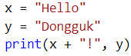

**(Attach the results)**



#2. Run the code below.

→ result :

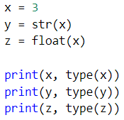

**(Attach the results)**

#3. Run the code below.

→ result :

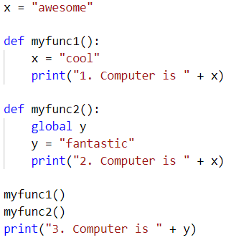

**(Attach the results)**

**6. Python String**

#4. Run the code below.

→ result :

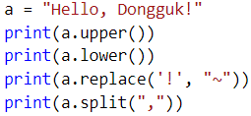

**(Attach the results)**

#5. Run the code below.

→ result :

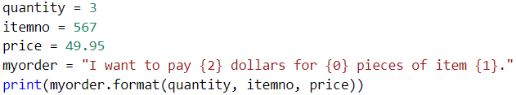

**(Attach the results)**

