**IPPO Assignment2 Final Design**

S1925815 Yuqing Wang

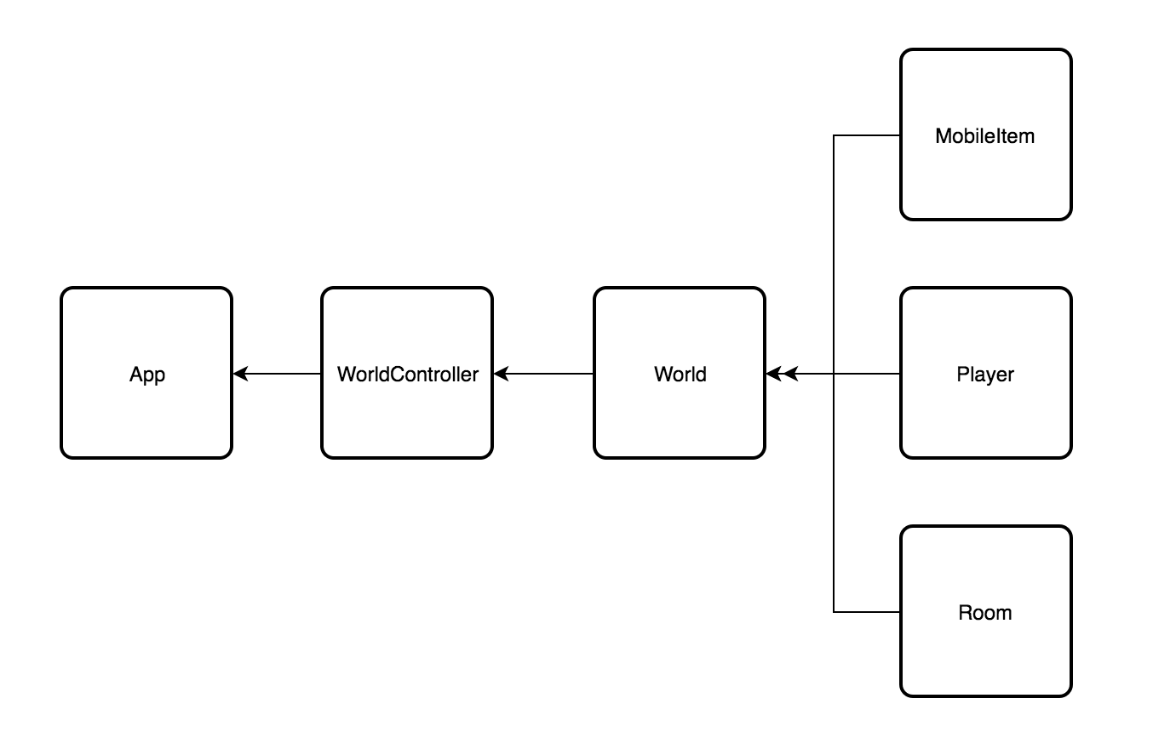

1. **Class**

* **MobileItem** provide function to connect the item name and the image name, and get the image name based on the item name;
* **Player** can (1) store/get the name of the current room/ current direction/ next room/ next direction; (2) set up the connection between directions; (3) It can also store/remove the item and check whether the player has the item;
* **Room** can (1) set/get the name of the next room(exit) and check whether current direction in the room has an exit to the next room; (2) set/get the name of the image file for each direction; (3) store/remove the item and check whether there is an item in current direction/room;
* **World** (1) set up the whole world and start position; (2) provide an arraylist of the names of all the possible items; (3) provide the name of the next direction’s/room’s image; (4) pick up an item; (5) put down an item;
* **WorldController** (1) initialize the GUI and the world; (2) move forward; (3) turn left; (4) turn right; (5) put an item; (6) pick up an item.
* **App** is responsible for connect the controller and the fxml file.

1. **Changes**

* A player class is added to store information of current room/direction and holed items. This class also hold two HashMaps that connects the directions in clockwise/anti-clockwies.
* Room and MobileItem are now two separate class instead of being subclasses of a superclass, because there is not that many common functions.
* The service class is deleted because this design only fetch image from the resources file.
* World class is added instead of building up the world in controller.
* All arrays in the previous design are changed into HashMap.