CPTS-223

Yurun Han

03/15/2021

Written Homework Assignment 3

1.

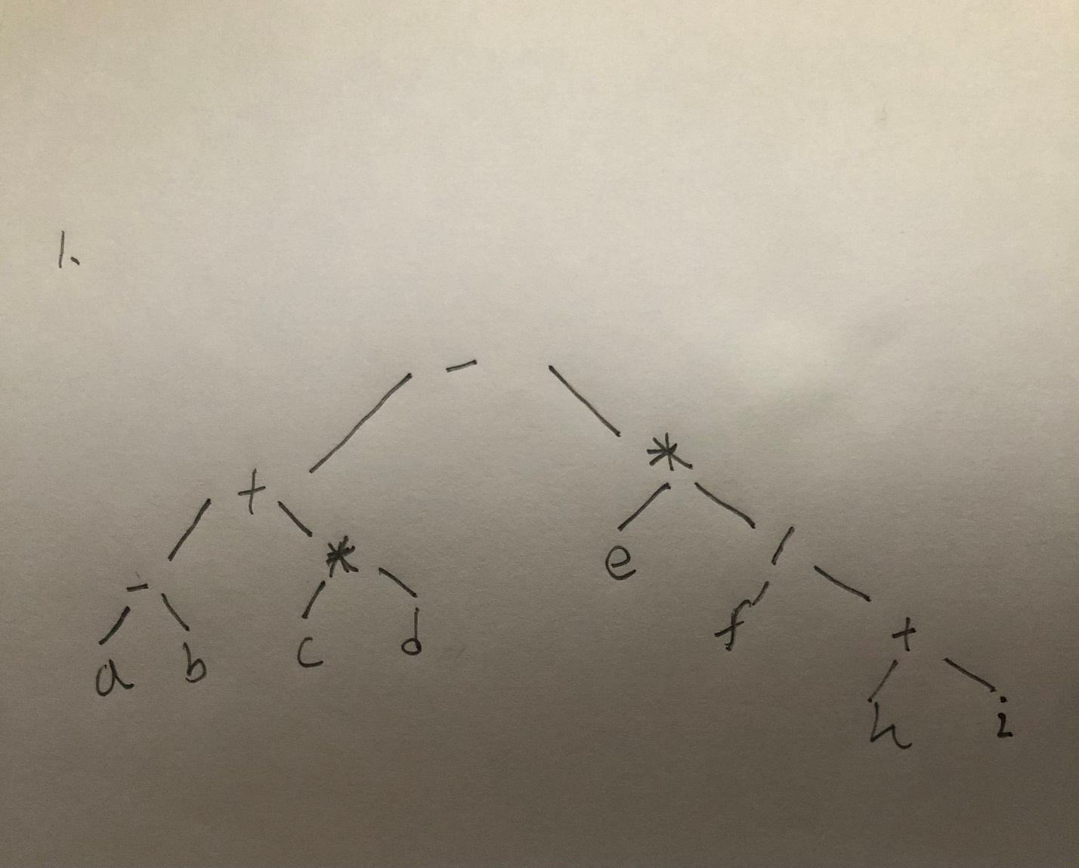

2.

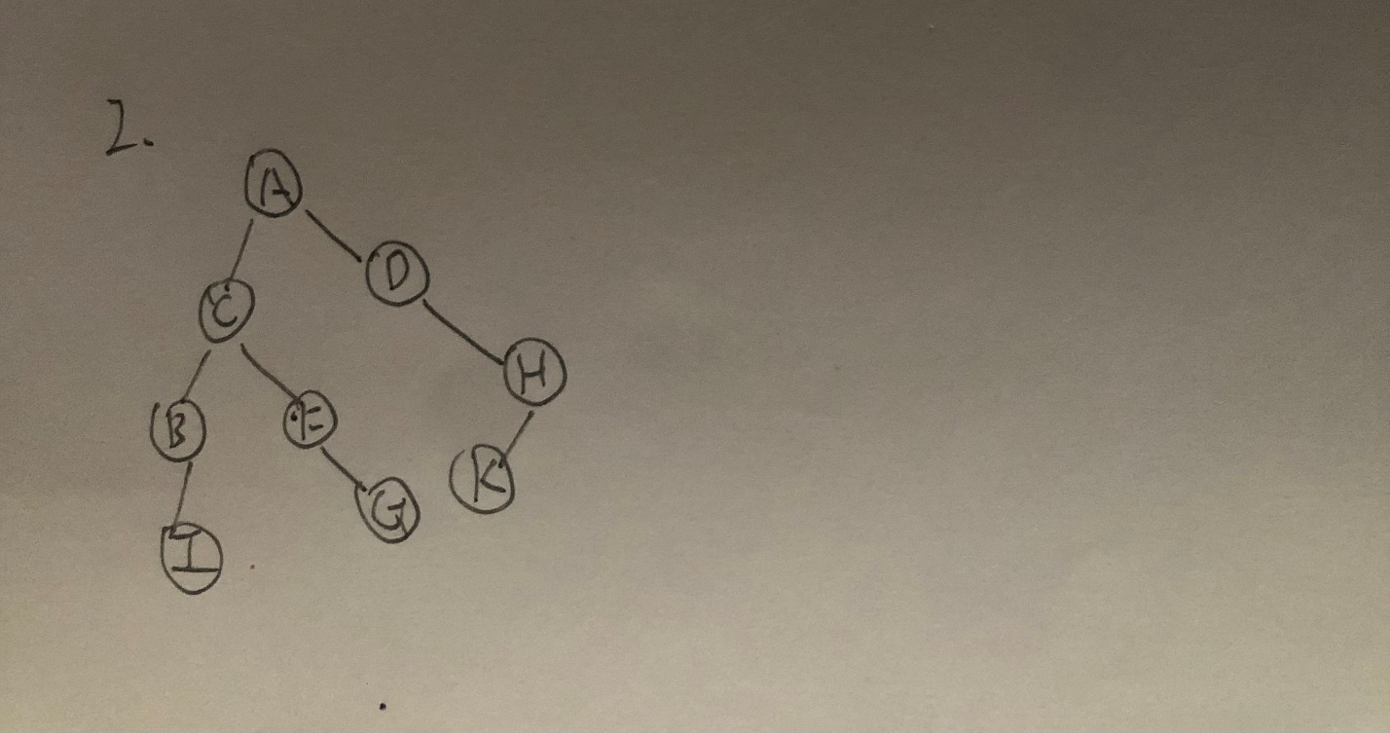

3.

a)4

b)0

c)1

d)4

e) 0001 0020 0052 0083 0099 0125 0152

f)0

g)

pre-order: 0010-0020-0003-0001-0050-0080-0052-0090-0083-0099-0150-0125-0152

in-order: 0001-0003-0020-0052-0050-0080-0083-0090-0099-0010-0125-0150-0152

post-order: 0001-0020-0003-0052-0083-0099-0090-0080-0050-0125-0152-0150-0010

4.

a) AVL tree is the first self-balancing binary search tree invented. The maximum difference between the heights of the two subtrees of any node in the AVL tree is 1, so it is also called a height-balanced tree. Adding and deleting may require one or more tree rotations to rebalance the tree.

b)

1. t is a binary search tree.

2. With balance condition: the absolute value (balance factor) of the difference between the height of the left and right subtrees of each node is at most 1.

5.

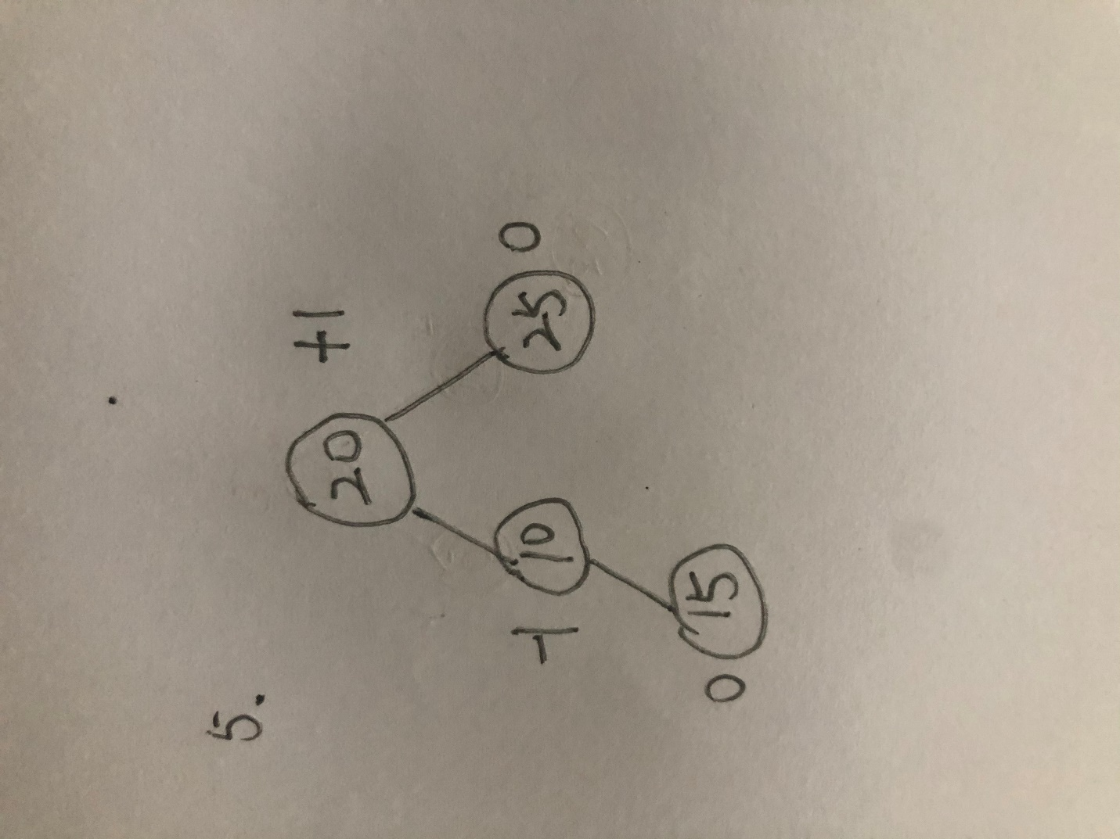

6.

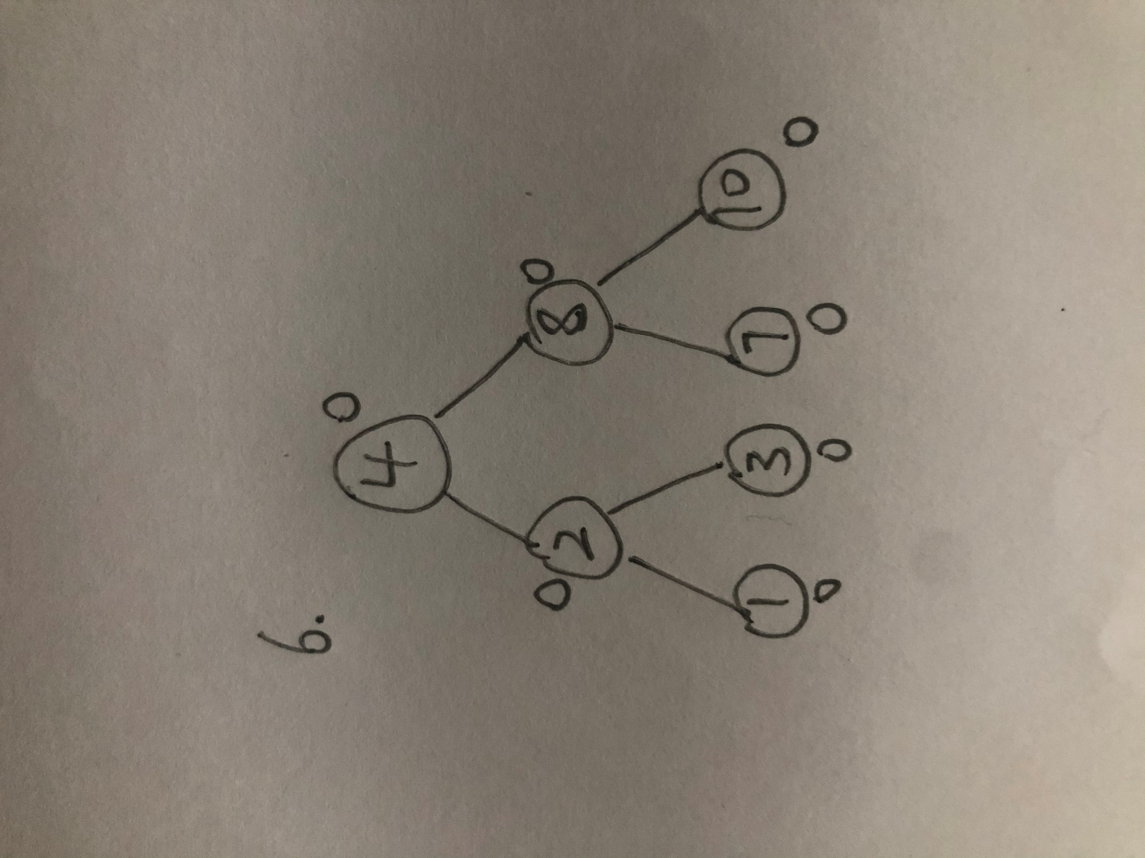

7.

