**SQL-GUVI-DB**

**Description:**

This SQL script sets up a relational database schema for managing information about mentors, batches, learners, marks, courses, and tasks.

**Table Creation:**

**mentors:** Stores mentor information (mentor_id, mentor_name).

**batches**: Stores batch information (batch_id, batch_name).

**learner:** Stores learner information (learner_id, learner_name, mentor_id, batch_id, course_id, task_id) with foreign key constraints referencing mentors, batches, course, and tasks tables.

**course:** Stores course information (course_id, course_name).

**tasks:** Stores task information (task_id, task_name, course_id) with a foreign key constraint referencing the course table.

**marks:** Initially created without a foreign key constraint for task_id, later added with a foreign key constraint referencing the tasks table.

**Table Alteration:**

**Adding Columns:** learner table has a column mark_id added to store mark primary keys. marks table has a column task_id added to store task primary keys.

**Adding Foreign Key Constraint:** A foreign key constraint named mark_constraint_name is added to the marks table ensuring referential integrity with the tasks table.

**Description Commands:**

**DESC learner;: Displays the structure of the learner table.**

**DESC marks;: Displays the structure of the marks table.**

**DESC tasks;: Displays the structure of the tasks table.**

**SQL QUERY:**

CREATE TABLE mentors(

mentor_id INT PRIMARY KEY,

mentor_name VARCHAR(255));

CREATE TABLE batches(

batch_id INT PRIMARY KEY,

batch_name VARCHAR(255));

CREATE TABLE learner(

learner_id INT PRIMARY KEY,

learner_name VARCHAR(255),

mentor_id INT,

batch_id INT,

course_id INT,

task_id INT,

FOREIGN KEY(mentor_id)REFERENCES mentors(mentor_id),

FOREIGN KEY(batch_id)REFERENCES batches(batch_id),

FOREIGN KEY(course_id)REFERENCES course(course_id),

FOREIGN KEY(task_id)REFERENCES tasks(task_id));

ALTER TABLE learner add COLUMN (mark_id INT);

DESC learner;

CREATE TABLE marks(

mark_id INT PRIMARY KEY,

learner_id INT,

FOREIGN KEY(learner_id) REFERENCES learner(learner_id),

marks INT);

desc marks;

CREATE TABLE course(

course_id INT PRIMARY KEY,

course_name VARCHAR(255));

CREATE TABLE tasks(

task_id INT PRIMARY KEY,

task_name VARCHAR(255),

course_id INT,

FOREIGN KEY(course_id)REFERENCES course(course_id));

desc tasks;

ALTER TABLE marks ADD column (task_id INT);

ALTER TABLE marks

ADD CONSTRAINT mark_constraint_name

FOREIGN KEY (task_id)

REFERENCES tasks(task_id);

desc marks;

**SQL-QUERY;**

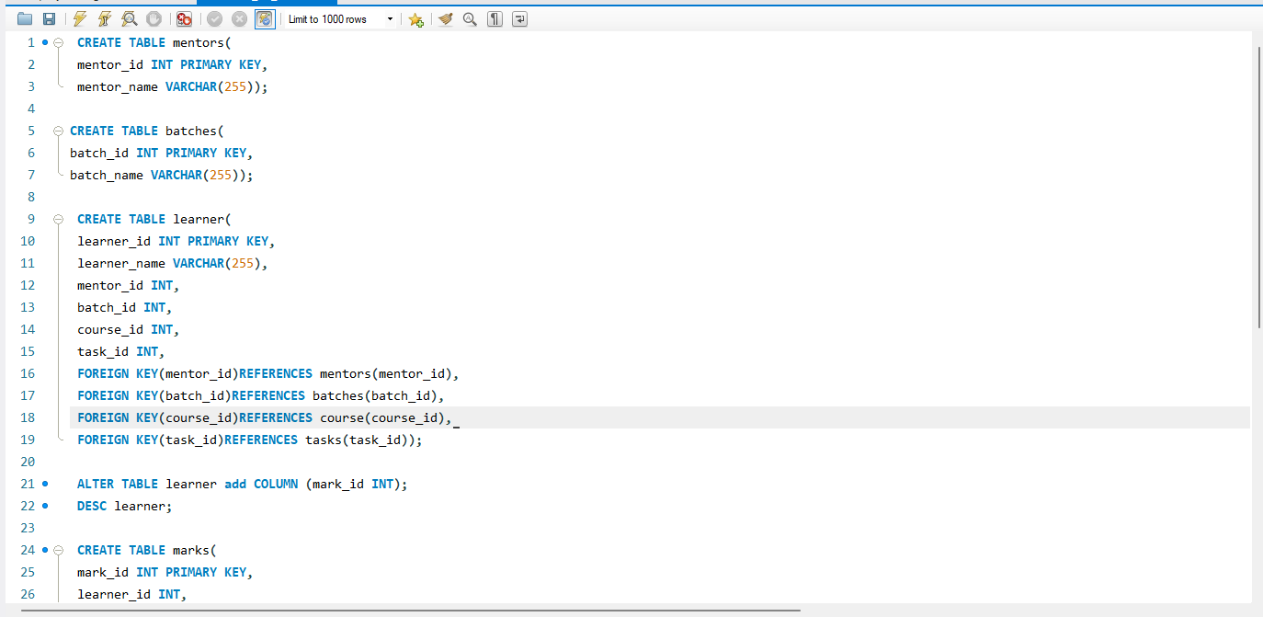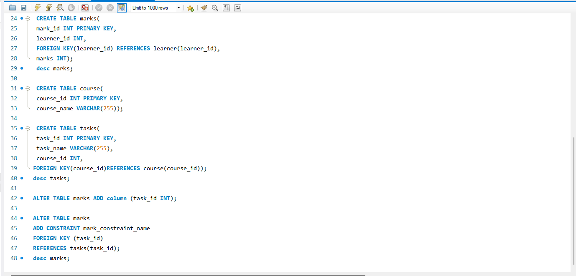

**SQL-EER-DIAGRAM;**

