1 . Spring Data JPA - Quick Example

Step Performed:
- Project Setup
Use Spring Initializr to create a Maven project with group com.cognizant and artifact orm-learn.
Select dependencies: Spring Boot DevTools, Spring Data JPA, MySQL Driver.
Import the generated project into Eclipse.
- MySQL Configuration
Create schema ormlearn in MySQL.
Configure database properties and logging in application.properties.
- Build the Project
Use mvn clean package with proxy settings if required.
- Main Application Setup
Add SLF4J logger to OrmLearnApplication.
Run the application and verify logger output from main().
- Project Structure Overview
- src/main/java: Java application code.
- src/main/resources: Config files (application.properties).
- src/test/java: Unit tests.
- @SpringBootApplication: Enables component scanning, configuration, and auto-configuration.
- pom.xml: Contains all project dependencies and build configuration.
- Database Table Creation
- Project Setup
Use Spring Initializr to create a Maven project with group com.cognizant and artifact orm-learn.
Select dependencies: Spring Boot DevTools, Spring Data JPA, MySQL Driver.
Import the generated project into Eclipse.
- MySQL Configuration
Create schema ormlearn in MySQL.
Configure database properties and logging in application.properties.
- Build the Project
Use mvn clean package with proxy settings if required.
- Main Application Setup
Add SLF4J logger to OrmLearnApplication.
Run the application and verify logger output from main().
- Project Structure Overview
- src/main/java: Java application code.
- src/main/resources: Config files (application.properties).
- src/test/java: Unit tests.
- @SpringBootApplication: Enables component scanning, configuration, and auto-configuration.
- pom.xml: Contains all project dependencies and build configuration.
- Database Table Creation
Create country table with co_code and co_name.
Insert sample records: IN - India, US - United States of America.
- Entity Class: Country
Annotate with @Entity and @Table(name="country").
Use @Id for primary key and @Column for mapping fields.
- Repository Interface: CountryRepository
Extend JpaRepository<Country, String>.
Annotate with @Repository.
- Service Class: CountryService
Annotate with @Service.
Autowire CountryRepository.
Add method getAllCountries() with @Transactional.
- Testing in OrmLearnApplication
Autowire CountryService using ApplicationContext.
Add and call testGetAllCountries() to print country list using logger.

<?xml version="1.0" encoding="UTF-8"?>
<project xmlns="http://maven.apache.org/POM/4.0.0"
xmlns:xsi="http://www.w3.org/2001/XMLSchema-instance"
xsi:schemaLocation="http://maven.apache.org/POM/4.0.0 https://maven.apache.org/xsd/maven-4.0.0.xsd">
<modelVersion>4.0.0</modelVersion>
<parent>
<groupId>org.springframework.boot</groupId>
<artifactId>spring-boot-starter-parent</artifactId>
<version>3.5.3</version>
<relativePath/> <!-- lookup parent from repository -->
</parent>
<groupId>com.example</groupId>
<artifactId>ormlearn</artifactId>
<version>0.0.1-SNAPSHOT</version>
<name>ormlearn</name>
<description>Demo project for Spring Boot</description>
<properties>
<java.version>17</java.version>
</properties>
<dependencies>
<dependency>
<groupId>org.springframework.boot</groupId>
<artifactId>spring-boot-starter-data-jpa</artifactId>
</dependency>
<dependency>
<groupId>com.mysql</groupId>
<artifactId>mysql-connector-j</artifactId>
<version>8.0.33</version>
<scope>runtime</scope>
</dependency>
<dependency>
<groupId>org.springframework.boot</groupId>
<artifactId>spring-boot-devtools</artifactId>
<scope>runtime</scope>
<optional>true</optional>
</dependency>

<dependency>
<groupId>org.springframework.boot</groupId>
<artifactId>spring-boot-starter-test</artifactId>
<scope>test</scope>
</dependency>
</dependencies>
<build>
<plugins>
<plugin>
<groupId>org.springframework.boot</groupId>
<artifactId>spring-boot-maven-plugin</artifactId>
</plugin>
</plugins>
</build>
</project>

application.properties
spring.application.name=ormlearn
# Logging
logging.level.org.springframework=info
logging.level.com.example.ormlearn=debug
logging.level.org.hibernate.SQL=debug
logging.level.org.hibernate.type.descriptor.sql=trace
# Database
spring.datasource.driver-class-name=com.mysql.cj.jdbc.Driver
spring.datasource.url=jdbc:mysql://localhost:3306/ormlearn
spring.datasource.username=root
spring.datasource.password=Shri19
# Hibernate
spring.jpa.hibernate.ddl-auto=validate
spring.jpa.properties.hibernate.dialect=org.hibernate.dialect.MySQLDialect

Country.java
package com.example.ormlearn.model;
import jakarta.persistence.Entity;
import jakarta.persistence.Id;
import jakarta.persistence.Table;
import jakarta.persistence.Column;
@Entity
@Table(name = "country")
public class Country {
@Id
@Column(name = "co_code")
private String code;
@Column(name = "co_name")
private String name;
public String getCode() {
return code;
}
public void setCode(String code) {
this.code = code;
}
public String getName() {
return name;
}
public void setName(String name) {
this.name = name;
}
@Override
public String toString() {
return "Country [code=" + code + ", name=" + name + "]";
}
}

CountryRepository.java
package com.example.ormlearn.repository;
import org.springframework.data.jpa.repository.JpaRepository;
import org.springframework.stereotype.Repository;
import com.example.ormlearn.model.Country;
@Repository
public interface CountryRepository extends JpaRepository<Country, String> {
}

CountryService.java
package com.example.ormlearn.service;
import java.util.List;
import jakarta.transaction.Transactional;
import org.springframework.beans.factory.annotation.Autowired;
import org.springframework.stereotype.Service;
import com.example.ormlearn.model.Country;
import com.example.ormlearn.repository.CountryRepository;
@Service
public class CountryService {
@Autowired
private CountryRepository countryRepository;
@Transactional
public List<Country> getAllCountries() {
return countryRepository.findAll();
}
}

OrmlearnApllication.java
package com.example.ormlearn;
import java.util.List;
import org.slf4j.Logger;
import org.slf4j.LoggerFactory;
import org.springframework.boot.SpringApplication;
import org.springframework.boot.autoconfigure.SpringBootApplication;
import org.springframework.context.ApplicationContext;
import com.example.ormlearn.model.Country;
import com.example.ormlearn.service.CountryService;
@SpringBootApplication
public class OrmlearnApplication {
private static final Logger LOGGER =
LoggerFactory.getLogger(OrmlearnApplication.class);
private static CountryService countryService;
public static void main(String[] args) {
ApplicationContext context = SpringApplication.run(OrmlearnApplication.class, args);
countryService = context.getBean(CountryService.class);
LOGGER.info("Inside main");
testGetAllCountries();
}
private static void testGetAllCountries() {
LOGGER.info("Start");
List<Country> countries = countryService.getAllCountries();
LOGGER.debug("countries={}", countries);
LOGGER.info("End");
}
}
Output:

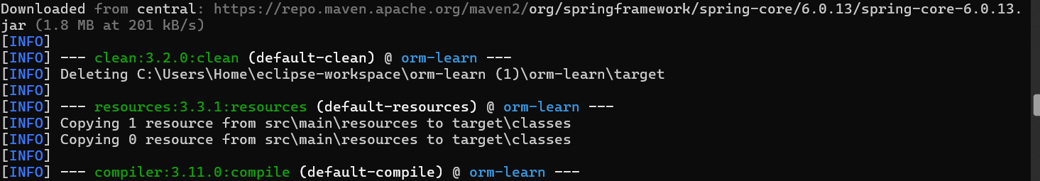

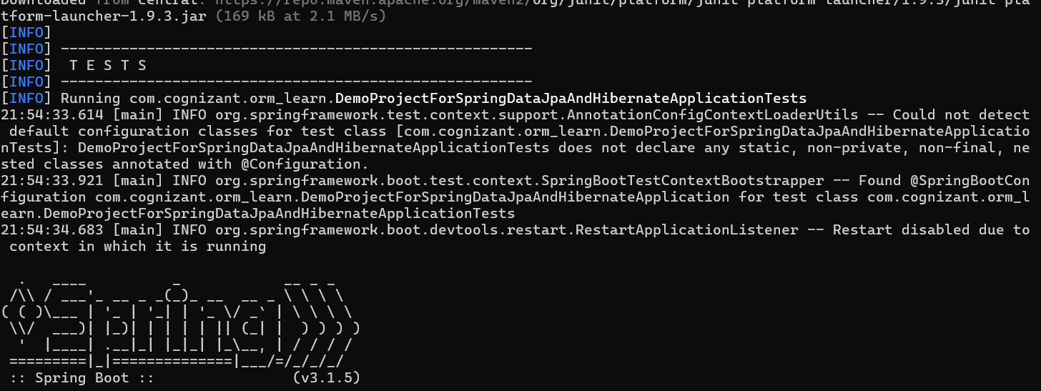

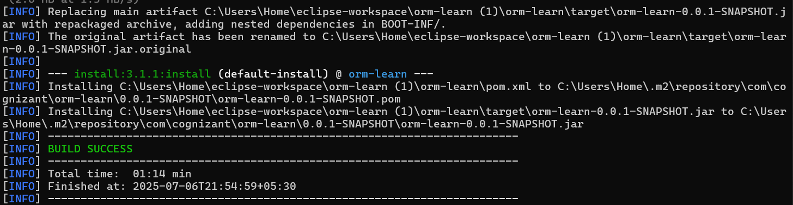

2. Difference between JPA, Hibernate and Spring Data JPA
Steps Performed:
- Understand that JPA is a specification (no implementation).
- Recognize that Hibernate is an ORM tool that implements JPA.
- Know that Spring Data JPA is an abstraction layer over JPA providers like Hibernate.
- Compare coding styles:
- Hibernate requires manual session and transaction handling.
- Spring Data JPA uses JpaRepository for CRUD with minimal code.
- Use annotations like @Autowired and @Transactional in Spring Data JPA for dependency injection and transaction management.
- Leverage Spring Boot's auto-configuration to manage repositories without XML or manual configuration.
- Understand that JPA is a specification (no implementation).
- Recognize that Hibernate is an ORM tool that implements JPA.
- Know that Spring Data JPA is an abstraction layer over JPA providers like Hibernate.
- Compare coding styles:
- Hibernate requires manual session and transaction handling.
- Spring Data JPA uses JpaRepository for CRUD with minimal code.
- Use annotations like @Autowired and @Transactional in Spring Data JPA for dependency injection and transaction management.
- Leverage Spring Boot's auto-configuration to manage repositories without XML or manual configuration.
Pom.xml
<project xmlns="http://maven.apache.org/POM/4.0.0"
xmlns:xsi="http://www.w3.org/2001/XMLSchema-instance"
xsi:schemaLocation="
http://maven.apache.org/POM/4.0.0
http://maven.apache.org/xsd/maven-4.0.0.xsd">
<modelVersion>4.0.0</modelVersion>
<groupId>com.example</groupId>
<artifactId>jpa-hibernate-employee</artifactId>
<version>0.0.1-SNAPSHOT</version>
<packaging>jar</packaging>
<name>jpa-hibernate-employee</name>
<description>Spring Boot app using Spring Data JPA and MySQL</description>
<parent>
<groupId>org.springframework.boot</groupId>
<artifactId>spring-boot-starter-parent</artifactId>
<version>3.2.4</version>
<relativePath/>
</parent>
<properties>
<java.version>17</java.version>
</properties>
<dependencies>
<dependency>
<groupId>jakarta.persistence</groupId>
<artifactId>jakarta.persistence-api</artifactId>
<version>3.1.0</version>
</dependency>
<dependency>
<groupId>org.springframework.boot</groupId>
<artifactId>spring-boot-starter-web</artifactId>
</dependency>
<dependency>
<groupId>org.springframework.boot</groupId>
<artifactId>spring-boot-starter-data-jpa</artifactId>
</dependency>
<dependency>
<groupId>com.mysql</groupId>
<artifactId>mysql-connector-j</artifactId>
<scope>runtime</scope>
</dependency>
<dependency>
<groupId>org.projectlombok</groupId>
<artifactId>lombok</artifactId>
<optional>true</optional>
</dependency>
<dependency>
<groupId>org.springframework.boot</groupId>
<artifactId>spring-boot-devtools</artifactId>
<scope>runtime</scope>
</dependency>
<dependency>
<groupId>org.springframework.boot</groupId>
<artifactId>spring-boot-starter-test</artifactId>
<scope>test</scope>
</dependency>
</dependencies>
<build>
<plugins>
<plugin>
<groupId>org.apache.maven.plugins</groupId>
<artifactId>maven-compiler-plugin</artifactId>
<version>3.11.0</version>
<configuration>
<source>17</source>
<target>17</target>
</configuration>
</plugin>
</plugins>
</build>
</project>

application.properties
spring.datasource.url=jdbc:mysql://localhost:3306/test_db
spring.datasource.username=Learning
spring.datasource.password=Cog191

spring.jpa.hibernate.ddl-auto=create
spring.jpa.show-sql=true
spring.jpa.properties.hibernate.dialect=org.hibernate.dialect.MySQL8Dialect

Employee.java
package com.example.employee.model;
import jakarta.persistence.Entity;
import jakarta.persistence.Id;
@Entity
public class Employee {
@Id
private int id;
private String name;
private String department;
public int getId() {
return id;
}
public void setId(int id) {
this.id = id;
}
public String getName() {
return name;
}
public void setName(String name) {
this.name = name;
}
public String getDepartment() {
return department;
}
public void setDepartment(String department) {
this.department = department;
}
}

EmployeeRepository.java
package com.example.employee.repository;
import org.springframework.data.jpa.repository.JpaRepository;
import com.example.employee.model.Employee;
public interface EmployeeRepository extends JpaRepository<Employee, Integer> {
}

EmployeeService.java
package com.example.employee.service;
import org.springframework.beans.factory.annotation.Autowired;
import org.springframework.stereotype.Service;
import org.springframework.transaction.annotation.Transactional;
import com.example.employee.model.Employee;
import com.example.employee.repository.EmployeeRepository;
@Service
public class EmployeeService {
@Autowired
private EmployeeRepository employeeRepository;
@Transactional
public void addEmployee(Employee employee) {
employeeRepository.save(employee);
}
}

JpahibernateemployeeApllication.java
package com.example.employee;
import org.springframework.beans.factory.annotation.Autowired;
import org.springframework.boot.CommandLineRunner;
import org.springframework.boot.SpringApplication;
import org.springframework.boot.autoconfigure.SpringBootApplication;
import com.example.employee.model.Employee;
import com.example.employee.service.EmployeeService;
@SpringBootApplication
public class JpahibernateemployeeApplication implements CommandLineRunner {
@Autowired
private EmployeeService employeeService;
public static void main(String[] args) {
SpringApplication.run(JpahibernateemployeeApplication.class, args);
}
@Override
public void run(String... args) throws Exception {
Employee emp = new Employee();
emp.setId(191);
emp.setName("Tarun Karrthick R S");
emp.setDepartment("ECE");
employeeService.addEmployee(emp);
}
}

Output:

