IntelliRender
Week 3 Progress Report
Reported by: Yuvaraj | Reporting Period: Week 3

Project Overview
IntelliRender is an AI-powered interactive workspace that enables users to generate, simulate, and interact with rich UI components — including dashboards, Kanban boards, gravity simulations, and HTML page renderers — directly through natural language prompts. Week 3 focused on expanding the platform's integration layer, refining the workspace UI, hardening the tooling infrastructure, and demonstrating advanced agentic capabilities including live web browsing and multi-model API key management.

Week 3 Accomplishments

1. Interactive Canvas & HTML Form Generation
Implemented the Interactive Canvas rendering engine, enabling the agent to produce live, interactive HTML components directly within the workspace. As a validation test, the agent was prompted to generate an Employee Registration form containing fields for Full Name, Employee ID, Company Name, Role, and Experience — which was rendered instantly in the Preview pane with no manual coding required. The canvas supports both a Preview mode for live interaction and a Code view for inspecting the generated output, establishing a powerful pattern for prompt-to-UI generation.
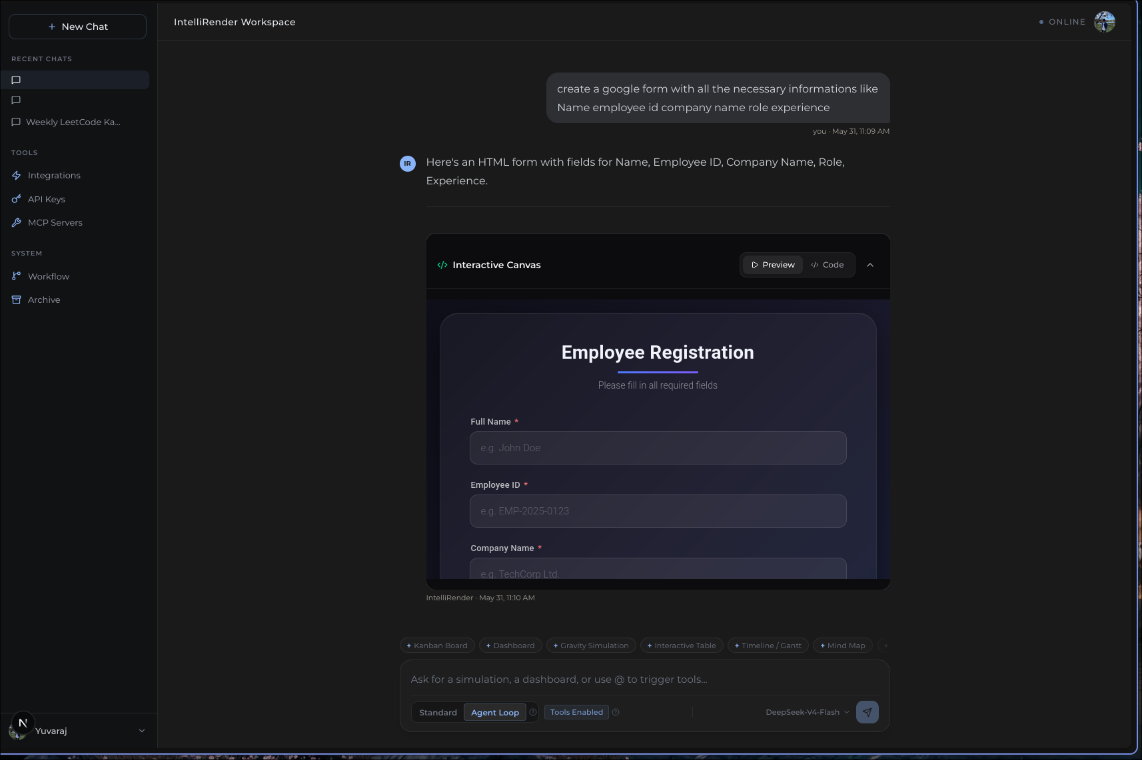
Figure 1: Interactive Canvas rendering an Employee Registration HTML form from a natural language prompt.

2. Sprint Board & Bug Tracking via GitHub Projects
Established an active sprint board on GitHub Projects to manage the development lifecycle of IntelliRender. Week 3 surfaced and tracked several critical issues, including Kanban widget rendering failures (empty columns and infinite re-render loops), browser_task tool misconfiguration causing Bad Request errors from FastAPI in the development environment, and a Playwright browser automation service integration issue. Completed items this week included the FastAPI microservices layer and a Docker Compose modularisation into frontend, API, database, and service containers — both marked Done at P0 priority.
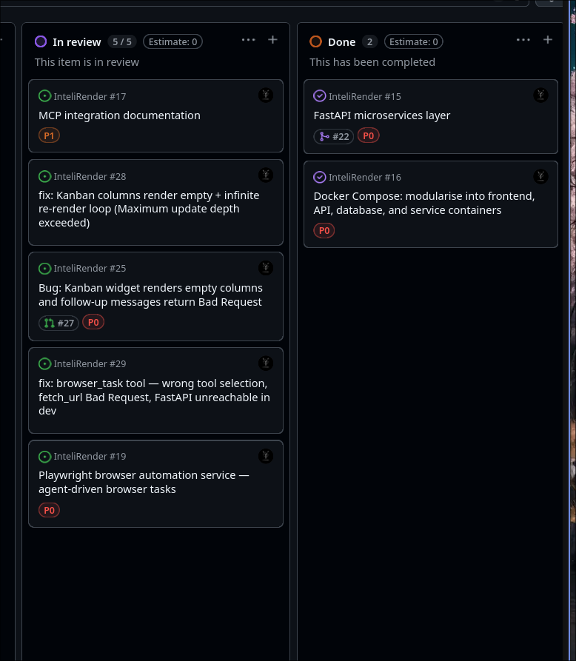
Figure 2: GitHub Projects sprint board showing In Review and Done columns with active issues and completed P0 tasks.

3. Multi-Provider API Key Management
Built a secure API Keys management panel within the workspace settings, supporting multiple LLM providers from a single interface. Users can configure keys for SiliconFlow (used for the primary DeepSeek-V4-Flash model), OpenAI (for GPT models), Anthropic (for Claude models), and a Custom MCP Token for private MCP server authentication. All keys are encrypted using AES-256-GCM before storage and are write-only — they cannot be retrieved after saving — ensuring a strong security posture for credential management.
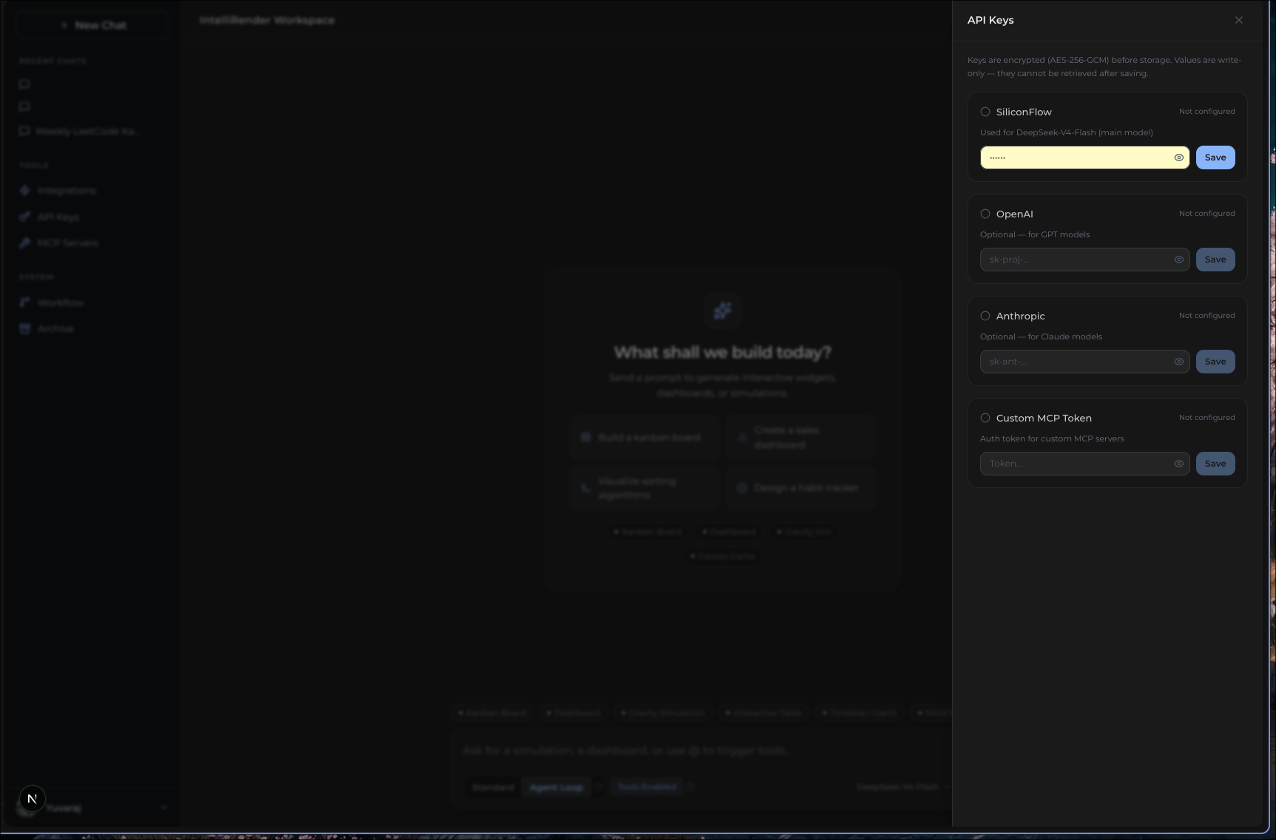
Figure 3: API Keys panel showing multi-provider support — SiliconFlow, OpenAI, Anthropic, and Custom MCP Token with AES-256-GCM encryption.

4. Refined Empty-State UX & Quick-Start Prompts
Redesigned the workspace empty state to provide a more guided and actionable onboarding experience. The updated layout presents four contextual quick-start prompt cards — Build a kanban board, Create a sales dashboard, Visualise sorting algorithms, and Design a habit tracker — alongside shortcut chips for Kanban Board, Dashboard, Gravity Sim, and Canvas Game. The cleaner layout reduces friction for new users and communicates the platform's core capabilities at a glance, without requiring prior familiarity with prompt syntax.
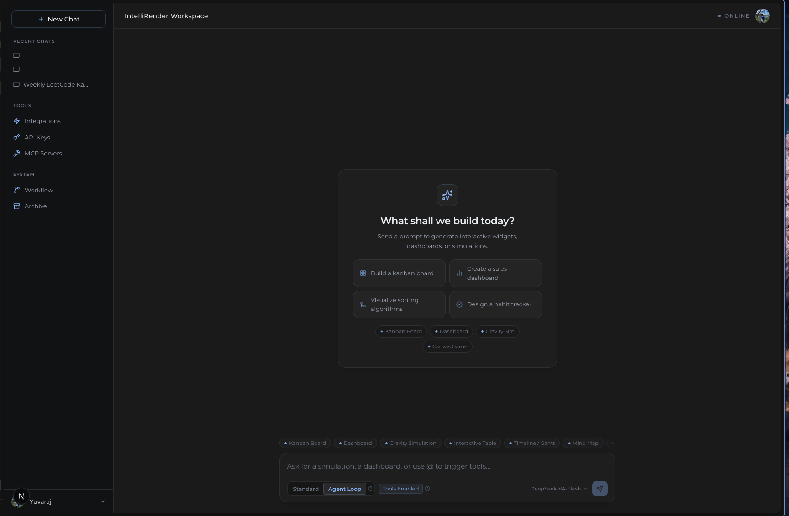
Figure 4: Redesigned workspace empty state with quick-start prompt cards and feature shortcut chips.

5. MCP Server Configuration Panel
Delivered a dedicated MCP Servers configuration panel that allows users to register and manage local Model Context Protocol servers running over Stdio as child processes. The panel ships with two pre-configured servers — a built-in Memory server (via the @modelcontextprotocol/server-memory package) and a Google Forms MCP server — both shown as Enabled. An Add Local Server form allows registration of additional custom servers by specifying a server name, executable, and space-separated arguments, giving the platform an extensible and operator-controlled tool surface for the agent.
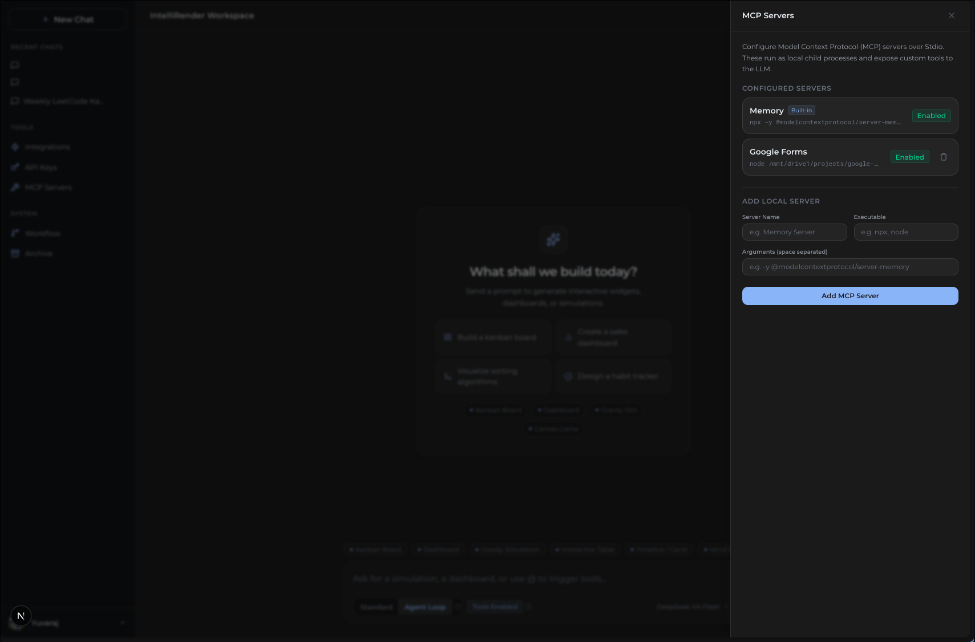
Figure 5: MCP Servers panel showing built-in Memory and Google Forms servers enabled, with custom server registration form.

6. Google OAuth & Integrations Panel
Implemented a full Integrations panel with Google OAuth app-level credentials, enabling the workspace to connect with a suite of Google and third-party services as agent tools. Configured integrations include Google Forms, Gmail, Google Drive, Google Calendar, GitHub, and Linear — each with a one-click Connect with Google flow. Once connected, services are automatically available as tools within Agent Loop mode with no manual MCP registration required. The Google OAuth app credential is configured via the client_secret JSON file from Google Cloud Console and is shared across all users of the platform.
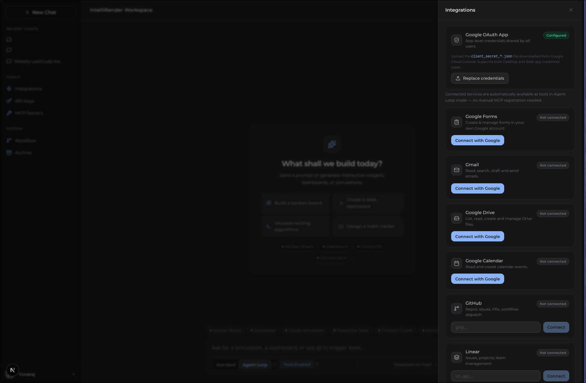
Figure 6: Integrations panel showing Google OAuth configuration and available service connections including Gmail, Drive, Calendar, GitHub, and Linear.

7. Agent Web Browsing Capability
Extended the agentic loop with live web browsing capability, allowing the agent to open and inspect real URLs on demand. In a live demonstration, the agent was prompted to open https://built-by-yuva.vercel.app/ and extract its functional elements. The agent successfully navigated to the Yuvaraj R — Developer Resume site and returned a structured breakdown of all interactive components including navigation menu sections (About, Skills, Projects, Contact), the hero section, and further page elements — all without any manual scraping or pre-processing. This validates the browser_task tool integration and marks a significant step toward general-purpose agentic web interaction.
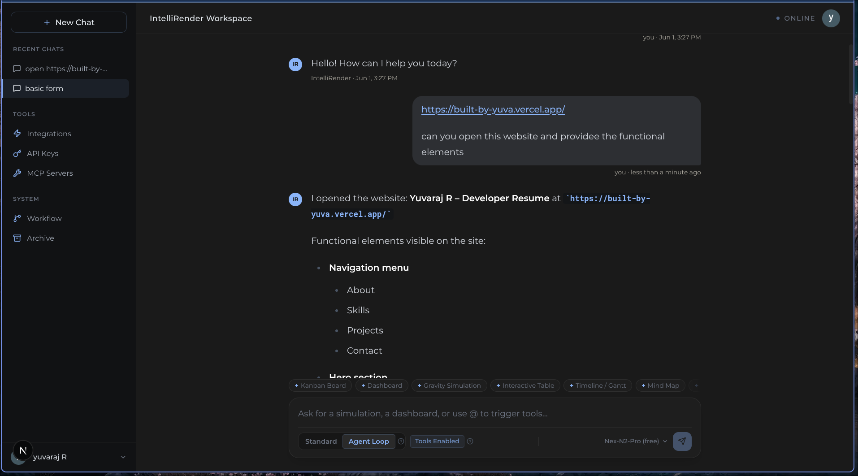
Figure 7: Agent browsing a live URL and returning a structured breakdown of the page's functional elements in real time.

8. Enhanced Kanban Widget with Priority Indicators
Resolved the previously tracked Kanban rendering bugs and shipped an enhanced Kanban widget with priority indicator support. The agent generated a fully functional Software Sprint Kanban Board with four columns — To Do, In Progress, Review, and Done — each populated with three sample tasks. Tasks are colour-coded by priority (red for high, yellow for medium, green for low) and are drag-and-drop capable for real-time sprint tracking. The agent also provided a natural language summary of the board structure alongside the rendered widget, demonstrating coherent multi-modal output.
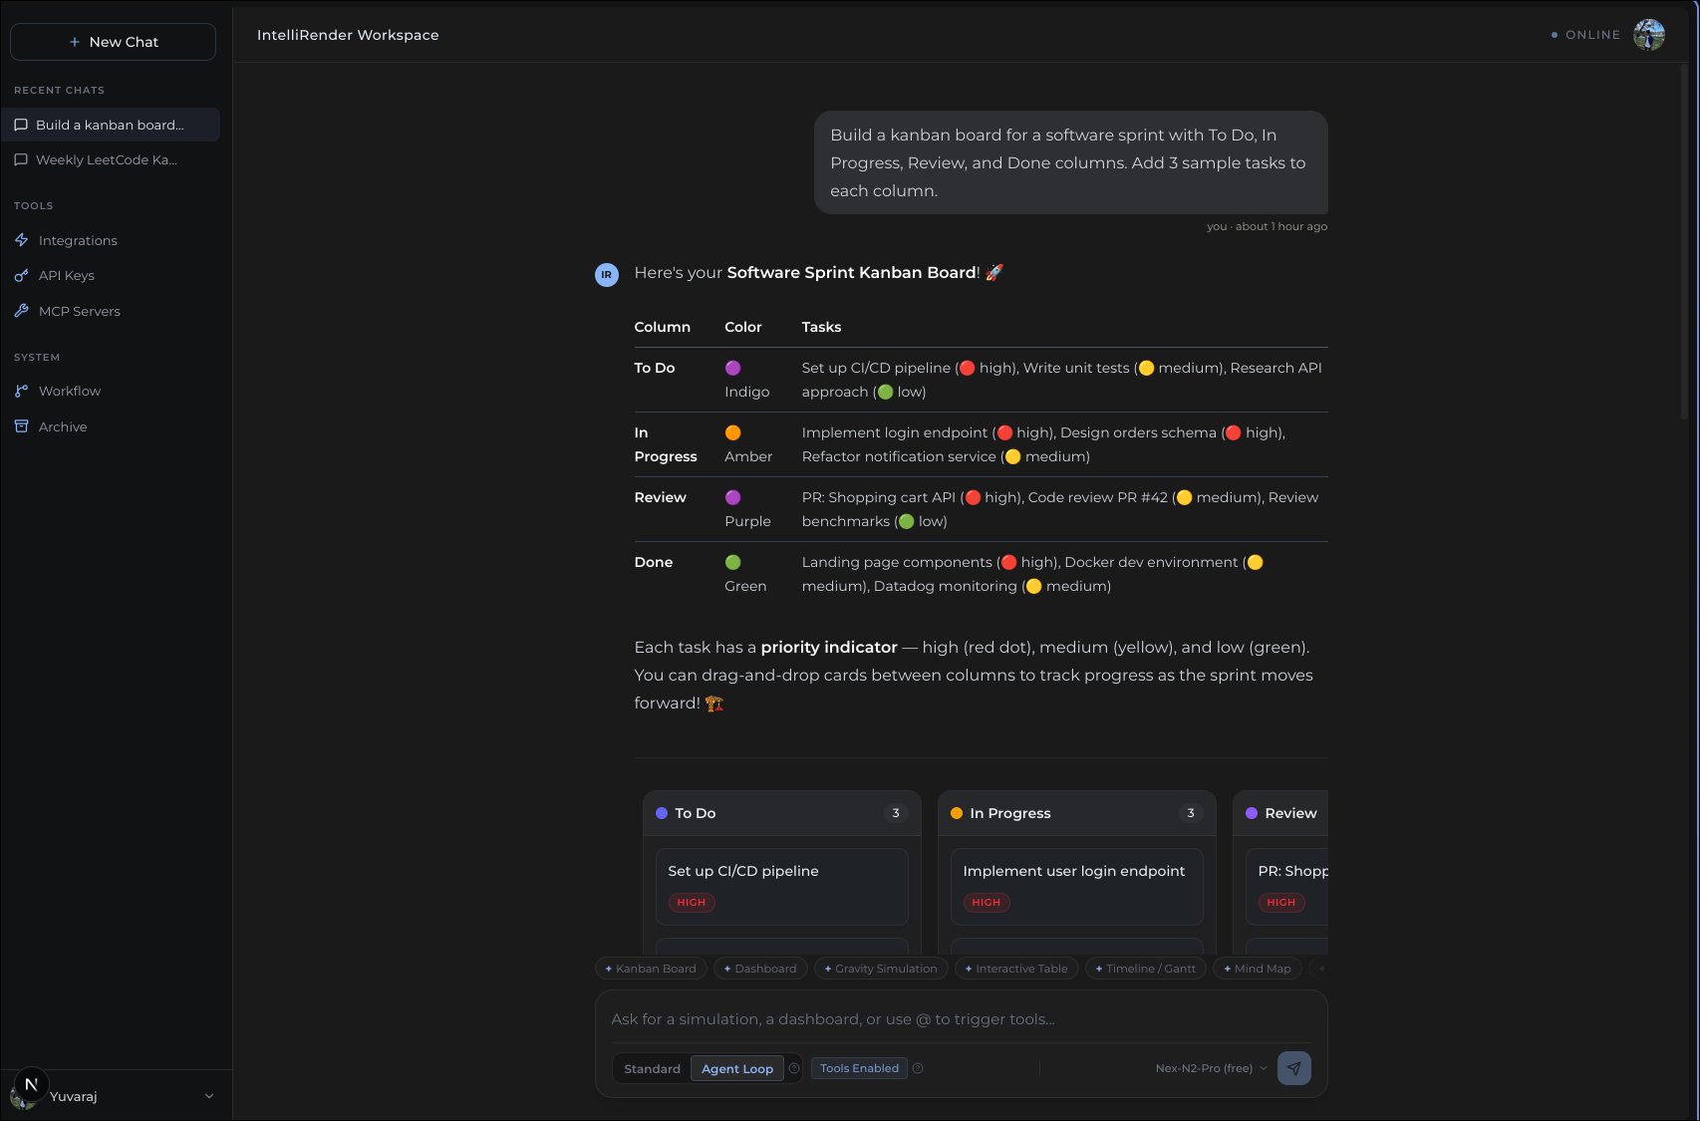
Figure 8: Enhanced Kanban widget with colour-coded priority indicators and drag-and-drop columns generated from a natural language prompt.

Plan for Week 4
Week 4 will focus on stabilising the integration layer, expanding live service connectivity, and deepening agentic capabilities. Key objectives include:
- Activate and test Google OAuth-connected services (Gmail, Google Drive, Google Calendar) as live agent tools within the Agent Loop
- Resolve remaining browser_task tool issues and validate Playwright-based browser automation end-to-end
- Expand the Interactive Canvas with additional component types beyond forms — charts, data tables, and timeline views
- Implement GitHub integration for agent-driven issue creation, PR management, and workflow dispatch
- Continue sprint board hygiene and close outstanding P0 bugs identified in Week 3
- Explore multi-model routing — allowing the agent to dynamically select between SiliconFlow, OpenAI, and Anthropic models based on task complexity

