Reverse logistics - EDA Report

# 1. Dataset Overview

Total Rows: 5000

Total Columns: 20

Missing Values:

- ReturnReason: 3558

- ReturnDate: 3558

# 1. Dataset Overview

Total Rows: 5000

Total Columns: 20

Missing Values:

- ReturnReason: 3558

- ReturnDate: 3558

# 6. Reverse Logistics Summary

# 6. Reverse Logistics Summary

Orders Successfully Delivered (0): 3558

Orders Returned (1): 1442

# 6. Reverse Logistics Summary

Orders Successfully Delivered (0): 3558

Orders Returned (1): 1442

# 6. Reverse Logistics Summary

Orders Successfully Delivered (0): 3558

Orders Returned (1): 1442

Overall Return Rate: 28.84%

# 3. Visual Insights

Returns by Region:

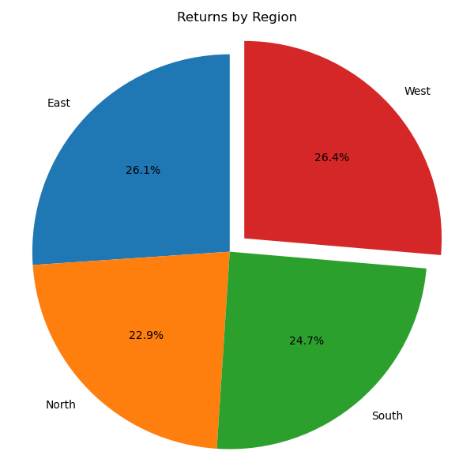

Returns by Product Category:

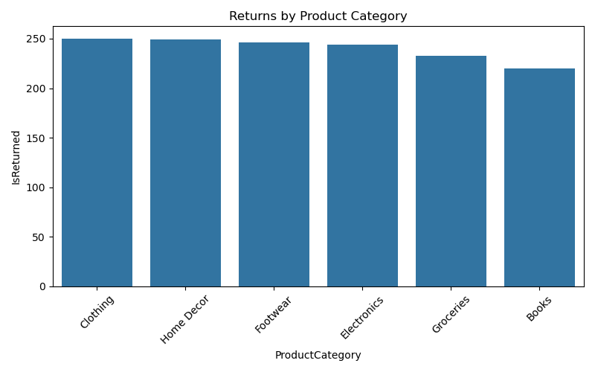

Returns by Customer:

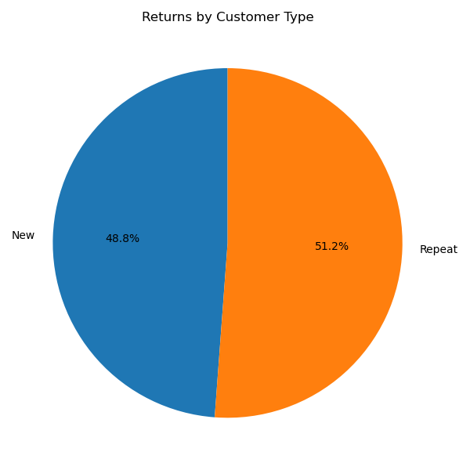

Top Return Reasons:

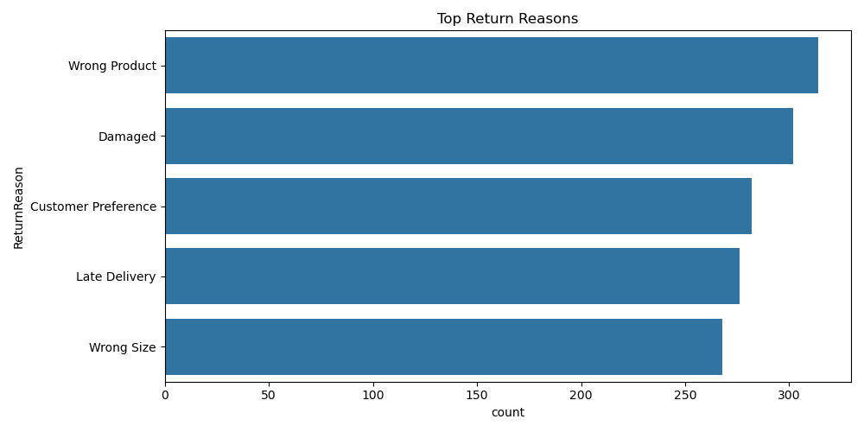

Refund Amount by Region:

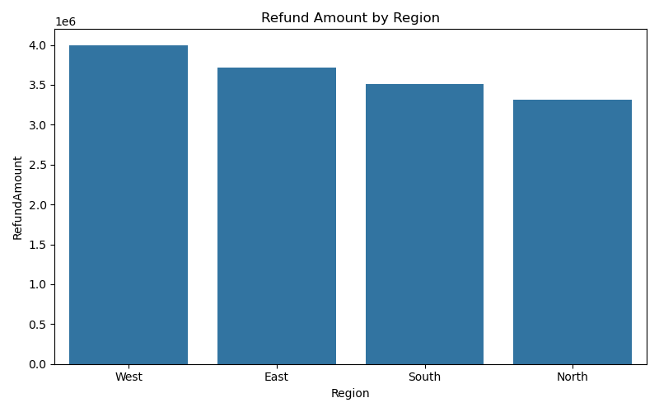

Refund Amount by Product Category:

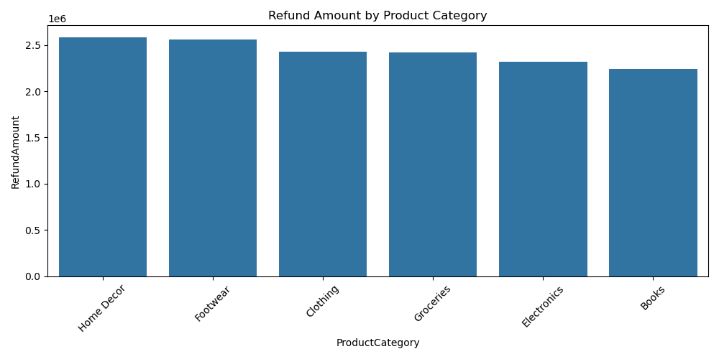

Refund Amount Distribution:

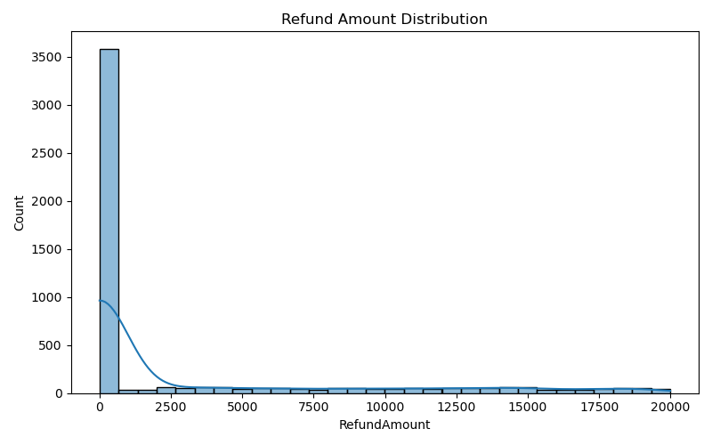

Delivery Delay Days Distribution:

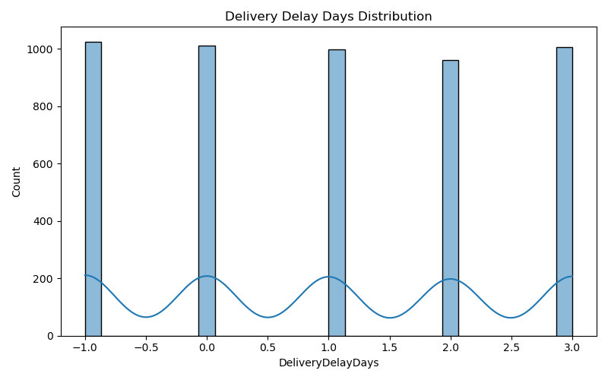

Delivery Delay Days vs Refund Amount:

