churn Analytics - EDA Report

# 1. Dataset Overview

Total Rows: 5000

Total Columns: 21

Missing Values:

- churn_date: 3599

- churn_reason: 3599

# 6. Churn Summary

Customers Stayed (0): 3599

Customers Churned (1): 1401

Overall Churn Rate: 28.02%

# 3. Visual Insights

Churn Distribution:

Churn Distribution:

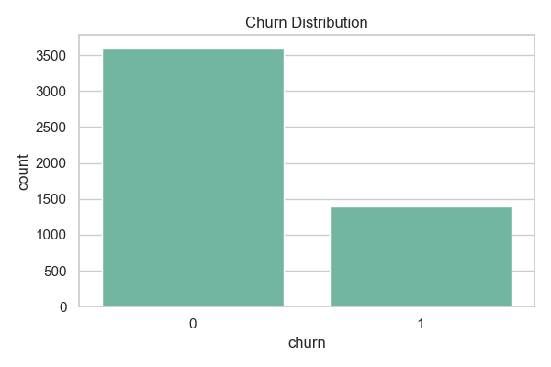

Churn by Plan:

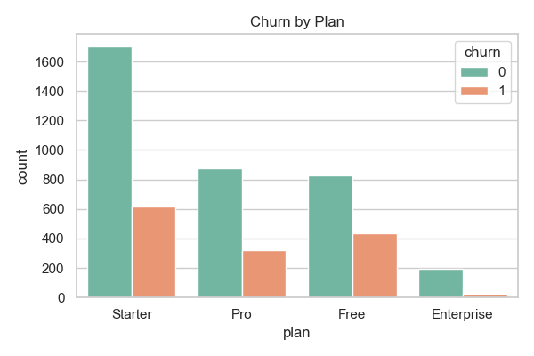

Churn by Plan:



Churn by Plan:



Churn By Region:

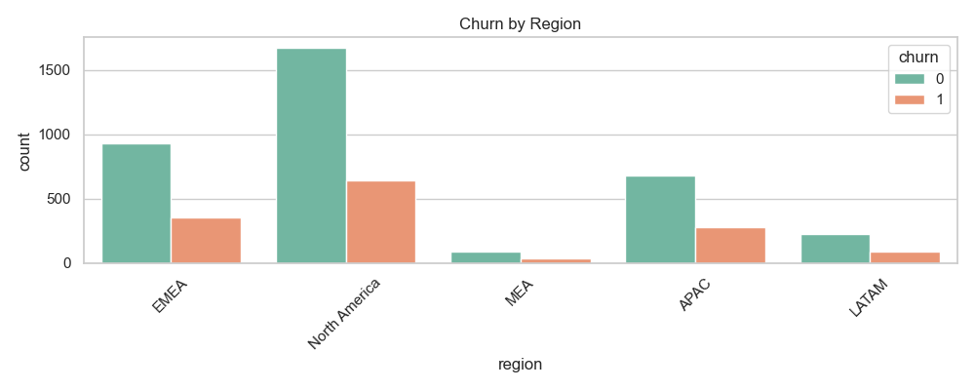

Revenue vs Churn:

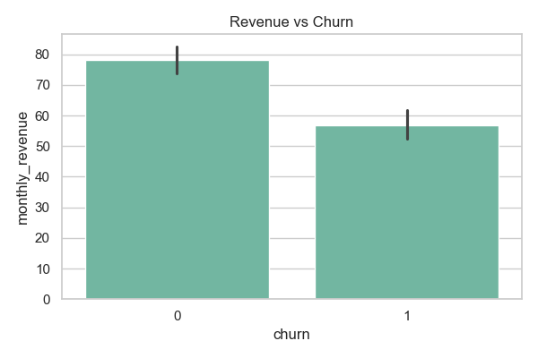

Feature Usage Score By Churn:

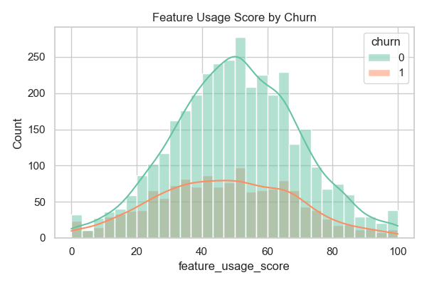

Login vs Churn:

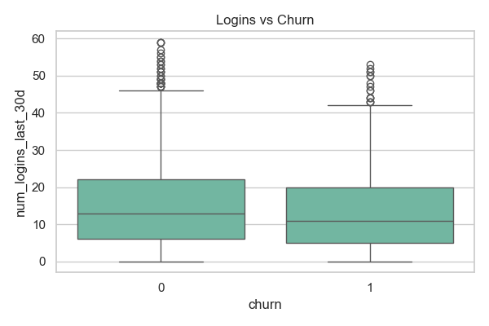

Distribution of Support Tickets By Churn Status:

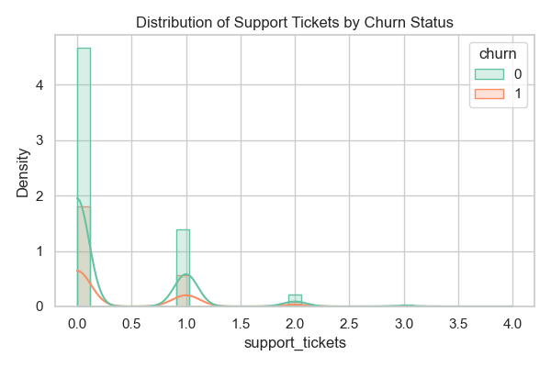

Failed Payment vs Churn:

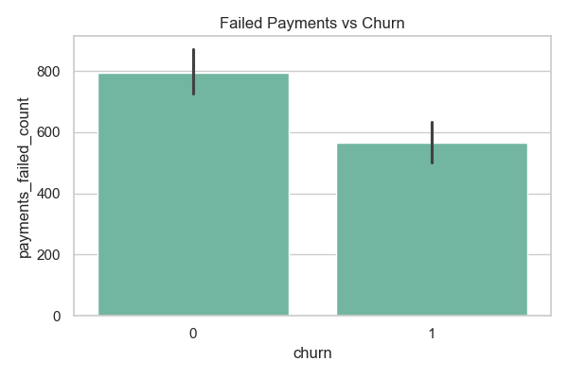

Churn Reason:

