Compliance Manager
System Specification Document

Document Control:
Version | Date | Author | Comments
0.1 | 30-03-2026 | Adhisivan R | DRAFT

Contents
Compliance Manager 1
1. Overview 3
2. Compliance Coverage Framework 3
3. System Specification 3
3.1 Asset-Centric Architecture 3
4. Organization Hierarchy 4
4.1 Multiple Levels of Organization Hierarchy 4
4.2 Ownership and Roles 4
5. Asset Management 5
5.1 Asset Identification 5
5.2 Technical and Functional Specifications (Requirements) 6
5.3 Asset Financials and Valuation 6
5.6 Document and Validation Linkage 7
6. Supplier and Procurement Support 8
7. Calibration and Maintenance 8
8. Release and Change Management 8
9. Testing and Validation Execution 8
10. Periodic Review and Ongoing Compliance 9
11. Future Roadmap: AI-Driven Compliance 9
Summary 9

1. Overview
Compliance Manager is a comprehensive, end-to-end platform designed to manage regulatory and quality compliance across the Life Sciences industry. It provides a unified system to address regulatory expectations, quality processes, validation, and operational compliance throughout the full system lifecycle.
The platform is designed to evolve from traditional compliance management into a continuous, risk-based, and AI-enabled compliance ecosystem, supporting both current regulatory needs and future innovations.

2. Compliance Coverage Framework
Compliance Manager addresses multiple layers of compliance through an integrated framework:
Compliance Layer | Scope
Regulatory Foundation | 21 CFR Part 11, EU Annex 11, GxP, Data Integrity (ALCOA+)
Quality Management System (QMS) | Change Control, CAPA, Deviations, Document Management, Training Records
Validation Framework | Validation Plan, Risk-Based Validation, GAMP5, Lifecycle Approach
System Lifecycle Documentation | URS, FS, DS, Traceability Matrix
Testing & Qualification | IQ, OQ, PQ, UAT, Security Testing
Operational Compliance | Periodic Reviews, Audit Trails, Incident Management, Backup & Restore
Future Layer – AI in CSV | Automated Testing, AI Risk Assessment, Continuous Validation, AI-Based Periodic Review

3. System Specification

3.1 Asset-Centric Architecture
The Asset Master is the central component of Compliance Manager. All compliance activities—validation, calibration, maintenance, quality events, and periodic reviews—are linked to physical or logical assets.
Key Principle:
Every compliance activity is driven by and traceable to an asset.
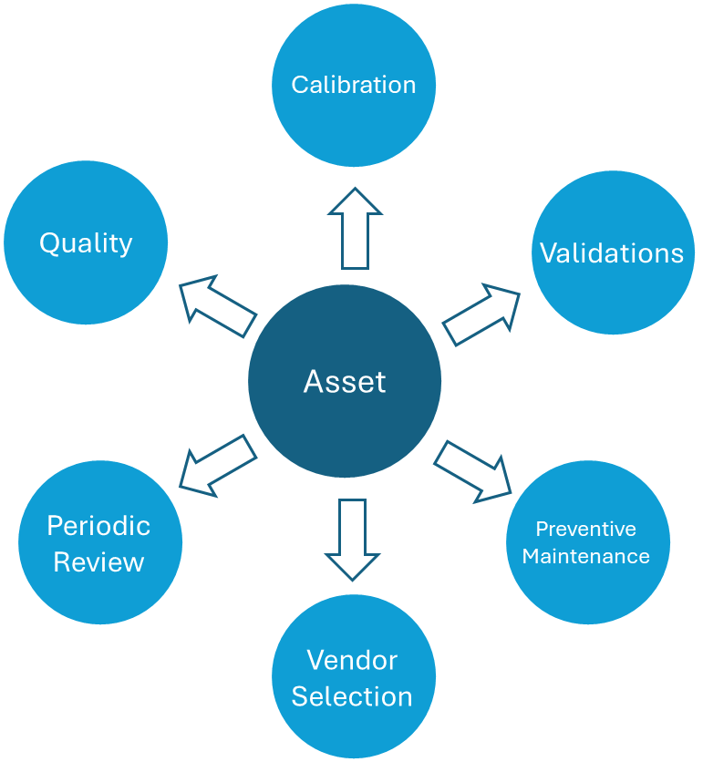
(Figure 1.0: Asset as the center of multiple compliance requirements)

4. Organization Hierarchy
Before defining assets, it is essential to establish a flexible organizational hierarchy. Each organization structures itself differently—some may follow a simple model, while others may operate complex structures such as corporate groups with multiple companies and branches.

4.1 Multiple Levels of Organization Hierarchy
The system should provide flexible ways to create multiple levels of organization structure while still maintaining the parent and child relationship.
Rule: Create a Parent to Child relationship when defining the organization Hierarchy. The rule is One Parent entity can have multiple child entities, but one child entity always belongs to one Parent entity.

4.2 Address and Location Information
Each node in the organization hierarchy should captured structured address (mandatory) and geo spatial information (optional)

4.3 Ownership and Roles
For each of the entity within the organization hierarchy should have one or more attached roles and who plays that role (ISO 55001:2014 requirement).
Define organization specific role as an independent role catalog. This should capture following information:
Entity: Role
Field Name | Field Type | Required | Example
Role Id | System Generated | Yes | 243234-23423-23423-2342
Role Name | String | Yes | Group Chief Executive Officer
Role RACI | Category [Responsible / Accountable / Consulted / Informed] | Yes | Accountable
Ownership | String | Yes | Ultimate accountability for total enterprise asset portfolio value and strategy
Role Type | Lookup | Yes | Strategic

Entity: Role_Actions
Field Name | Field Type | Required | Example
Role Id | System Generated | Yes | 243234-23423-23423-2342
Seq | Int | Yes | 1
Action Type | Lookup | Yes | Endorse
Action | String | Yes | Group Asset Management Policy and strategic objectives

Assign one or more roles to a given organization entity, we should capture both the person’s name and the role played.

5. Asset Management

5.1 Asset Identification
Entity: Asset
Field Name | Data Type | Required | Rules | Description | Sample
Asset ID | String (20) | Yes | Enterprise standardized pattern to be followed | Globally unique enterprise asset identifier | EQ-20240001-MX
Asset UUID | UUID | Yes | System generated | Immutable system-generated universal identifier | 550e8400-e29b-41d4-a716
Legacy ID | String (30) | No | Free text; comma-separated if multiple | Previous identifier from legacy systems | LGY-12345 / SAP-9900123
qr_barcode | String (50) | No | ISO/IEC 15415 or GS1-128 Compliant | Physical label identifier scanned in field | QR:EQ202400012025
Rfid_tag | String (30) | No | EPC Gen2 Standard | Radio frequency identification tag number | E2000017211800000000
Serial_number | String (50) | No | Manufacturer-defined format | OEM assigned serial number | SN-MFR-2024-XR900-007
Asset class | Lookup | Yes | Equipment, Facility, IT, Fleet, Land etc. | Top-Level ISO 55000 asset class – Asset class should capture if upgrade supported | Equipment
Asset category | Lookup | Yes | Rotating, Static, Electrical, Civil, Software… | Second-Level Classification | Rotating Equipment
Asset sub category | Lookup | Yes | Pump, Compressor, Motor, HV Switchgear… | Third-level Classification | Rotating Equipment
Asset Type | Lookup | No | Specific Equipment Type | Defined per sub-category; max 200 values | API 610 BB2 Pump
Criticality Class | Lookup | Yes | A | B | C | D | Business criticality rating (A=critical, D=non-critical) | A
Asset Nature | Lookup | Yes | Owned, Leased, Loaned, Rental… | Legal ownership / possession nature | Owned
Tags | Multiple | No | Free form tokens | Tokens string for flexible filtering and grouping | Equipment, Owned
Asset Name | String (100) | Yes | Title case; include location code prefix | Standard descriptive name | Feed Water Pump 01A
Asset Description | String (500) | Yes | Plain English | Detailed functional description | Horizontal multi-stage centrifugal pump
Short Description | String (40) | Yes | Max 40 chars; abbreviations allowed | Condensed description for labels and reports | FWP-01A CENTRIFUGAL
Tag Number | String (20) | No | ISA-5.1 or project tag convention | P&ID instrument/equipment tag number | P-2301A
Asset Owner | String (150) | Yes | Free Form | Name of the single owner for the asset

*only asset class with upgrade option can create release records

5.2 Technical and Functional Specifications (Requirements)
Defined specification criteria and values. For each asset sub-category level specification parameters should be declared and captured, there will be multiple associated specification parameters.
Entity: Asset Specs
Field Name | Data Type | Required | Rules | Description | Sample
Asset Sub-category ID | ID | Yes | Lookup Reference Field ID | Globally unique enterprise asset identifier
Parameter Grouping | String (50) | Yes | Free Text | Logically groups parameters into separate buckets. | Example: Safety parameters, Monitoring parameters etc
Parameter ID | int | Yes | System generated sequence no | Automated sequence number (unique) | 1
Parameter Name | String (50) | Yes | Free text | Name of the specification parameter | Weight (in Kg)
Parameter Value | String (150) | Yes | Free text | Expected parameter value for the key | 2.5
Guidelines | String (150) | No | Range and other limits | Specify general guidelines for the parameter value | 1 to 3 kg

5.3 Asset Financials and Valuation
Every asset should capture the purchasing information and financial valuation in a separate entity table.
Entity: Asset Finance
Field Name | Data Type | Required | Rules | Description | Sample
Asset UUID | UUID | Yes | Reference from the Master table | For reference | 550e8400-e29b-41d4-a716
Acquisition_dt | Date | Yes | Must be <= today; cannot be before company founding | Date asset was acquired / PO issued | 15-Mar-2024
Purchase_order_no | String (20) | No | Valid PO from procurement system | PO reference for asset purchase | PO-2024-00456
Invoice_ref | String (20) | No | Supplier invoice number | Supplier invoice number | INV-SUPPLIER-98765
Supplier Id | UUID | Yes | Supplier id reference | Supplier reference | 5e84fg0-e29c-4et4-z685
Make | String (50) | No | Make | Supplier provided make | 2024
Model | String (50) | No | Model | Supplier provided model number | GT
Manufacturer | String (100) | No | Manufacturer name when supplier is not the manufacturer | Name of the original manufacturer | Fujitsu
OEM Release URL | String | No | Web Link | Supplier provided release URL | Web url link
Capitalization Date | Date | Yes | Date placed in service; must be ≥ acquisition date | Date asset was placed in service | 01-Jun-2024
Acquisition Cost | Decimal (18,2) | Yes | Positive Number; in functional currency | Total capitalized acquisition cost | 285000.00
Currency Code | Currency Lookup | Yes | ISO 4217 format | Transaction Currency | USD
Book Value | Currency (18,2) | Yes | Formula:=Acquisition Cost – Accumulated Depreciation | Current book value per accounting records | 285000.00
Replacement Value | Currency (18,2) | No | Updated annually via appraisal or index | Estimated cost to replace in kind today | 320000.00
Insured value | Currency (18,2) | No | As per insurance schedule | Value declared for insurance purposes | 300000.00
Salvage Value | Currency (18,2) | No | Estimated value at end of useful life | Expected value at disposal | 5000.00
Depreciation method | Lookup | Yes | Straight Line, Declining Balance, Units of Production, Sum of Years Digits | Account depreciation method | Straight line
Useful life years | Integer | Yes | 1-99 years; per asset class policy | Expected useful economic life | 15
Depreciation rate % | Decimal (5,2) | No | Auto-calculated; override if non-standard | Annual depreciation percentage | 6.67
Accumulated Depreciation | Currency (18,2) | Yes | Formula calculated, system maintained | Total depreciation to date | 57000.00
Cost Center | String (15) | No | Valid cost center from chart of accounts | Responsible cost center code | CC-OPS-UTIL-001
GL account Capex | String (15) | No | Valid GL account from chart of accounts | Fixed asset general ledger account | 1520-PUMP-MECH
Asset Class GL | Lookup | No | Per local GAAP/IFRS asset class table | Financial asset classification | PP&E – Plant
WBS Element | String (20) | No | Valid project WBS structure element | Project WBS for CAPEX tracking | WBS-2024-PLT-EXP-007

5.4 Asset Grouping
Individual assets can be grouped into sub-systems and systems. This helps in formulating all connected assets and equipment to understand the overall impact in the system when one of the assets goes down.
A sub-system is made of all connected individual assets. A system can be made of either individual assets or sub-systems or both.

5.5 Asset Location Identification
Every asset should be identifiable physically within a given premise or a site. It should have building reference, floor reference, local reference. The site is known from the entity it is attached to, however within the site where that asset is located needs to be tracked.

5.6 Document and Validation Linkage
Every asset should have associated documents. The user should be able to start drafting any specific type of document based on available template. For example: the user should be able to author URS (user requirement document) using existing template, information available from asset master and specification master along with any additional inputs provided by the user.
Linked validated documents
Auto-generated URS (AI-assisted) with review and approval workflows
Approved URS published to Veeva
Supplier-submitted documentation:
IQ
OQ
PQ
AI-based Requirements Traceability Matrix (RTM) generation

6. Supplier and Procurement Support
Identification of qualified suppliers
Collection and management of supplier quotations
Submission and review of supplier documentation
Structured response capture for feature-specific requirements
AI-assisted technical and functional comparison
AI-generated comparison summaries and selection recommendations
Identification of key differentiators

7. Calibration and Maintenance
Calibration requirements and configuration
Calibration schedules
Calibration certificates
Integration with preventive maintenance where applicable
Compliance-ready calibration history

8. Release and Change Management
Creation and management of system releases
AI-assisted impact assessment
Change traceability across assets, documents, and validation artifacts

9. Testing and Validation Execution
Automated validation testing
Manual and automated testing logs
Support for:
IQ
OQ
PQ
UAT
Security and compliance testing
Validation summary and reporting

10. Periodic Review and Ongoing Compliance
Configurable periodic review controls
Defined review frequency
Review artifacts and reports
Ongoing compliance status visibility
Support for continuous validation models

11. Future Roadmap: AI-Driven Compliance
Compliance Manager is designed to progressively introduce AI-powered compliance capabilities, including:
Automated test generation and execution
AI-driven risk assessments
Continuous validation
AI-assisted periodic review preparation and analysis

Summary
Compliance Manager evolves compliance management from a document-heavy, reactive process into a connected, intelligent, and continuously compliant platform, aligning regulatory expectations with operational efficiency and future-ready innovation.

